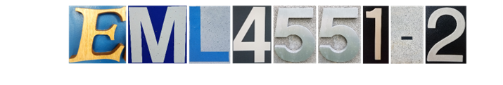 8/28/2017

Team 518: NASA MSFC - Powder Removal in Microgravity Environments Experiment

Prototype Description

Team Members: Cole Daly, Kyle Evans, Alexander Fryer, Chelsea Kiselewski, Tripp Lappalainen, Lauren McNealy
Current State of Design
Our selected design is the ultrasonic cleaner. The current prototype uses a plastic container as the body. A suitable hole was cut into the container using a Dremel, and the speaker was placed in the hole. Silicone based gasket maker is used to produce a watertight seal around the speaker. The speaker used in the design is a 5-inch car speaker. The response range is from 55Hz-22kHz. The speaker is driven by an Arduino at a frequency of 1kHz and a voltage of 5V.
Currently, the prototype is most limited by the voltage supplied to the speaker. A larger voltage to the speaker results in a larger sound pressure in the fluid which is necessary for more scrubbing force. The frequency supplied to the speaker should also be increased. Increasing the frequency shortens the wavelength which allows the design to clean smaller particle sizes. Finally, the prototype is not prepared to function in microgravity. To function in microgravity, a sealing lid, filling, and draining functions must be added to prevent the cleaning medium from escaping the design, and to keep the particles from settling back on to the part.
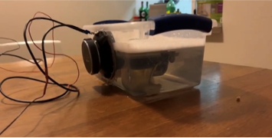
Figure 1: Current Prototype
Forecast of Work Ahead
The work ahead for the design is to research soldering and ultrasonic cleaners for design considerations such as speaker placement and UI. Coding the basic ultrasonic pulses while incorporating the user interface is the next step to ensure the mechanism works properly. Next is designing the tank where the part and fluid medium will go to provide the most cleaning power with the available frequency. Creating the outer shell with wiring and speaker size in mind to ensure our targets are met and these components are hidden is the next step and lastly the placement of the screen on the outer wall to provide ease of selection for the user. With all this in mind the forecast work is mostly coding and wiring to ensure user experience and usability is maximized.
Future Work
First, ordering parts must begin immediately. Once parts have arrived, assembly can begin. Assembly includes fabricating the metal body out of aluminum. The ultrasonic sensors and fittings for drain and fill lines can then be attached. Work to connect the ultrasonic sensors to transformers must also be done, and code to control the ultrasonic sensors must be done. Code for controlling the draining valve and the pump valve must be implemented and tested to ensure the flow rate between them is constant and working properly. Testing of the design can commence after determining that determining in and out at the same constant rate, and the ultrasonic sensors are working and the cleaning frequency.
Problem Areas
A concern with the current design is supplying enough power and frequency to efficiently clean the parts. A transformer will be used to attempt to supply the speakers with enough voltage. In addition, special care must be put into the interfaces between drain and fill lines because there is potential for leaks.

