Project Overview
The objective of this project is to create a device that cleans selective laser melted (SLM) parts in microgravity environments. When creating holes in these parts powder will become trapped and unable to function correctly. The powder can block the flow of fluid for cooling/heating or transferring leading to errors. This powder is very toxic. The metal powder can cause extreme health issues for people, explosions, and electrical hazard, and is extremely small particle size. This device cleans the powder off the interior/exterior surfaces and holds it for repurposing or disposal.
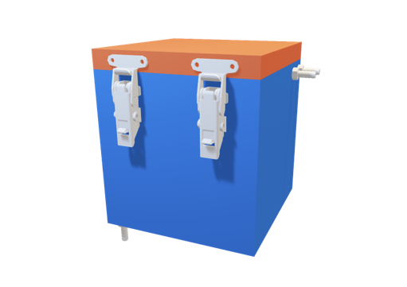
Component and Modular Description
Cleaning module: The device comes with several modules. The cleaning module consists of the following: a metal box, a lid, a mesh basket, and a sensor compartment. The metal box holds a mesh basket on the inside. The mesh basket filters the metal powder and will need replacing for long-term use. The sensor compartment goes on the side of the aluminum box; it comes with a timer that tells the user the operation in action.
Electrical, LCD: This module holds the Arduino, the buttons for operation, and an LCD screen for a user interface. This module gives the user a proper way of viewing the operation in process, as it shows the time to the user, and when the machine stops or starts.
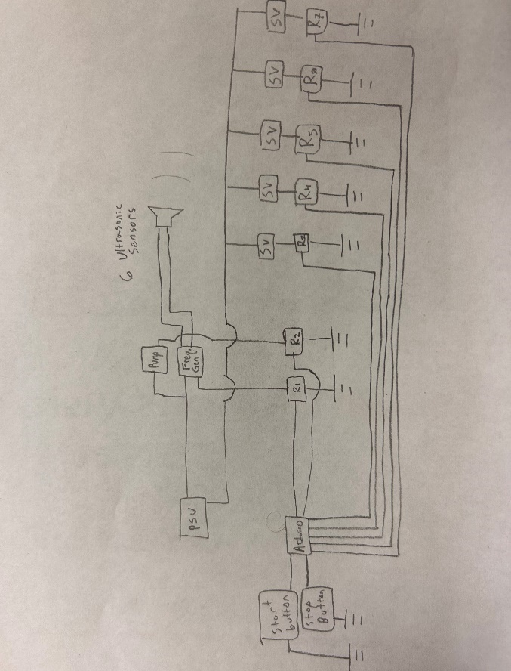
Figure 1: Wiring Diagram. Rn represents a relay and SV represents a Solenoid Valve. Each wire leaving the Arduino is on an individual pin.
Specimen: The specimen input in the machine should come from a SLM 3-D printing machine. This specimen should be made of metal and fit inside the module of a 5’ x 5’’ x 4.5’’ mesh basket. If SLM is not available a selective laser melting (SLM) part can be substituted. A drawing of the test specimen to test with is shown below. A SLM part can be made from the Innovation Hub at FSU’s campus.
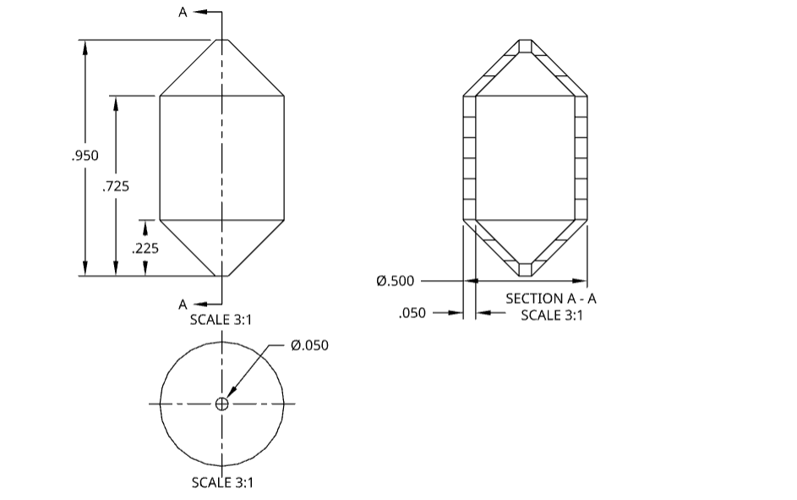
All the dimensions listed are in inches. The test part is to show the worst-case scenario where there is a large cavity inside full of powder with small exterior holes to remove the powder.
Integration
Schematic of the part including numbers indicating which part represents what in the model.
Plumbing System
A rubber hose, solenoid valves controlled with relays, and a submersible water pump are used to control the fluid's location in the design. The Plumbing System is pictured in figure 2 below.
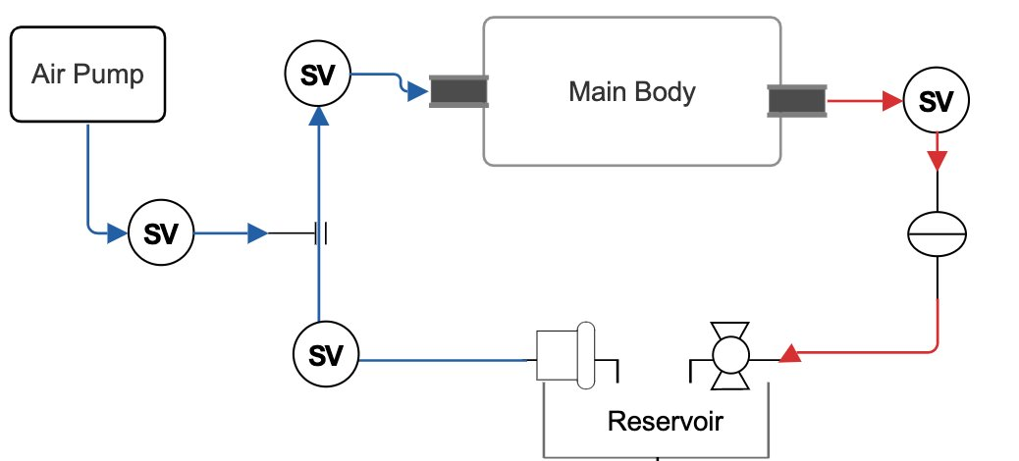
Figure 2: Plumbing Diagram
Operation
- Ensure the specimen has the right material before operation.
- Open the lid of the box through the two hinges on the front of the box.
- Check the inside of the machine mesh does not contain any powder. If not, run the cleaning operation until most powder has left the machine.
- Place the specimen on the mesh basket.
- Close the lid of the box specimen using the two hinges on the side.
- Press the on (green) switch.
- Wait 20 minutes for the timer to elapse. If you notice a problem, press the off (red) switch, and see troubleshooting.
- Open the lid once the timer finishes. If everything operated correctly, you should get a clean SLM part.
Troubleshooting
Low Cleaning Power
Low cleaning power could be due to a malfunctioning sensor. At operating frequency, the ultrasonic sensors produce noise outside the human range of hearing. To diagnose the sensors, reduce the frequency on the frequency generator using the grey knob to the lowest value. At this frequency, the ultrasonic sensors are audible.
If the sensors do not produce audible noise at a low frequency, then there is an issue with this portion of the circuit. Check that all wire connections are secure, and that the sensor is switching properly. If the connections are wired correctly, then the sensor may be faulty.
To check if a sensor is faulty, remove it from the system and test it in the setup shown below. The sensor should be audible.
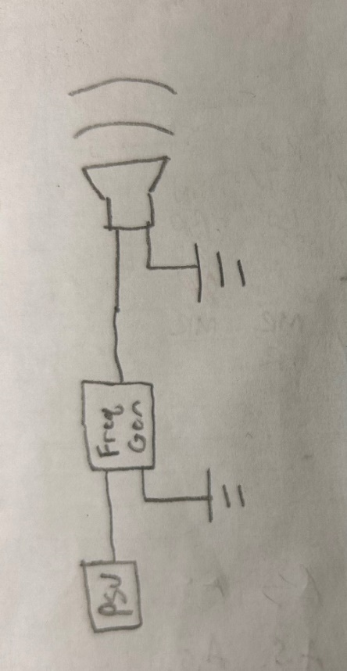
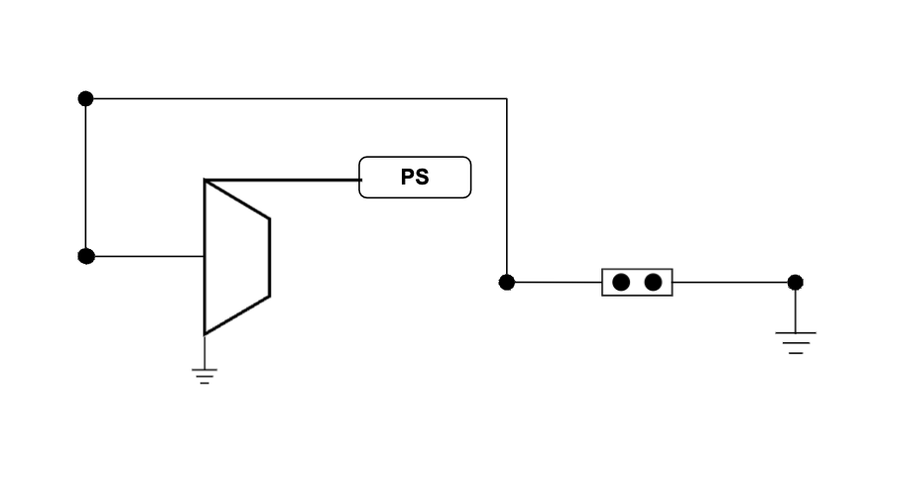
Figure 2: Control system for the sensor. A frequency generator occurs in the middle.

Low Flow Rate
Low flow rate could be due to a clogged hose or a stuck solenoid valve.
To test the solenoid valves, remove them from the setup and test them individually. When connected to a 12V DC power source, the solenoid clicking should be audible. The valves flow when power is connected. If a solenoid valve is stuck, gently tap it to try freeing the solenoid, or replace the valve.
To test for low flow rate, remove individual sections of hose from the design and visually inspect them for blockage. Connect the sections of hose directly to the pump and test the flow rate. Clean the hose. If a section of the hose is clogged, clean the section, or replace it.
Poor Lid Sealing
If the lid is not sealed, the gasket could be old or seated incorrectly. The gasket should appear shiny and be pliable. If the gasket is dry, cracked, or brittle it should be replaced. If the gasket seems healthy, ensure that it makes flush contact with the rim of the box and the lid when the device is shut. A proper seal is necessary to prevent the fluid from escaping the cleaning device.
Leaking Valves
If the valves are leaking it could be due to two issues. Either the hose is not making proper contact with the fittings allowing the cleaning fluid to leak or the fitting to the valve is not making proper contact. To fix the hose contact to the fitting you can cut off the hose making contact and use a new hose. Another way to solve this is to tighten the hose to the fitting by applying more force such as a zip tie.
To fix the fittings to the valve remove the fitting and apply Teflon tape to the threads again. Then screw on the fittings to the valve. If the problem consists of consider replacing the fitting and/or valve.

