Team 516: Instrumented Baseball

Yanni Giannareas   
*Mechanical Engineering* *Florida State University*Tallahassee, Florida, US  
yg18@my.fsu.edu

Riley Ferrer  
*Mechanical Engineering*  
*Florida State University*Tallahassee, Florida, US  
rjf19k@my.fsu.eduDavid Adams   
*Mechanical Engineering* *Florida State University*Tallahassee, Florida, US  
dja18b@my.fsu.edu

line 1: 5th Given Name Surname  
line 2: City, Country  
line 5: email address or ORCIDMathew Brown   
*Mechanical Engineering* *Florida State University*Tallahassee, Florida, USmjb17d@my.fsu.edu

Charles Whitaker  
*Mechanical Engineering  
Florida State University*Tallahassee, Florida, US  
csw19d@my.fsu.edu

*Abstract*— This paper describes the design and manufacturing involved in a device that measures dynamic fingertip forces involved in pitching a standard baseball. Our design uses piezoelectric force sensors to determine a pitcher’s fingertip forces the instant the user throws the baseball. A custom 3D printed design holds the technology inside our baseball to avoid physical damage. This design can support difficulties with the baseball’s rotation, size and weight on release and makes sure our baseball is up to official standards. Data regarding a pitcher’s fingertip forces allows for player-specific performance to be collected and studied during practices. Knowing these forces could decrease the chance of injury and increase overall player performance. A phone or computer can be used to track these changes by means of a Bluetooth receiver inside the ball. This receiver will then connect to an application that shows the information gained from the sensors.

Keywords—piezoelectricity, 3D printing, Shear force, Compression force, baseball, pitcher

# Introduction

## Project Description

Our sponsor and advisor, Dr. William Oates, instructed us to develop technology that can be used to instrument a baseball for greater feedback and performance of athletes. More specifically, this project is concerned with the measurement of dynamic fingertip forces applied by pitchers when throwing baseballs. To do this in a practical manner, measurement equipment must be inserted inside of a baseball to provide local measurements and real-time feedback to the user. This will be done by the instrumented baseball.

## Key Goals

A key goal for this project is to develop an accurate method of measurement for dynamic fingertip forces that can be inserted into the baseball to perform local measurements. Another important goal of the project is to facilitate access to the gathered data so that the user will be informed based of off their performance. This requires both the ability to process the data instantaneously and an interface which informs the user of the forces gathered.

The final key goal for the instrumented baseball is to maintain the overall feel of pitching, so that the user can relate his/her performance with the device to a competitive or recreational setting. This will allow the data gathered from the device to be comparable to what would be observed with a standard baseball.

## Assumptions

Some assumptions were made to limit the scope and feasibility of the project. First, it is assumed that the instrumented baseball will be caught after release by a non-destructive apparatus, such as a net or a blanket. It is also assumed that the user will hold the ball in the position specified by the device to facilitate force gathering. Finally, for data visualization purposes, it is assumed that the user has an electronic device to read data from, such as a computer, laptop, or smartphone.

# Targets and metrics

## Standard Moment of Inertia

Matching the moment of inertia to that of a standard baseball is an important target that the group aims to accomplish. A baseball that is not of size would be an unusable practice ball that most pitchers would not use. Pitchers, whether college, major league, or other upcoming aspiring players, need a standard size ball to practice with so that their gametime pitching form is not skewed. That is, the ball’s skewed projection or other measures that might disrupt a pitcher’s ability to throw a perfect game. This target was determined by calculating the moment of inertia of a standard size baseball (solid sphere): $I= \frac{2}{5}MR^{2}$, where *M* is the mass of a standard baseball (calculated to be around 145 g) and *R* is the radius (about 37.5 mm). The value obtained from these calculations was $81.56 kg*{mm}^{2}$. We also determined that a feasible tolerance for this value would be $5\%$ since it would be improbable to get the exact value. An experimental approach can be used to determine the moment of inertia of the final product. With the use of a cable and a stopwatch, the product can be attached to a fixed table and allowed to rotate in a free manner for a known angle. This action can be monitored with a stopwatch to determine the time of travel. With this data, the following equations can be applied to determine the moment of inertia:

$$τ=Iα$$

$$τ=mgh\sin{θ}$$

In these equations, τ represents the torque, *I* the moment of inertia, α the angular acceleration, *m* the product’s mass, *g* the acceleration of gravity, *h* the height at which the ball is suspended, and θ the traveled angle. This method was chosen as it is inexpensive and easy to perform. It can also be used to determine if the pitching feel of the product is like the standard, which will result in the user getting more valuable data.

## Component Movement

Locking components in place will be important to avoid structural damages and variations on the moment of inertia. Ideally, components will not displace at all during operation, but this will be difficult when the product is subjected to high forces. A maximum of 0.5mm will be allowed as this length value is small compared to the diameter of a standard baseball (75mm) and possible components that can be introduced to the product (around 53mm). This displacement value applies for the x, y, and z directions. When keeping the components within the baseball in place an experimental approach could be used to determine the best housing for the final product. The use of additive manufacturing methods can help house the electrical components and with varying tolerances to ensure some flexibility whilst maintaining structural integrity. With some tolerance levels set in place, the housing will provide the ability to capture the shear directional forces coming off from the ball as well as allow room to flex instead of a rigid impact the ball may experience.

## Supplied Voltage

For the product to operate correctly, the voltage must be within a range of 7-12V to power the electronics inside the baseball. The voltage range was based on the voltage allowed to power different types of microcontrollers inside the core of the baseball. When finding the voltage range for the microcontroller it was determined through testing different ranges of voltage that using a range of 7-12V is reliable to prevent short-circuits as well as overheating the microcontroller inside the baseball. The voltage range also prevents the need to repair the microcontroller after extended use of the product.

## Plotting Time Dependent Data

Plotting time-dependent data efficiently is principle in providing useful data for the user. The sensors need to read the data and plot the time dependent data within 2 seconds. This value was determined from the average time it takes a pitcher to release the baseball. In terms of plotting the time-dependent data the use of tools to measure the accuracy of the forces generated from the Δt of the ball releasing from the pitcher’s hand should be within three significant figures. The value obtained is a plotted force vs time for each individual sensor to ensure a proper reading for each fingertip force generated.

## Region for Force Application

To accurately gather data from the surface of our ball, there needs to be a region that is isolated for the index and middle fingertips. This region can be determined by the average fingertip area plus the standard deviation of the fingertip area. This value is roughly 3.9cm2.However, additional area should be included to take into consideration of potential variation in a person’s individual fingertips. Increasing this tolerance will accommodate all types of pitcher's hands making it a universal design. When determining the area necessary for fingertip application a digital caliper can be utilized. The shape of the region may be irregular but accurate estimations can be made by designing the region as an ellipse. This shape closely resembles a fingertip. The width and length of the shape can be determined by modeling the dimensions of an “extreme case”. The extreme case is defined as a person with well above average fingertips.

## Senses applied force

The group established that sensing a load of 117N was a realistic goal for the project given the market that we are trying to attract. This load value is equivalent to a 90-mph fastball in the MLB (Major League Baseball), which is close to the average pitching speed that can be seen. Applying Newton’s laws of motion, this speed was related to the force applied. This goal also allows us to attract other markets where pitching speeds are lower, as we expect the force response of the sensors to be close to linear.

# Component description

## Piezoelectric sensors

The piezoelectric chips used for this project are the PL5FB shear sensors [1] and the TA0505D024 pressure sensors [2] that can be found on Thorlabs website. Sensors are to be assembled in a stack that is composed of one pressure sensor and two shear sensors to capture the three components of the force applied.

The function of these piezoelectric sensors is to generate a voltage whenever a force is applied on top of them. Each sensor has a positive and negative electrode through which the voltage is generated. Given the size of these sensors, certain aspects regarding their mechanical and electrical handling must be considered [3]. Some of these aspects are as follows:

* Do not store these at temperatures above 80°C.
* Avoid soldering directly to the electrodes.
* Consider using a resistor (>1kΩ) connected between the electrodes to avoid discharging.
* Do not load the sensors at locations close to the edges to avoid failure.

Figure 1 below shows the location of the electrodes for both the pressure and shear sensors. Since these electrodes are flat, copper tape was used to ensure a reliable electrical connection. It is recommended that the copper tape is wrapped around the cable and secured using insulation to prevent current leakage. Figure 2 shows how copper tape can be used in shear sensors.

Figure 1: Location of the electrodes for shear (left figure) and pressure sensors (right figure).

Figure 2: Use of copper tape for electrical connection in shear sensors.

A total of two shear sensors and one pressure sensor are going to be stacked in individual housing to measure the forces coming from each fingertip. This allows us to quantify these forces in three different components (axial, lateral in the x-direction, and lateral in the y-direction).

## 3D Printed Housing

The group decided to fabricate all housing components found within the baseball through 3D printing. This design process was crafted within PTC-Creo 8 and is broken down into 6 primary components found within the appendix. For the software used to 3d print, the group used open-source slicing program Cura. Within Cura the printer was set for each component on .12 quality to ensure a precision print as well as a 30% infill to ensure the parts are sturdy enough to be within ball and not break when thrown. We also are printing using standard PLA as its sturdy enough and can be printed safely in a closed environment. Figure 3 shows each component that was housed inside the instrumented baseball.

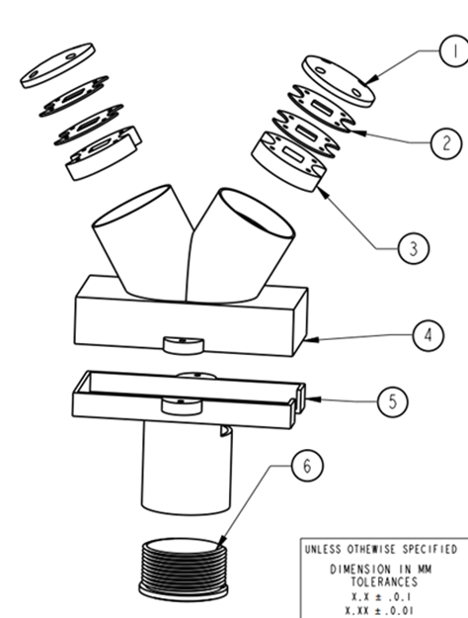

Figure 3: 3D printed housing components.

Components 1 to 3 were designed to hold both sensor stacks. Components 4 to 6 were designed to accommodate the Arduino and the batteries, as well as to connect the stacks to the rest of the housing.

## Arduino Bluno Nano

The group plans to use an Arduino Blue Nano microcontroller for several reasons. One is because of its small, sub-compact design the microcontroller can easily fit inside the instrumented baseball and weighs only 5 grams. The microcontroller also has a built-in Bluetooth module in which information can be transmitted to Bluetooth devices. Lastly, the microcontroller has enough analog pins (7) in which the piezo sensors can be connected to.

Operating the Bluetooth module requires 3 main steps in which the user needs to connect their device to this Bluetooth device. First, the user needs to find the settings menu on their device and make sure their Bluetooth is ON. Secondly, the user must download the “Bluetooth for Arduino” application and connect to the devices named “Bluno” to establish communication with the microcontroller. Lastly, the user should wait 30 seconds before the first throw to ensure that the sensors are fully decompressed and provide reasonable data. An illustration of a typical Bluetooth window can be seen below in Figure 4.

Figure 4: Device's Bluetooth window showing real-time data of sensors.

Figure 5 shows the overall circuit diagram for the piezoelectric sensors in the Arduino Bluno Nano. The main advantages of this circuit are the use of common grounds for each to save space and the incorporation of 1 MΩ resistors between the electrodes of each sensor.

Figure : Circuit diagram of the Arduino Bluno Nano.

## Lithium Ion Batteries

The Arduino Blue Nano microcontroller needs at least 9V and 19 mA of current to sufficiently power the Bluetooth controller over a period. Due to the sub-compact scale of the project, the group chose to implement a stack of 3V lithium-ion batteries. Stacking 3 batteries in series, as seen in Figure 6, will allow for the proper voltage (9V).

This wired battery stack will be placed inside component 5 of the 3D printed housing seen in Figure 3. This cylindrical tube will allow the user to easily place the stack of batteries inside. Component 6 is screwed into the battery housing and fastens the stack so that the components do not come loose.

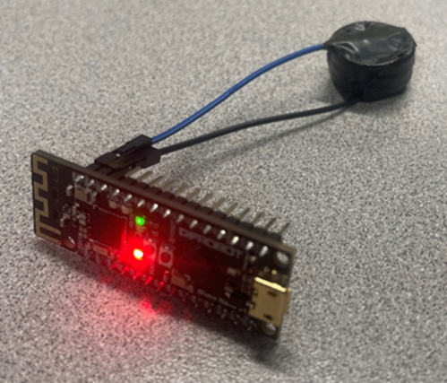

Figure 6: Li-ion battery stack powering the Arduino Bluno Nano.

## Casting Mold

When molding the baseball, the group decided on a silicon rubber-based compound as the material of choice. This compound is the “Smooth-Sil 945” as its properties can match the requirements needed for a baseball. This material, once cured, has a similar texture to that of the rubber cage balls used for training. With properties such as being waterproof, crackproof, and minimal flexibility, this silicon compound is what is ideal regarding material selection. Typical baseballs fall within the density of where this compound is and that increase makes up for some of the material carved out of the ball.

This mold was put into a housing that contained solid versions of the components discussed previously. This was done to ensure that the resulting mold has sufficient space to contain the required components. The curing time was approximately 6 hours, and the mold was then cut in half to insert the components inside of it. Figure 7 shows the initial housing for molding and the integration of the components inside of it.

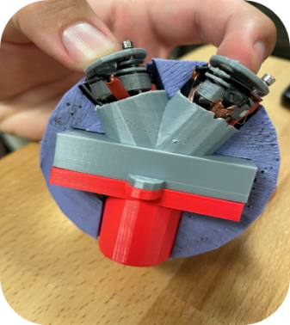

Figure 7: 3D printed housing for mold curing (left) and integration of components on resulting mold (right).

# Results and discussion

Sensor testing consisted of using an MTS load cell in the AME lab. The setup of the test can be seen below in Figure 8. The small piezoelectric sensors were places directly underneath the load cell, and with the use of a micrometer stage the group was able to accurately test the sensor’s response under different strengths of loads.

Different devices were considered to calibrate the sensors, such as force gauges and directly loading them with the load cell. After careful consideration, it was decided that the micrometer stage was needed to get accurate measurements. This stage allowed for a displacement of 100 μm per one turn of the knob, which allowed for very fine displacements.

Figure 8: Testing setup for sensor testing

The output voltage was actively monitored as the load cell increased its dynamic load. To obtain accurate time-dependent data, the group took a video of these responses to ensure that data was recorded at each 1 second interval. The sensors managed to produce accurate readings up to 400N, which is substantially higher than our initial goal of 117N, and it also validates that the recommended goal (400N) produced valuable output.

The relationship between the force applied and the output voltage was considered using a linear fit. Additionally, knowing that the analog pins from the Arduino produce values from 0 to 1023 (which is equivalent to 0 to 5V), a linear calibration curve was obtained to relate force applied and analog response, as seen in Figure 9. Although the noise obtained in these measurements is considerable given the use of the electrometer, the statistics show that the linear fit has an R2 value of 0.94, which is sufficient to ensure accurate measurements. This linear relationship is described by the following equation:



$$Response=4.11*Force-21.38$$

Figure : Linear relationship between applied force and dynamic pressure analog response.

To sufficiently pour a gravity mold, the group 3D printed a spherical mold which had the necessary components inside to shape the mold that was needed. This two-part mold consisted of a top section and bottom section which was clamped down as the casting material (silicon-rubber) was poured in the top. After the casting material was fully cured, the mold was taken off from the casting material and a 2-part baseball mold was successfully manufactured. An important feature of our resulting mold was that all the components were able to be force fitted inside the baseball, thus limiting the component movement below our established threshold.

The final assembly of our project consisted of implementing all the hardware components inside the necessary 3D printed housings, as seen previously in Figure 7. This allowed us to verify that all the components could be powered using our battery stack. This was validated as the Arduino shows a red light when turned on, which was the case when the components were installed. account for wire management, a custom PCB I2C board was printed and soldered to the Arduino. This board sat flush to the Arduino pins and allowed room inside for additional battery wires and other connections.

After wiring the batteries and sensors to the Arduino, the group wanted to ensure that the baseball had a similar feel and touch to that of a standard ball. In doing so, laces were hand-stitched to the rubber baseball. The process can be seen below in Figure 10.

Figure 10: Hand-stitching of the instrumented baseball.

The final design showed dimensions similar to official baseballs [4], although the additional electrical components added more weight. In total, the instrumented baseball had a weight of 150 g and a radius of 37.5 mm. This equals a moment of inertia of 84.375 kg*mm2, which falls into the considerable tolerance that was expected during the ideation and manufacturing process.

Figure 11 shows various pressure measurements that were obtained by loading the instrumented baseball. This further validates data can be obtained, processed, and displayed to the user instantaneously. It can be seen that the pressure behavior increased until a point where force application stalls, which is equivalent to the moment in which the baseball is thrown.

Figure : Pressure measurements from the instrumented baseball.

# Conclusions

The validation process that was conducted shows that all the components in the instrumented baseball work as intended. Results shows that the use of embedded electronics inside a baseball that can be used to gather pitching metrics accurately. Additionally, by strategically incorporating 3D printed elements, these components can be housed to avoid structural damage and maintain the overall physical characteristics of an official baseball. Even though our final design has certain limitations, such as the restriction of the pitching mechanism, it is a valuable proof of concept that can be applied to different types of throws and, with further adaptations, other sports. With some additional small changes, the instrumented baseball can be a valuable tool for teams and baseball fanatics by providing critical and reliable data regarding pitching mechanics.

##### Acknowledgment

We would like to take a moment to recognize the sponsor and academic advisor for our project, Dr. William Oates. Next, we would like to thank everyone at the FAMU-FSU College of Engineering and the machine shop who helped manufacture our project. Also special thanks to Dr. Campbell, Dr. Hooker, CISCOR Robotics Lab, and Jakob Consoliver-Zack for working with us to achieve the build for our project. This was all accomplished through them helping us with testing in the AME lab and bringing new ideas to our notice. Lastly, we want to give the biggest thank you possible to our senior design professor and coordinator, Dr. Shayne McConomy.

##### References

1. “PL5FB shear piezo chip, ±200 V, 1.3 µm displacement, 5.0 × 5.0 × 0.5 mm, bare electrodes,” Thorlabs. [Online]. Available: https://www.thorlabs.com/thorproduct.cfm?partnumber=PL5FB. [Accessed: 12-Apr-2022].
2. “TA0505D024 piezo chip, 75 v, 2.8 µm displacement, 5.0 x 5.0 x 2.4 mm, bare electrodes,” Thorlabs. [Online]. Available: https://www.thorlabs.com/thorproduct.cfm?partnumber=TA0505D024. [Accessed: 12-Apr-2022].
3. IEEE Standard 176-1978, IEEE Standard on Piezoelectricity. Accessed on 11/19/21
4. “2019 Official Baseball Rules 2019 official ... - mlb.com.” [Online]. Available: https://content.mlb.com/documents/2/2/4/305750224/2019_Official_Baseball_Rules_FINAL_.pdf. [Accessed: 12-Apr-2022].