Team 515 Operation Manual
McAnarney Borngesser, Braden Dukes, Brian McGough, Jaxon Stadelnikas
FAMU-FSU College of Engineering
Project Overview
This project consists of two parts, a proposed design and a testing design. Many of the materials that would be used for the proposed design are extremely harmful and dangerous and unobtainable for this class. The proposed design is the design that would be used if tungsten, uranium, Big BUSTER, the SIRIUS module, and the TREAT reactor could be used. The testing design is an alternative design that can be tested with the available proper equipment and fits within the budget of the senior design team.

Project Description
NASA and the Idaho National Laboratory have partnered to conduct research on nuclear thermal propulsion (NTP) engine fuels. This research into NTP would allow for faster and more efficient space travel to and from Mars, allowing for manned missions to Mars. The senior design team project is tasked with designing a device that can fit within Big BUSTER and the SIRIUS module to go into the Transient Reactor (TREAT) to test different nuclear fuels. To do this, the device must be able to withstand the elevated temperatures of the nuclear reaction and allow for the hydrogen propellent to flow through the canister to be heated by the nuclear reaction.

Project Objective
The objective of the project is to develop and test a canister to go into Big BUSTER and the SIRUIS module to test nuclear fuel compounds for thermal nuclear propulsion systems in the Transient Reactor (TREAT).

Key Goals
There are three key goals for this project. The first goal is for the canister to be temperature resistant. The canister must be able to withstand the high temperatures of the nuclear reaction happening inside of the canister. If the canister cannot withstand the high temperatures it will fail in the experiment. The next goal is that the canister must resist the effects of radiation. During a nuclear reaction, when radiation interacts with materials, it can cause radiation hardening which can cause very durable materials to become very brittle and this can lead to cracks and a failure of the canister. The canister must remain inert to the effects of the radiation and not change material properties. The final key goal is for reusability of the canister. The canister should be able to able to be reused to save on material costs and allow for multiple tests in the TREAT reactor. Further research into NTP may be deterred due to low reusability.

Assumptions
There are some key assumptions that are made to complete the project. The first assumption is that Big BUSTER and the SIRIUS module will function according to the specifications given by NASA. This research project is an ongoing project with constant changes to the design of Big BUSTER and the SIRIUS module. Our project will focus on the initial design specifications given to us by NASA about Bit BUSTER and the SIRIUS module. The second assumption that was made is that weight will not be a constraining factor. Given that this project is a custom-made part for testing that will only happen in the Idaho National Laboratory, the project will not be concerned about adapting the design for use in a spacecraft engine. This leads to weight not being a factor when creating the canister. The third assumption is that the temperature range will not exceed 3000K. This is due to the maximum temperature of the nuclear reaction and the fact that liquid hydrogen will be constantly running through the system keeping the canister below 3000K. The final assumption is that radiation containment will be done by Big BUSTER and the TREAT reactor. This means that our canister will not have to contain the radiation from the experiment. The TREAT Reactor and Big BUSTER will make sure that no radiation will reach outside of the reactor and affect the researchers.

Component/Module Description
Given that there are two separate components to the project this section will be broken into the proposed design and the testing design.

Proposed Design
The proposed design is a cylinder made from 99.99% pure tungsten that is powder coated with zirconium carbide. The cylinder is 14 inches long and has 28, 0.25inch holes that run through the entire canister. The center whole for the canister runs the length of the canister with a pressure fit at the top to seal the uranium in the center whole. The entire assembly would then be placed within the SIRIUS module which goes into Big BUSTER, which goes into the TREAT Reactor. It is then the job of the SIRIUS module, Big BUSTER, and the TREAT Reactor to activate the uranium through controlling the boron drums that reflect the neutrons and trigger the nuclear reaction. The SIRIUS module and Big BUSTER will then supply the liquid hydrogen to run through the canister allowing for the researchers to gather the results from the test. A CAD model of the proposed design is shown in Figure 1: Proposed Design CAD Model.
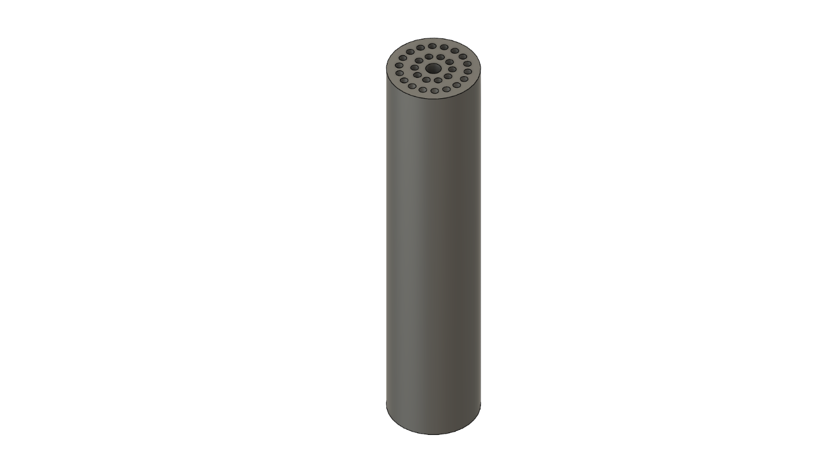
Figure 1: Proposed Design CAD Model

Testing Design
The testing design consists of a cylinder of identical dimensions as the proposed design; however, it is made of 6061 aluminums. The center hole is replaced with a 7-inch deep with a 0.5 NTP thread. A heating element will act as the uranium. Our canister will be going through purely conduction heat transfer. Instead of using liquid hydrogen, argon will be used. There are two K-type thermocouples that will be used for performing the experiment. Each thermocouple is controlled by an Arduino. Both Arduinos can be run from a single computer. The mass flowrate is determined by the regulator on the argon cylinder. 3-inch diameter tubing will be used along with a 3D printed adapter to connect the argon to the canister. The tubing will also allow for the heated argon to be directed to a place for proper venting. A testing station made from aluminum extrusion was used to keep the canister in a secure and stationary location for testing.

Integration
For assembling the experiment, the first step is to assemble a test rig to hold the canister. This can be done in a variety of ways; however, our team built a cradle out of aluminum extrusion for the canister to sit. Once the base is created, the heating element should be screwed into the canister. Making sure the wires for the heating element are running through the tubing, attach and seal the tubing to either side of the canister. From here holes can be made in the tubing to retrieve the wires for the heating element and to insert the thermocouples. These holes need to be sealed to prevent the argon from leaking. Attach and seal the 3D printed adapter to tubing on the side of the heating element and attach the regulator. A diagram of the assembly of can be seen in Figure 2: Testing Diagram.
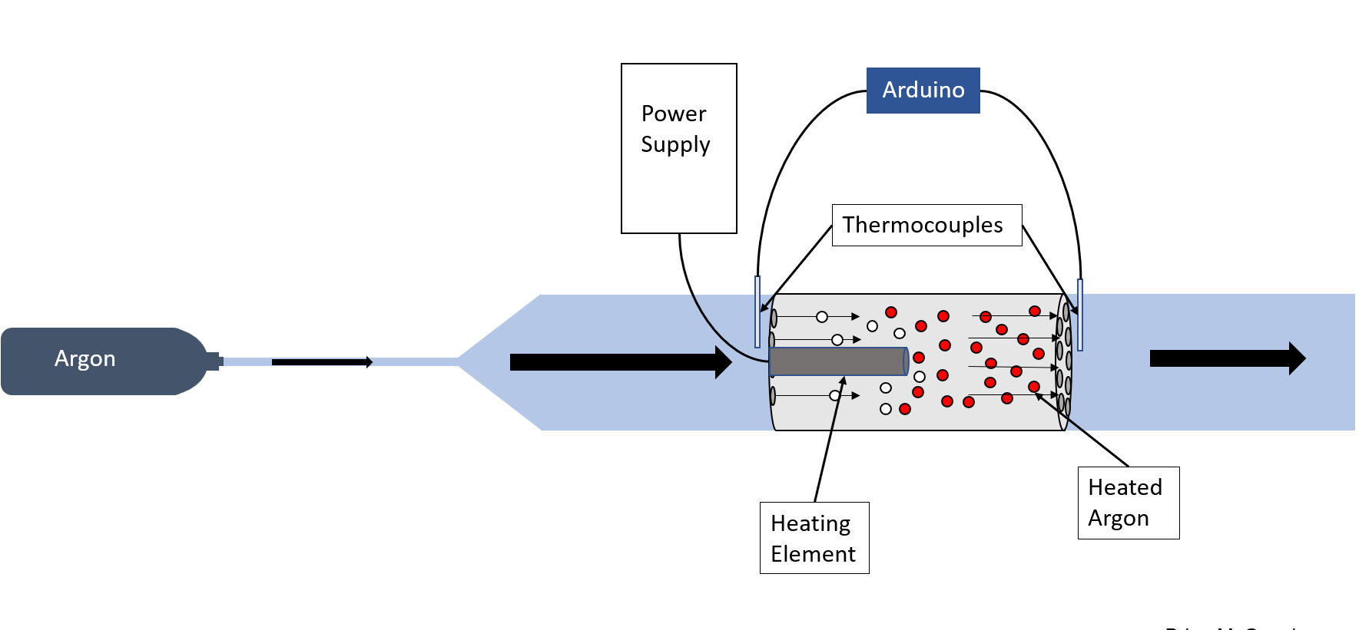
Figure 2: Testing Diagram
Once the testing rig has been assembled, each Arduino can be wired to the respected thermocouple. A wiring diagram can be shown in Figure 3: Thermocouple Wiring Diagram
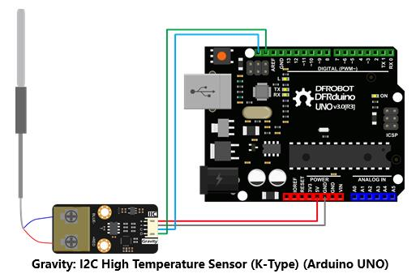
Figure 3: Thermocouple Wiring Diagram

Operation
Before conducting any experiments, first verify that all connections are secure. These connections include the regulator joining the argon gas tank and the narrow tubing, the tubing adapter joining the narrow tubing with the larger tubing, the large tubing connecting to each end of the canister, the heating element being fastened to the canister, and the rear large tubing connecting to a ventilation system. Next, turn on the power supply and set it to 120V. Wait for one hour for the canister to heat up. Then, activate both Arduinos and turn on the gas regulator. Record the inlet and outlet temperatures every minute, as well as the mass flow rate of the argon displayed by the regulator. Repeat until 10 values for each have been recorded. Complete the experiment by shutting off the regulator and turning off the power supply. Wait for the canister to cool down before dismantling the project.

Troubleshooting
Our design has very few parts that require replacement or maintenance. The biggest expense would be the physical canister itself and if there are any flow interruptions or indecisive data that does not correlate with expected results, ensure that the channels are not obstructed and that the tubing is sealed around the canister firmly to ensure correct flow direction. For errors of leaking gas, ensure that the holes for the thermocouples and heating elements are fully resealed and the connections of the tubing to the argon regulator and canister are clamped securely. If incorrect data is being received, ensure the wiring for the thermocouples and the Arduino are secure and that the code for the Arduino is satisfactory. Also, allow for the power supply to correctly input 5V to the Arduino and enough voltage to the heating element to allow for maximum heating. And parts that would break would be the heating element, tubing, or the thermocouples however, these parts are easily replaceable as they are inexpensive. For other parts such as the argon tank, regulator, and canister, these parts would need to be handled with extreme care to ensure they do not break.

Appendix A – Drawing
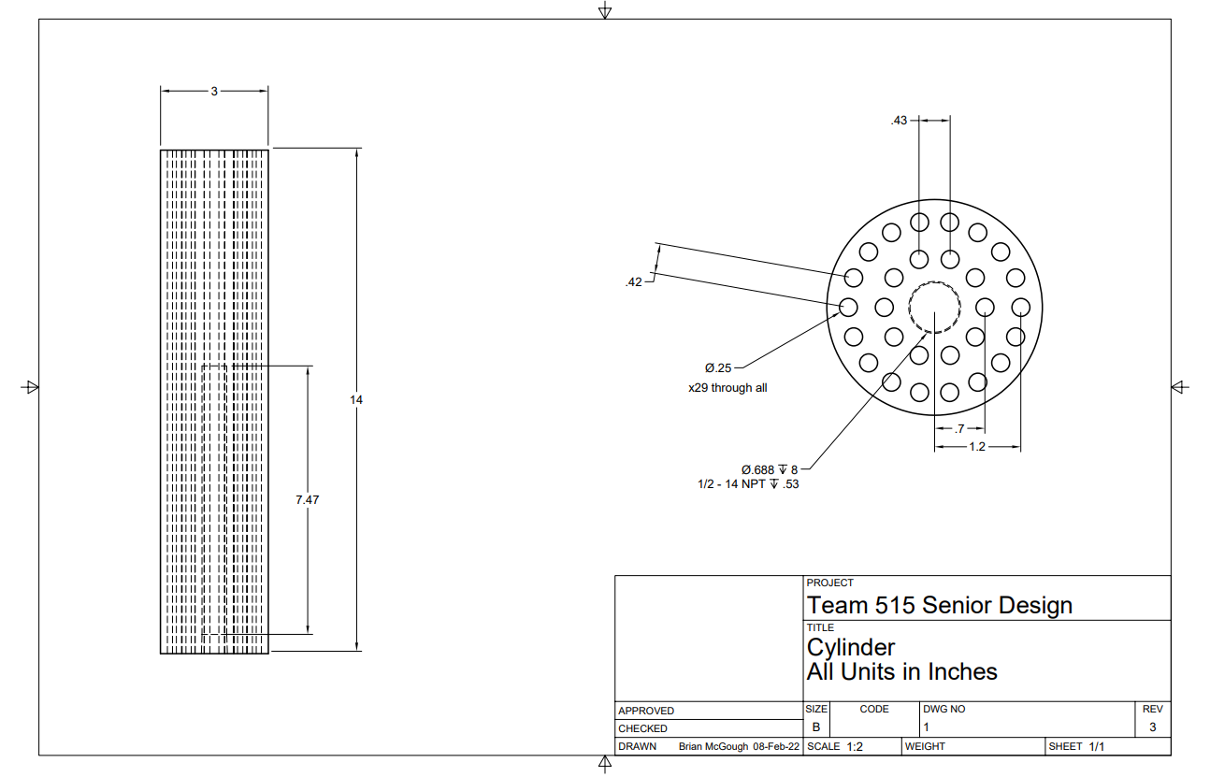
The following image is a drawing to was sent to be machined for the project.

Appendix B – Code
Below is the code used in the Arduinos connected to their respective thermocouple. The code converts the voltage change from the thermocouples to the relevant temperature and displays the currently measured temperature in Celsius.
