Nicholas Blenker, Tucker Hall, David Wilson
FAMU-FSU College of Engineering 2525 Pottsdamer St. Tallahassee, FL. 32310

Team 503: Danfoss - Environment - Controlled Compressor Test Stand Chamber
1/14/2022

Abstract
The abstract is a concise statement of the significant contents of your project. The abstract should be one paragraph of between 150 and 500 words. The abstract is not indents.

Keywords: list 3 to 5 keywords that describe your project.

Disclaimer
Your sponsor may require a disclaimer on the report. Especially if it is a government sponsored project or confidential project. If a disclaimer is not required delete this section.

Acknowledgement
These remarks thank those that helped you complete your senior design project. Especially those who have sponsored the project, provided mentorship advice, and materials. 4

- Paragraph 1 thank sponsor!
- Paragraph 2 thank advisors.
- Paragraph 3 thank those that provided you materials and resources.
- Paragraph 4 thank anyone else who helped you.

Table of Contents
Abstract ii
Disclaimer iii
Acknowledgement iv
List of Tables vi
List of Figures viii
Notation ix
Chapter One: EML 4551C 1
1.1 Project Scope 1
1.2 Customer Needs 3
1.3 Functional Decomposition 5
1.4 Target Summary 9
1.5 Concept Generation 13
1.6 Concept Selection 26
1.8 Spring Project Plan 35
Chapter Two: EML 4552C 36
2.1 Spring Plan 36
Project Plan. 36
Build Plan. 36
Appendices 37
Appendix A: Code of Conduct 38
Appendix B: Functional Decomposition 45
Appendix C: Target Catalog 46
Appendix D: Concept Generation 47
Appendix E: Concept Selection AHP Tables 54
Appendix B Figures and Tables (delete) 59
Flush Left, Boldface, Uppercase and Lowercase 60
References 61

List of Tables
Table 1: Customer Responses and Interpreted Needs 3
Table 2: Functional Decomposition Cross Reference Chart 7
Table 3: Critical Targets and Metrics 9
Table 4: Anti-Problem 14
Table 5: Morphological Chart 15
Table 6: Customer Requirements and Engineering Characteristics 26
Table 7: Binary Pairwise Comparison 27
Table 8: House of Quality 27
Table 9: Top Design Concepts 29
Table 10: Pugh Chart Iteration 1 29
Table 11: Pugh Chart Iteration 3 30
Table 12: Criteria Comparison Matrix 32
Table 13: Normalized Comparison Matrix 32
Table 14: Consistency Check 33
Table 15: Final Rating Matrix Transpose 34
Table 16: Alternate Value Chart 34
Table 17: Pugh Chart Iteration 2 54
Table 18: Temperature and Humidity Manipulation Comparison 54
Table 19: Temperature and Humidity Manipulation Normalized 55
Table 20: Temperature and Humidity Manipulation Weights 55
Table 21: Consistency Check #1 55
Table 22: Automatic Control Comparison 55
Table 23: Automatic Control Normalized 55
Table 24: Provide Access Weights 56
Table 25: Consistency Check #2 56
Table 26: Display Conditions Comparison 56
Table 27: Display Conditions Normalized 56
Table 28: Provide Visibility Weights 57
Table 29: Consistency Check #3 57
Table 30: Monitor Conditions Comparison 57
Table 31: Monitor Conditions Normalized 57
Table 32: Monitor Conditions Weights 57
Table 33: Consistency Check #4 58
Table 34: Final Rating Matrix Transpose 58
Table 35: Concept Alternative Value 58
Table 36 The Word Table and the Table Number are Normal Font and Flush Left. The Caption is Flush Left, Italicized, Uppercase and Lowercase 60

List of Figures
Figure 1: Functional Decomposition Hierarchy Chart 6
Figure 2: Originally approved design 16
Figure 3: Duct Insulation 17
Figure 4: Increased Wall Panel Thickness 18
Figure 5: Heater Inside Duct 19
Figure 6: Hotplate with Water Dropper Humidifier 20
Figure 7: U-tube Bottom Surface 21
Figure 8: Wall-mounted AHU with detachable overhead ducts 23
Figure 9: Floor-mounted AHU with fixed side ducts 24
Figure 10: Floor-mounted AHU with detachable overhead ducts 25
Figure 11. Flush left, normal font settings, sentence case, and ends with a period. 59

Notation
A17 | Steering Column Angle
A27 | Pan Angle
A40 | Back Angle
A42 | Hip Angle
AAA | American Automobile Association
AARP | American Association of Retired Persons
AHP | Accelerator Heel Point
ANOVA | Analysis of Variance
AOTA | American Occupational Therapy Association
ASA | American Society on Aging
BA | Back Angle
BOF | Ball of Foot
BOFRP | Ball of Foot Reference Point
CAD | Computer Aided Design
CDC | Centers for Disease Control and Prevention
CU-ICAR | Clemson University - International Center for Automotive Research
DDI | Driver Death per Involvement Ratio
DIT | Driver Involvement per Vehicle Mile Traveled
Difference | Difference between the calculated and measured BOFRP to H-point
DRR | Death Rate Ratio
DRS | Driving Rehabilitation Specialist
EMM | Estimated Marginal Means
FARS | Fatality Analysis Reporting System
FMVSS | Federal Motor Vehicle Safety Standard
GES | General Estimates System
GHS | Greenville Health System
H13 | Steering Wheel Thigh Clearance
H17 | Wheel Center to Heel Pont
H30 | H-point to accelerator heel point
HPD | H-point Design Tool
HPM | H-point Machine
HPM-II | H-point Machine II
HT | H-point Travel
HX | H-point to Accelerator Heel Point
HZ | H-point to Accelerator Heel Point
IIHS | Insurance Institute for Highway Safety
L6 | BFRP to Steering Wheel Center

Chapter One: EML 4551C

1.1 Project Scope
Project Description
This project aims to validate the existing design of an environmental testing chamber and deliver an assembly that monitors and regulates its internal temperature and humidity for use in a laboratory environment.
Key Goals
The goals of this project are to complete, validate, and implementthe chamber design. These include conducting a thorough heat balance analysis, modifying and finalizing the hardware and software, and overseeing the construction of the final product. The chamber is desired to be capable of fluctuating from conditions ranging from 10°C to 50°C and 0-95% relative humidity within 15 minutes. Other goals are that the compressor can be seen during testing and can be easily accessed. The final goal is to deliver a system capable of long-term testing of Danfoss Turbocor compressors.
Markets
The primary market of this project is the end-users of the environmentally controlled test chamber, Danfoss Turbocor Compressors, Inc. They will use it to test the performance of their products, benefiting the company directly. Secondary markets include any individual or company which requires the chamber for testing of their own. This would consist of other compressor manufacturers, companies that provide air-conditioned storage, ecology companies, and laboratories storing sensitive substances.
Assumptions
Some assumptions were made about this project to limit its scope and maintain focus on achieving the key goals. It is assumed that the design will rest on a flat test rig that rests on a level surface. There will be access to machining services and a 110V power outlet. Another presumption is that the compressor’s conductive heat is small enough to be considered negligible and hence unaccounted for. It is also assumed that the user has access to a crane capable of lifting and lowering the compressor into the test chamber. The existing support for the test chamber is assumed to have sufficient load capacity for the compressor, and the compressor’s size remains the same. These assumptions allow for concentration on the content and challenges of this project’s scope.
Stakeholders
The main stakeholders of this project are Danfoss Turbocor Compressors, Inc., William M. Bilbow, Mr. Larson, and Dr. McConomy. Each will contribute to the project in some capacity and benefit from the design. Another stakeholder would be an original equipment manufacturer (OEM) of compressors.

1.2 Customer Needs
Danfoss Turbocor, Inc. is developing an environmentally controlled test chamber to simulate the environments in which their compressors will be used. William Bilbow is the project sponsor and has provided the responses shown in Table 1 below.
Table 1: Customer Responses and Interpreted Needs
Question Asked | Customer Statements | Interpreted Needs
1. What problem(s) need to be solved? | “Build upon the previous team’s design and assemble the test chamber at the Danfoss Turbocor R&D Lab Facility.” | Adapt and tune a chamber design and build it to provide environmental control.
2. What are the expectations by the end of the project? | “Finalize the specification and sourcing of all hardware and controls.” | Ensure all hardware can reach the specified conditions.
 | “Review and confirm the heat balance analysis conducted by the previous team.” | Perform and validate the heat balance calculations done by the previous team.
 | “Tune the environmental chamber system controls to achieve stable and specified test conditions.” | Tune the controls to achieve stable and specified conditions quickly and accurately.
 | “Demonstrate fundamental 6-sigma methods of problem-solving in 1+ project challenges.” | Use fundamental 6-sigma problem-solving practices for 1 or more project challenges.
 | “Use the numbers that the previous project group used for assumptions and target values.” | The chamber must go from 10 to 55 degrees Celsius and from 10% to 95% relative humidity.
3. What is the volume of air that needs to be controlled? | “The environment of the entire chamber does not need to be controlled, just the air surrounding the compressor.” | Focus on regulating the temperature and humidity of the air surrounding the compressor.
4. What components are already in place? | “The main test rig (base and large chamber) is already in place.” | The design fits in and around the test rig and its surroundings.
 | “The supports for the compressor have already been installed.” | The design is supported by previously installed parts.
5. What are some other design considerations? | “The compressor will be installed using a crane.” | Accommodate space for the crane to install the compressor from above.
 | “The compressor should be visible from all sides during the test.” | The compressor and components are in view and the panels provide internal visibility.
The team was provided with an overview of the project background, the work completed by previous teams, and a list of the project objectives. After brainstorming the questions displayed in Table 1, responses were gathered and interpreted into the true project needs over three meetings with the sponsor. The questions were presented via Microsoft Teams meetings and responses were recorded and evaluated into interpreted needs, also shown in Table 1. The primary project needs are to ensure all hardware can regulate air from 10°C to 55°C and 10% to 95% relative humidity for the Danfoss Turbocor R&D Lab Facility. The design will need to fit within the existing test rig and allow room for installation of the compressor by crane (from above).
Based on these interpreted needs, the team will continue moving forward in validating the previous design and begin formulating ways to address any issues and necessary improvements.

1.3 Functional Decomposition
Introduction
The process of functional decomposition was used to break down the broad project scope into specific tasks that the final product needs to achieve. Establishing these basic level functions of the environmentally controlled test chamber allows the group to easily identify the targets and metrics of the project.
Data Generation
The functions displayed in the hierarch chart (Figure 1) below were a result of asking what the tasks are that the chamber needs to perform. Answers to this question were found by conducting a thorough analysis of the project description, assumptions, key goals, and customer needs. Once all functions were determined, they were classified into major and minor functions based on their importance in delivering a test chamber capable of simulating the necessary conditions.
Flow Chart Reasoning
The three main systems which the testing chamber comprises of are: support, control, and accessibility. Support includes the tasks pertaining to the structural stability and keeping the compressor secure. The control system entails the functions relating to the monitoring and manipulation of the heating, cooling, humidifying, and dehumidifying components. Accessibility covers the visibility and access to the compressor, clearance for the overhead crane, and display and adjustment of the chamber’s temperature and humidity. Breaking down the test chamber into these three systems ensures that the goals and interpreted needs from the sponsor will be met.
These include:
- Building a testing chamber to be used in a lab to simulate environmental conditions.
- Providing access to the test chamber from any angle depending on the lab environment.
- Raising and lowering temperature and relative humidity around a compressor to specified values within the specified time period (15 minutes)
The control of the system is separated into control of the temperature, humidity, and airflow in order to maintain the desired climate conditions. For each of these subsystems, the chamber will monitor and manipulate each condition as necessary. Accessibility is divided into two subsystems, chamber accessibility and climate control.

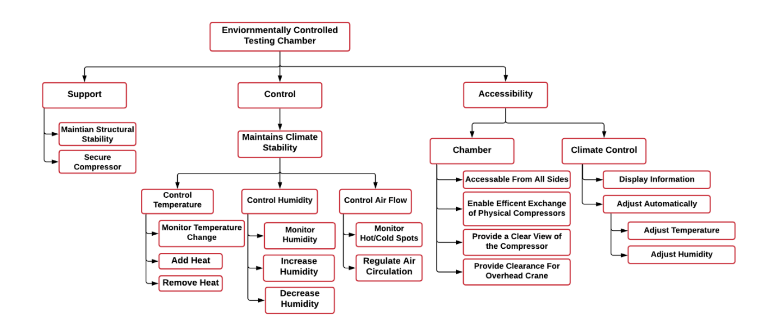
Figure 1: Functional Decomposition Hierarchy Chart

Connection to Systems
A visual comparison of the functions and their relation to each system is shown in the functional decomposition cross reference chart in Table 2 below. The X’s indicate which system(s) each function influences, which can be more than one.

Table 2: Functional Decomposition Cross Reference Chart
System Functional Decomposition
Function | Support | Control | Accessibility
Maintain Structural Stability | X
Secure Compressor | X
Add Heat |  | X
Remove Heat |  | X
Increase Humidity |  | X
Decrease Humidity |  | X
Regulate Air Circulation |  | X
Accessible From All Sides |  |  | X
Enable Efficient Exchange of Physical Compressors |  |  | X
Provide a Clear View of the Compressor |  |  | X
Provide Clearance for Overhead Crane |  |  | X
Adjust Temperature |  | X | X
Adjust Humidity |  | X | X
Integration
The functions of the chart were made to be interrelated to each other on a row-by-row basis. The stability of the climate and the structure itself both describe the need for the chamber to be secure and stable. Within the control branch, each row describes the same needs but for different portions of the project that need to be monitored and controlled. Also, when adjusting the temperature, the relative humidity will be adjusted as described in a psychrometric chart. To control the humidity or temperature, the airflow must also be controlled appropriately to add or remove air with the desired conditions. The adjustment of temperature and humidity from the accessibility branch is also related to the control since it describes that accessibility to the controls must be provided in order to control the system.
Action and Outcome
The outcome of this project is to assemble and implement a working environmental control system that adjusts temperature and relative humidity for testing compressors. The control system will be able to control to and from a range of desired temperatures and humidity. This chamber is to allow for installation, access, and visibility of the tested compressor at all times.

1.4 Target Summary
Development of the critical targets and metrics is necessary for all designs to determine their success once the design is completed. Targets are specific values used to design for, which are found by analyzing the required functions of the system, and metrics are the means of measuring or validating that a target is met (size, weight, temperature, etc.). The critical targets and metrics for the Environmentally Controlled Test Chamber are listed in Table 3 below. Other targets and metrics not relating to a function, but were customer requirements, are noted in Appendix C. The entire functional decomposition chart relating to each target and metric can be found in Appendix B.
Table 3: Critical Targets and Metrics
Functions | Metric | Target | Description
Increase and Decrease Humidity | Relative Humidity | 0-95% RH | Relative humidity is desired to reach any value in this range
Add and Remove Heat | Temperature | 10°C ≤ T ≤ 55°C | Temperature is desired to reach any value in this range
Regulate Air Circulation | Volumetric Flow Rate | 1 m³/min | Air handling unit should be capable of providing this flow rate
Maintain Structural Stability | Deformation | ~ 5% | Chamber should not move or deform
Provide Clearance for Overhead Crane | Area | OSHA requires only 2” of clearance on the side and 3” above. | There should be no obstructions in the way of the crane
Display Information | Display Temperature and Humidity | Yes, they are always displayed during testing | Temperature and humidity will be always shown
Adjust Temperature and Humidity Automatically | Automatic Adjustment | No human action required to reach the desired conditions | Desired temperature and humidity are reached automatically by the system

Determination of Critical Targets and Metrics
The critical functions for the success of this project are summarized in Table 3 above. The critical targets and metrics were chosen because they relate directly to the key functions of the test chamber. The first critical target is for the air surrounding the compressor to be controlled in a range of 0% to 95% relative humidity. The metric (relative humidity) will be manipulated and maintained by implementing feedback control. In addition to humidity, the chamber’s temperature must be manipulated and maintained within a range of 10°C to 55°C. Feedback control will also be used to control the temperature metric recorded by a sensor within the control volume. To provide adequate heat and humidity to the control volume, the air-flow must be able to reach 1 m³/min. This target was determined by performing a heat balance analysis of the system, including the control volume, ductwork, and infiltration.
Another critical function of the design is to provide sufficient structural stability. Since the system must be stable and sturdy, its structure needs to be strong and rigid. In other words, the chamber cannot move or deform during testing and will be able to support its own weight. The metric was chosen to be deformation, the standard method of measuring structural stability, and its target is 0%. This applies not only to the base and frame of the chamber, but also the doors, which need to seal the chamber from the outside air to prevent infiltration.
It is also important to provide sufficient space for the compressor to be loaded into the chamber by an overhead crane. Based on regulations by OSHA, the target clearance is 2 inches on the sides and 3 inches above. This means that there should be an opening with at least this clearance compared to the crane on top of the control volume, and the ductwork should not be in the way of the crane during the exchange. The climate conditions of the control volume should also be displayed to the user, so the target is that the temperature and humidity values are indeed always displayed to the user during the testing process. Finally, it is key that the temperature and humidity are adjusted automatically. As a result, the design aims to require zero human interaction in order to reach the desired conditions once the temperature and humidity are chosen.
Methods of Validation
The means of validating each target includes the tools used as well as the methods of testing which will be conducted. The first method of validation will be a small-scale test of the controls and display of the system to make sure that all components can be easily controlled and that the temperature and relative humidity is accurately measured and displayed. The final system will then be tested once it is installed at the Danfoss Turbocor R&D Lab Facility to validate each target. An extensive test will be run to ensure that the control volume can reach any condition within 10°C to 50°C and 0% to 95% relative humidity. The flow rate will be determined by measuring the air velocity through the ductwork with a pitot-static tube and multiplying this value by the cross-sectional area of the duct.
To validate the structural stability of the design, the chamber will be bumped and pushed to observe if the components break apart or deform. When the compressor is loaded into the chamber by the overhead crane, it will be clear whether there is adequate space for installing the compressor from above. Finally, the full-scale test will indicate if the display system properly displays the climate conditions to the user and if the system automatically adjusts the temperature and relative humidity to the desired values. The control system will require tuning, which will consist of modifying the controller gains to meet the desired time limit of 15 minutes. Separate temperature and humidity sensors will be used to compare results and ensure that the control volume’s conditions are accurately measured. All measurements will be taken in SI units during testing and validation.

1.5 Concept Generation
In order to come up with a good design for our project, 100 design concepts of varying fidelities were made by incorporating multiple ideation processes. Our team used biomimicry, antiproblem, crapshoot, morphological analysis as tools to generate the concept ideas. The best eight concepts were chosen and are described in detail below as medium and high-fidelity concepts. All 100 concepts are tabulated and displayed in Appendix D. Reaching 100 ideas was challenging since this was completed once before for this project but was made possible by imagination and concept generation tools.
Biomimicry
Our team used biomimicry the practice of using inspiration from animals and natural phenomena and adapting this into engineering solutions. Multiple biological systems were analyzed to result in innovative designs to control temperature and humidity within the chamber.
By designing an intricate system of porous walls, termites create their own natural air conditioning system which uses the increase surface area to heat and cool their mounds. The mound’s shape allows for warmer air to move upwards, leaving cooler air at the bottom, similar to how a chimney works. This concept has employed by engineers into building design for more efficient energy usage. For our application, this design can be scaled down by adding extrusions into the vertical portion of the ductwork above the test chamber.
Tropical dog tics can absorb moisture from the air around them using a fluid which they secrete. This concept has been used by engineers in the past to make liquid desiccant dehumidifiers which use salt solutions to pull humidity from the air in buildings. This could be used in our case to more rapidly remove the water from the air inside of the chamber by attaching it to our vent system.
Clams have grooved backs which allow them to more easily glide through the water without being caught by waves or currents. This may be used in order to modify the shapes of fan fins or the ventilation to improve the air flow of the ventilation system.
Another practice our team used was our own version of biomimicry, “baby mimicry” which looks ate baby incubators and relatively similar to a control chamber. Baby incubators are used to provide a safe controlled space for infants to develop their vital organs, which is an excellent to look for inspiration on ways the chamber can be improved to provide a consistent desired environment.
Anti-Problem
Another concept generation technique is anti-problem, where designers analyze the desired goals of a product and all of the challenges or issues that could arise in trying to achieve these goals. This technique can be helpful in shifting the perspective from how to optimize a design towards the possible failures that may occur which could otherwise be overlooked. Table 4, shown below, displays the challenge, anti-problem, reverse solution, and a possible solution to this challenge.
Table 4: Anti-Problem
Challenge | Anti-Problem | Reverse Solution | Possible Solution
How do we make the interior chamber accessible? | What can we do to make the chamber inaccessible? | - Make walls completely opaque and sealed  - Make chamber dangerous  - No openings or doors  - Make chamber too big to fit into the lab | - Keep the chamber walls see-through  - Make sure the chamber is safe for use  - Allow the chamber to be opened  - Make the chamber compact
How do we control the temperature and humidity? | How do we make the temperature and humidity uncontrolled? | - No feedback or sensors  - Make inputs random  - Make everything run randomly  - No off switch | - Make sure sensors are placed and working  - Allow outside inputs  - Use a feedback controller
How do we maintain the stability of our additional parts? | How do we make the ventilation and equipment unstable? | - Place the equipment on unstable surfaces  - Have the equipment freely standing or hanging  - Place equipment in the way of other moving parts | - Make sure the equipment is securely fastened  - Keep ventilation and parts clear from other lab equipment  - Attach the equipment to nonobtrusive surfaces like the walls or ceiling
How do we keep the chamber insulated? | How do we make the chamber have high heat transfer? | - Add in holes for leakage.  - Remove walls  - Make walls have their own heat generation  - Add a thin layer of highly conductive material around the chamber | - Keep walls secure and sealed during testing  - Have leak detection and ways to seal them
Morphological Chart
We also used a morphological chart as a generation tool. To do this, we created a chart using various requirements of the design and then connected an idea from each column to each other to make a full idea using them. This technique was used to make 50 concepts. The morphological chart is shown below in Table 5.
Table 5: Morphological Chart
Mount AHU | Route Ductwork to Chamber | Ductwork | Increase Humidity | Decrease Humidity | Provide Cooling | Connect Ducts | Insulate Ducts
Wall-mounted | Ductwork attached to roof | Flexible ductwork | Boiler humidifier | No dehumidifier | Air-cooled chiller | Duct tape | Fiberglass  insulation
Floor-mounted | Ductwork attached to floor | Rigid ductwork | Ultrasonic humidifier | Heat pump dehumidifier | Water-cooled chiller | Screws/nails | Polyethylene  insulation
Brainstorming
Brainstorming, the most basic and classic method of concept generation, was also used to come up with a portion of the 100 concepts. The individual and collective creativity of the group was utilized to develop as many ideas as possible, with no restrictions on feasibility or practicality. These ideas were then narrowed down into the 100 concepts, shown in Appendix D.
Medium Fidelity Concepts
Since the previous team has created an approved design from Danfoss our medium fidelity concepts are designs that would improve or make the existing design more efficient.
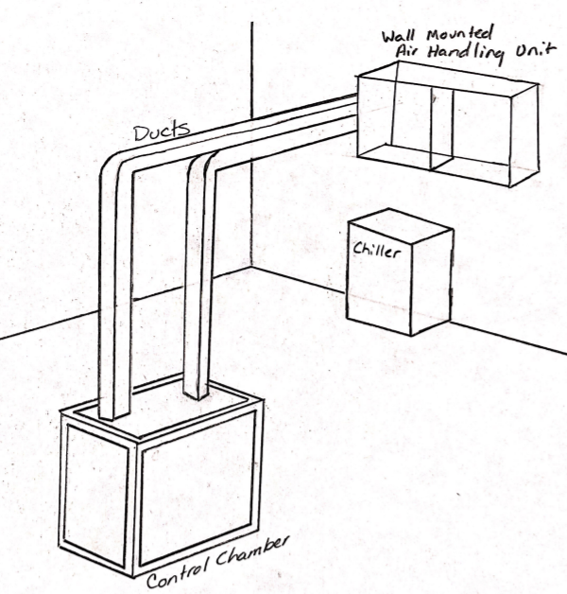
Figure 2: Originally approved design

Concept 1. Duct Insulation
This concept is adding insulation to the ductwork in order to increase the fractional increase in thermal resistance.
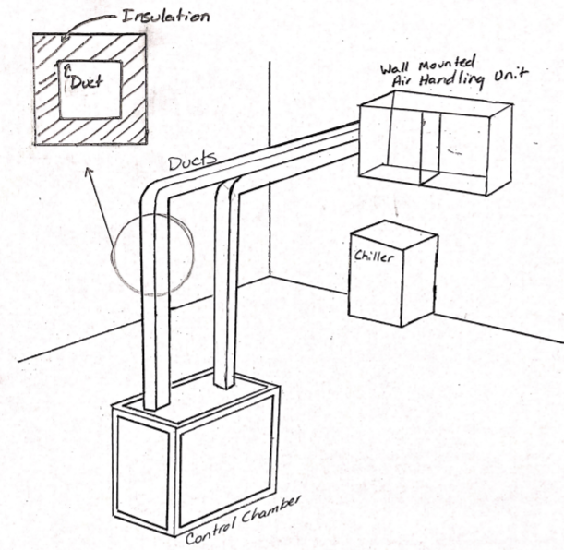
Figure 3: Duct Insulation

Concept 2: Increased Wall Thickness
This concept increases the wall thickness of the material used for the walls of the control chamber.
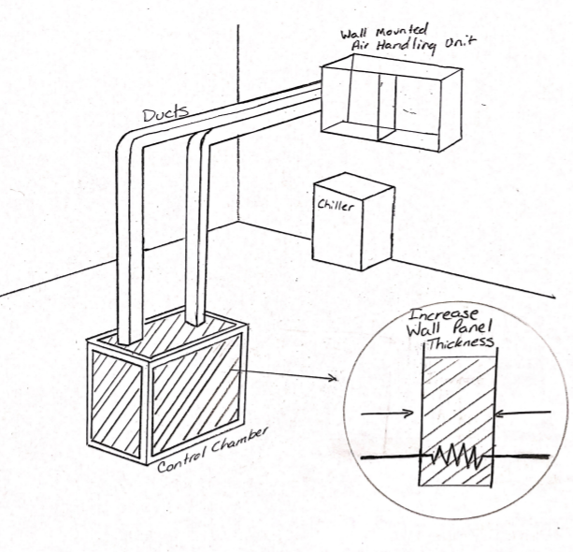
Figure 4: Increased Wall Panel Thickness

Concept 3: Heater Inside Duct
This concept places a heater inside the duct in order to increase the heat of the air entering the chamber. This duct heater is a way to increase the heat of the surrounding air used to help control the environment of the chamber. Duct heaters allow increased humidity control, and machinery pre-heating.
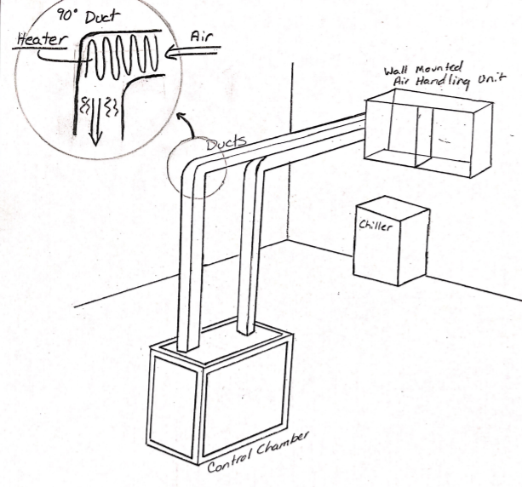
Figure 5: Heater Inside Duct

Concept 4: Hotplate with Water Dropper Humidifier
A hotplate placed in the chamber as a heating element to increase the overall temperature and heat of the chamber. The water droplet controller is positioned and secured over the hotplate where it would release water droplets onto the hotplate increasing the overall humidity of the chamber.
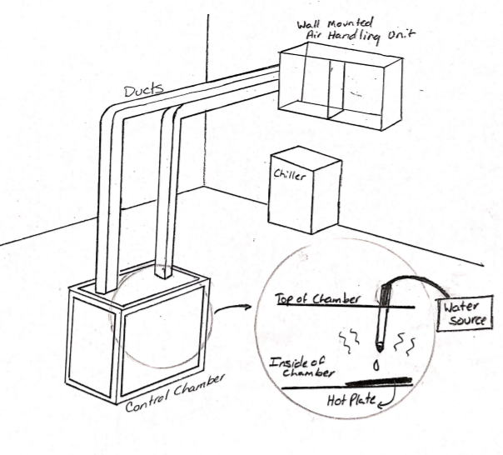
Figure 6: Hotplate with Water Dropper Humidifier

Concept 5: U-tube Bottom Surface
This concept uses an extra bit of fluid tubing connected to its own fluid conditioning cycle which goes through the chamber to heat or cool the surrounding volume during while the humidity is controlled via a separate boiler system. These are attached to the chamber via tubes of their own, which pump the fluid through. The fluid tubing will be set up similarly to a u-tube, which can be used as a primary source of heat transfer within systems. The tubing could minimize hot and cold spots within the chamber by being placed nominally.
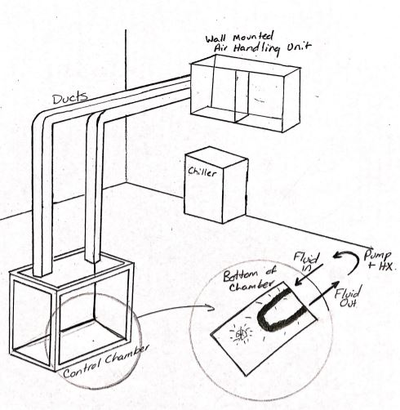
Figure 7: U-tube Bottom Surface

High Fidelity Concepts
Wall-Mounted AHU with Detachable Overhead Ducts
In this design, ducts are detachable using screw on connections, which allows the crane to insert and remove the compressor from above without issue. This also means that the system could be moved to a different location and the ductwork could simply be extended to the new location. The ducts will be made of a rigid material and covered by insulation to prevent as much condensation and heat transfer out of the system as possible. By placing the AHU on the wall, more floor area is available for other lab equipment in the facility. The chamber also has putty infiltration seals placed inside due to holes in the bottom of the chamber which normally allow wires through but also cause extra convection transfer. The putty would be placed in these holes to minimize the convection that occurs. The design also proposes to have rubber inserts seal the edges of the chamber where the plexiglass walls meet the aluminum frame and would otherwise allow for significant infiltration. These inserts will not affect the accessibility of the compressor. To account for condensation pooling within the ducts, several dips will be added into the horizontal portion of ductwork, which should be drained following each test cycle or once significant condensation accumulates.
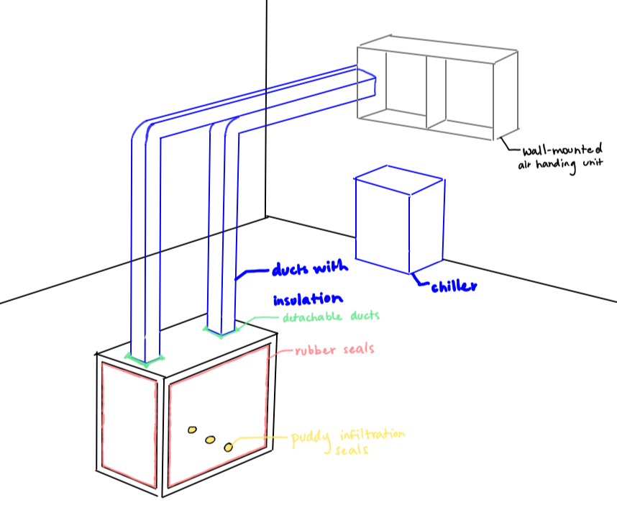
Figure 8: Wall-mounted AHU with detachable overhead ducts
Floor-Mounted AHU with Fixed Side Ducts
In this design, ducts are fixed to their positions with nuts and bolts, which keep them more stable in their positions and lowers the chance that they will be knocked over or broken. Since they are rigidly attached, they will need to be placed around the other equipment in the room and so that they do not obstruct the overhead crane which moves the compressor. The ducts will be made of a flexible material so that they can be bent around obstacles and covered with insulation to prevent significant condensation and heat transfer with the surrounding lab environment. The floor-mounted air handling unit heats and humidifies the air while the chiller cools it down and dehumidifies it. Placing the AHU on the floor allows for easier installation and eliminates the issue of making sure that the wall and supporting brackets provide sufficient support for the heavy components. The chamber also has putty infiltration seals placed inside due to holes in the bottom of the chamber which normally allow wires through but also cause extra convection transfer. The putty would be placed in these holes to minimize the convection that occurs. The design also proposes to have double-layered plexiglass walls and rubber seals around the edges of the plexiglass to minimize heat transfer and infiltration. By using double-layered walls, heat transfer is reduced significantly, and less condensation will accumulate on the walls to allow for more visibility of the compressor. To account for condensation pooling within the ducts, several sponges will be placed inside, and the ductwork will have several connections in order to drain any excess condensation after testing.
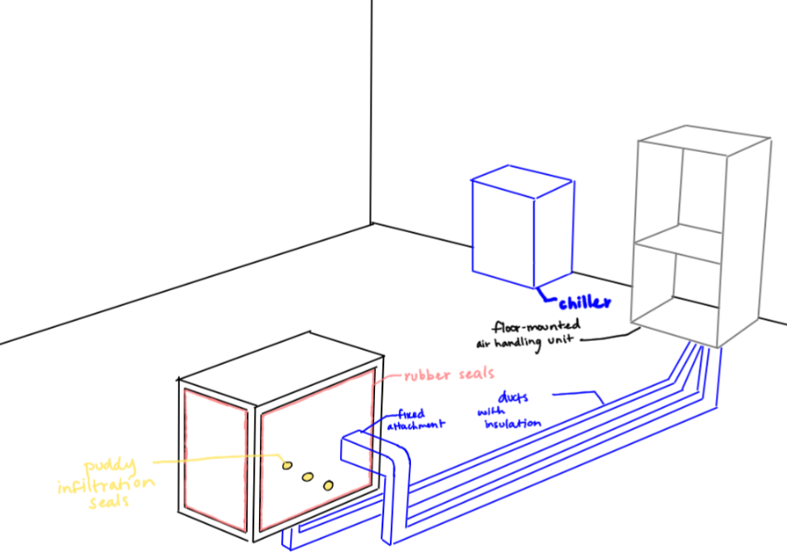
Figure 9: Floor-mounted AHU with fixed side ducts
Floor-Mounted AHU with Detachable Overhead Ducts
In this design, ducts are detachable using a snap-on connection, which allows for quick attachment and removal of the ducts to insert and remove the compressor with a crane from above. This also means that the system could be moved to a different location and the ductwork could simply be extended to the new location. The ducts will be made of a rigid material and covered with insulation to prevent as much condensation and heat transfer out of the system as possible. The floor-mounted air handling unit heats and humidifies the air while the chiller cools it down and dehumidifies it. Placing the AHU on the floor allows for easier installation and relocation and eliminates the issue of ensuring that the wall and supporting brackets provide sufficient load capacity for the heavy system. The chamber also has putty infiltration seals placed inside due to holes in the bottom of the chamber which normally allow wires through but also cause extra convection transfer. The putty would be placed in these holes to minimize the convection that occurs. The design also proposes to have the outside of the chamber sealed with an extra layer of rubber to prevent as much leakage as possible while not sacrificing the user’s access to the chamber itself. With a duct close off or open the airway to further control the airflow from the air handling unit to the chamber.
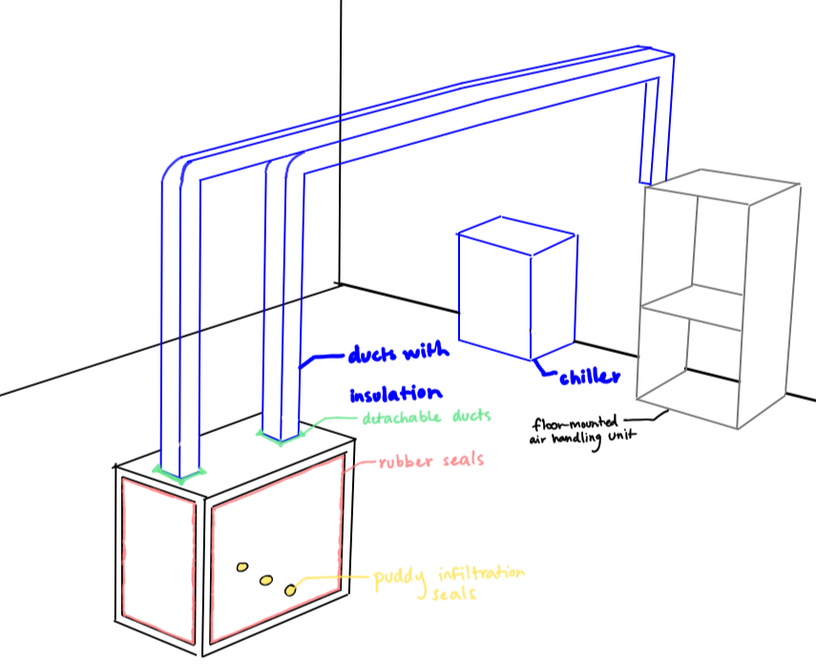
Figure 10: Floor-mounted AHU with detachable overhead ducts

1.6 Concept Selection
Once the concept generation process was completed, the concept selection process began by using standard design selection methods including binary pairwise comparison of design criteria, House of Quality, Pugh charts, and the Analytical Hierarchy Process. These tools were used to minimize bias during the selection phase and improve the feasibility of the final design.
Binary Pairwise
The binary pairwise comparison chart, shown below in Table 7, was used to analyze the customer needs obtained from the project sponsor. A more detailed list of customer needs can be found in Table 6.
Table 6: Customer Requirements and Engineering Characteristics
# | Customer Requirements | Engineering Characteristics
1 | The compressor and all ductwork will be adequately supported | Provide support
2 | The control volume will reach 10-50C and 0-95% relative humidity | Manipulate temperature and humidity
3 | The air flow will be controlled | Regulate air circulation
4 | The compressor will be accessible within a reasonable amount of time | Provide access
5 | Clearance will be provided for the overhead crane | Provide clearance
6 | The temperature and humidity of the control volume will be displayed | Display conditions
7 | The temperature and humidity of the control volume will be measured | Monitor conditions
8 | The compressor will be visible at all times during testing | Provide visibility
9 | The conditions of the chamber will be automatically adjusted | Automate control
This comparison chart works by judging if the row is more important than the column (1) or vice versa (0). These results provided an importance weight factor for each criterion, showing that manipulating temperature and humidity is the highest priority of the design. This importance weight factor was then utilized in the house of quality chart, shown in Table 8, to rank the outcomes of the environmentally controlled test chamber. Further detail of the engineering characteristics can be found in Table 6.
Table 7: Binary Pairwise Comparison
Binary Pairwise Comparison
Customer Needs | #1 | #2 | #3 | #4 | #5 | #6 | #7 | #8 | #9 | Total
#1 | - | 0 | 0 | 0 | 0 | 1 | 0 | 0 | 0 | 1
#2 | 1 | - | 1 | 1 | 1 | 1 | 1 | 1 | 1 | 8
#3 | 1 | 0 | - | 0 | 0 | 1 | 0 | 1 | 0 | 3
#4 | 1 | 0 | 1 | - | 0 | 1 | 0 | 1 | 0 | 4
#5 | 1 | 0 | 1 | 1 | - | 1 | 0 | 1 | 0 | 5
#6 | 0 | 0 | 0 | 0 | 0 | - | 0 | 0 | 0 | 0
#7 | 1 | 0 | 1 | 1 | 13 | 1 | - | 1 | 0 | 6
#8 | 1 | 0 | 0 | 0 | 0 | 1 | 0 | - | 0 | 2
#9 | 1 | 0 | 1 | 1 | 1 | 1 | 1 | 1 | - | 7
Total | 7 | 0 | 5 | 4 | 3 | 8 | 2 | 6 | 1 | n-1=8

House of Quality
The House of Quality chart compares the engineering characteristics, or decomposed functions, against the requirements expressed by the customer. The importance weight factor of each requirement is used to rank how well each characteristic fit that need. The result is a complete ranking of engineering characteristics by importance of the final chamber design.
Table 8: House of Quality
House of Quality | Engineering Characteristics
Improvement Direction | ↓ | ↑ |  | ↑ | ↓ | ↑ |  |  | ↑
Units |  | m | °C % | cfm | t | m | - | - | % | -
Customer Requirements | IPF | #1 | #2 | #3 | #4 | #5 | #6 | #7 | #8 | #9
#1 | 1 | 9 |  |  | 1 | 1
#2 | 8 |  | 9 | 3 | 1 |  | 3 | 3 | 1 | 3
#3 | 3 |  | 9 | 9 | 3 |  |  | 1 | 3 | 3
#4 | 4 |  |  |  | 9 |  |  |  |  | 3
#5 | 5 | 1 |  |  |  | 9
#6 | 0 |  | 3 |  |  |  | 9 | 9 |  | 3
#7 | 6 |  | 3 | 1 | 3 |  | 9 | 9 | 1 | 3
#8 | 2 |  | 1 | 1 |  |  |  | 1 | 9
#9 | 7 |  | 3 | 3 | 3 |  | 3 | 3 |  | 9
Raw Score | 743 | 14 | 140 | 80 | 93 | 46 | 99 | 104 | 41 | 126
Relative Weight |  | 1.9 | 18.8 | 10.8 | 12.5 | 6.2 | 13.3 | 14.0 | 5.5 | 17.0
Rank Order |  | 9 | 1 | 6 | 5 | 7 | 4 | 3 | 8 | 2
From the results presented in the House of Quality chart, the most important functions are manipulating temperature and humidity, automatic control, monitoring the chamber conditions, and displaying those conditions. These top four functions were later used as criteria for AHP comparison charts and subsequently the alternative value chart. On the other hand, the least important functions are providing clearance, visibility, and support. This information helps to evaluate the viability of each concept objectively and quantitatively. By using this process, concepts that may seem favorable at first glance can be judged more accurately in comparison to other concepts.

Pugh Chart
A Pugh chart is a method of design selection which compares a set of medium and high-fidelity designs and compares each of them to a selected datum or reference. The chart indicates whether a concept is favorable by determining if each criterion is met better (+), worse (-), or satisfactorily (S) when compared to this reference.
The top concepts generated from the previous section are compared to the design functions of each. The to a visit eight concepts that were chosen from concept generation have been adjusted to represent a floor-mounted this is due to a visit that occurred over at the Danfoss lab facility, where the wall space did not seem suitable to mount an air-handling unit. The floor mounted unit was favored when discussing and visiting with Jerry Huang the paired engineer.
Table 9: Top Design Concepts
Top 8 Concepts
# | Description | Fidelity
1 | Floor-mounted AHU with duct insulation | Medium
2 | Floor-mounted AHU with increased wall thickness | Medium
3 | Floor-mounted AHU with heater inside duct | Medium
4 | Floor-mounted AHU with hotplate and water dropper humidifier | Medium
5 | Floor-mounted AHU with vein-like inner surface of chamber | Medium
6 | Wall-mounted AHU with detachable overhead ducts, putty infiltration seals, rubber inserts, and dips inside ductwork | High
7 | Floor-mounted AHU with fixed side ducts, putty infiltration seals, double-layered walls, and sponges inside ductwork | High
8 | Floor-mounted AHU with detachable overhead ducts, putty infiltration seals, rubber inserts, and a duct close off inside ductwork | High

In the first iteration of the Pugh chart, shown in Table 10, the datum was selected to be the existing design chosen by the previous team. The results from this chart clearly show that concepts 6, 7, and 8 were most favorable, which were chosen for the second iteration of the Pugh chart in Table 17. Concept 1 became the datum since it was the least polarizing design along with concept 3, and was the simpler of the two.
Table 10: Pugh Chart Iteration 1
Pugh Chart: Iteration 1
Function |  | Concepts
 |  | 1 | 2 | 3 | 4 | 5 | 6 | 7 | 8
Provide support | Datum | S | S | S | S | S | S | - | S
Manipulate conditions |  | + | + | + | + | + | + | + | +
Regulate circulation |  | S | S | S | S | S | + | + | +
Provide access |  | S | S | S | S | S | + | + | +
Provide clearance |  | S | S | S | S | S | S | S | S
Display conditions |  | S | S | S | S | S | S | S | S
Monitor conditions |  | S | S | S | S | S | S | S | S
Provide visibility |  | S | - | S | - | - | S | + | S
Automate control |  | S | S | S | S | S | S | S | S
Plus (+) |  | 1 | 1 | 1 | 1 | 1 | 3 | 4 | 3
Satisfactory (S) |  | 8 | 7 | 8 | 7 | 7 | 6 | 4 | 6
Minus (-) |  | 0 | 1 | 0 | 1 | 1 | 0 | 1 | 0
The second iteration of the Pugh chart consisted of the concepts which were at least satisfactory for the criteria that were deemed highly important. This was done in order to prevent criteria of low importance from causing a design to be overlooked.
A third iteration of the Pugh chart was also performed to do an analysis on two of the top 3 design concepts, using concept 8 as datum, as well as concept 1 to see how the less polarized concepts from chart 1 would fare in comparison to the others. It was determined that Concept 1 was insufficient for the final design. However, concept 3, which had a similar score to concept 1 in Pugh chart 1, is still used later in the AHP Design Alternatives charts.
Table 11: Pugh Chart Iteration 3
Pugh Chart: Iteration 3
Function | Concept 8 | Concept 1 | Concept 7
Provide Support | Datum | S | -
Manipulate conditions |  | S | S
Regulate circulation |  | - | -
Provide access |  | S | +
Provide clearance |  | + | +
Display conditions |  | S | S
Monitor conditions |  | S | S
Provide visibility |  | - | +
Automate control |  | S | S
Plus (+) |  | 1 | 3
Satisfactory (S) |  | 6 | 4
Minus (-) |  | 2 | 2
Analytical Hierarchy Process
Another method that was used for determining the importance of the chosen criteria was an analytical hierarchy process (AHP), which determines the importance of each of the criteria relative to its other. These criteria are compared on a scale of odd numbers from 1 to 9. When comparing two criteria, A and B, a 9 means criteria A is much more important than criteria B, while if the comparison is given a 1, the two criteria are equally important. The inverse value was then placed on the opposite side of the table, as seen in Table _. The columns represent criteria A, and the rows represent criteria B. After summing each column, the most important criteria were determined to be manipulating temperature and humidity, which corresponds to the lowest sum of the columns. The least important, on the other hand, was found to be providing visibility.
Table 12: Criteria Comparison Matrix
Criteria Comparison Matrix
Customer  Needs | #1 | #2 | #3 | #4 | #5 | #6 | #7 | #8 | #9
#1 | 1.00 | 0.11 | 0.33 | 1.00 | 1.00 | 3.00 | 0.33 | 1.00 | 0.33
#2 | 9.00 | 1.00 | 3.00 | 5.00 | 5.00 | 9.00 | 1.00 | 7.00 | 3.00
#3 | 3.00 | 0.33 | 1.00 | 3.00 | 3.00 | 5.00 | 1.00 | 7.00 | 1.00
#4 | 1.00 | 0.20 | 0.33 | 1.00 | 1.00 | 3.00 | 0.33 | 1.00 | 0.33
#5 | 1.00 | 0.20 | 0.33 | 1.00 | 1.00 | 1.00 | 0.20 | 0.33 | 0.14
#6 | 0.33 | 0.11 | 0.20 | 0.33 | 1.00 | 1.00 | 0.14 | 0.33 | 0.14
#7 | 3.00 | 1.00 | 1.00 | 3.00 | 5.00 | 7.00 | 1.00 | 5.00 | 0.33
#8 | 1.00 | 0.14 | 0.14 | 1.00 | 3.00 | 3.00 | 0.20 | 1.00 | 0.14
#9 | 3.00 | 0.33 | 1.00 | 3.00 | 7.00 | 7.00 | 3.00 | 7.00 | 1.00
Sum | 22.33 | 3.43 | 7.34 | 18.33 | 27.00 | 39.00 | 7.21 | 29.67 | 6.43

In order to ensure consistency, the table was normalized by dividing each cell in each column by the sum of that column. Then each row was averaged to get the criteria weight (W) for each row.
Table 13: Normalized Comparison Matrix
Normalized Criteria Comparison
Criteria | #1 | #2 | #3 | #4 | #5 | #6 | #7 | #8 | #9 | Criteria  Weight
#1 | 0.04 | 0.03 | 0.05 | 0.05 | 0.04 | 0.08 | 0.05 | 0.03 | 0.05 | 0.05
#2 | 0.40 | 0.29 | 0.41 | 0.27 | 0.19 | 0.23 | 0.14 | 0.24 | 0.47 | 0.29
#3 | 0.13 | 0.10 | 0.14 | 0.16 | 0.11 | 0.13 | 0.14 | 0.24 | 0.16 | 0.14
#4 | 0.04 | 0.06 | 0.05 | 0.05 | 0.04 | 0.08 | 0.05 | 0.03 | 0.05 | 0.05
#5 | 0.04 | 0.06 | 0.05 | 0.05 | 0.04 | 0.03 | 0.03 | 0.01 | 0.02 | 0.04
#6 | 0.01 | 0.03 | 0.03 | 0.02 | 0.04 | 0.03 | 0.02 | 0.01 | 0.02 | 0.02
#7 | 0.13 | 0.29 | 0.14 | 0.16 | 0.19 | 0.18 | 0.14 | 0.17 | 0.05 | 0.16
#8 | 0.04 | 0.04 | 0.02 | 0.05 | 0.11 | 0.08 | 0.03 | 0.03 | 0.02 | 0.05
#9 | 0.13 | 0.10 | 0.14 | 0.16 | 0.26 | 0.18 | 0.42 | 0.24 | 0.16 | 0.20
Sum | 1.00 | 1.00 | 1.00 | 1.00 | 1.00 | 1.00 | 1.00 | 1.00 | 1.00 | 1.00

A consistency vector was then created by dividing the weighted sum vector by the criteria weight as shown in the table below. Finally, a consistency ratio was calculated, which is ideally below 0.1. Since the consistency ratio was found to be 0.05, the results are acceptable.
Table 14: Consistency Check
Consistency Check
Customer  Needs | Weighted Sum  Vector (Ws) | Consistency  Vector (Cons)
#1 | 0.45 | 9.60
#2 | 2.88 | 9.84
#3 | 1.45 | 10.05
#4 | 0.48 | 9.57
#5 | 0.34 | 9.35
#6 | 0.22 | 9.51
#7 | 1.54 | 9.55
#8 | 0.45 | 9.29
#9 | 1.97 | 9.95
Lambda: |  | 9.63
Consistency Index: |  | 0.08
Random Index: |  | 1.45
Consistency Ratio: |  | 0.05
Is it consistent? |  | YES

The process described above was completed for each criterion and used to evaluate the final 4 concepts: Concept #3: Floor-mounted AHU with heater inside duct, Concept #6: Wall-mounted AHU with detachable overhead ducts, putty infiltration seals, rubber inserts, and dips inside ductwork, Concept #7: Floor-mounted AHU with fixed side ducts, putty infiltration seals, double-layered walls, and sponges inside ductwork, and Concept #8: Floor-mounted AHU with detachable overhead ducts, putty infiltration seals, rubber inserts, and a duct close off inside ductwork. The computed consistency ratios along with all the comparison charts are shown in Appendix E.
The final rating matrix, shown in Table 15, displayed the weight of criteria for each of the 4 concepts. These weights were calculated using the criteria comparison matrices, which are then used in the following chart to compute the alternate value.
Table 15: Final Rating Matrix Transpose
Final Rating Matrix Transpose
 | Criteria #1 | Criteria #2 | Criteria #3 | Criteria #4
Concept #3 | 0.250 | 0.100 | 0.100 | 0.129
Concept #6 | 0.250 | 0.300 | 0.300 | 0.388
Concept #7 | 0.250 | 0.300 | 0.300 | 0.304
Concept #8 | 0.250 | 0.300 | 0.300 | 0.179
Table 16: Alternate Value Chart
Concept | Alternative Value
Concept #3: Floor-mounted AHU with heater inside duct | 0.145
Concept #6: Wall-mounted AHU with detachable overhead ducts, putty infiltration seals, rubber inserts, and dips inside ductwork | 0.321
Concept #7: Floor-mounted AHU with fixed side ducts, putty infiltration seals, double-layered walls, and sponges inside ductwork | 0.296
Concept #8: Floor-mounted AHU with detachable overhead ducts, putty infiltration seals, rubber inserts, and a duct close off inside ductwork | 0.272
The alternate value chart compares each criterion weight with the score that each concept received in the final rating matrix. The results showed that concept 6 was the most viable concept to move forward with due to its high score.
Final Selection
Team 503’s final selection was chosen as concept 6, which was a wall-mounted AHU with detachable overhead ducts, putty infiltration seals, rubber inserts, and dips inside ductwork. However, due to a recent visit to Danfoss’s facility, having a wall-mounted unit has been determined to be undesirable. However, switching to a floor-mounted version of the same concept is a negligible change, as the primary aspects of the design are the attachments and additional equipment. The design is the best because the dipping ductwork provides an effective manner of releasing excess duct moisture while the detachable manner of the ducts allows it to be better at providing access to the chamber and slightly improving the ability to monitor the internal conditions of the chamber. 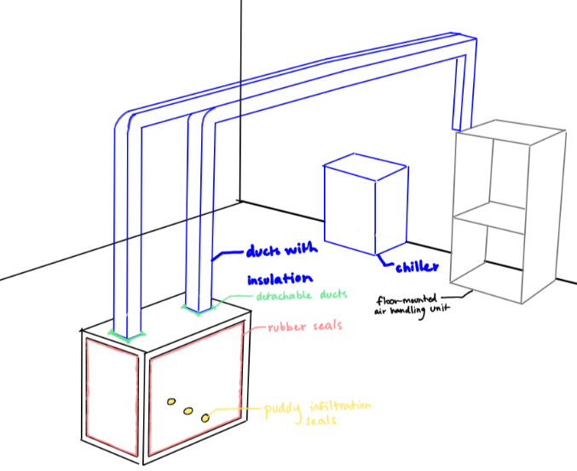
Figure 11: Final Design Selection

1.8 Spring Project Plan

Chapter Two: EML 4552C

2.1 Spring Plan

Project Plan.

Build Plan.

Appendices

Appendix A: Code of Conduct
- Mission Statement
This team’s mission is to develop our professional skills in engineering, communication, and presentation while delivering test and measure support equipment for our sponsor, Danfoss. This will be achieved by working and communicating effectively with one another.
- Outside Obligations
This team has agreed that no one has outside obligations during the highlighted areas. Areas that are not highlighted indicate that there is at least one individual on the team who has an outside obligation such as class, work, etc.
  - Group Availability Spring 2021
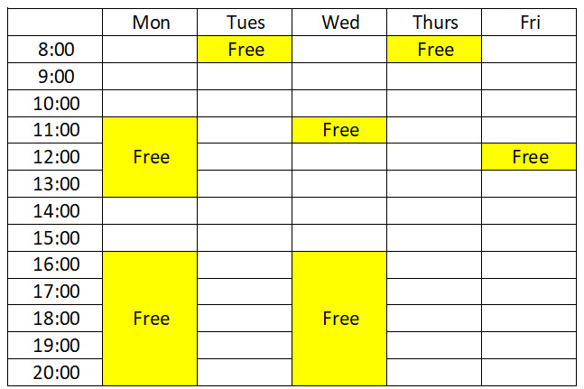
Figure 12: Fall Schedule of Availability

  - Group Availability Fall 2022
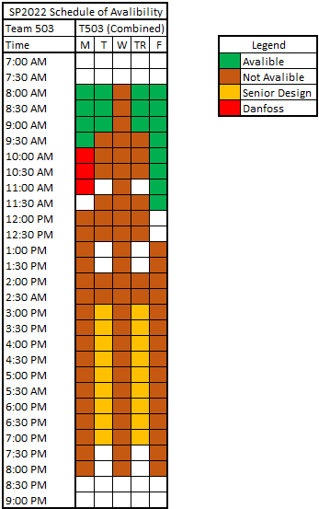
Figure 13: Spring Schedule of Availability
The work week for this group is from 8:00 am on Monday to 5:00 pm on Friday. Weekends are to be deemed personal days. However, if the group decides work needs to be done, that will take priority.
- Team Roles
The team roles for this project are relative on the tasks needed to complete the project. Every member is responsible for all aspects in the progression and advancements of this project.
- Nicholas Blenker – Mechanical/Design Engineer
Focuses on the mechanical aspects of the project and responsibilities include helping with necessary research, implementing innovative design ideas, and CAD modeling.
- David Wilson - Controls Engineer
Responsible for aspects of the project involving control systems as well as contributing to engineering calculations, CAD modeling, and simulations.
- Tucker Hall - Systems Engineer
Responsible for the timeline of events, integration of ideas, and improvements to the existing project. Keeps track of the project goals and makes sure the project meets sponsor needs.
- Decision Making
Our faculty advisor, Mr. Larson, should be consulted with for any major decisions about the direction of the project. In the case that there is not unanimous agreement between the group on a decision, Mr. Larson should be contacted. If he is unavailable, a TA or Dr. McConomy’s opinion should be considered. If none of these options are available, the decision should be made by the 2/3 majority.
- Communication
Communication will be incorporated through University Email, Group Chat, Basecamp, Microsoft Teams, Professional Meetings and Contacting Dr. McConomy/TAs further defined below in this section.
- University Email
University email will be the main formal mode of communication between group members, sponsor, faculty advisor, TAs, and Dr. McConomy. It will be used for documentation purposes and each group member should check their university email at least once per day.
Any group member who sends an email on behalf of the group one should CC the other group members. If a group member receives an email pertaining to the group and the rest of the group is not included, the receiving group member should then forward that email to the rest of the group.
For documents and emails within the group, the main form of contact will be the email group “Senior Design Group FSU”, which includes all members’ school emails:
seniordesigngroupfsu@admin.my.fsu.edu
This will be used so send links for editing project documents and providing any updates deemed necessary.
- Group Chat
The text message group chat will be the primary mode of general communication between group members; it will be an informal communication method. Group members are not required to respond in the group chat, but it is advised.
- Basecamp
Basecamp will be used to manage the group schedule, to-do lists, and discussions.
- To-Do lists
No one person will be solely responsible for creating to-do lists. Each assignment will receive its own to-do list which will include a list of tasks required to complete the assignment. The group should ensure that to-do lists are created when assignments are released so the group stays up to date. Each task should be specific, including the assignment name, due date, and submission date of the assignment.
- Schedule
No one person will be responsible for creating and updating the schedule. Group meetings should be added to the schedule, and if there is a change in meeting details, one should notify the team and update the schedule on Basecamp.
- Message Board
The message board is a formal communication method, a resource to keep track of important conversations and to have conversations written in a common, visible location. Teammates are expected to respond within 48 hours if addressed.
- Microsoft Teams
For this project Microsoft Teams will be the main meeting platform when meeting with advisors from Danfoss. Virtual meetings through Microsoft Teams will follow the dress code outlined in this document.
- Professional Meetings
All group members should interact in a professional manner when communicating with TAs, the project manager, the functional manager, and the project sponsor. This includes being respectful, listening to all input, and being prepared for questions they may pose.
- Contacting Dr. McConomy/TAs
Any problems between team members or regarding decision making should first be discussed amongst the group prior to contacting anyone else. If issues persist after having a group discussion, the TAs will be contacted for input. Dr. McConomy will then be contacted if the TA deems it necessary. All input from Dr. McConomy and the TAs should be respected by the group.
- Dress Code
Group members should dress synchronously for activities and follow the following dress code for specific events. Members will hold one another accountable by addressing violations directly, as soon as possible.
  - Team Meetings
Casual attire, or what is normally worn to class, is acceptable.
  - Meetings with Sponsors
Business casual, or a collared shirt with dress pants and a belt, at minimum.
  - Presentations
At a minimum: dress shirt and tie; formal.
- Attendance and Participation Policy
- Attendance
An attendance log will be maintained and updated through Microsoft excel. The log will be used to keep accountability and track team member attendance at any meeting in which the entire group is needed. No one person is specifically responsible for recording attendance; it is the responsibility of the group as a whole.
The document can be accessed through the following link: https://adminmyfsu-my.sharepoint.com/:x:/g/personal/njb17_my_fsu_edu/EYekHMKpCMBKsy7iv_K527kBGkUphQ-kh5EdDsxVo2joBw?e=fruppb
- Participation
All members are expected to contribute their fair share to the project. Participation and attendance should be desired by each group member, and no one should need to be forced to participate. It is the group’s responsibility to complete the required tasks throughout the semester; if a group member is not available to complete an assigned task, it is the group’s responsibility to complete it.
- Excused Absences
If a member notifies the members of the group 24 hours in advance, unless the meeting or assignment is an emergency, the absence will be marked excused in the attendance log. The group should be notified by either group text message or group email to ensure all members are aware. The member does not need to provide a reason for their absence and the group will not demand a reason.
- Privacy Clause
Group members will respect the privacy and personal information of all group members. Group members will never share personal information about other group members.
- Amending the Code of Conduct
When revisions to this document are necessary, a proposed draft of the updated section(s) will be shared with the group. To update the Code of Conduct, all three group members must approve and sign it. A PDF version will be saved and shared with all members for future reference.
- Statement of Understanding
Signing below indicates the group member is committed to the mission statement and accepts this Code of Conduct as a whole:
Figure 14: Signed Statement of Understanding

Appendix B: Functional Decomposition
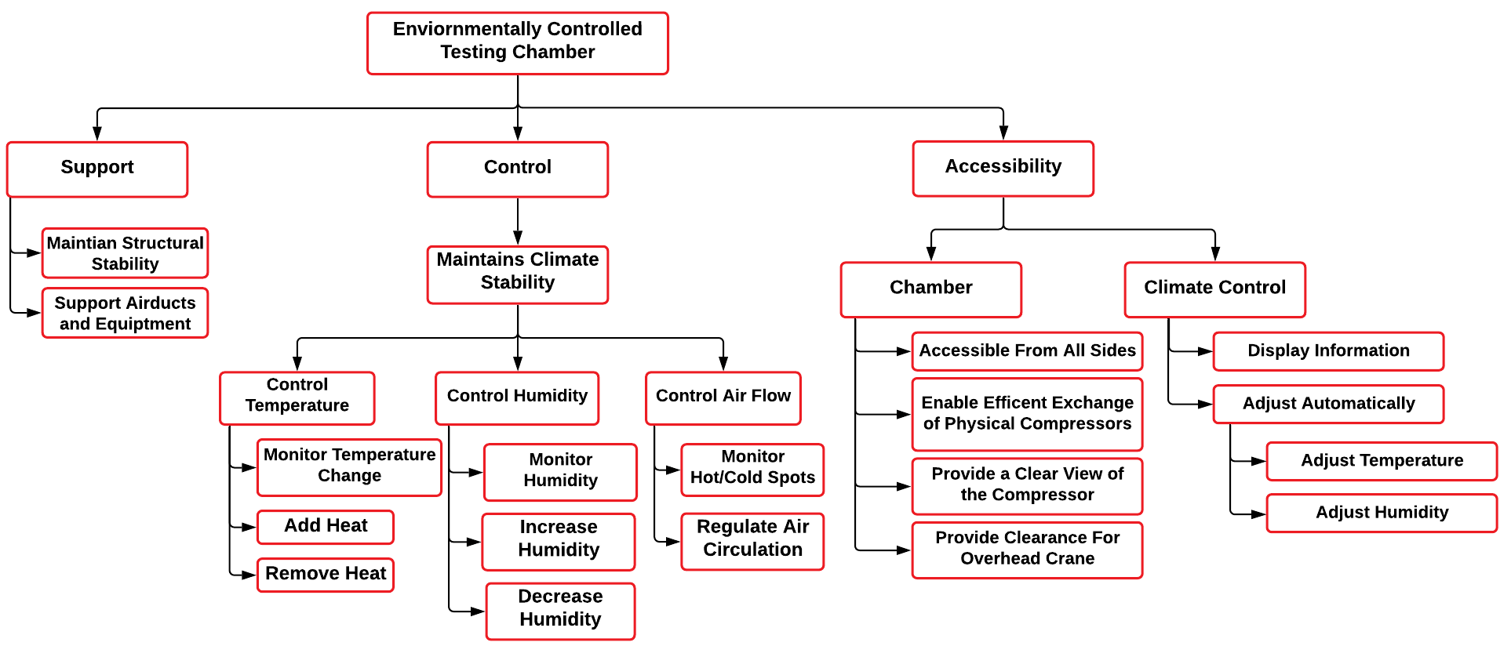

Appendix C: Target Catalog
Functions | Metric | Target | Description
Support Air Ducts and Equipment | Weight | ?? | Equipment supports itself
Monitor Humidity | Relative Humidity | 1% | Measure relative humidity within 1% of its true value
Increase and Decrease Humidity | Relative Humidity | 0-95% RH | Relative humidity is desired to reach any value in this range
Monitor Temperature Change | Temperature | 1°C | Measure temperature within 1°C of its true value
Add and Remove Heat | Temperature | 10°C ≤ T ≤ 55°C | Temperature is desired to reach any value in this range
Regulate Air Circulation | Volumetric Flow Rate | 1 m3/min | Air handling unit should be capable of providing this flow rate
Monitor Hot and Cold Spots | Sensors | 3 sensors | Measure temperature from at least 3 places in the control volume
Maintain Structural Stability | Deformation | ~ 5% | Chamber should not move or deform
Provide Clearance for Overhead Crane | Area | OSHA requires only 2” of clearance on the side and 3” above. | There should be no obstructions in the way of the crane
Display Information | Display temperature and Humidity | Yes, they are always displayed during testing | Temperature and humidity will be always shown
Allow Access from All Sides | Number of accessible Sides | 4 sides | Allow access to the compressor from the front, back, left, and top sides
Enable Efficient Exchange of Compressors | Ease of compressor removal and installation | Yes, the compressors were exchanged successfully | Enable installation of other compressors
Provide Clear View of the Compressor | Visibility | 360° visibility | Compressor is fully visible from 360° during the entire testing process
Adjust Temperature and Humidity Automatically | Automatic adjustment | No human action required to reach the desired conditions | Desired temperature and humidity are reached automatically by the system
 | Time | 1 minute | Allow cancellation of the process for emergencies within a reasonable timeframe
 | Total Transmittance | 90% ± 10% | There should not be significant condensation on the walls of the chamber to lower the transmittance of the wall
 | Time | 15 minutes | Design can be assembled and disassembled within a reasonable time

Appendix D: Concept Generation
Concept Generation (100 Ideas)
# | Concept | Reasoning/ Description
1. | Wall-mounted AHU, flexible ductwork attached to roof, boiler humidifier, no dehumidifier, air-cooled chiller, duct tape, fiberglass insulation, PID controller | Morphological Chart
2. | Floor-mounted AHU, flexible ductwork attached to roof, boiler humidifier, no dehumidifier, air-cooled chiller, duct tape, fiberglass insulation, PID controller | Morphological Chart
3. | Wall-mounted AHU, flexible ductwork attached to roof, boiler humidifier, no dehumidifier, air-cooled chiller, duct tape, polyethylene insulation, PID controller | Morphological Chart
4. | Floor-mounted AHU, flexible ductwork attached to roof, boiler humidifier, no dehumidifier, air-cooled chiller, duct tape, polyethylene insulation, PID controller | Morphological Chart
5. | Wall-mounted AHU, flexible ductwork attached to roof, boiler humidifier, no dehumidifier, air-cooled chiller, screws/nails, fiberglass insulation, PID controller | Morphological Chart
6. | Floor-mounted AHU, flexible ductwork attached to roof, boiler humidifier, no dehumidifier, air-cooled chiller, screws/nails, fiberglass insulation, PID controller | Morphological Chart
7. | Wall-mounted AHU, flexible ductwork attached to roof, boiler humidifier, no dehumidifier, air-cooled chiller, screws/nails, polyethylene insulation, PID controller | Morphological Chart
8. | Floor-mounted AHU, flexible ductwork attached to roof, boiler humidifier, no dehumidifier, air-cooled chiller, screws/nails, polyethylene insulation, PID controller | Morphological Chart
9. | Wall-mounted AHU, flexible ductwork attached to roof, boiler humidifier, no dehumidifier, water-cooled chiller, duct tape, fiberglass insulation, PID controller | Morphological Chart
10. | Floor-mounted AHU, flexible ductwork attached to roof, boiler humidifier, no dehumidifier, water-cooled chiller, duct tape, fiberglass insulation, PID controller | Morphological Chart
11. | Wall-mounted AHU, flexible ductwork attached to roof, boiler humidifier, no dehumidifier, water-cooled chiller, duct tape, polyethylene insulation, PID controller | Morphological Chart
12. | Floor-mounted AHU, flexible ductwork attached to roof, boiler humidifier, no dehumidifier, water-cooled chiller, duct tape, polyethylene insulation, PID controller | Morphological Chart
13. | Wall-mounted AHU, flexible ductwork attached to roof, boiler humidifier, no dehumidifier, water-cooled chiller, screws/nails tape, fiberglass insulation, PID controller | Morphological Chart
14. | Floor-mounted AHU, flexible ductwork attached to roof, boiler humidifier, no dehumidifier, water-cooled chiller, screws/nails, fiberglass insulation, PID controller | Morphological Chart
15. | Wall-mounted AHU, flexible ductwork attached to roof, boiler humidifier, no dehumidifier, water-cooled chiller, screws/nails, polyethylene insulation, PID controller | Morphological Chart
16. | Floor-mounted AHU, flexible ductwork attached to roof, boiler humidifier, no dehumidifier, water-cooled chiller, screws/nails, polyethylene insulation, PID controller | Morphological Chart
17. | Wall-mounted AHU, flexible ductwork attached to roof, boiler humidifier, heat pump dehumidifier, air-cooled chiller, duct tape, fiberglass insulation, PID controller | Morphological Chart
18. | Floor-mounted AHU, flexible ductwork attached to roof, boiler humidifier, heat pump dehumidifier, air-cooled chiller, duct tape, fiberglass insulation, PID controller | Morphological Chart
19. | Wall-mounted AHU, flexible ductwork attached to roof, boiler humidifier, heat pump dehumidifier, air-cooled chiller, duct tape, polyethylene insulation, PID controller | Morphological Chart
20. | Floor-mounted AHU, flexible ductwork attached to roof, boiler humidifier, heat pump dehumidifier, air-cooled chiller, duct tape, polyethylene insulation, PID controller | Morphological Chart
21. | Wall-mounted AHU, flexible ductwork attached to roof, boiler humidifier, heat pump dehumidifier, air-cooled chiller, duct tape, polyethylene insulation, PID controller | Morphological Chart
22. | Floor-mounted AHU, flexible ductwork attached to roof, boiler humidifier, heat pump dehumidifier, air-cooled chiller, duct tape, polyethylene insulation, PID controller | Morphological Chart
23. | Wall-mounted AHU, flexible ductwork attached to roof, boiler humidifier, heat pump dehumidifier, air-cooled chiller, duct tape, polyethylene insulation, PID controller | Morphological Chart
24. | Floor-mounted AHU, flexible ductwork attached to roof, boiler humidifier, heat pump dehumidifier, air-cooled chiller, duct tape, polyethylene insulation, PID controller | Morphological Chart
25. | Wall-mounted AHU, rigid ductwork attached to roof, boiler humidifier, heat pump dehumidifier, air-cooled chiller, duct tape, fiberglass insulation, PID controller | Morphological Chart
26. | Floor-mounted AHU, rigid ductwork attached to roof, boiler humidifier, heat pump dehumidifier, air-cooled chiller, duct tape, fiberglass insulation, PID controller | Morphological Chart
27. | Wall-mounted AHU, rigid ductwork attached to roof, boiler humidifier, heat pump dehumidifier, air-cooled chiller, duct tape, polyethylene insulation, PID controller | Morphological Chart
28. | Floor-mounted AHU, rigid ductwork attached to roof, boiler humidifier, heat pump dehumidifier, air-cooled chiller, duct tape, polyethylene insulation, PID controller | Morphological Chart
29. | Wall-mounted AHU, rigid ductwork attached to roof, boiler humidifier, heat pump dehumidifier, air-cooled chiller, screws/nails, fiberglass insulation, PID controller | Morphological Chart
30. | Floor-mounted AHU, rigid ductwork attached to roof, boiler humidifier, heat pump dehumidifier, air-cooled chiller, screws/nails, fiberglass insulation, PID controller | Morphological Chart
31. | Wall-mounted AHU, rigid ductwork attached to roof, boiler humidifier, heat pump dehumidifier, air-cooled chiller, screws/nails, polyethylene insulation, PID controller | Morphological Chart
32. | Floor-mounted AHU, rigid ductwork attached to roof, boiler humidifier, heat pump dehumidifier, air-cooled chiller, screws/nails, polyethylene insulation, PID controller | Morphological Chart
33. | Wall-mounted AHU, rigid ductwork attached to roof, boiler humidifier, heat pump dehumidifier, water-cooled chiller, duct tape, fiberglass insulation, PID controller | Morphological Chart
34. | Floor-mounted AHU, rigid ductwork attached to roof, boiler humidifier, heat pump dehumidifier, water-cooled chiller, duct tape, fiberglass insulation, PID controller | Morphological Chart
35. | Wall-mounted AHU, rigid ductwork attached to roof, boiler humidifier, heat pump dehumidifier, water-cooled chiller, duct tape, polyethylene insulation, PID controller | Morphological Chart
36. | Floor-mounted AHU, rigid ductwork attached to roof, boiler humidifier, heat pump dehumidifier, water-cooled chiller, duct tape, polyethylene insulation, PID controller | Morphological Chart
37. | Wall-mounted AHU, rigid ductwork attached to roof, boiler humidifier, heat pump dehumidifier, water-cooled chiller, screws/nails, fiberglass insulation, PID controller | Morphological Chart
38. | Floor-mounted AHU, rigid ductwork attached to roof, boiler humidifier, heat pump dehumidifier, water-cooled chiller, screws/nails, fiberglass insulation, PID controller | Morphological Chart
39. | Wall-mounted AHU, rigid ductwork attached to roof, boiler humidifier, heat pump dehumidifier, water-cooled chiller, screws/nails, polyethylene insulation, PID controller | Morphological Chart
40. | Floor-mounted AHU, rigid ductwork attached to roof, boiler humidifier, heat pump dehumidifier, water-cooled chiller, screws/nails, polyethylene insulation, PID controller | Morphological Chart
41. | Wall-mounted AHU, rigid ductwork attached to roof, boiler humidifier, no dehumidifier, air-cooled chiller, duct tape, fiberglass insulation, PID controller | Morphological Chart
42. | Floor-mounted AHU, rigid ductwork attached to roof, boiler humidifier, no dehumidifier, air-cooled chiller, duct tape, fiberglass insulation, PID controller | Morphological Chart
43. | Wall-mounted AHU, rigid ductwork attached to roof, boiler humidifier, no dehumidifier, air-cooled chiller, duct tape, polyethylene insulation, PID controller | Morphological Chart
44. | Floor-mounted AHU, rigid ductwork attached to roof, boiler humidifier, no dehumidifier, air-cooled chiller, duct tape, polyethylene insulation, PID controller | Morphological Chart
45. | Wall-mounted AHU, rigid ductwork attached to roof, boiler humidifier, no dehumidifier, air-cooled chiller, screws/nails, fiberglass insulation, PID controller | Morphological Chart
46. | Floor-mounted AHU, rigid ductwork attached to roof, boiler humidifier, no dehumidifier, air-cooled chiller, screws/nails, fiberglass insulation, PID controller | Morphological Chart
47. | Wall-mounted AHU, rigid ductwork attached to roof, boiler humidifier, no dehumidifier, air-cooled chiller, screws/nails, polyethylene insulation, PID controller | Morphological Chart
48. | Floor-mounted AHU, rigid ductwork attached to roof, boiler humidifier, no dehumidifier, air-cooled chiller, screws/nails, polyethylene insulation, PID controller | Morphological Chart
49. | Wall-mounted AHU, rigid ductwork attached to roof, boiler humidifier, no dehumidifier, water-cooled chiller, duct tape, fiberglass insulation, PID controller | Morphological Chart
50. | Floor-mounted AHU, rigid ductwork attached to roof, boiler humidifier, no dehumidifier, water-cooled chiller, duct tape, fiberglass insulation, PID controller | Morphological Chart
51. | Portable AHU on wheels, rigid ductwork attached to roof, boiler humidifier, no dehumidifier, water-cooled chiller, duct tape, fiberglass insulation, PID controller | Brainstorming
52. | Portable AHU on wheels, rigid ductwork attached to roof, boiler humidifier, no dehumidifier, water-cooled chiller, duct tape, fiberglass insulation, PID controller | Brainstorming
53. | Portable AHU on wheels, flexible ductwork attached to roof, boiler humidifier, no dehumidifier, water-cooled chiller, duct tape, fiberglass insulation, PID controller | Brainstorming
54. | Portable AHU on wheels, rigid ductwork attached to floor, boiler humidifier, no dehumidifier, water-cooled chiller, duct tape, fiberglass insulation, PID controller | Brainstorming
55. | Portable AHU on wheels, flexible ductwork attached to floor, boiler humidifier, no dehumidifier, water-cooled chiller, duct tape, fiberglass insulation, PID controller | Brainstorming
56. | Portable AHU on wheels, rigid ductwork attached to roof, boiler humidifier, heat pump dehumidifier, water-cooled chiller, duct tape, fiberglass insulation, PID controller | Brainstorming
57. | Portable AHU on wheels, flexible ductwork attached to roof, boiler humidifier, heat pump dehumidifier, water-cooled chiller, duct tape, fiberglass insulation, PID controller | Brainstorming
58. | Portable AHU on wheels, rigid ductwork attached to roof, boiler humidifier, no dehumidifier, water-cooled chiller, duct tape, fiberglass insulation, PID controller | Brainstorming
59. | Portable AHU on wheels, flexible ductwork attached to roof, boiler humidifier, no dehumidifier, air-cooled chiller, duct tape, fiberglass insulation, PID controller | Brainstorming
60. | Portable AHU on wheels, rigid ductwork attached to roof, boiler humidifier, no dehumidifier, air-cooled chiller, duct tape, fiberglass insulation, PID controller | Brainstorming
61. | Wall-mounted AHU, dips in ductwork to collect condensation, boiler humidifier, no dehumidifier, air-cooled chiller, duct tape, fiberglass insulation, PID controller | Brainstorming
62. | Wall-mounted AHU, sponges in ductwork to collect condensation, boiler humidifier, no dehumidifier, air-cooled chiller, duct tape, fiberglass insulation, PID controller | Brainstorming
63. | Wall-mounted AHU, dips in ductwork to collect condensation, boiler humidifier, heat pump dehumidifier, air-cooled chiller, duct tape, fiberglass insulation, PID controller | Brainstorming
64. | Wall-mounted AHU, sponges in ductwork to collect condensation, boiler humidifier, heat pump dehumidifier, air-cooled chiller, duct tape, fiberglass insulation, PID controller | Brainstorming
65. | Wall-mounted AHU, dips in ductwork to collect condensation, boiler humidifier, no dehumidifier, water-cooled chiller, duct tape, fiberglass insulation, PID controller | Brainstorming
66. | Wall-mounted AHU, sponges in ductwork to collect condensation, boiler humidifier, no dehumidifier, water-cooled chiller, duct tape, fiberglass insulation, PID controller | Brainstorming
67. | Wall-mounted AHU, dips in ductwork to collect condensation, boiler humidifier, no dehumidifier, water-cooled chiller, screws/nails, fiberglass insulation, PID controller | Brainstorming
68. | Wall-mounted AHU, sponges in ductwork to collect condensation, boiler humidifier, no dehumidifier, water-cooled chiller, screws/nails, fiberglass insulation, PID controller | Brainstorming
69. | Wall-mounted AHU, dips in ductwork to collect condensation, boiler humidifier, no dehumidifier, water-cooled chiller, screws/nails, polyethylene insulation, PID controller | Brainstorming
70. | Wall-mounted AHU, sponges in ductwork to collect condensation, boiler humidifier, no dehumidifier, water-cooled chiller, screws/nails, polyethylene insulation, PID controller | Brainstorming
71. | Make a more secure chamber with opaque walls and better insulation, and add in a camera with protection so that it won’t fog or deactivate under high and low heats | Brainstorming
72. | Make a chamber that can be regulated using thermo currents from heat vents deep below the earth | Brainstorming
73. | Make a chamber which can be heated and cooled off using the sun’s rays and a roof window like a giant magnifying glass | Brainstorming
74. | Make the chamber itself have a heating and cooling unit installed on it, to heat and cool the inner temperatures using the walls as a medium | Brainstorming
75. | Submerge the entire chamber in water to allow for humidity to be changed much quicker if necessary | Brainstorming
76. | Use a human-powered air pump along with some friction surfaces to heat and flow the air into the chamber | Brainstorming
77. | Intentionally cause condensation and evaporation of water in the chamber to more quickly disperse humidity and temperature changes | Brainstorming
78. | Add light bulbs into the chamber to use electricity as a heating element and to assist internal visibility | Brainstorming
79. | Use clam-like ridges in the fans or the ventilation along with heating and cooling elements to improve heat transfer | Biomimicry
80. | Add oven heating coils to the chamber to control the heat of the chamber | Brainstorming
81. | Use the attached compressor that is inside of the chamber to assist in the control of the humidity and heat of the outer chamber | Brainstorming
82. | Use lasers as a method of heating and cooling the chamber | Brainstorming
83. | Wall-mounted AHU, rigid ductwork, ultrasonic humidifier, double-layered plexiglass walls, puddy to plug infiltration holes, PID controller | Anti-Problem
84. | Floor-mounted AHU, rigid ductwork, ultrasonic humidifier, double-layered plexiglass walls, puddy to plug infiltration holes, PID controller | Anti-Problem
85. | Wall-mounted AHU, rigid ductwork, ultrasonic humidifier, double-layered plexiglass walls, puddy to plug infiltration holes, rubber inserts for walls, PID controller | Anti-Problem
86. | Floor-mounted AHU, rigid ductwork, ultrasonic humidifier, double-layered plexiglass walls, puddy to plug infiltration holes, rubber inserts for walls, PID controller | Anti-Problem
87. | Wall-mounted AHU, rigid ductwork, humidifier, liquid desiccant dehumidifiers like ticks, chiller, duct tape/screws/nails, insulation, PID controller | Biomimicry
88. | Floor-mounted AHU, rigid ductwork, humidifier, liquid desiccant dehumidifiers like ticks, chiller, duct tape/screws/nails, insulation, PID controller | Biomimicry
89. | Wall-mounted AHU, ductwork with internal extrusions to increase surface area like veins, humidifier, dehumidifier, chiller, duct tape/screws/nails, insulation, PID controller | Biomimicry
90. | Floor-mounted AHU, ductwork with internal extrusions to increase surface area like veins, humidifier, dehumidifier, chiller, duct tape/screws/nails, insulation, PID controller | Biomimicry
91. | Wall-mounted AHU, ductwork with root-like suction to reduce moisture, humidifier, dehumidifier, chiller, duct tape/screws/nails, insulation, PID controller | Biomimicry
92. | Floor-mounted AHU, ductwork with root-like suction to reduce moisture, humidifier, dehumidifier, chiller, duct tape/screws/nails, insulation, PID controller | Biomimicry
93. | Adding insulation to the ductwork | Medium Fidelity
94. | Increased wall panel thickness for chamber | Medium Fidelity
95. | Heater inside duct at the 90 degree change in angle | Medium Fidelity
96. | Hotplate with water dropper humidifier | Medium Fidelity
97. | Vein-like inner surface | Medium Fidelity
98. | Wall-mounted AHU, detachable insulated ductwork, chiller, rubber sealing and puddy infiltration seals | High Fidelity
99. | Floor-mounted AHU, fixed insulated ductwork, chiller, rubber sealing and puddy infiltration seals | High Fidelity
100. | Floor-mounted AHU, detachable insulated ductwork, chiller, rubber sealing and puddy infiltration seals | High Fidelity

Appendix E: Concept Selection Tables
Table 17: Pugh Chart Iteration 2
Pugh Chart: Iteration 2
Function | #1 | Concepts
 |  | 6 | 7 | 8
Provide support | Datum | S | - | S
Manipulate conditions |  | S | S | S
Regulate circulation |  | + | + | +
Provide access |  | S | + | S
Provide clearance |  | - | + | -
Display conditions |  | S | S | S
Monitor conditions |  | S | S | S
Provide visibility |  | S | + | +
Automate control |  | S | S | S
Plus (+) |  | 1 | 4 | 2
Satisfactory (S) |  | 7 | 4 | 6
Minus (-) |  | 1 | 1 | 1

Table 18: Temperature and Humidity Manipulation Comparison
Temperature and Humidity Manipulation Comparison
 | Concept #3 | Concept #6 | Concept #7 | Concept #8
Concept #3 | 1.000 | 1.000 | 1.000 | 1.000
Concept #6 | 1.000 | 1.000 | 1.000 | 1.000
Concept #7 | 1.000 | 1.000 | 1.000 | 1.000
Concept #8 | 1.000 | 1.000 | 1.000 | 1.000
Sum | 4.000 | 4.000 | 4.000 | 4.000

Table 19: Temperature and Humidity Manipulation Normalized
Temperature and Humidity Manipulation Normalized
 | Concept #3 | Concept #6 | Concept #7 | Concept #8 | Weight {W}
Concept #3 | 0.250 | 0.250 | 0.250 | 0.250 | 0.250
Concept #6 | 0.250 | 0.250 | 0.250 | 0.250 | 0.250
Concept #7 | 0.250 | 0.250 | 0.250 | 0.250 | 0.250
Concept #8 | 0.250 | 0.250 | 0.250 | 0.250 | 0.250
Sum | 1.000 | 1.000 | 1.000 | 1.000 | 1.000

Table 20: Temperature and Humidity Manipulation Weights
Temperature and Humidity Manipulation Weights
Concepts | Weighted Sum Vector | Consistency Vector
Concept #3 | 1.000 | 4.000
Concept #6 | 1.000 | 4.000
Concept #7 | 1.000 | 4.000
Concept #8 | 1.000 | 4.000

Table 21: Consistency Check #1
Consistency Check #1
Lambda: | 4.000
Consistency Index: | 0.000
Random Index: | 0.890
Consistency Ratio: | 0.000
Is it consistent? | Yes

Table 22: Automatic Control Comparison
Automatic Control Comparison
 | Concept #3 | Concept #6 | Concept #7 | Concept #8
Concept #3 | 1.000 | 0.333 | 0.333 | 0.333
Concept #6 | 3.000 | 1.000 | 1.000 | 1.000
Concept #7 | 3.000 | 1.000 | 1.000 | 1.000
Concept #8 | 3.000 | 1.000 | 1.000 | 1.000
Sum | 10.000 | 3.333 | 3.333 | 3.333

Table 23: Automatic Control Normalized
Automatic Control Normalized
 | Concept #3 | Concept #6 | Concept #7 | Concept #8 | Weight {W}
Concept #3 | 0.100 | 0.100 | 0.100 | 0.100 | 0.100
Concept #6 | 0.300 | 0.300 | 0.300 | 0.300 | 0.300
Concept #7 | 0.300 | 0.300 | 0.300 | 0.300 | 0.300
Concept #8 | 0.300 | 0.300 | 0.300 | 0.300 | 0.300
Sum | 1 | 1 | 1 | 1 | 1

Table 24: Provide Access Weights
Provide Access Weights
Concepts | Weighted Sum Vector | Consistency Vector
Concept #3 | 0.400 | 4.000
Concept #6 | 1.200 | 4.000
Concept #7 | 1.200 | 4.000
Concept #8 | 1.200 | 4.000

Table 25: Consistency Check #2
Consistency Check #2
Lambda: | 4.000
Consistency Index: | 0.000
Random Index: | 0.890
Consistency Ratio: | 0.000
Is it consistent? | Yes

Table 26: Display Conditions Comparison
Display Conditions Comparison
 | Concept #3 | Concept #6 | Concept #7 | Concept #8
Concept #3 | 1.000 | 0.333 | 0.333 | 0.333
Concept #6 | 3.000 | 1.000 | 1.000 | 1.000
Concept #7 | 3.000 | 1.000 | 1.000 | 1.000
Concept #8 | 3.000 | 1.000 | 1.000 | 1.000
Sum | 10.000 | 3.333 | 3.333 | 3.333

Table 27: Display Conditions Normalized
Display Conditions Normalized
 | Concept #3 | Concept #6 | Concept #7 | Concept #8 | Weight {W}
Concept #3 | 0.100 | 0.100 | 0.100 | 0.100 | 0.100
Concept #6 | 0.300 | 0.300 | 0.300 | 0.300 | 0.300
Concept #7 | 0.300 | 0.300 | 0.300 | 0.300 | 0.300
Concept #8 | 0.300 | 0.300 | 0.300 | 0.300 | 0.300
Sum | 1.000 | 1.000 | 1.000 | 1.000 | 1.000

Table 28: Provide Visibility Weights
Provide Visibility Weights
Concepts | Weighted Sum Vector | Consistency Vector
Concept #3 | 0.400 | 4.000
Concept #6 | 1.200 | 4.000
Concept #7 | 1.200 | 4.000
Concept #8 | 1.200 | 4.000

Table 29: Consistency Check #3
Consistency Check #3
Lambda: | 4.000
Consistency Index: | 0.000
Random Index: | 0.890
Consistency Ratio: | 0.000
Is it consistent? | Yes

Table 30: Monitor Conditions Comparison
Monitor Conditions Comparison
 | Concept #3 | Concept #6 | Concept #7 | Concept #8
Concept #3 | 1.000 | 0.333 | 0.333 | 1.000
Concept #6 | 3.000 | 1.000 | 1.000 | 3.000
Concept #7 | 3.000 | 1.000 | 1.000 | 1.000
Concept #8 | 1.000 | 0.333 | 1.000 | 1.000
Sum | 8.000 | 2.667 | 3.333 | 6.000

Table 31: Monitor Conditions Normalized
Monitor Conditions Normalized
 | Concept #3 | Concept #6 | Concept #7 | Concept #8 | Weight {W}
Concept #3 | 0.125 | 0.125 | 0.100 | 0.167 | 0.129
Concept #6 | 0.375 | 0.375 | 0.300 | 0.500 | 0.388
Concept #7 | 0.375 | 0.375 | 0.300 | 0.167 | 0.304
Concept #8 | 0.125 | 0.125 | 0.300 | 0.167 | 0.179
Sum | 1.000 | 1.000 | 1.000 | 1.000 | 1.000

Table 32: Monitor Conditions Weights
Monitor Conditions Weights
Concepts | Weighted Sum Vector | Consistency Vector
Concept #3 | 0.539 | 4.172
Concept #6 | 1.617 | 4.172
Concept #7 | 1.258 | 4.137
Concept #8 | 0.742 | 4.140

Table 33: Consistency Check #4
Consistency Check #4
Lambda: | 4.155
Consistency Index: | 0.052
Random Index: | 0.890
Consistency Ratio: | 0.058
Is it consistent? | Yes

Table 34: Final Rating Matrix Transpose
Final Rating Matrix Transpose
 | Criteria #1 | Criteria #2 | Criteria #3 | Criteria #4
Concept #3 | 0.250 | 0.100 | 0.100 | 0.129
Concept #6 | 0.250 | 0.300 | 0.300 | 0.388
Concept #7 | 0.250 | 0.300 | 0.300 | 0.304
Concept #8 | 0.250 | 0.300 | 0.300 | 0.179

Table 35: Concept Alternative Value
Concept | Alternative Value
Concept #3 | 0.145
Concept #6 | 0.321
Concept #7 | 0.296
Concept #8 | 0.272

Appendix B Figures and Tables (delete)
The text above the cation always introduces the reference material such as a figure or table. You should never show reference material then present the discussion. You can split the discussion around the reference material, but you should always introduce the reference material in your text first then show the information. If you look at the Figure 1 below the caption has a period after the figure number and is left justified whereas the figure itself is centered.

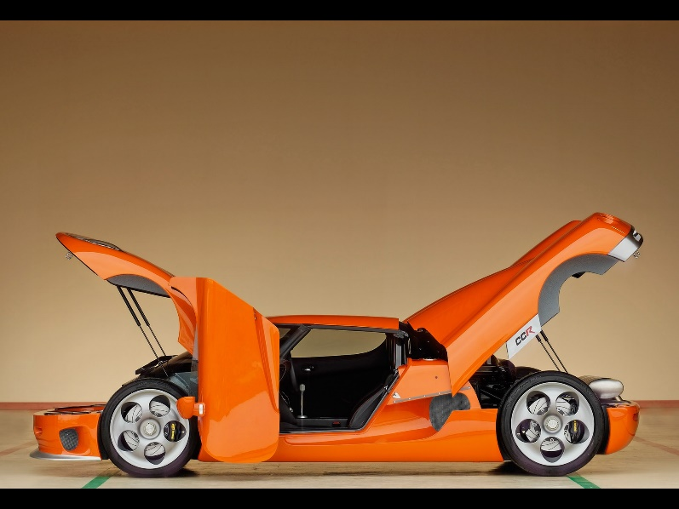
Figure 15. Flush left, normal font settings, sentence case, and ends with a period.
In addition, table captions are placed above the table and have a return after the table number. The second line of the caption provided the description. Note, there is a difference between a return and enter. A return is accomplished with the shortcut key shift + enter. Last, unlike the caption for a figure, a table caption does not end with a period, nor is there a period after the table number.

Table 36
The Word Table and the Table Number are Normal Font and Flush Left. The Caption is Flush Left, Italicized, Uppercase and Lowercase
Level of heading | Format
1 | Centered, Boldface, Uppercase and Lowercase Heading
2 | Flush Left, Boldface, Uppercase and Lowercase
3 | Indented, boldface lowercase paragraph heading ending with a period
4 | Indented, boldface, italicized, lowercase paragraph heading ending with a period.
5 | Indented, italicized, lowercase paragraph heading ending with a period.

References
McConomy, S. (2018, September 12). Customer Needs. FAMU - FSU College of Engineering. Retrieved September 13, 2021
McConomy, S. (2018, September 10). Project Scope. FAMU - FSU College of Engineering. Retrieved September 9, 2021

