1.3 Functional Decomposition
Introduction
The process of functional decomposition was used to break down the broad project scope into specific tasks that the final product needs to achieve. Establishing these basic level functions of the environmentally controlled test chamber allows the group to easily identify the targets and metrics of the project.
Data Generation
The functions displayed in the hierarch chart (Figure 1) below were a result of asking what the tasks are that the chamber needs to perform. Answers to this question were found by conducting a thorough analysis of the project description, assumptions, key goals, and customer needs. Once all functions were determined, they were classified into major and minor functions based on their importance in delivering a test chamber capable of simulating the necessary conditions.
Flow Chart Reasoning
The three main systems which the testing chamber comprises of are: support, control, and accessibility. Support includes the tasks pertaining to the structural stability and keeping the compressor secure. The control system entails the functions relating to the monitoring and manipulation of the heating, cooling, humidifying, and dehumidifying components. Accessibility covers the visibility and access to the compressor, clearance for the overhead crane, and display and adjustment of the chamber’s temperature and humidity. Breaking down the test chamber into these three systems ensures that the goals and interpreted needs from the sponsor will be met.
These include:
- Building a testing chamber to be used in a lab to simulate environmental conditions.
- Providing access to the test chamber from any angle depending on the lab environment.
- Raising and lowering temperature and relative humidity around a compressor to specified values within the specified time period (15 minutes)
The control of the system is separated into control of the temperature, humidity, and airflow in order to maintain the desired climate conditions. For each of these subsystems, the chamber will monitor and manipulate each condition as necessary. Accessibility is divided into two subsystems, chamber accessibility and climate control.

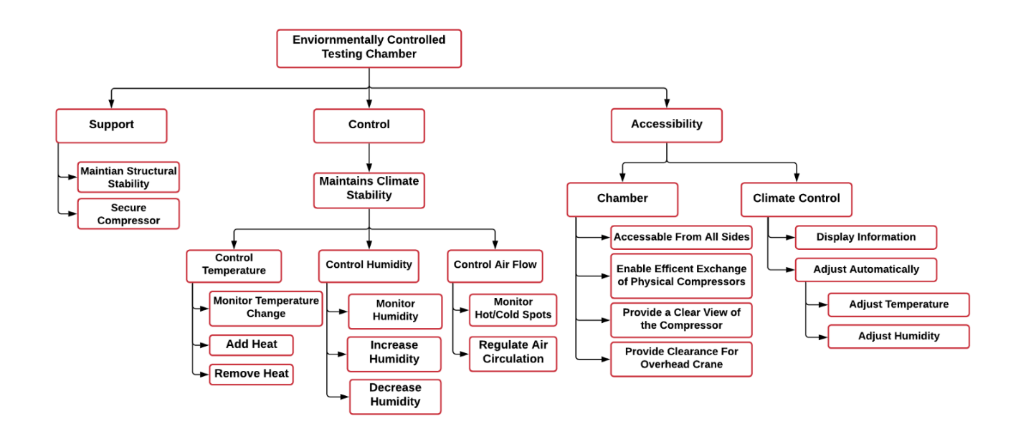
Figure 1: Functional Decomposition Hierarchy Chart

Connection to Systems
A visual comparison of the functions and their relation to each system is shown in the functional decomposition cross reference chart in Table 2 below. The X’s indicate which system(s) each function influences, which can be more than one.

Table 2: Functional Decomposition Cross Reference Chart
System Functional Decomposition
Function | Support | Control | Accessibility
Maintain Structural Stability | X
Secure Compressor | X
Add Heat |  | X
Remove Heat |  | X
Increase Humidity |  | X
Decrease Humidity |  | X
Regulate Air Circulation |  | X
Accessible From All Sides |  |  | X
Enable Efficient Exchange of Physical Compressors |  |  | X
Provide a Clear View of the Compressor |  |  | X
Provide Clearance for Overhead Crane |  |  | X
Adjust Temperature |  | X | X
Adjust Humidity |  | X | X
Integration
The functions of the chart were made to be interrelated to each other on a row-by-row basis. The stability of the climate and the structure itself both describe the need for the chamber to be secure and stable. Within the control branch, each row describes the same needs but for different portions of the project that need to be monitored and controlled. Also, when adjusting the temperature, the relative humidity will be adjusted as described in a psychrometric chart. To control the humidity or temperature, the airflow must also be controlled appropriately to add or remove air with the desired conditions. The adjustment of temperature and humidity from the accessibility branch is also related to the control since it describes that accessibility to the controls must be provided in order to control the system.
Action and Outcome
The outcome of this project is to assemble and implement a working environmental control system that adjusts temperature and relative humidity for testing compressors. The control system will be able to control to and from a range of desired temperatures and humidity. This chamber is to allow for installation, access, and visibility of the tested compressor at all times.

