1.5 Concept Generation
In order to come up with a good design for our project, 100 design concepts of varying fidelities were made by incorporating multiple ideation processes. Our team used biomimicry, antiproblem, crapshoot, morphological analysis as tools to generate the concept ideas. The best eight concepts were chosen and are described in detail below as medium and high-fidelity concepts. All 100 concepts are tabulated and displayed in Appendix D. Reaching 100 ideas was challenging since this was completed once before for this project but was made possible by imagination and concept generation tools.
Biomimicry
Our team used biomimicry the practice of using inspiration from animals and natural phenomena and adapting this into engineering solutions. Multiple biological systems were analyzed to result in innovative designs to control temperature and humidity within the chamber.
By designing an intricate system of porous walls, termites create their own natural air conditioning system which uses the increase surface area to heat and cool their mounds. The mound’s shape allows for warmer air to move upwards, leaving cooler air at the bottom, similar to how a chimney works. This concept has employed by engineers into building design for more efficient energy usage. For our application, this design can be scaled down by adding extrusions into the vertical portion of the ductwork above the test chamber.
Tropical dog tics can absorb moisture from the air around them using a fluid which they secrete. This concept has been used by engineers in the past to make liquid desiccant dehumidifiers which use salt solutions to pull humidity from the air in buildings. This could be used in our case to more rapidly remove the water from the air inside of the chamber by attaching it to our vent system.
Clams have grooved backs which allow them to more easily glide through the water without being caught by waves or currents. This may be used in order to modify the shapes of fan fins or the ventilation to improve the air flow of the ventilation system.
Another practice our team used was our own version of biomimicry, “baby mimicry” which looks ate baby incubators and relatively similar to a control chamber. Baby incubators are used to provide a safe controlled space for infants to develop their vital organs, which is an excellent to look for inspiration on ways the chamber can be improved to provide a consistent desired environment.
Anti-Problem
Another concept generation technique is anti-problem, where designers analyze the desired goals of a product and all of the challenges or issues that could arise in trying to achieve these goals. This technique can be helpful in shifting the perspective from how to optimize a design towards the possible failures that may occur which could otherwise be overlooked. Table 4, shown below, displays the challenge, anti-problem, reverse solution, and a possible solution to this challenge.
Table 4: Anti-Problem
Challenge | Anti-Problem | Reverse Solution | Possible Solution
How do we make the interior chamber accessible? | What can we do to make the chamber inaccessible? | - Make walls completely opaque and sealed  - Make chamber dangerous  - No openings or doors  - Make chamber too big to fit into the lab | - Keep the chamber walls see-through  - Make sure the chamber is safe for use  - Allow the chamber to be opened  - Make the chamber compact
How do we control the temperature and humidity? | How do we make the temperature and humidity uncontrolled? | - No feedback or sensors  - Make inputs random  - Make everything run randomly  - No off switch | - Make sure sensors are placed and working  - Allow outside inputs  - Use a feedback controller
How do we maintain the stability of our additional parts? | How do we make the ventilation and equipment unstable? | - Place the equipment on unstable surfaces  - Have the equipment freely standing or hanging  - Place equipment in the way of other moving parts | - Make sure the equipment is securely fastened  - Keep ventilation and parts clear from other lab equipment  - Attach the equipment to nonobtrusive surfaces like the walls or ceiling
How do we keep the chamber insulated? | How do we make the chamber have high heat transfer? | - Add in holes for leakage.  - Remove walls  - Make walls have their own heat generation  - Add a thin layer of highly conductive material around the chamber | - Keep walls secure and sealed during testing  - Have leak detection and ways to seal them
Morphological Chart
We also used a morphological chart as a generation tool. To do this, we created a chart using various requirements of the design and then connected an idea from each column to each other to make a full idea using them. This technique was used to make 50 concepts. The morphological chart is shown below in Table 5.
Table 5: Morphological Chart
Mount AHU | Route Ductwork to Chamber | Ductwork | Increase Humidity | Decrease Humidity | Provide Cooling | Connect Ducts | Insulate Ducts
Wall-mounted | Ductwork attached to roof | Flexible ductwork | Boiler humidifier | No dehumidifier | Air-cooled chiller | Duct tape | Fiberglass  insulation
Floor-mounted | Ductwork attached to floor | Rigid ductwork | Ultrasonic humidifier | Heat pump dehumidifier | Water-cooled chiller | Screws/nails | Polyethylene  insulation
Brainstorming
Brainstorming, the most basic and classic method of concept generation, was also used to come up with a portion of the 100 concepts. The individual and collective creativity of the group was utilized to develop as many ideas as possible, with no restrictions on feasibility or practicality. These ideas were then narrowed down into the 100 concepts, shown in Appendix D.
Medium Fidelity Concepts
Since the previous team has created an approved design from Danfoss our medium fidelity concepts are designs that would improve or make the existing design more efficient.
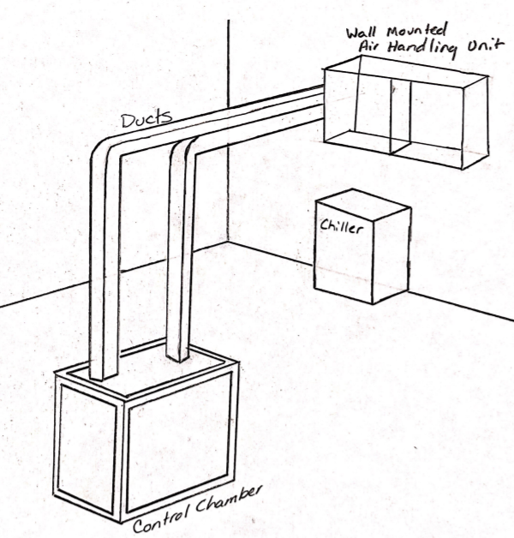
Figure 2: Originally approved design

Concept 1. Duct Insulation
This concept is adding insulation to the ductwork in order to increase the fractional increase in thermal resistance.
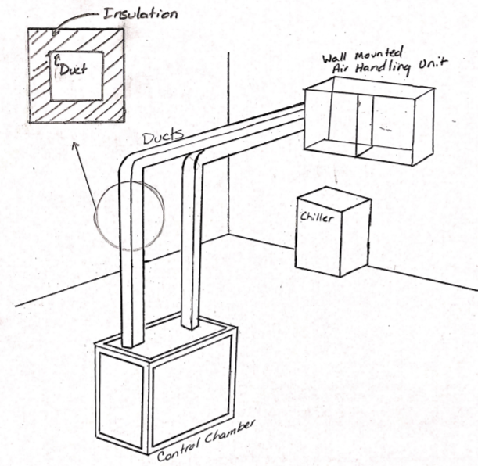
Figure 3: Duct Insulation

Concept 2: Increased Wall Thickness
This concept increases the wall thickness of the material used for the walls of the control chamber.
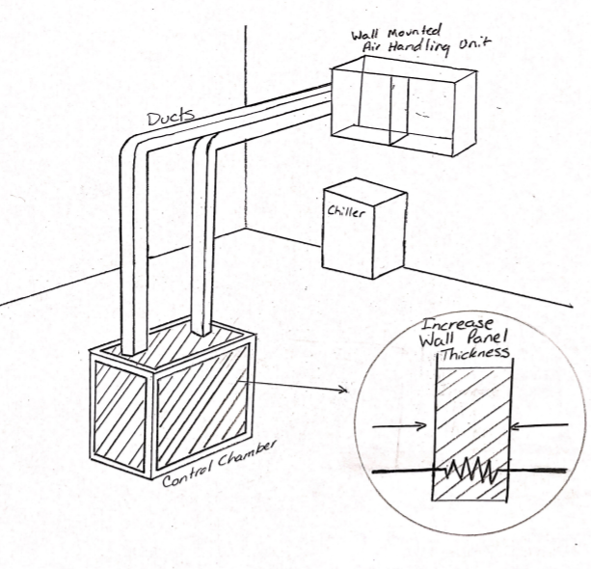
Figure 4: Increased Wall Panel Thickness

Concept 3: Heater Inside Duct
This concept places a heater inside the duct in order to increase the heat of the air entering the chamber. This duct heater is a way to increase the heat of the surrounding air used to help control the environment of the chamber. Duct heaters allow increased humidity control, and machinery pre-heating.
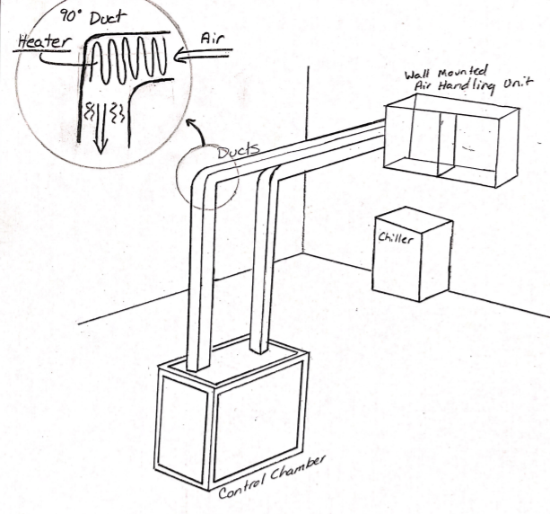
Figure 5: Heater Inside Duct

Concept 4: Hotplate with Water Dropper Humidifier
A hotplate placed in the chamber as a heating element to increase the overall temperature and heat of the chamber. The water droplet controller is positioned and secured over the hotplate where it would release water droplets onto the hotplate increasing the overall humidity of the chamber.
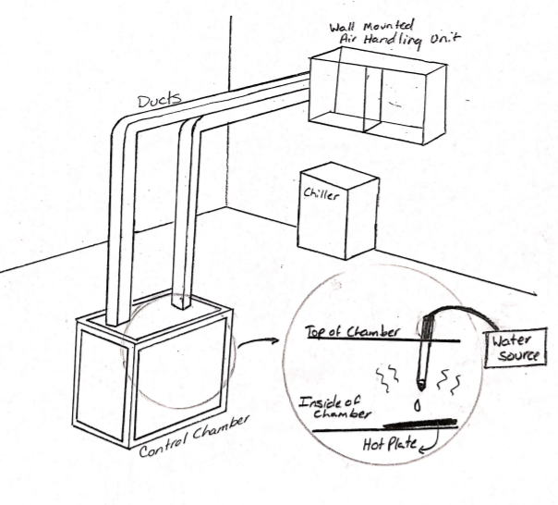
Figure 6: Hotplate with Water Dropper Humidifier

Concept 5: U-tube Bottom Surface
This concept uses an extra bit of fluid tubing connected to its own fluid conditioning cycle which goes through the chamber to heat or cool the surrounding volume during while the humidity is controlled via a separate boiler system. These are attached to the chamber via tubes of their own, which pump the fluid through. The fluid tubing will be set up similarly to a u-tube, which can be used as a primary source of heat transfer within systems. The tubing could minimize hot and cold spots within the chamber by being placed nominally.
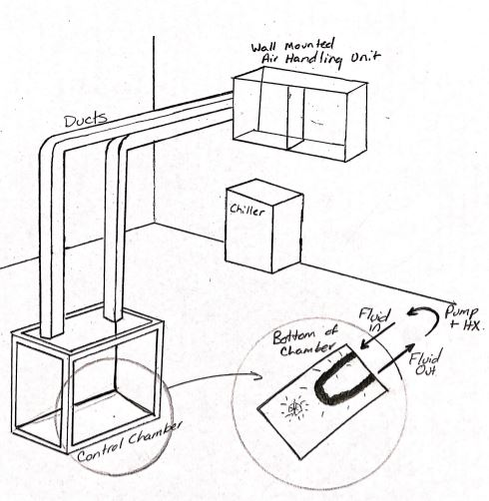
Figure 7: U-tube Bottom Surface

High Fidelity Concepts
Wall-Mounted AHU with Detachable Overhead Ducts
In this design, ducts are detachable using screw on connections, which allows the crane to insert and remove the compressor from above without issue. This also means that the system could be moved to a different location and the ductwork could simply be extended to the new location. The ducts will be made of a rigid material and covered by insulation to prevent as much condensation and heat transfer out of the system as possible. By placing the AHU on the wall, more floor area is available for other lab equipment in the facility. The chamber also has putty infiltration seals placed inside due to holes in the bottom of the chamber which normally allow wires through but also cause extra convection transfer. The putty would be placed in these holes to minimize the convection that occurs. The design also proposes to have rubber inserts seal the edges of the chamber where the plexiglass walls meet the aluminum frame and would otherwise allow for significant infiltration. These inserts will not affect the accessibility of the compressor. To account for condensation pooling within the ducts, several dips will be added into the horizontal portion of ductwork, which should be drained following each test cycle or once significant condensation accumulates.
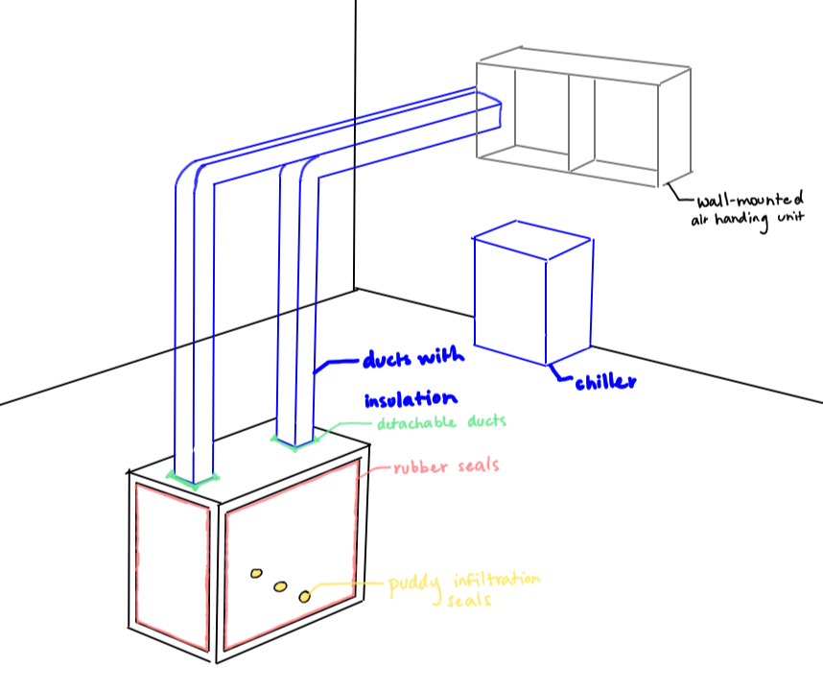
Figure 8: Wall-mounted AHU with detachable overhead ducts
Floor-Mounted AHU with Fixed Side Ducts
In this design, ducts are fixed to their positions with nuts and bolts, which keep them more stable in their positions and lowers the chance that they will be knocked over or broken. Since they are rigidly attached, they will need to be placed around the other equipment in the room and so that they do not obstruct the overhead crane which moves the compressor. The ducts will be made of a flexible material so that they can be bent around obstacles and covered with insulation to prevent significant condensation and heat transfer with the surrounding lab environment. The floor-mounted air handling unit heats and humidifies the air while the chiller cools it down and dehumidifies it. Placing the AHU on the floor allows for easier installation and eliminates the issue of making sure that the wall and supporting brackets provide sufficient support for the heavy components. The chamber also has putty infiltration seals placed inside due to holes in the bottom of the chamber which normally allow wires through but also cause extra convection transfer. The putty would be placed in these holes to minimize the convection that occurs. The design also proposes to have double-layered plexiglass walls and rubber seals around the edges of the plexiglass to minimize heat transfer and infiltration. By using double-layered walls, heat transfer is reduced significantly, and less condensation will accumulate on the walls to allow for more visibility of the compressor. To account for condensation pooling within the ducts, several sponges will be placed inside, and the ductwork will have several connections in order to drain any excess condensation after testing.
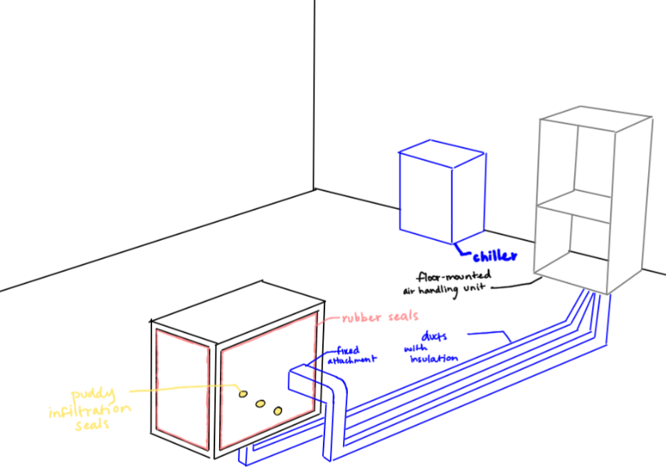
Figure 9: Floor-mounted AHU with fixed side ducts
Floor-Mounted AHU with Detachable Overhead Ducts
In this design, ducts are detachable using a snap-on connection, which allows for quick attachment and removal of the ducts to insert and remove the compressor with a crane from above. This also means that the system could be moved to a different location and the ductwork could simply be extended to the new location. The ducts will be made of a rigid material and covered with insulation to prevent as much condensation and heat transfer out of the system as possible. The floor-mounted air handling unit heats and humidifies the air while the chiller cools it down and dehumidifies it. Placing the AHU on the floor allows for easier installation and relocation and eliminates the issue of ensuring that the wall and supporting brackets provide sufficient load capacity for the heavy system. The chamber also has putty infiltration seals placed inside due to holes in the bottom of the chamber which normally allow wires through but also cause extra convection transfer. The putty would be placed in these holes to minimize the convection that occurs. The design also proposes to have the outside of the chamber sealed with an extra layer of rubber to prevent as much leakage as possible while not sacrificing the user’s access to the chamber itself. With a duct close off or open the airway to further control the airflow from the air handling unit to the chamber.
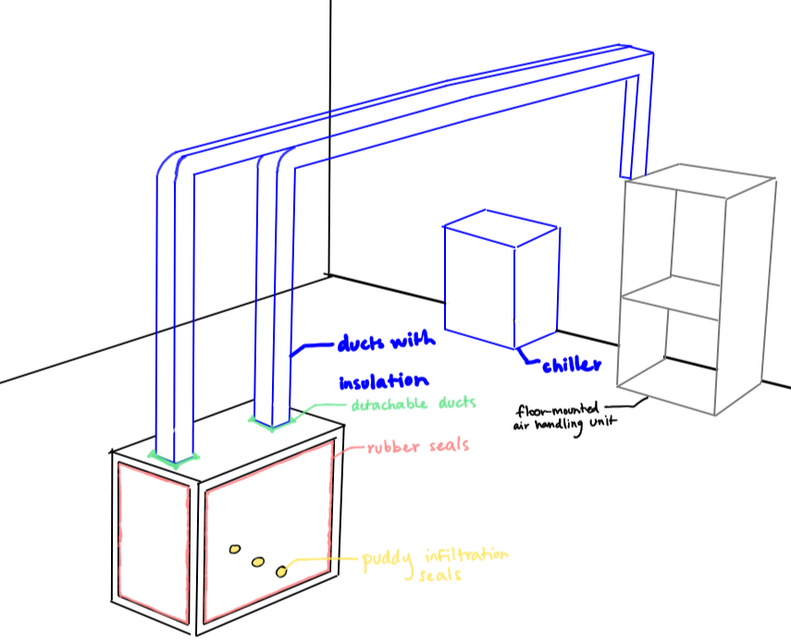
Figure 10: Floor-mounted AHU with detachable overhead ducts

Appendix D: Concept Generation

Concept Generation (100 Ideas)
# | Concept | Reasoning/ Description
1. | Wall-mounted AHU, flexible ductwork attached to roof, boiler humidifier, no dehumidifier, air-cooled chiller, duct tape, fiberglass insulation, PID controller | Morphological Chart
2. | Floor-mounted AHU, flexible ductwork attached to roof, boiler humidifier, no dehumidifier, air-cooled chiller, duct tape, fiberglass insulation, PID controller | Morphological Chart
3. | Wall-mounted AHU, flexible ductwork attached to roof, boiler humidifier, no dehumidifier, air-cooled chiller, duct tape, polyethylene insulation, PID controller | Morphological Chart
4. | Floor-mounted AHU, flexible ductwork attached to roof, boiler humidifier, no dehumidifier, air-cooled chiller, duct tape, polyethylene insulation, PID controller | Morphological Chart
5. | Wall-mounted AHU, flexible ductwork attached to roof, boiler humidifier, no dehumidifier, air-cooled chiller, screws/nails, fiberglass insulation, PID controller | Morphological Chart
6. | Floor-mounted AHU, flexible ductwork attached to roof, boiler humidifier, no dehumidifier, air-cooled chiller, screws/nails, fiberglass insulation, PID controller | Morphological Chart
7. | Wall-mounted AHU, flexible ductwork attached to roof, boiler humidifier, no dehumidifier, air-cooled chiller, screws/nails, polyethylene insulation, PID controller | Morphological Chart
8. | Floor-mounted AHU, flexible ductwork attached to roof, boiler humidifier, no dehumidifier, air-cooled chiller, screws/nails, polyethylene insulation, PID controller | Morphological Chart
9. | Wall-mounted AHU, flexible ductwork attached to roof, boiler humidifier, no dehumidifier, water-cooled chiller, duct tape, fiberglass insulation, PID controller | Morphological Chart
10. | Floor-mounted AHU, flexible ductwork attached to roof, boiler humidifier, no dehumidifier, water-cooled chiller, duct tape, fiberglass insulation, PID controller | Morphological Chart
11. | Wall-mounted AHU, flexible ductwork attached to roof, boiler humidifier, no dehumidifier, water-cooled chiller, duct tape, polyethylene insulation, PID controller | Morphological Chart
12. | Floor-mounted AHU, flexible ductwork attached to roof, boiler humidifier, no dehumidifier, water-cooled chiller, duct tape, polyethylene insulation, PID controller | Morphological Chart
13. | Wall-mounted AHU, flexible ductwork attached to roof, boiler humidifier, no dehumidifier, water-cooled chiller, screws/nails tape, fiberglass insulation, PID controller | Morphological Chart
14. | Floor-mounted AHU, flexible ductwork attached to roof, boiler humidifier, no dehumidifier, water-cooled chiller, screws/nails, fiberglass insulation, PID controller | Morphological Chart
15. | Wall-mounted AHU, flexible ductwork attached to roof, boiler humidifier, no dehumidifier, water-cooled chiller, screws/nails, polyethylene insulation, PID controller | Morphological Chart
16. | Floor-mounted AHU, flexible ductwork attached to roof, boiler humidifier, no dehumidifier, water-cooled chiller, screws/nails, polyethylene insulation, PID controller | Morphological Chart
17. | Wall-mounted AHU, flexible ductwork attached to roof, boiler humidifier, heat pump dehumidifier, air-cooled chiller, duct tape, fiberglass insulation, PID controller | Morphological Chart
18. | Floor-mounted AHU, flexible ductwork attached to roof, boiler humidifier, heat pump dehumidifier, air-cooled chiller, duct tape, fiberglass insulation, PID controller | Morphological Chart
19. | Wall-mounted AHU, flexible ductwork attached to roof, boiler humidifier, heat pump dehumidifier, air-cooled chiller, duct tape, polyethylene insulation, PID controller | Morphological Chart
20. | Floor-mounted AHU, flexible ductwork attached to roof, boiler humidifier, heat pump dehumidifier, air-cooled chiller, duct tape, polyethylene insulation, PID controller | Morphological Chart
21. | Wall-mounted AHU, flexible ductwork attached to roof, boiler humidifier, heat pump dehumidifier, air-cooled chiller, duct tape, polyethylene insulation, PID controller | Morphological Chart
22. | Floor-mounted AHU, flexible ductwork attached to roof, boiler humidifier, heat pump dehumidifier, air-cooled chiller, duct tape, polyethylene insulation, PID controller | Morphological Chart
23. | Wall-mounted AHU, flexible ductwork attached to roof, boiler humidifier, heat pump dehumidifier, air-cooled chiller, duct tape, polyethylene insulation, PID controller | Morphological Chart
24. | Floor-mounted AHU, flexible ductwork attached to roof, boiler humidifier, heat pump dehumidifier, air-cooled chiller, duct tape, polyethylene insulation, PID controller | Morphological Chart
25. | Wall-mounted AHU, rigid ductwork attached to roof, boiler humidifier, heat pump dehumidifier, air-cooled chiller, duct tape, fiberglass insulation, PID controller | Morphological Chart
26. | Floor-mounted AHU, rigid ductwork attached to roof, boiler humidifier, heat pump dehumidifier, air-cooled chiller, duct tape, fiberglass insulation, PID controller | Morphological Chart
27. | Wall-mounted AHU, rigid ductwork attached to roof, boiler humidifier, heat pump dehumidifier, air-cooled chiller, duct tape, polyethylene insulation, PID controller | Morphological Chart
28. | Floor-mounted AHU, rigid ductwork attached to roof, boiler humidifier, heat pump dehumidifier, air-cooled chiller, duct tape, polyethylene insulation, PID controller | Morphological Chart
29. | Wall-mounted AHU, rigid ductwork attached to roof, boiler humidifier, heat pump dehumidifier, air-cooled chiller, screws/nails, fiberglass insulation, PID controller | Morphological Chart
30. | Floor-mounted AHU, rigid ductwork attached to roof, boiler humidifier, heat pump dehumidifier, air-cooled chiller, screws/nails, fiberglass insulation, PID controller | Morphological Chart
31. | Wall-mounted AHU, rigid ductwork attached to roof, boiler humidifier, heat pump dehumidifier, air-cooled chiller, screws/nails, polyethylene insulation, PID controller | Morphological Chart
32. | Floor-mounted AHU, rigid ductwork attached to roof, boiler humidifier, heat pump dehumidifier, air-cooled chiller, screws/nails, polyethylene insulation, PID controller | Morphological Chart
33. | Wall-mounted AHU, rigid ductwork attached to roof, boiler humidifier, heat pump dehumidifier, water-cooled chiller, duct tape, fiberglass insulation, PID controller | Morphological Chart
34. | Floor-mounted AHU, rigid ductwork attached to roof, boiler humidifier, heat pump dehumidifier, water-cooled chiller, duct tape, fiberglass insulation, PID controller | Morphological Chart
35. | Wall-mounted AHU, rigid ductwork attached to roof, boiler humidifier, heat pump dehumidifier, water-cooled chiller, duct tape, polyethylene insulation, PID controller | Morphological Chart
36. | Floor-mounted AHU, rigid ductwork attached to roof, boiler humidifier, heat pump dehumidifier, water-cooled chiller, duct tape, polyethylene insulation, PID controller | Morphological Chart
37. | Wall-mounted AHU, rigid ductwork attached to roof, boiler humidifier, heat pump dehumidifier, water-cooled chiller, screws/nails, fiberglass insulation, PID controller | Morphological Chart
38. | Floor-mounted AHU, rigid ductwork attached to roof, boiler humidifier, heat pump dehumidifier, water-cooled chiller, screws/nails, fiberglass insulation, PID controller | Morphological Chart
39. | Wall-mounted AHU, rigid ductwork attached to roof, boiler humidifier, heat pump dehumidifier, water-cooled chiller, screws/nails, polyethylene insulation, PID controller | Morphological Chart
40. | Floor-mounted AHU, rigid ductwork attached to roof, boiler humidifier, heat pump dehumidifier, water-cooled chiller, screws/nails, polyethylene insulation, PID controller | Morphological Chart
41. | Wall-mounted AHU, rigid ductwork attached to roof, boiler humidifier, no dehumidifier, air-cooled chiller, duct tape, fiberglass insulation, PID controller | Morphological Chart
42. | Floor-mounted AHU, rigid ductwork attached to roof, boiler humidifier, no dehumidifier, air-cooled chiller, duct tape, fiberglass insulation, PID controller | Morphological Chart
43. | Wall-mounted AHU, rigid ductwork attached to roof, boiler humidifier, no dehumidifier, air-cooled chiller, duct tape, polyethylene insulation, PID controller | Morphological Chart
44. | Floor-mounted AHU, rigid ductwork attached to roof, boiler humidifier, no dehumidifier, air-cooled chiller, duct tape, polyethylene insulation, PID controller | Morphological Chart
45. | Wall-mounted AHU, rigid ductwork attached to roof, boiler humidifier, no dehumidifier, air-cooled chiller, screws/nails, fiberglass insulation, PID controller | Morphological Chart
46. | Floor-mounted AHU, rigid ductwork attached to roof, boiler humidifier, no dehumidifier, air-cooled chiller, screws/nails, fiberglass insulation, PID controller | Morphological Chart
47. | Wall-mounted AHU, rigid ductwork attached to roof, boiler humidifier, no dehumidifier, air-cooled chiller, screws/nails, polyethylene insulation, PID controller | Morphological Chart
48. | Floor-mounted AHU, rigid ductwork attached to roof, boiler humidifier, no dehumidifier, air-cooled chiller, screws/nails, polyethylene insulation, PID controller | Morphological Chart
49. | Wall-mounted AHU, rigid ductwork attached to roof, boiler humidifier, no dehumidifier, water-cooled chiller, duct tape, fiberglass insulation, PID controller | Morphological Chart
50. | Floor-mounted AHU, rigid ductwork attached to roof, boiler humidifier, no dehumidifier, water-cooled chiller, duct tape, fiberglass insulation, PID controller | Morphological Chart
51. | Portable AHU on wheels, rigid ductwork attached to roof, boiler humidifier, no dehumidifier, water-cooled chiller, duct tape, fiberglass insulation, PID controller | Brainstorming
52. | Portable AHU on wheels, rigid ductwork attached to roof, boiler humidifier, no dehumidifier, water-cooled chiller, duct tape, fiberglass insulation, PID controller | Brainstorming
53. | Portable AHU on wheels, flexible ductwork attached to roof, boiler humidifier, no dehumidifier, water-cooled chiller, duct tape, fiberglass insulation, PID controller | Brainstorming
54. | Portable AHU on wheels, rigid ductwork attached to floor, boiler humidifier, no dehumidifier, water-cooled chiller, duct tape, fiberglass insulation, PID controller | Brainstorming
55. | Portable AHU on wheels, flexible ductwork attached to floor, boiler humidifier, no dehumidifier, water-cooled chiller, duct tape, fiberglass insulation, PID controller | Brainstorming
56. | Portable AHU on wheels, rigid ductwork attached to roof, boiler humidifier, heat pump dehumidifier, water-cooled chiller, duct tape, fiberglass insulation, PID controller | Brainstorming
57. | Portable AHU on wheels, flexible ductwork attached to roof, boiler humidifier, heat pump dehumidifier, water-cooled chiller, duct tape, fiberglass insulation, PID controller | Brainstorming
58. | Portable AHU on wheels, rigid ductwork attached to roof, boiler humidifier, no dehumidifier, water-cooled chiller, duct tape, fiberglass insulation, PID controller | Brainstorming
59. | Portable AHU on wheels, flexible ductwork attached to roof, boiler humidifier, no dehumidifier, air-cooled chiller, duct tape, fiberglass insulation, PID controller | Brainstorming
60. | Portable AHU on wheels, rigid ductwork attached to roof, boiler humidifier, no dehumidifier, air-cooled chiller, duct tape, fiberglass insulation, PID controller | Brainstorming
61. | Wall-mounted AHU, dips in ductwork to collect condensation, boiler humidifier, no dehumidifier, air-cooled chiller, duct tape, fiberglass insulation, PID controller | Brainstorming
62. | Wall-mounted AHU, sponges in ductwork to collect condensation, boiler humidifier, no dehumidifier, air-cooled chiller, duct tape, fiberglass insulation, PID controller | Brainstorming
63. | Wall-mounted AHU, dips in ductwork to collect condensation, boiler humidifier, heat pump dehumidifier, air-cooled chiller, duct tape, fiberglass insulation, PID controller | Brainstorming
64. | Wall-mounted AHU, sponges in ductwork to collect condensation, boiler humidifier, heat pump dehumidifier, air-cooled chiller, duct tape, fiberglass insulation, PID controller | Brainstorming
65. | Wall-mounted AHU, dips in ductwork to collect condensation, boiler humidifier, no dehumidifier, water-cooled chiller, duct tape, fiberglass insulation, PID controller | Brainstorming
66. | Wall-mounted AHU, sponges in ductwork to collect condensation, boiler humidifier, no dehumidifier, water-cooled chiller, duct tape, fiberglass insulation, PID controller | Brainstorming
67. | Wall-mounted AHU, dips in ductwork to collect condensation, boiler humidifier, no dehumidifier, water-cooled chiller, screws/nails, fiberglass insulation, PID controller | Brainstorming
68. | Wall-mounted AHU, sponges in ductwork to collect condensation, boiler humidifier, no dehumidifier, water-cooled chiller, screws/nails, fiberglass insulation, PID controller | Brainstorming
69. | Wall-mounted AHU, dips in ductwork to collect condensation, boiler humidifier, no dehumidifier, water-cooled chiller, screws/nails, polyethylene insulation, PID controller | Brainstorming
70. | Wall-mounted AHU, sponges in ductwork to collect condensation, boiler humidifier, no dehumidifier, water-cooled chiller, screws/nails, polyethylene insulation, PID controller | Brainstorming
71. | Make a more secure chamber with opaque walls and better insulation, and add in a camera with protection so that it won’t fog or deactivate under high and low heats | Brainstorming
72. | Make a chamber that can be regulated using thermo currents from heat vents deep below the earth | Brainstorming
73. | Make a chamber which can be heated and cooled off using the sun’s rays and a roof window like a giant magnifying glass | Brainstorming
74. | Make the chamber itself have a heating and cooling unit installed on it, to heat and cool the inner temperatures using the walls as a medium | Brainstorming
75. | Submerge the entire chamber in water to allow for humidity to be changed much quicker if necessary | Brainstorming
76. | Use a human-powered air pump along with some friction surfaces to heat and flow the air into the chamber | Brainstorming
77. | Intentionally cause condensation and evaporation of water in the chamber to more quickly disperse humidity and temperature changes | Brainstorming
78. | Add light bulbs into the chamber to use electricity as a heating element and to assist internal visibility | Brainstorming
79. | Use clam-like ridges in the fans or the ventilation along with heating and cooling elements to improve heat transfer | Biomimicry
80. | Add oven heating coils to the chamber to control the heat of the chamber | Brainstorming
81. | Use the attached compressor that is inside of the chamber to assist in the control of the humidity and heat of the outer chamber | Brainstorming
82. | Use lasers as a method of heating and cooling the chamber | Brainstorming
83. | Wall-mounted AHU, rigid ductwork, ultrasonic humidifier, double-layered plexiglass walls, puddy to plug infiltration holes, PID controller | Anti-Problem
84. | Floor-mounted AHU, rigid ductwork, ultrasonic humidifier, double-layered plexiglass walls, puddy to plug infiltration holes, PID controller | Anti-Problem
85. | Wall-mounted AHU, rigid ductwork, ultrasonic humidifier, double-layered plexiglass walls, puddy to plug infiltration holes, rubber inserts for walls, PID controller | Anti-Problem
86. | Floor-mounted AHU, rigid ductwork, ultrasonic humidifier, double-layered plexiglass walls, puddy to plug infiltration holes, rubber inserts for walls, PID controller | Anti-Problem
87. | Wall-mounted AHU, rigid ductwork, humidifier, liquid desiccant dehumidifiers like ticks, chiller, duct tape/screws/nails, insulation, PID controller | Biomimicry
88. | Floor-mounted AHU, rigid ductwork, humidifier, liquid desiccant dehumidifiers like ticks, chiller, duct tape/screws/nails, insulation, PID controller | Biomimicry
89. | Wall-mounted AHU, ductwork with internal extrusions to increase surface area like veins, humidifier, dehumidifier, chiller, duct tape/screws/nails, insulation, PID controller | Biomimicry
90. | Floor-mounted AHU, ductwork with internal extrusions to increase surface area like veins, humidifier, dehumidifier, chiller, duct tape/screws/nails, insulation, PID controller | Biomimicry
91. | Wall-mounted AHU, ductwork with root-like suction to reduce moisture, humidifier, dehumidifier, chiller, duct tape/screws/nails, insulation, PID controller | Biomimicry
92. | Floor-mounted AHU, ductwork with root-like suction to reduce moisture, humidifier, dehumidifier, chiller, duct tape/screws/nails, insulation, PID controller | Biomimicry
93. | Adding insulation to the ductwork | Medium Fidelity
94. | Increased wall panel thickness for chamber | Medium Fidelity
95. | Heater inside duct at the 90 degree change in angle | Medium Fidelity
96. | Hotplate with water dropper humidifier | Medium Fidelity
97. | Vein-like inner surface | Medium Fidelity
98. | Wall-mounted AHU, detachable insulated ductwork, chiller, rubber sealing and puddy infiltration seals | High Fidelity
99. | Floor-mounted AHU, fixed insulated ductwork, chiller, rubber sealing and puddy infiltration seals | High Fidelity
100. | Floor-mounted AHU, detachable insulated ductwork, chiller, rubber sealing and puddy infiltration seals | High Fidelity

