Operation Manual
Danfoss Team 503: Environmental Test Chamber

Nicholas Blenker
Tucker Hall
David Wilson

FAMU-FSU College of Engineering
Florida State University

EML 4552C Senior Design 2
Dr. Shayne McConomy
March 25, 2022

Table of Contents
List of Figures 3
Project Overview 4
Component/Module Description 4
1. Koldwave Portable Air Conditioner 4
General Safety Guidelines 4
Controls 6
2. Industrial Humidifier 7
General Safety Guidelines 7
Controls 8
3. Electric Space Heater 9
General Safety Guidelines 9
Controls 10
Integration of Components 10
Material List 10
Wiring Diagrams 10
Assembly Process 10
Other Components 11
Operation 11
Related Documents 14
Team 503: Contact Information 14
Pseudocode 15
Troubleshooting 17
Appendix A: Connections and Wiring Diagrams 19
Appendix B: Pictures 21

List of Figures
Figure 1: Koldwave AC Unit (Front) 4
Figure 2: KOLDWAVE AC Unit (Back) 4
Figure 3: KOLDWAVE AC Unit (Control Panel) 6
Figure 4: KOLDWAVE AC Unit (Ambient Air Adapter) 6
Figure 5: Industrial Humidifier (Part Breakdown) 7
Figure 6: Industrial Humidifier 7
Figure 7: Industrial Humidifier (Control Panel) 8
Figure 8: Electric Space Heater 9
Figure 9: Electric Space Heater (Control Module) 10
Figure 10: LED Display 12
Figure 11: 3D Printed (Control Panel) 12
Figure 12: Basecamp (Form Invitation) 14
Figure 13: Solenoid (Button Pusher) Connections 19
Figure 14: Waterproof Heater Connections 19
Figure 15: Temperature/Humidity Sensor Connections 19
Figure 16: Stepper Motor Connections 20
Figure 17: 3D Printed Solenoid Cover 21
Figure 18: Duct Connections (Front View) 21
Figure 19: Duct Connections (Side View) 21
Figure 20: Overall System (Side View) 22

Project Overview
Our project goal is to design an air control system that attaches to a plastic chamber to test compressors at different temperatures and humidity levels. Compressors are parts of air-conditioners that compress a liquid to cool down and draw moisture from the air. Each one must work in the weather where it will be used. The main issues when testing them are air leaks and heat loss through the testing cell. Our design addresses this problem by putting the air control unit right next to the chamber. This reduces the needed amount of duct, which lessens air leaks and heat transfer. All cracks and holes seal tightly to create a closed volume of air, as well. These choices allow for accurate control of inner conditions within 15 minutes. The design also stops condensed water from building up by collecting and returning it to the humidifier.
Our design improves an existing design by increasing the range of cooling, humidity, and mobility, and by lowering the heat lost to the surrounding air. It features a more powerful air chiller, humidifier, and two more heaters. Ducts from these pieces attach to the chamber’s sidewalls and are easily removable. Putting the unit on the floor rather than a wall simplifies the previous design greatly. Sensors check the inner temperature and humidity levels to adjust to the user’s wanted values. This achieves hands-free testing in harsh and mild settings. Testing the compressor’s performance in each condition allows the user to find out its abilities before selling or using it. Since the system is mobile, it can attach to any large box for testing devices in common weather. In this way, our project has wide application and can help many industries.

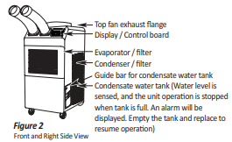
Component/Module Description
Figure 1: Koldwave AC Unit (Front)

Koldwave Portable Air Conditioner
Model No: KK17BGA2AA00
Power Supply: Single Phase 115V, 60Hz
Cooling Capacity: 16,800 BYU/h
Power Consumption: 1700 W

General Safety Guidelines
- Transport and store the unit in an upright position only. Leave the unit in an upright position for at least 3 hours before first use.
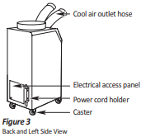
- Always place the unit on an even, level surface.
Figure 2: KOLDWAVE AC Unit (Back)
- Ensure the unit is connected to a grounded power supply of the correct rating/capacity.
- The unit will cool when the room temperature is between 18°C (64°F) ~ 45°C(113°F) depending on the thermostat setting.
- DO NOT use this unit for functions other than those described in this instruction manual.
- DO NOT tilt the unit.
- DO NOT cover or obstruct the unit's inlet and outlet grilles.
- DO NOT use the unit in areas where it will be exposed to rain or water.
- NEVER unplug the unit while it is operating.
- DO NOT use the unit in wet environments, such as a laundry room, to avoid the risk of electrical shock.10. DO NOT place any foreign objects on the unit.
- DO NOT operate the unit with wet or damp hands.
- DO NOT allow chemical substances to contact the unit.
- DO NOT operate the unit in the presence of flammable substances or vapors such as alcohols, pesticides, gasoline, etc.
- DO NOT operate the unit in explosive or flammable environments.
- DO NOT use the plug to start and to stop the unit. Always use the control panel to start and stop the unit.
- Always turn off the unit when it is not in use and unplug the power plug from the electrical outlet.
- Always turn the unit off and unplug the main power plug from the electrical outlet before cleaning, moving, or performing maintenance.
- AVOID the use of adapter plugs or extension cords. If it is necessary to use an extension cord or an adapter plug to operate the unit, ensure that they are correctly rated for the application. Consult a local qualified electrician and all local electrical codes to ensure proper setup. Any extension cord used with this device must be rated for a minimum of 15A.(120V)
- DO NOT unplug the unit by pulling on the electrical cord. Keep the electrical cord away from heat sources and always completely unroll the cord to avoid overheating. If the power cord becomes damaged, a qualified service agent, qualified electrician, or similarly qualified person must replace it, to avoid a hazard or shock. DO NOT operate a unit with a damaged power cord.
- The filters must be used with the product at all times. When the filters are removed for cleaning, always ensure that the unit has been turned off and unplugged from the electrical outlet.
- Regularly clean the filters to maintain efficiency. If the filters are not cleaned regularly, the unit’s output performance and efficiency will decline, and energy consumption will increase.
- DO NOT operate the unit with a damaged power cord or plug, after it malfunctions, has been dropped, or damaged.
- Only use in the upright position on an even, flat surface. The unit must be positioned at least 24inches (60 cm) from the nearest object in any direction.
- Stop operation immediately if abnormal noise or odor is noticed. Contact a local service center.
- Appliance is not to be used by children or persons with reduced physical, sensory, or mental capabilities, or lack of experience and knowledge unless they have been given supervision or instruction.
- Children being supervised not to play with appliances.
- That the appliance shall be installed in accordance with national wiring regulations.
- If the supply cord is damaged, it must be replaced by the manufacturer, its service agent, or similarly qualified persons to avoid a hazard.

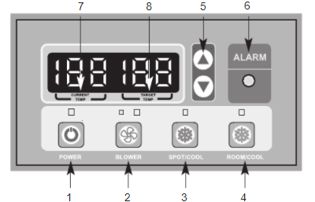
Controls
Figure 3: KOLDWAVE AC Unit (Control Panel)
- POWER BUTTON: Activates unit when POWER BUTTON is pressed. (Fan starts on low speed). If the power button is pressed during operation, the unit stops.
- BLOWER BUTTON: Changes fan speed from (Low) to (High) when pressed.
- SPOT/COOL BUTTON: Activates compressor and begins producing cool air 5 seconds after the button is pressed. Regulates temperature based on outlet cool air temperature.
- ROOM/COOL BUTTON: Activates compressor and produces cool air 5 seconds after button is pressed. Regulates temperature based on inlet ambient air temperature.
- SET TEMP BUTTONS: Change target temperature/data value by +/- 1. Change data value by +/-10 by pressing continually. Press the SET TEMP BUTTONS to set the temperature. The upper button is to heighten temperature and the Lower button is to lower temperature.
- ALARM: Alarm indicator lights (blinks) and indicates abnormal system operation. If Alarm occurs, the compressor stops. System operation stops when the ALARM light is activated (blinks) longer than 3 minutes.
- CURRENT TEMP: Displays current room temperature in display in Fahrenheit. (In RoomCool Mode only). SPOT/COOL Mode – Displays outlet (cool air) temperature during normal operations. To change °F to °C, press SPOT/COOL and ROOM/COOL buttons together for 2 seconds. C will blink 2 times and the Figure will change to °C. ALARM codes blink and are displayed when an abnormal operation occurs.
- TARGET TEMP: displays the unit set temperature for ROOM/COOL mode only. OFF-TIMER: Enter to Timer Setting Mode if you press the BLOWER Button and SPOT/COOL Button together for 1 second. Press the UP/DOWN button to set the timer until it shows the figure you want to set. After 5 seconds, the figure will be memorized, and the compressor will stop after the time set. AUTO RESTART: If the unit goes off due to an electrical interruption, the unit will automatically restart when the power resumes.

Ambient Air Adapter
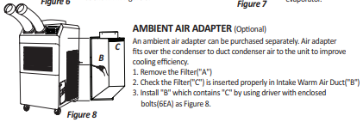
This component attaches to the right side of the A/C unit using screws (provided) and allows for improved spot cooling capabilities when attached to a duct reducer and flex duct (also provided).
Figure 4: KOLDWAVE AC Unit (Ambient Air Adapter)

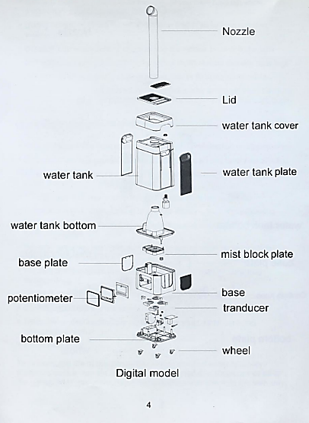
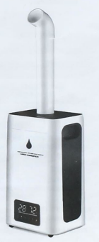
Industrial Humidifier
When using the humidifier, basic electrical safety precautions should always be followed.
WARNING: TO AVOID THE RISK OF ELECTRICAL SHOCK, FIRE, OR INJURY TO PERSON, ALWAYS MAKE SURE THE PRODUCT IS UNPLUGGED FROM THE ELECTRICAL OUTLET BEFORE RELOCATING, SERVICING OR CLEANING IT.
Figure 5: Industrial Humidifier (Part Breakdown)
Figure 6: Industrial Humidifier

General Safety Guidelines
Read all the instructions before using the humidifier:
- Use this humidifier only as described in this manual. Anything outside the
guidelines are not recommended, may cause fire, electric shock, or injury
to persons.
- Ensure all packaging is removed before use.
- Check the power cord and plug regularly for damage. If the power cord or the plug is damaged, DO NOT use it. It must be replaced by a manufacturer or a qualified person to avoid an electrical hazard.
- DO NOT pull the cord too hard as it could damage and fray. If it becomes damaged after prolonged use it should be repaired by a qualified technician
- Ensure that the voltage used corresponds to the voltage indicated on the rating plate
- DO NOT allow the power cord to touch hot surfaces and DO NOT place near a hot gas or electric burners
- Place the humidifier on a flat, level surface away from direct sunlight NEVER operate the unit without water
- Use only clean, cool water to fill the tank. (If you have hard tap water, it is strongly suggested to use distilled water)
- During operation, rotate the mist nozzle so it aims away from children, walls, and furniture.
- DO NOT add medication of any type into the nozzle, base, or water tank.
- DO NOT cover any openings on the unit or insert objects into any openings.
- DO NOT tilt or tip the unit or attempt to empty or fill while in operation.
- DO NOT leave the unit unattended in closed rooms as the air could become saturated and leave condensation on walls or furniture. Always ensure good ventilation.
- To protect against electric shock, do not immerse unit, plug, or cord in water or other liquids.
- Keep the cord away from areas where it could be walked on or tripped on.
- Close supervision is necessary when any appliance is used by or near children
- To disconnect, first turn the unit OFF, grip the plug and pull from the wall outlet. Never pull the plug by the cord
- Turn the unit OFF and unplug from the outlet when not in use
- Turn the unit OFF when moving to another location and before cleaning
- DO NOT operate the humidifier in the presence of explosive and/or flammable fumes
- DO NOT place the humidifier or any parts near an open flame, cooking, or other heating appliance
- The use of attachments not recommended by the manufacturer may be hazardous
- DO NOT place the humidifier on a wooden or polished surface
- DO NOT operate if the housing is damaged
- There are no user-serviceable parts in this product. Refer servicing to a qualified person
- This is NOT a toy
To prolong the life of this humidifier, using distilled water is highly recommended or run via an RO machine. Do not add fragrance or oil in the water, it will cause the machine to malfunction and void the warranty.

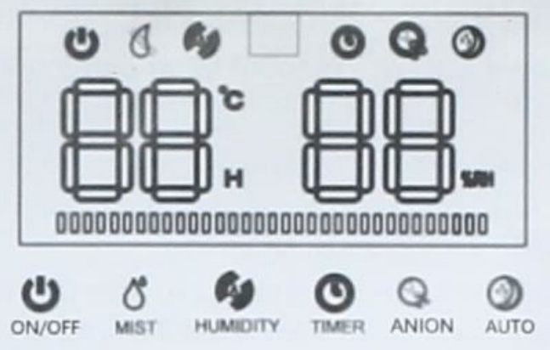
Controls
Figure 7: Industrial Humidifier (Control Panel)
- DEFAULT START: display indicate the room temperature, default mist level is “3" level, if not touch any function , display will turn dark after 5 seconds , fan working.
- MIST LEVEL SELECTION: press the “mist", it chooses between “1-5, 5 level is the biggest power working mode.
- SET HUMIDITY: Touch “humidity”, the humidity will increase 5%RH between 45%-95%RH, continue to touch max 95%RH then cancel humidity setting. if humidity %RH is twinkle, it's meant the room humidity still does not reach your set target humidity, it will work on the current mist level. when the %RH reaches your target humidity, it will stop making mist, the fan will stop after 10 seconds, anion stop too.
- TIMER (turn off): timer is between 1-12 hours, when you choose the hours after 3 seconds, it will turn to timer mode, if the time counts out, the machine will auto turn off. Touch the power can restart.
- ANION: turn on the machine, touch “ANION”, anion generator will work, touch one more time, it will turn on. if water shortage, the anion will auto turn off. If fill the water before auto-turn off (15 seconds), the anion will work again.
- AUTO function: Touch AUTO to start sleep mode, touch any button to wake up. Water shortage: working situation, if water shortage, the mist will stop making, the fan will stop after 10 seconds, water shortage signal twinkle per 0.5 seconds, beep sound 3 times then turn off after 15 seconds, water level light turn off too.

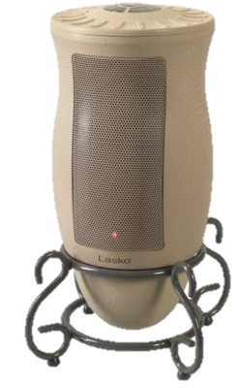
Electric Space Heater
Figure 8: Electric Space Heater

General Safety Guidelines
- Carefully remove the Heater from the plastic bag and the carton.
- Place the Heater on a firm and level surface. Plastic or rubber tabs, like the feet on this unit, may stick to furniture surfaces and/or hardwood floors. The unit may leave a residue that could darken, stain, or leave permanent blemishes on the finish of certain furniture surfaces, including wood surfaces, and/or hardwood floors.
- Plug the cord set into a 120-volt outlet. Be sure that the plug fits tightly into outlet. When plugs fit loosely into receptacles, they may slip partially or completely out of the receptacle with only the slight movement of the attached cord. Receptacles in this condition may overheat and pose a serious fire hazard; if covered by a curtain or drape, the fire hazard is even greater.
- When the Heater is initially plugged in, there will be a ‘beep’, indicating that there is power to the unit. The power light will remain lit until the Heater is unplugged from the outlet. 5. Turn the Heater ON by pressing the Power Button.
- When initially turned on, the Heater will be in High heat (1500 Watts) on Max. (The High light will be steady, and the Max light will be blinking).
- Press the Power Button once and the Heater will be in Low Heat, indicated by the steady light beside Low. The MAX light will be blinking.
- Pressing the Power Button a third time will turn the Heater OFF.

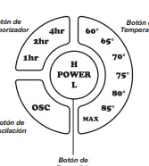
Controls
Figure 9: Electric Space Heater (Control Module)
- Oscillation Function: Pressing the Oscillation Button (OSC) will allow the Heater to oscillate back and forth. To stop the oscillation, press the Oscillation Button (OSC) once again. The oscillation function will stop when the temperature function is in use and the Heater has reached the desired temperature. The oscillation function will resume when the Heater turns back on.
- Temperature Function: To set the room at a specific temperature, press the Temperature Button to the desired setting. The light under the chosen temperature will continue to blink until the room reaches the desired temperature. For increased efficiency, the Temperature Function will only run on High heat. When set on MAX, the Heater will run continuously.
- Timer Function: The Timer Function may be activated when the Heater display is in any speed or temperature. This function allows you to set the length of time the Heater will run before turning itself off, from 1 hour to 7 hours. Pressing the Timer Button will increase the length of time, in combinations of 1, 2 and 4 hours. Continuously pressing the button will result in the timer being set for 7 hours. The Heater will turn off when the set time has elapsed.

Integration of Components

Material List
Link to final bill of materials: Updated Bill of Materials.xlsx

Wiring Diagrams
See Appendix A.

Assembly Process
- Three 4.5” diameter holes were drilled into the long side of the plastic tote using a Dremel circular saw. The pipe coming from the humidifier was traced with a marker on the bottom of the tote, and a circle of this size was drilled using the same hole.
- By holding a duct flange over each of the three side holes, the locations of six holes per flange were marked using a marker. A ¼” acrylic drill bit was used to drill all 6 holes surrounding each 4.5” hole.
- Three 6” duct flanges were fastened to the side holes of the tote using 6 ¼”-20 screws 6 ¼” washers, and 6 ¼”-20 wing nuts. The humidifier pipe was slid through the hole in the bottom of the tote and attached back to the humidifier.
- The blue covers on the end of each of the A/C unit ducts were removed, and the ducts were placed over two of the flanges. The other flange was attached to a 6” to 5” duct reducer, 6” flex duct, and 25” to 6” duct reducer. The large duct reducer attached to the ambient air adapter, which attached to the right side of the portable A/C unit via screws.
- A 9”x9.5” rectangle was drawn in the middle of the tote’s lid, and the Dremel circular saw was used to cut out this section. One of the 9” sides of this panel was pressed into the 3D-printed mechanical door shaft.
- The stepper motor shaft was placed into the hollow end of the mechanical door shaft, and the other end was placed into a 608 bearing inside the 3D-printed bearing holder.
- Solenoids and servos were placed into the A/C control panel and humidifier control panel, respectively. One solenoid was placed in the heater control panel. The solenoids, stepper, servo, sensors, and main control panel were all wired to the Arduino according to Table X. The Arduino code can be found in X.

Other Components
- SunFounder IIC I2C TWI 1602 Serial LCD Module Display
A LED display is used with the Arduino to display the internal settings of the chamber, the ambient air, user selection and the process values of the system working.
- Button #1
The first button is used to start up the system and initiate the priming cycle, or turn the system off and initiate the system shut down functions.
- Potentiometer #1
The first potentiometer will be connected to the main breadboard controlling the user-defined temperature.
- Potentiometer #2
The second potentiometer will be connected to the main breadboard controlling the user-defined temperature.
- Button #2
The second button is for the user to select the internal desired temperature and relative humidity values.
- RGB Light
The main control board will include a RGB light displaying the overall progress of the internal environment.
Red Error
Blue Human Interaction
Yellow In Progress
Green System Satisfied

Operation
A close-up of the liquid crystal display (LCD), which can be found in the top-right of the control panel shown in Figure X, is shown below.

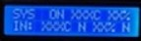
Figure 10: LED Display

The top row, labelled “SYS” (system), displays from left to right:
  - The system status (ON or OFF)
  - The current temperature inside the chamber in degrees Celsius
  - The current relative humidity inside the chamber in percent
The bottom row labelled “IN” (input), displays from left to right:
  - The current temperature inside the chamber in degrees Celsius
  - Whether or not the current temperature matches the input (Y or N)
  - The current relative humidity inside the chamber in percent
  - Whether or not the current humidity matches the input (Y or N)

The centralized control panel for monitoring and regulating the chamber’s temperature and humidity is shown in the image below.

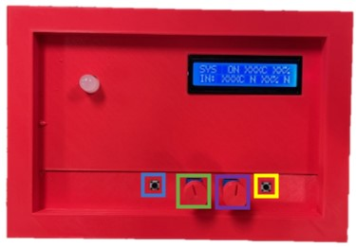
Figure 11: 3D Printed (Control Panel)

The system’s power is controlled by the button on the left (shown in blue). Once the button is pressed and the system is turned on, turn the temperature knob (shown in green) and the humidity knob (shown in purple) until the desired values for each are shown in the bottom row of the LCD screen. Once the desired values are set, press the “OK” button on the right side (shown in yellow). The system status is indicated by the color of the light in top left.

RGB Light Color Codes
Blue: User Input Required
- Occurs when the system detects a change in the desired temperature or humidity (when a knob is turned), but the user has not clicked the “OK” button. This status can be ignored if a knob is accidentally turned.
Green: Complete
- Occurs when the system achieves the desired temperature and humidity conditions previously input by the user, within 1%. The user can begin testing the compressor (or other equipment) when this light is on.
Yellow: In Progress
- Occurs when the user inputs desired values which differ from the current conditions. In this state, the components are manipulated automatically by the built-in controls to work towards the desired inner conditions.
Red: Error
- Occurs when one of the system components encounters an issue that cannot be resolved without human interaction. Turn off all components manually if the control system fails to do so on its own. Refer to the troubleshooting section of this manual to resolve the issue.

Related Documents
The important documents and files related to this project’s completion can be found in the basecamp provided by Shayne McConomy, the instructor for Senior Design at the FAMU-FSU College of Engineering. To be added to see important documents to the projects completion please contact one of the group members to complete the form from Basecamp shown below.
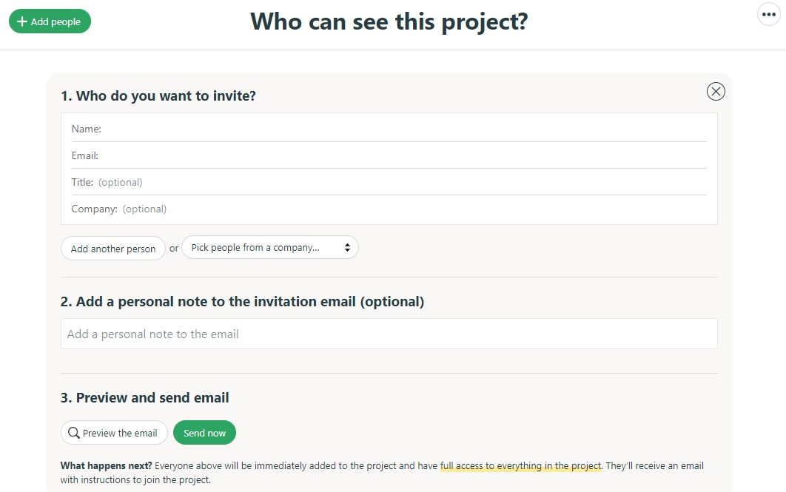
Figure 12: Basecamp (Form Invitation)

Team 503: Contact Information
The following is the group members’ contact information:

Nicholas Blenker
Phone Number: (954) 300-9764
Email: njb17@my.fsu.edu
Linkedin: https://www.linkedin.com/in/nicholas-blenker/

David Wilson
Phone Number: (904) 307-1125
Email: dhw18@my.fsu.edu
Linkedin: https://www.linkedin.com/in/david-h-wilson/

Tucker Hall
Phone Number: (850) 512-2718
Email: tdh16@my.fsu.edu
Linkedin: https://www.linkedin.com/in/tucker-hall-aa1b36191/

Pseudocode
Libraries
LCD variables
Stepper variables
RGB variables
General variables

void setup() {
Serial.begin(9600);
Sensor setup
LCD setup
RGB setup
}

void loop() {
Read sensor data
Display status on LCD
Check for user input
Adjust RGB based on input/status
Implement control logic
If current temperature = desired temperature & current humidity = desired humidity
Green RGB
End
If current temperature = desired temperature
If current temperature = room temperature
No action
Else if current temperature > room temperature + value
Keep heater running
Else if current temperature < room temperature - value
Keep A/C running
End
Else If current temperature > desired temperature & current temperature > 43C
Yellow RGB
Open vent door
Else If current temperature < desired temperature
Yellow RGB
Set heater to desired temperature
Else If current temperature > desired temperature
If vent door is open & current temperature < 43C
Close vent door
End
Yellow RGB
Set A/C to desired temperature
End
If current humidity = desired humidity
If current humidity = room humidity
No action
Else if current humidity > room humidity + value
Keep heater running
Else if current humidity < room humidity - value
Keep A/C running
End
Else If current humidity < desired humidity
Yellow RGB
Set humidifier to desired humidity
Else If current humidity > desired humidity
Yellow RGB
Set A/C to desired temperature
End
}

Troubleshooting
Issue |  | Possible Cause(s) |  |  | Corrective Action(s)
- Koldwave Portable Air Conditioner
Water Leakage |  | High water level in condensate tank |  |  | 1. Remove blockage from drain hose  2. Remove any object stuck under the black panel under the water tank
The Unit Doesn’t Work |  | 1. Check the power supply  to verify that power is  available to the unit  2. Verify that the power  cord is connected |  |  | 1. Reset the circuit breaker and restart the unit  2. Connect the power cord
No cold air flows from the cold air outlet |  | 1. Ambient air cannot be  properly cooled if the filter is dirty and not regularly cleaned  2. Compressor will not work if the unit is turned off and on quickly  3. The ambient air temperature may be too high |  |  | 1. Clean the filter  2. Wait 2 minutes after the unit is turned off before turning the unit back on  3. The temperature of the compressor can be higher when the ambient temperature is too high. The compressor will not work unless the ambient air temperature is within the  acceptable operating range of the unit
Water flow can be heard after the compressor shuts off |  | 1. No cause |  |  | 1. Common to hear the coolant flowing after the unit shuts off
The alarm displays "FT" with less than half of condensate water in the tank Spring is possibly broken |  | 1. Spring is possibly broken |  |  | 1. Replace with a new spring
- Industrial Humidifier
Light off, fan not working, no mist |  |  | 1. Power not connected or has a problem |  |  | 1. Change to another new power socket
Light on, fan not working, no mist |  |  | 1. Too much base water |  |  | 1. Pour out a little water of the base and restart
Mist small |  |  | 1. Transducer covered by furring |  |  | 1. Clean the furring and change cleaner water
Water cannot reach base |  |  | 1. Valve stuck  2. Water higher than the full mark |  |  | 1. Clean valve and place the water tank in the right position  2. Pour out some water to be lower than the full mark
- Electric Space Heater
If your heater shuts off unexpectedly or fails to operate, the previously mentioned safety feature may have been activated to prevent overheating. | 1. Be sure the power cord is plugged into a working electrical outlet.  2. Check your Temperature setting. The Heater may be off because it has reached the desired temperature setting.  3. If your Heater runs for several minutes and shuts off repeatedly, your Heater may require cleaning. |  |  | If you have a problem that can not be resolved by the steps listed above, contact Technical Assistance at 1-800-233-0268, Monday through Friday, between the hours of 8 a.m. and 5 p.m. EST

Appendix A: Connections and Wiring Diagrams
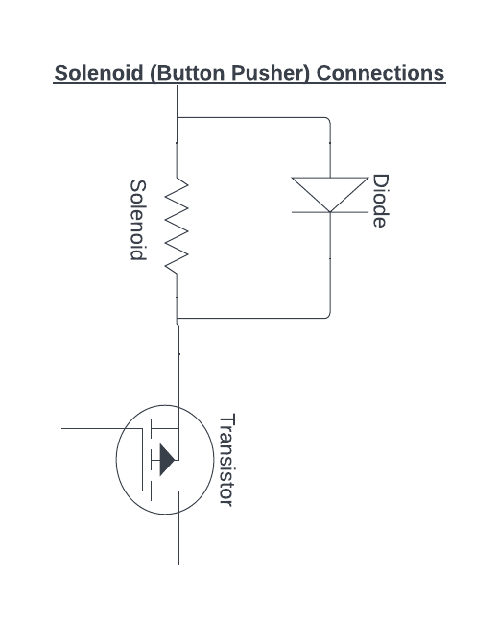
Figure 13: Solenoid (Button Pusher) Connections

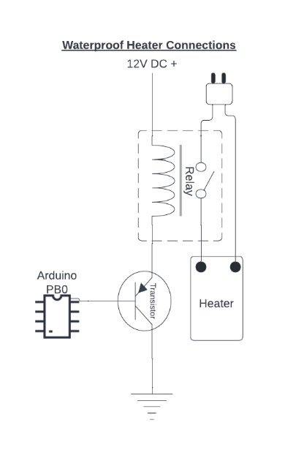
Figure 14: Waterproof Heater Connections
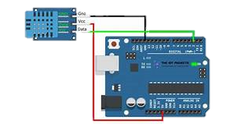
Figure 15: Temperature/Humidity Sensor Connections
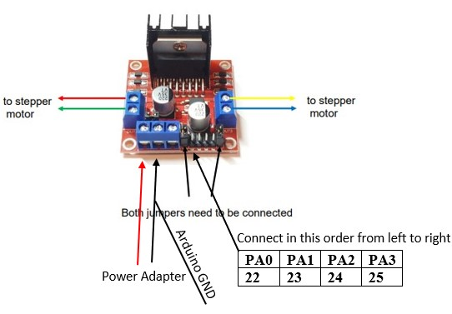
Figure 16: Stepper Motor Connections

Appendix B: Pictures
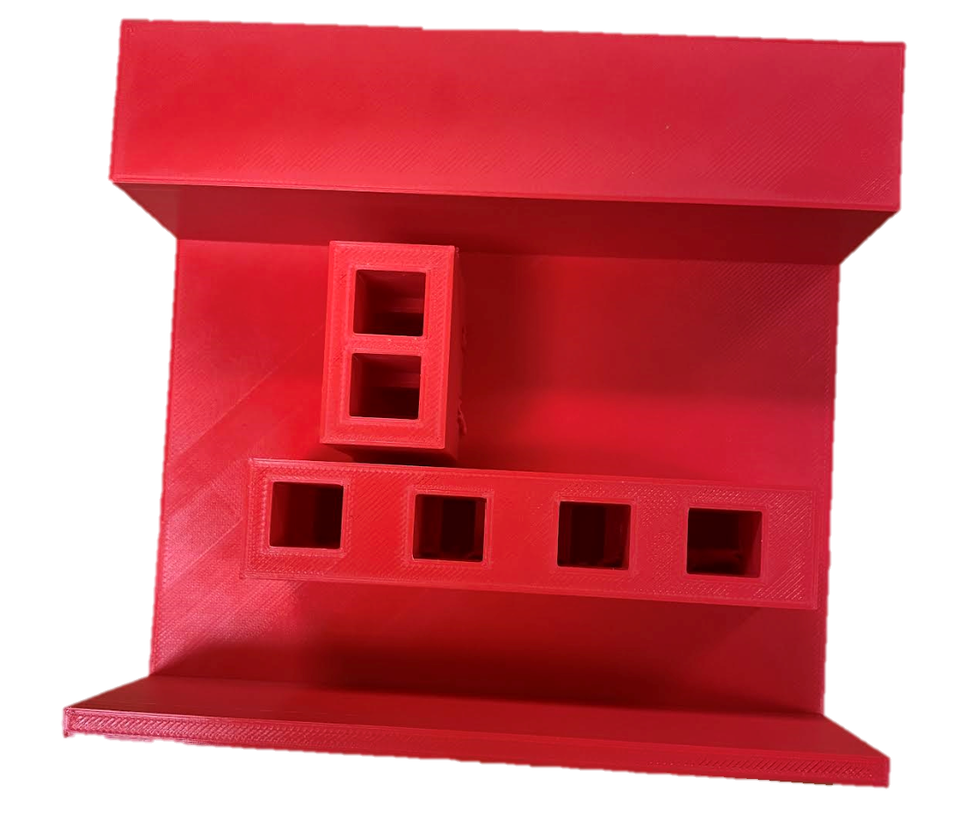
Figure 17: 3D Printed Solenoid Cover
Figure 18: Duct Connections (Front View)
Figure 19: Duct Connections (Side View)
Figure 20: Overall System (Side View)

