Author1 Name: Makada S. Brown; Author2 Name: Erich A. Noack; Author3 Name: Charles E. Stubbs; Author4 Name: Amelia F. Veith

FAMU-FSU College of Engineering  2525 Pottsdamer St. Tallahassee, FL. 32310

Team 502: Material Handling of Ceramics

4/12/2022

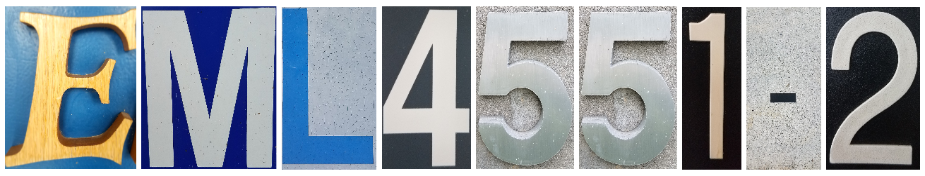

# Abstract

Team 502’s mission is to provide a solution to handling ceramic filters without introducing damage; our design will achieve this by preventing visible damage at the location where the handler contacts the filter’s outer walls. Corning produces brittle, cylindrical ceramic filters for vehicles with internal combustion engines to filter exhaust air. Throughout production, these ceramic filters are at times subjected to damage when moved from one manufacturing stage to another. Damage to these filters typically occurs from crushing the filter’s skin, making the filters unusable. These ceramic filters have varying sizes, with diameters ranging from 7.5 to 15 inches and weighing from 4 to 40 pounds. Our handler design has three fingers that approach the filter’s surface in three separate places around the filter’s circumference. The design is adjustable depending on the size of the filter it is handling. There is compliant padding attached to the design that contacts the filter’s surface to lessen the contact forces applied on the filter. Force sensors indicate when the handler should stop applying pressure, allowing for part movement. This procedure is quick and consistent with the use of motors and a computer, making the design usable in a lean manufacturing system. The linear motion of the padded three-finger design also allows the handler to pick and place various sizes of these ceramic filters with a controlled motion. Corning has provided our team with part samples. Our team will show the effectiveness of the design by evaluating the handler performance with these sample filters. A successful test would result in the handler not causing damage to the ceramic parts after grasping and moving the parts. The handler design will demonstrate success by regulating the forces applied by the handler, adding cushioning to the interface, and increasing the contact area. Thus, reducing the damage introduced to the cylindrical ceramic parts by handling.

*Keywords*: ceramic, handler, adjustable



# Acknowledgement

Team 502 would like to thank our sponsor Corning and the Corning representatives Tevin Smith and Dr. Alexander Richter. Tevin, thank you for all your help throughout the project. The bi-weekly meetings have been extremely beneficial, and the feedback given has been helpful. Dr. Richter, thank you for your encouragement throughout both semesters.

Team 502 would also like to thank our advisor Dr. McConomy for continuous devotion and attention to our team and project.

Team 502 would like to recognize the FSU-FAMU College of Engineering machine shop. Thank you, Tom and Justin, for helping construct the project’s parts when needed. Also, we would like to thank Neil and Chrissy for the help with purchase orders.

Finally, Team 502 would like to thank Dr. Hellstrom for his expertise when it came time for material selection.

# Notation

|  |  |
| --- | --- |
| EOAT | End of Arm Tooling |
| CAD | Computer Aided Design |
| OSHA | Occupational Safety and Health Administration |
| HOQ | House of Quality |
| AHP | Analytical Hierarchy Process |
|  |  |
|  |  |
|  |  |
|  |  |
|  |  |
|  |  |
|  |  |
|  |  |
|  |  |
|  |  |
|  |  |
|  |  |
|  |  |
|  |  |
|  |  |

Table of Contents

Abstract 2

Acknowledgement 3

Notation 4

List of Tables 9

List of Figures 10

Chapter One: EML 4551C 12

1.1 Project Scope 12

Project Description 12

Project Objective 12

Key Goals 13

Primary Market 13

Secondary Market 13

Assumptions 13

Stakeholders 14

1.2 Customer Needs 14

1.3 Functional Decomposition 18

1.4 Target Summary 22

Move 23

Support 24

Navigate 25

Targets Outside Functions 25

1.5 Concept Generation 26

Concept Generation Tools 26

Medium Fidelity Concepts 27

High Fidelity Concepts 28

1.6 Concept Selection 29

1.7 Spring Project Plan 38

Chapter Two: EML 4552C 39

2.1 Restated Project Definition and Scope 39

Project Description 39

Project Objective 39

Key Goals 39

Primary Market 40

Secondary Market 40

Assumptions 40

Stakeholders 41

2.2 Results 42

Discussion 42

Conclusions 42

Future Work 43

Appendices 44

Appendix A: Code of Conduct 45

Mission Statement 46

Team Roles 46

Facilities and Manufacturing Engineer - Makada Browne 46

Structural Design Engineer – Erich Noack 46

Mechanical Test Engineer- Charles Stubbs 46

Materials Analysis Engineer – Amelia Veith 47

Communication 47

Internal Communication 47

External Communication 47

Dress Code Policy 48

Classroom Dress Code 48

Team Meeting Dress Code 48

Presentation Dress Code 48

Senior Design Day Dress Code 49

Attendance Policy 49

Team Meetings 49

Presentations and Project Sponsor Meetings 49

Attendance Violations 49

Outside Obligations 50

Unsatisfactory Participation 50

Amendment Procedure 50

Statement of Understanding 51

Appendix B: Functional Decomposition 52

Appendix C: Target Catalog 53

Appendix D: 100 Concepts 54

Appendix E: AHP Charts 57

Appendix F: Operations Manual 62

Appendix G: Engineering Drawings 63

Appendix H: Calculations 88

Appendix I: Risk Assessment 1

**List emergency response contact information:** 12

**Safety review signatures** 12

# List of Tables

Table 1: *Customer Responses and Interpreted Need*s ……………………………….13

Table 2: *Functional Decomposition Cross Reference Table* ……………….……….19

Table 3: *Critical Targets and Metrics* ………………………………………………21

Table 4: *Binary Pairwise Comparison*………………………………………………29

Table 5: *House of Quality*…………………………………………………………...30

Table 6: *Concept* *Indices*…………………………………………………………....33

Table 7: *First Pugh Chart Iteration*………………………………………………...33

Table 8: *Second Pugh Chart Iteration*……………………………………………...34

Table 9: *Criteria Comparison Matrix*………………………………………………34

Table 10: *Alternative Values*………………………………………………….…….35

# List of Figures

Figure 1: *Functional Decomposition Hierarchy Chart* ……………………………….18

Figure 2: *Spring Project Plan* ………………………………………………………...37

Figure 3: *Ceramic Handler* …………………………………………………………...62

Figure 4: *Bill of Materials* ….………………………………………………………...70

Figure 5: *General FSR Wiring Diagram* ……………………………………………...71

Figure 6: *General Linear Actuator Wiring Diagram* ………………………………...72

|  |  |
| --- | --- |
|  |  |
|  |  |
|  |  |
|  |  |
|  |  |
|  |  |
|  |  |
|  |  |
|  |  |
|  |  |
|  |  |
|  |  |
|  |  |
|  |  |
|  |  |
|  |  |
|  |  |
|  |  |
|  |  |
|  |  |
|  |  |
|  |  |
|  |  |
|  |  |
|  |  |
|  |  |
|  |  |
|  |  |
|  |  |
|  |  |
|  |  |
|  |  |
|  |  |
|  |  |
|  |  |
|  |  |
|  |  |
|  |  |
|  |  |
|  |  |

# Chapter One: EML 4551C

## Project Scope

### Project Description

In order to keep up with advancing standards and manufacturing processes for ceramic materials, Corning is seeking alternative systems for handling fragile ceramic substrates. To achieve this, the team must design an end effector to be incorporated in the manufacturing process. This implementation does not damage parts while they are moving from the end of the firing stage to the finishing stage.

### Project Objective

The team will propose and develop solutions for successful manipulation of ceramic parts without observed damage.

### Key Goals

The project has an emphasis on producing innovative ideas to service the automatic handling process. One of the key goals of the project is that the final system should reduce damage to parts. The current process Corning is using is too damaging to parts and may not be sufficient for production as materials exhibit reduced strength in favor of higher porosity. Damage to parts must be avoided to remain in compliance with part specifications. Another key goal is to produce a design that accommodates a lean manufacturing process. A secondary goal of this project is for the system to be adaptable for handling of any fragile materials.

### Primary Market

The primary market for this project is ceramic substrate manufacturers. The results of the project are intended to benefit Corning.

### Secondary Market

The secondary markets for this project include the following manufacturing markets: Computer chips, satellite components, laboratory glassware, windows/windshields, and pottery.

### Assumptions

The material will have characteristics of solid ceramics: brittle, high melting point, high wear resistance, low impact strength. The materials being maneuvered are cylindrical extrusions with parallel channels. These assumptions are based on the samples provided by Corning.

The current manufacturing process is automated. The manufacturing environment is under ambient conditions. This project cannot leverage any existing handling processes used by Corning, so the developed product must not rely on these processes.

### Stakeholders

The sponsors are members that have a monetary interest in the project. These members include Corning Inc., with Tevin Smith and Alexander Richter being the main line of communication between Team 502 and the company, and FAMU-FSU College of Engineering.

The advisors are members that give educational and engineering mentorship throughout the project. Dr. Shayne McConomy is our faculty advisor.

More general stakeholders include the facility operators and technicians, people researching material handling, and quality control groups.

## Customer Needs

To determine the true need that the design will address, the team needs to collect as much relevant information as possible. To collect useful information from the customer, Team 502 had a meeting with the customer via WebEx and asked a series of questions, as well as sending out a follow up survey so the customer had time to respond. A collective list of questions asked, responses, and interpretation of these respective responses from the customer interview is presented below in Table 1.

Table :

 Customer interview and responses

|  |  |  |  |
| --- | --- | --- | --- |
| **#** | **Our Questions** | **Customer Answers** | **Interpreted Need** |
| 1 | Where on the surfaces is damage consistently observed? | Damage caused by robot handling is specifically observed in the center location of the part, as robot EOAT grippers typically engage the skin near the center. | The solution avoids damaging the ceramic part skin. |
| 2 | At what point in the manufacturing process is damage occurring? | The damage is occurring when parts are handled by robots through the Finishing process steps (after parts are Fired). | The solution is capable of handling ceramics throughout the finishing process. |
| 3 | Are there any size constraints for the project? | There are no specific constraints for size. | The solution is of reasonable size. |
| 4 | Are there any weight constraints for the project? | There are no specific constraints for weight. | The solution is of reasonable weight. |
| 5 | Are there any power constraints for the project? | There are no specific constraints for power. | The solution has reasonable power requirements. |
| 6 | Are there publicly available specifications similar to the samples provided? | Yes, see document attached for mechanical properties specific to each product family of the samples provided. | The project is intended for materials close to the specifications given. |
| 7 | Are there any movement limitations for the prototype? | Movement should be evaluated across at least 2 axes (horizontal, vertical movement) while part is being handled. | The project allows for movement along two perpendicular axes. |
| 8 | Is there an audible noise level limit? | Corning follows the OSHA standard when it comes to audible noise level limit, which is no more than an average of 85 dB over 8 hours. | The project complies with OSHA standards. |
| 09 | What should we consider the state of the part just prior to handling? | Parts can be in either horizontal or vertical orientation prior to handling. | The solution handles parts from horizontal and vertical orientations. |
| 10 | Is there any induced motion, or is the part laying still? | The part is typically laying still on a part nest sitting on a conveyor prior to handling. | The solution maneuvers parts from a still position relative to the surface it is on. |
| 11 | Is there a specific surface dedicated for handling the parts? | It does not matter what surfaces or edges to pick up. | The solution interfaces with the part on a part surface. |
| 12 | What is the most important thing you want out of this project? | At minimum, an option or path forward that reduces part handling or processing damage, based on research and data. | The core concept selected for the project is supported by credible research and data. |
| 13 | How would you define success for this project? | Success would be a built prototype and zero part damage indicated in results of data with repeatable results and a reliable process. | The project final deliverable includes a functional prototype to eliminate part damage. |
| 14 | How would you define success for this project? | Success would be a built prototype and zero part damage indicated in results of data with repeatable results and a reliable process. | The project test reports indicate repeatable results and a reliable process. |
| 15 | Is there an induced vibrational frequency/amplitude to avoid? | Our processes are not impacted by vibrational frequency/amplitude, avoidance of induced vibrational frequency/amplitudes should not be required. | The project is reasonably unaffected by ordinary vibrations. |
| 16 | What impact do you want the project to have on the manufacturing process? | The product is not intended to go directly into the process but solely purpose as a proof of concept. | The project demonstrates proof of concept. |
| 17 | Can you elaborate on the need for this solution? | As the porosity of the ceramic materials increases, the part strength will decrease. Future parts are expected to decrease in porosity for improving other properties. | The solution accommodates reduced strength materials. |
| 18 | How is the problem being handled currently? | Several methods currently exist; roller grippers that contact the skin of the part, rubber and foam padding, vacuum handling. | The solution leverages success from existing methods. |
| 19 | Are we providing a mechanism or material? | The project is very unique in the aspect that it is open to you all. The last thing we want to do is provide a prescription to the problem. | The solution is imaginative. |
| 20 | What is the main issue you are trying to solve here? | The main challenge is the isostatic strength measurement for how strong the part is prior to shipping out, damage observed for lower strength, fragile, and lower porosity parts. | The evaluation of success for the project considers isostatic strength and porosity. |
| 21 | Does the solution need to be automated? | It does not have to be automated, looking for pick and place for one axis or two, linear servo to move around. | The project relocates parts across one or more axes. |

Although the project brief is not definitive, Team 502 is tasked with developing a solution to eliminate ceramic part damage, considering expected increases in porosity and reduced part strength. The working prototype has the capability to pick up and relocate the part from an assumed position. While the project can incorporate existing methods, the functional prototype is innovative. At the conclusion of the project, Team 502 provides a proof of concept with detailed reporting of reliable and repeatable results. These are major customer needs for the project.

## Functional Decomposition

Functional decomposition is a tool used to break down a complex system into simpler parts, providing a way to work with a system via its elements rather than in whole. This breakdown allows for a better understanding of the problem, which leads to a more functional solution. Functional decomposition is useful to target the individual components of the design because each step in the design process corresponds to the one before it. It is important to remember that when completing functional decomposition, each component has a purpose in serving the whole and does not stand alone in functionality.

Team 502 used functional decomposition to better understand the desired outcome of the material handling solution. This involved conducting a series of interviews to better determine the main functions the resulting product should perform. The answers from these interviews were translated to data. Using this data, the required functions of the product were recorded, allowing for better interpretation, and understanding of what is expected from the result.

Using the functions, a flow chart was created as seen below in Figure 1. The chart progresses from the Handler system block to the main subsystem blocks, and then these lead to the functions of each system. The main systems are move, support, navigate and power.

Figure 1: Functional Decomposition Hierarchy Chart.

The “move” system is crucial to the project because the ceramic must move from one area to another without any harm. Rotating and translating the system is essential as it traverses the assembly line and becomes aligned with the ceramic part at each station.

The next system identified by the team was “support”. Since the project needs to handle the ceramic, support becomes a key issue. Due to the ceramic’s fragile properties, several functions were identified that relate to supporting the ceramic. These functions are as follows: secure part, release part, carry part load and regulate applied pressure. Securing and releasing the part is important as the project must be reliable and the part’s motion must be constrained or released. Carrying the part load and regulating the applied pressure are the final functions of the system. These functions were defined as the project must reduce damage to the ceramic.

Additionally, the “navigate” system was identified by the team. The manufacturing process contains many steps, and the system must be able to account for errors. Locating the part and the destination are key functions of the navigate system. These functions accommodate for alignment issues with where the ceramic is and where it needs to be.

Lastly, the “power” system was identified by the team. This system will regulate how the project is powered. The receive power function is important as it gives the project power to operate. The next function is converting the power into actuation. Since the output of the system must affect physical action, converting electrical power into actuation is a critical step. Finally, the process signal’s function is important because the project must communicate through signals. This will involve signal conditioning, computation, sending and receiving signals.

The determined functions were then compared and related to each other through a cross reference table. This table is included as follows:

Table 2: Functional Decomposition Cross Reference Table.

|  |  |  |  |  |
| --- | --- | --- | --- | --- |
| Functions | Systems | | | |
| Move | Support | Navigate | Power |
| Rotate | **X** |  | **X** |  |
| Orient part | **X** |  |  |  |
| Orient to part | **X** |  |  |  |
| Translate | **X** |  | **X** |  |
| Lift part | **X** | **X** | **X** |  |
| Place part | **X** |  | **X** |  |
| Travel with part | **X** |  | **X** |  |
| Secure part | **X** | **X** |  |  |
| Release part | **X** |  |  |  |
| Carry part load |  | **X** |  |  |
| Regulate applied pressure | **X** | **X** |  |  |
| Locate part |  |  | **X** |  |
| Locate destination |  |  | **X** |  |
| Avoid collisions | **X** |  | **X** |  |
| Receive power |  |  |  | **X** |
| Convert power into actuation | **X** | **X** |  | **X** |
| Process signals | **X** |  | **X** | **X** |
| Send signals | **X** |  |  | **X** |
| Transduce signals |  |  |  | **X** |
| Receive signals |  |  | **X** | **X** |
| Compute signals | **X** |  | **X** | **X** |

Table 2 indicates the overlap between functions and systems. Each cell where an “X” is populated, represents a direct relationship between the corresponding row and column, or function and system. For example, the subsystem “Lift Part” has an “X” under three of the systems because lifting the ceramic part includes moving it, supporting it, and navigating where it should be lifted. However, the lifting the part is not directly related to the power of the whole system, so there is no “X”. Similarly, the function “rotate” falls under “move” and “navigate” because to rotate the part, it is necessary to navigate where the part’s starting orientation is so the part can be rotated to a specified angle. The functionality of the solution’s ability to receive power and signals falls solely under the power because the only direct relation to these functions is from the power source.

A benefit of using Table 2 is it helps understand the connections between the functions and systems. Since the “Move” has the most functions tied to it, motion of the part can take precedence over the other two systems. This delegation will impact the project objectives since the focus can now be narrowed to the movement functionality of the project. Second to moving the part, the “Navigate” system also encompasses several functions, which is reasonable because moving the part and navigating where it must go correlate since moving something to a specific place requires navigation. Following the navigation part, the “Power” system and “Support” system accounted for the least number of functions connected to it, which makes sense because the functions for the power and support system are internal machine status components that could be considered last. This reasoning does not consider the complexity of each function but that is also important to include that as a consideration when establishing project objectives. If a certain function is determined to be considerably complex, it would require more attention.

Ultimately, the summation of the systems provides a high-level description of what the project must do. The project is powered as it moves, supports, and navigates to handle parts. The functions facilitate these systems through actions. To physically accomplish these, the project allows motion in a 3-D space while rigidly securing the part to the mechanism. The project reacts to forces induced by gravity and actuation, while regulating applied pressure to the parts to reduce damage imposed. The functions in sum produce the system actions to achieve the desired outcome expected by the customer.

## 1.4 Target Summary

The established functions must have associated numerical targets to evaluate the system performance. Each target quantifies the extent that each function should accomplish an action. The entirety of the targets and metrics can be found in the Target Catalog Appendix C. Within the functional decomposition subsystems, there are certain targets that are identified as mission critical. They are critical because they play a key role in demonstrating success for the project as defined by the customer needs. These critical targets and metrics are shown in Table 3. This table is as follows:

Table 3: Critical Targets and Metrics

|  |  |  |  |
| --- | --- | --- | --- |
| **System** | **Function** | **Metric** | **Target** |
| Move | Orient to part | Angular position (degrees) | 90 deg |
| Move | Lift part | Distance (inches or cm) | 0.5 in |
| Move | Place part | Distance (inches or cm) | 0.5 in |
| Support | Carry part load | Mass (lbm or kg) | 25 lbm |
| Support | Regulate applied pressure | Pressure (psi/kPa) | 100-150Mpa |
| Navigate | Locate part | Distance (in or mm) | 0.5 in |

Each target has a corresponding metric which defines the measurement system for each target quantity. For identifying the targets and metrics, each function’s physical action was considered. For instance, for the Function “Receive Power”, the metric associated is identified by the standard quantity in the S.I. metric system for power – Watts. Then the associated target was identified by the amount of power available to the Handler system, 30 Watts. The following sections include a summary of the critical targets and metrics within their corresponding subsystem.

### Move

For the system to be able to move the part, it is crucial for the Handler to have the capability to accommodate the orientation relative to the part. The target assigned for this function is 90 degrees because the Handler must be able to reach the part horizontally and vertically. To test this target, we will observe the manipulation to verify if the Handler system successfully orients to the part from horizontal and vertical positions.

The system must successfully relocate the part by lifting the part from its starting position. The target for this function is 0.5 inches because that is the minimum vertical distance required to translate the part. To test this value, the team will measure the vertical distance achieved from the part’s starting position, making sure that it is at least 0.5 inches.

To avoid damage to the part during manipulation, the system must be able to place the part carefully. Half an inch is the target for this function because to place the part, the final Handler needs to place the part back down the same vertical distance it was lifted. The team will measure the success of this target by examining the part after placement, making sure it was placed the minimum distance without damage. To verify these distances, a ruler or measuring tape will be used.

### Support

For successful manipulation, the end Handler will be able to support the part load. Since Corning has provided that the ceramic part will weigh a maximum of 25 pounds, this mass is a necessary target for the Carry Part Load function. The team will know if this target is met based on whether the Handler can maintain position when a ceramic weighing 25 pounds is being tested.

Additionally, applied pressure is causing damage to the part, so it is crucial that the pressure on the part applied by the handler is regulated. The target range of 100-150Mpa for applied pressure allows the handler to successfully engage with the part without crushing but can maintain enough to not disengage with the part. To test this function, the team would use a load cell to measure the applied pressure, making sure it remains in the desired range.

### Navigate

The system is expected to correct misalignment with the part given the part’s initial position and orientation. The Handler target for response to misalignment is within 0.5inches. This allows the system to be misaligned due to any errors in positioning, and still accomplish the functions. The team will ensure that this target is met by using a vernier caliper to measure the misalignment, verifying that it stays under 0.5inches.

### Targets Outside Functions

Some targets are set for metrics outside of the system functions. However, it does not make them any less important as these targets are important to the end factor. The first target outside the functional decomposition is durability. For the system to be durable, a target of one million cycles was determined, based on how large the plant is and how many times the ceramics are moved.

Another target based off customer needs is the acceleration difference between the part and the Handler system. The part cannot slip out of the Handler’s engagement and become substantially misaligned or out of the Handler’s hold. This acceleration difference should not exceed 0.01g since this would not fulfil the needs of the customer and the part would be more likely to slip out of hold. This target may be validated with at least two 3-axis accelerometers and observing the difference.

An additional target was identified for the response of the system to loading. This is the amount of time it takes for the system to fall within 2% of the steady state values. The settling time of the system response to loading should not exceed 100 ms. This is assuming that the system response is stable and can maintain the desired value.

## Concept Generation

### Concept Generation Tools

In coming up with 100 different concepts for the ceramic part handler, Team 502 used a variety of concept generation tools. One tool that was used was biomimicry. Biomimicry gave many useful concepts that were not thought of during the initial brainstorm. By looking into nature and seeing how nature deals with problems, Team 502 was able to find inspiration. Another concept generation tool that was utilized was targeted solution research. Team 502 assigned each member to research ways that the ceramic part could be moved without damage. The findings were presented during a group meeting, where the group used this research to generate project specific ideas. Much of the research involved different state of the art End of Arm Tooling (EOAT) grippers, adhesion-based part securing methods, levitation methods and soft material research. These items from research were considered and organized in an Affinity Diagram where similar ideas were grouped and the relationships between each idea were pointed out through shapes, arrows, and colors. This Affinity Diagram was helpful for visualizing the means of achieving successful proof of concept for the project. After all of these tools were used, including brainstorming sessions, one hundred concepts were assimilated in a list which is included in Appendix D: 100 Concepts of this document. These concepts were organized into three different classes: low, medium, and high fidelity concepts. Low fidelity concepts demonstrate a potentially implementable concept but do not have a strong case to be competitive with the high and medium fidelity concepts. Medium fidelity concepts are plausible for concept selection consideration but are not to be among the high-performance concepts. The high fidelity concepts are very strong ideas that have potential to be the principal concept for embodiment and detailed design.

### Medium Fidelity Concepts

#### Concept 1 – Multi-arm Octopus Tentacle Inspired resul Suction Gripper.

This concept is a tentacle-like multi-arm mechanism with vacuum suction grippers that will maneuver the part using soft robotics.

#### Concept 2 – Padded Grippers with Internal Sensing Feedback.

This concept consists of padded grippers that would use sensors to adjust the pressure of the grip upon engagement with the part.

#### Concept 3 – Adaptive Molded EOAT for Grip Across Entire Surface.

This EOAT concept would have a moldable gripper that can adjust its shape upon contact with the part based on geometry and contact pressure.

#### Concept 4 – Air Filled Cushions Sandwich Ceramic Part for Grip.

This concept would have two air cushions that would surround the part for securing the part. The air in the cushions will be adjustable based on the pressure necessary for grip.

#### Concept 5 – Temporary Coating on Ceramic Part.

This concept would be a temporary coating that protects the part from damage without affecting the chemical properties. After the relocation occurs, the coating should be easily removed.

### High Fidelity Concepts

#### Concept 6 – Two Flexible Flywheels.

One high fidelity concept includes two flexible flywheels in between the ceramic. This would allow the ceramic to move without slipping with much reaction force compliance. The flywheels will be moving in opposite directions at a regulated speed so the ceramic will not fly out. The flywheels will be made from a soft, ductile material such that it is hard enough to move the ceramic, but not too hard where it will damage the ceramic.

#### Concept 7 – Elastomeric Silicone Flexible Suction-Based Grippers.

Another high fidelity concept is the Elastomeric Silicone Flexible Vacuum Tube Grippers concept. This is based off the generic Vacuum Tube gripper for EOAT with the exception of a flexible nozzle/shaft and a diaphragm to create a vacuum force on the part for grip. The flexibility allows for an adaptive response to the geometry of the part that is being manipulated, the seal over the part surface also adapts to the shape. This also allows the flow of air through the vacuum to change based on the forces reacted by the part.

#### Concept 8 – Gas-Lubricated Vibration-Based Adhesion EOAT.

The last high fidelity concept would be having a gas-lubricated vibration-based adhesion EOAT. This involves a vibrating flexible disc that induces a gas film between the disc in the part applying only normal force because of Stefan adhesion. This concept would eliminate the need for the use of grippers, thus eliminated the concern of compression damage. Having a vibration-based EOAT would ensure that the ceramic will not have any contact with the EOAT. Another benefit of having this concept selected would be the ease of control. The tooling’s motor can be easily modified to various frequencies and amplitudes for the different ceramics that need to be moved. This would integrate into the automatic production process easily as little modification would be needed.

## 1.6 Concept Selection

After the concept generation, Team 502 used a variety of tools to select a concept. These tools all vary in processes, but they all relate to each other. In this concept selection, the tools were used in specific ways since they are sequential. The selection tools in order are the binary pairwise comparison, House of Quality (HOQ), Pugh charts, and Analytical Hierarchy Process (AHP).

**Binary Pairwise Comparison**

The first step in concept selection was binary pairwise comparison. For binary pairwise comparison, each customer need was compared to one another to determine which needs would be prioritized in the design. Shown below in Table 4, if there is a “1” in the cell, then the need in the column ranks above the corresponding need in the top row. Similarly, if there is a “0” in the cell, the need in the column is not as important as the need in the corresponding row. From this comparison, importance weight factors for each need were determined, as shown below in the far-right column. Eliminate Part Damage and Testable Proof of Concept have the highest importance weight factor, therefore they are the top priorities of the project.

*Table 4: Binary Pairwise Comparison*

|  |  |  |  |  |  |  |  |  |  |
| --- | --- | --- | --- | --- | --- | --- | --- | --- | --- |
| Bitwise Comparison | | | | | | | | | |
|  | Eliminate Part Damage | Handle Two Orientations | Durable | Pick and Place | Eliminate Slippage | Testable Proof of Concept | Reliable Process | Travel along Two Axes | Total: |
| Eliminate Part Damage | **-** | **1** | **1** | **1** | **1** | **1** | **1** | **1** | **7** |
| Handle Two Orientations | **0** | **-** | **1** | **0** | **1** | **0** | **1** | **0** | **3** |
| Durable | **0** | **0** | **-** | **0** | **0** | **0** | **0** | **0** | **0** |
| Pick and Place | **0** | **1** | **1** | **-** | **0** | **0** | **1** | **0** | **3** |
| Eliminate Slippage | **0** | **0** | **1** | **1** | **-** | **0** | **0** | **0** | **2** |
| Testable Proof of Concept | **0** | **1** | **1** | **1** | **1** | **-** | **1** | **1** | **6** |
| Reliable Process | **0** | **0** | **1** | **0** | **1** | **0** | **-** | **0** | **2** |
| Travel along Two Axes | **0** | **1** | **1** | **1** | **1** | **0** | **1** | **-** | **5** |

**House of Quality**

The House of Quality (HOQ) is used to show how the customer requirements relate directly to the engineering characteristics. Since the customer needs represent *what* needs to be done, the engineering characteristics represent metrics for *how* those needs will be fulfilled. By incorporating the customer requirements, the engineering characteristics are then sorted from least to most important. The HOQ uses a logarithmic scale when selecting the most appropriate engineering characteristic for satisfying the customer requirements.

The engineering characteristics are scored as a 0, 1, 3, or 9. These numbers relate the overall importance of the engineering characteristic by translating to not related at all, slightly related, moderately related, and significantly related. The logarithmic score is then multiplied by the customer requirements weight factor gathered from the binary pairwise function and the absolute importance. The sum of all the columns scores multiplied by the columns corresponding weight factor is absolute importance. The total raw score is the sum of all the absolute importance values. Finally, to find the relative importance, the absolute importance of each engineering characteristic is divided by the raw score. The HOQ then shows the rank of the highest to lowest relative importance value. Below is Table 5 with the results of the HOQ.

Table 5: House of Quality

|  |  |  |  |  |  |  |  |  |  |  |
| --- | --- | --- | --- | --- | --- | --- | --- | --- | --- | --- |
|  |  | **Engineering Characteristics** | | | | | | | | |
| **Improvement Direction** |  | ˅ | ˅ | ˄ | ˄ | ˅ | ˄ | ˄ | ˄ | ˄ |
| **Units** |  | psi | s | lb | deg | in | in | in | N/A | 10^9 cycles |
| **Customer Requirements** | **Importance Weight Factor** | **Applied Pressure** | **Engagement Time** | **Supported Load** | **Angular Loading Range** | **Part Slippage** | **Part Displacement** | **Part Misalignment** | **Part Size Scalability** | **Durability** |
| **Eliminate Part Damage** | 11 | 9 | 3 | 9 | 1 | 9 | 1 | 9 | 3 | 0 |
| **Handle Two Orientations** | 7 | 3 | 0 | 3 | 9 | 3 | 3 | 3 | 3 | 0 |
| **Durable** | 4 | 9 | 3 | 9 | 0 | 9 | 1 | 0 | 0 | 9 |
| **Pick and Place** | 7 | 3 | 9 | 9 | 9 | 9 | 1 | 9 | 3 | 1 |
| **Eliminate Slippage** | 6 | 9 | 3 | 9 | 3 | 9 | 1 | 9 | 3 | 3 |
| **Testable Proof of Concept** | 10 | 9 | 3 | 9 | 3 | 9 | 9 | 3 | 9 | 0 |
| **Reliable Process** | 6 | 9 | 1 | 9 | 1 | 9 | 9 | 9 | 3 | 9 |
| **Travel along Two Axes** | 9 | 1 | 0 | 9 | 3 | 3 | 9 | 1 | 0 | 3 |
| **Raw Score** | 2653 | 384 | 162 | 498 | 218 | 444 | 274 | 330 | 201 | 142 |
| **Relative Weight %** |  | 14.5 | 6.11 | 18.8 | 8.22 | 16.7 | 10.3 | 12.4 | 7.58 | 5.35 |
| **Rank Order** |  | 3 | 8 | 1 | 6 | 2 | 5 | 4 | 7 | 9 |

The HOQ ranked the engineering characteristics on a one through nine scale. The top six engineering characteristics are as follows: supported load, part slippage, applied pressure, part misalignment, part displacement, and angular loading range.

In rank one, supported load was deemed to meet all the customer requirements the most. This is due because this engineering characteristic had higher weight values than the other characteristics. Next, part slippage was in rank two in importance. This characteristic has to do with making sure the ceramic gets to the destination safely. By eliminating slippage in the handler, the ceramic will be intact throughout the handling process. Thirdly is applied pressure. This characteristic has to do with regulating how much pressure is applied by the end effector and the ceramic. It is important to have regulated pressure as a critical engineering characteristic as the ceramics need to be unharmed. In fourth place is part misalignment. This characteristic examines how much the handler can grab the ceramic off center. It is important to ensure that this value is as close to zero as possible. Part displacement comes in fifth place. The handler must be able to move the ceramic from one point to another. This needs to be incorporated in the already existing process that Corning conducts. Lastly, in sixth place is angular loading range. As the ceramics are going to be presented either horizontally or vertically, the handler must be able to account for it by turning itself.

Using all this information that was given by the HOQ, using these engineering characteristics will be used in the Pugh Charts for comparison. The HOQ gives the relative importance of each of the engineering characteristics which will assist in selecting the appropriate concept.

**Pugh Charts**

Pugh charts were used to rank each concept. These concepts are listed below in Table 5. The engineering characteristics were used to cross reference each concept against a datum. The datum is representative of what is assumed to be currently used in the industry. Progressing down the column, each concept is compared to the datum; if the concept could perform the engineering characteristic better than the datum, the concept receives a plus (+) and if it is not, it receives a minus (-). If the engineering characteristic is performed equally by both the datum and the concept, an “S” goes in the cell. The concept with the most pluses is predicted to perform the best, while the concepts with multiple minuses and S’s are predicted to not perform as well. The first Pugh chart is below in Table 6. The lower performing concepts are eliminated for new iterations of the Pugh chart. The second iteration of the Pugh chart is shown below in Table 7, where three of the concepts have been eliminated. According to the Pugh Charts, when compared to the existing datum, Gecko dry adhesive grippers are the best competition.

Table 6: Concept Indices

|  |  |
| --- | --- |
| Index | Concepts |
| 1 | Vibration-Based Adhesion EOAT |
| 2 | Flexible Suction-Based Grippers |
| 3 | Vacuum Suction Grippers |
| 4 | Two Parallel Flexible Flywheels |
| 5 | Padded Grippers with Internal Sensing Feedback |
| 6 | Adaptive Part Molded EOAT |
| 7 | Air Filled Cushions Sandwich Part |
| 8 | Gecko dry adhesive gripper |
| 9 | Gripper Array |

Table 7: First Pugh Chart Iteration

|  |  |  |  |  |  |  |  |  |  |
| --- | --- | --- | --- | --- | --- | --- | --- | --- | --- |
|  | **Concepts** | | | | | | | | |
| **Selection Criteria** | Gripper Array | 1 | 2 | 3 | 4 | 5 | 6 | 7 | 8 |
| Applied Pressure | Datum | + | + | + | + | + | + | + | + |
| Supported Load | - | + | + | - | + | + | - | + |
| Angular Loading Range | - | - | - | - | S | + | - | + |
| Part Slippage | - | + | + | - | - | + | - | + |
| Part Displacement | - | S | S | - | S | S | S | S |
| Part Misalignment | + | + | + | + | + | - | + | - |
| Minuses (-) | | 4 | 1 | 1 | 4 | 1 | 1 | 3 | 1 |
| Pluses (+) | | 2 | 4 | 4 | 2 | 3 | 4 | 2 | 4 |
| Same (S) | | 0 | 1 | 1 | 0 | 2 | 1 | 1 | 1 |

Table 8: Second Pugh Chart Iteration

|  |  |  |  |  |  |  |
| --- | --- | --- | --- | --- | --- | --- |
|  | **Concepts** | | | | | |
| **Selection Criteria** | 5 | 2 | 3 | 9 | 6 | 8 |
| Applied Pressure | Datum | - | - | - | - | S |
| Supported Load | + | + | S | + | + |
| Angular Loading Range | - | - | S | - | S |
| Part Slippage | S | S | - | - | + |
| Part Displacement | - | - | S | S | S |
| Part Misalignment | - | S | - | - | - |
| Minuses (-) | | **4** | **3** | **3** | **4** | **1** |
| Pluses (+) | | 1 | 1 | 0 | 1 | 2 |
| Same (S) | | 1 | 2 | 3 | 1 | 3 |

**AHP Charts**

Analytical Hierarchy Process (AHP) was used to rank the engineering criteria against one another and evaluate the competitiveness of each principal concept. The Criteria Comparison Matrix illustrates the relevancy of the criterions against each other, based on a ranking factor of 1,3,5,7,9. If the two criteria that are being compared contribute equally to the product, the rating factor is 1. If the criterion on the rows is slightly more important than the criteria on the column, the ranking factor will be 3; Inversely, if the criterion on the column is slightly more important than the criteria on the row the ranking factor will be 1/3. This proceeds to a rank of 9 which is the most important for demonstrating success. This Criteria Comparison Matrix is as follows:

Table 9: Criteria Comparison Matrix

|  |  |  |  |  |  |  |
| --- | --- | --- | --- | --- | --- | --- |
|  | Criteria Comparison Matrix | | | | | |
|  | Applied Pressure | Supported Load | Angular Loading Range | Part Slippage | Part Displacement | Part Misalignment |
| Applied Pressure | 1 | 3 | 5 | 5 | 5 | 7 |
| Supported Load | 0.33 | 1 | 3 | 3 | 5 | 5 |
| Angular Loading Range | 0.20 | 0.33 | 1 | 0.333 | 0.333 | 3 |
| Part Slippage | 0.20 | 0.33 | 3.00 | 1 | 0.333 | 3 |
| Part Displacement | 0.20 | 0.20 | 3.00 | 3.00 | 1 | 5 |
| Part Misalignment | 0.14 | 0.20 | 0.33 | 0.33 | 0.20 | 1 |
| Sum | 2.08 | 5.07 | 15.3 | 12.7 | 11.9 | 24 |

From this matrix we normalize each value by dividing each element by the sum of the column it belongs to. This process yields the Normalized Criteria Comparison Matrix. This matrix is shown below:

|  |  |  |  |  |  |  |  |
| --- | --- | --- | --- | --- | --- | --- | --- |
|  | Normalized Criteria Comparison Matrix | | | | | |  |
|  | Applied Pressure | Supported Load | Angular Loading Range | Part Slippage | Part Displacement | Part Misalignment | Criteria Weights |
| Applied Pressure | 0.481 | 0.592 | 0.326 | 0.395 | 0.421 | 0.292 | 0.418 |
| Supported Load | 0.160 | 0.197 | 0.195 | 0.236 | 0.421 | 0.208 | 0.236 |
| Angular Loading Range | 0.096 | 0.065 | 0.065 | 0.026 | 0.028 | 0.125 | 0.067 |
| Part Slippage | 0.096 | 0.065 | 0.195 | 0.047 | 0.028 | 0.125 | 0.098 |
| Part Displacement | 0.096 | 0.039 | 0.195 | 0.236 | 0.084 | 0.208 | 0.143 |
| Part Misalignment | 0.068 | 0.039 | 0.021 | 0.026 | 0.016 | 0.041 | 0.035 |
| SUM | 1 | 1 | 1 | 1 | 1 | 1 | 1 |

This matrix yields the criteria weights which will be used at a later point in the concept selection process to add weights to the concept comparisons.

This process is repeated for each criteria with all three principal concepts iterating until the final matrix is generated and then the criteria weights are applied. This process is seen through the various matrices in Appendix E AHP Charts.

Table 10: Alternative Values

|  |  |
| --- | --- |
| **Concept** | **Alternative Value** |
| Vacuum Gripper | 0.261 |
| Sensing Feedback Gripper | 0.391 |
| Gecko Dry Adhesive | 0.348 |

**Winning Concept**

Using all the tools analyzed above a final concept was chosen. Using Table 8 along with Table 9 the criteria weight and the overall composite weight was calculated. It is shown that the sensing feedback grippers is the concept that aligns with all the necessary aspects for the project to be successful. This concept is best aligned with all the engineering characteristics that were deemed most important.

## 1.7 Spring Project Plan

Blow in Figure 2 is the updated spring semester project plan. This highlights which assignments will be completed at a specific date

*Figure 2: Spring Project Plan*

# Chapter Two: EML 4552C

## 2.1 Restated Project Definition and Scope

### Project Description

In order to keep up with advancing standards and manufacturing processes for ceramic materials, Corning is seeking alternative systems for handling fragile ceramic substrates. To achieve this, the team must design an end effector to be incorporated in the manufacturing process. This implementation does not damage parts while they are moving from the end of the firing stage to the finishing stage.

### Project Objective

The team will propose and develop solutions for successful manipulation of ceramic parts without observed damage.

### Key Goals

The project has an emphasis on producing innovative ideas to service the automatic handling process. One of the key goals of the project is that the final system should reduce damage to parts. The current process Corning is using is too damaging to parts and may not be sufficient for production as materials exhibit reduced strength in favor of higher porosity. Damage to parts must be avoided to remain in compliance with part specifications. Another key goal is to produce a design that accommodates a lean manufacturing process. A secondary goal of this project is for the system to be adaptable for handling of any fragile materials.

### Primary Market

The primary market for this project is ceramic substrate manufacturers. The results of the project are intended to benefit Corning.

### Secondary Market

The secondary markets for this project include the following manufacturing markets: Computer chips, satellite components, laboratory glassware, windows/windshields, and pottery.

### Assumptions

The material will have characteristics of solid ceramics: brittle, high melting point, high wear resistance, low impact strength. The materials being maneuvered are cylindrical extrusions with parallel channels. These assumptions are based on the samples provided by Corning.

The current manufacturing process is automated. The manufacturing environment is under ambient conditions. This project cannot leverage any existing handling processes used by Corning, so the developed product must not rely on these processes.

### Stakeholders

The sponsors are members that have a monetary interest in the project. These members include Corning Inc., with Tevin Smith and Alexander Richter being the main line of communication between Team 502 and the company, and FAMU-FSU College of Engineering.

The advisors are members that give educational and engineering mentorship throughout the project. Dr. Shayne McConomy is our faculty advisor.

More general stakeholders include the facility operators and technicians, people researching material handling, and quality control groups.

## 2.1 Test Operation

A. Test Operation: The test operation consists of 6 stages. The test fixture will

hoist the fixture and ceramic upwards and safely place it back down after being transported horizontally. Damage will be assessed before and after operation.

Stage 1: Pre-test: During this stage, the ceramic is marked on its outer skin at its 120 degree marks with three different colored markers. These three marks are lined up with corresponding marks on a flat wooden palette. The ceramic at this point is evaluated for damage, and all damage is noted in the lab notebook. Additionally, photos at each marked point of the ceramic are taken.

Stage 2: Gripper Engagement with Ceramic: Once in the correct position, the computer operator will type the code word to begin the motion of the linear actuators. Once the

force sensing resistors read in the desired value; the gripper stops closing in. At this stage, the regulate pressure target is evaluated based on any damage caused during engagement.

Stage 3: Vertical Motion of Gripper and Ceramic: During this stage, the test fixture will move the part vertically 18 inches. The target evaluated at this stage will be the support of part load, because if the filter drops, the part load is not supported.

Stage 4: Horizontal Motion of Gripper and Ceramic: At this point in the test operation, the wheels on the bottom of the test fixture will be used to roll the test fixture, gripper and ceramic horizontally 18 inches. The target evaluated at this stage is part displacement.

Stage 5: Placing the Ceramic and Fixture Down: Now that the ceramic and fixture have been successfully lifted and moved, the ceramic must be lowered back down and the gripper must successfully disengage with the part.

Stage 6: Damage Evaluation: After safe disengagement, the ceramic can be placed back on the wooden palette for evaluation of the damage inflicted. New pictures are taken at each point and compared with the original photos.

## 2.2 Results

The test described above was performed on 3 different sized ceramic. The three were an 8 inch diameter filter, an 11 inch diameter filter and a 14 inch diameter filter.

### Discussion

### Conclusions

### Future Work

Test with samples- Team 502 plans to test their final design by April 7th with the given part samples, ensuring compliance for varying diameters.

Validation documents- Team 502 plans to compile findings from testing into a final document for submission by April 22nd.

Tolerancing- The design errors will be accounted for and corrected as much as possible. Additional adjustments may be necessary after the validation process but will be completed by April 22nd.

Incorporation- Eventually, it is assumed that the next stage of this project would be to integrate the handler into the current design process. For this to be possible, the current robot arm used by Corning would need to be known as well as the current manufacturing process.

# Appendices

# Appendix A: Code of Conduct

Code of Conduct

Makada Browne, Erich Noack, Charles Stubbs, Amelia Veith

Senior Design Team 502

FAMU-FSU College of Engineering

# Mission Statement

Team 502 goes beyond completing the tasks assigned. With diverse backgrounds and experiences, the team is equipped to handle all challenges presented. Punctuality and communication are paramount to the team’s success and goals.

# Team Roles

The following section includes all student team members assigned roles and responsibilities.

## Facilities and Manufacturing Engineer - Makada Browne

The facilities engineer is responsible for coordinating facilities and planning facility protocol. The manufacturing engineer ensures that the system works smoothly with the manufacturing process.

## Structural D**esign Engineer – Erich Noack**

The structural design engineer is responsible for the mechanical design aspect as well as performing the mechanical calculations, creating drafts and design review.

## Mechanical Test Engineer- Charles Stubbs

The test engineer is responsible for all aspects of testing conduct, preparation, and reporting, as well as all simulations.

## Materials Analysis Engineer – Amelia Veith

The materials engineer is responsible for ensuring smooth operation and functionality. They are also responsible for managing material selection and analyzing the quality of the chosen design.

*Note: This is the official role designation for all team members. It may be necessary for team members to accomplish tasks outside of their roles to support the team.*

# Communication

The following sections include an overview of how the group will communicate.

## Internal Communication

Internal Communication is among the student team members. The method of correspondence is through the student team SMS group chat and via email. Internal sharing of documents will be conducted on the Florida State University OneDrive site and through email for final document copies intended for a grade submission. It is expected that all student team members actively check emails and SMS messages. It is expected that all student team members respond to internal correspondence if a response is requested within 12 hours.

## External Communication

External Communication is between the student team and anyone outside of this group. This outside person(s) could be the Program or Functional Managers, the Teaching Assistants, Sponsors or anyone that is not a student team member. All external communication must be done through email correspondence, the class or team Canvas sites, or on Basecamp. The Point of Contact (POC) for the student team and all mechanical engineering department stakeholders is **Charles Stubbs** (ces17f@my.fsu.edu). The POC for all industrial engineering department stakeholders is **Makada Browne** (msb16f@my.fsu.edu). The POC is responsible for all external communication on the behalf of the student team. All student team members must be CC’d on email correspondence for external communication on behalf of the student team. For any meetings or external communications on behalf of the team other than indicated previously, the team must be notified of any relevant information that resulted from such an occurrence. For example, if the sponsor calls a single student team member for the purpose of communicating information to the group through a phone call.

# Dress Code Policy

The following sections indicate the dress code policies for various situations that involve the student team.

## Classroom Dress Code

For the classroom, all team members must adhere to a business casual dress code. E.g.: A polo shirt, slacks, and nice shoes.

## Team Meeting Dress Code

For team meetings, all team members must wear environmentally appropriate clothing. E.g.: Attire for meeting in a park might be a cotton t-shirt, cargo shorts and Teva sandals.

## Presentation Dress Code

For presentations and all meetings with the project sponsors and advisors, all team members must wear business professional attire. E.g.: Slacks, button-down shirt and nice shoes.

## Senior Design Day Dress Code

For Senior Design Day and team photos, all team members must wear business professional attire including a blazer or jacket. E.g.: Slacks, button-down shirt, blazer and nice shoes.

# Attendance Policy

## Team Meetings

A Team Meeting is defined as a planned event where the entire team congregates and participates in work on the project. At the conclusion of each team meeting a “Wellness Check” must be conducted for all attendees of the meeting. There will be at least three team meeting occurrences per standard business week (weeks with national holidays are an exception). All team members will be notified of a formal team meeting through internal communication at least 36 hours prior to the meeting occurrence. Attendance will be required for all formal team meetings except if a team member notifies the team of a reasonable absence at least 24 hours prior to the meeting. Attendance to any impromptu team meetings will not be required except in an emergency circumstance where all team member participation may be necessary.

## Presentations and Project Sponsor Meetings

Attendance is required for all team members for any project presentations or meetings with the project sponsors.

## Attendance Violations

A violation of the attendance policy is defined as missing a required meeting or event without prior notice provided. Any violation of the attendance policy will result in the responsible team member(s) bringing snacks to the next team meeting. After two consecutive attendance violations without notice or three total per semester, an intervention will take place at the next meeting and formal notice will be given to the responsible team member(s). After five total attendance violations per semester, the responsible team member’s corresponding functional manager will be notified of the non-compliance to the team’s Attendance Policy.

## Outside Obligations

The following section includes all the student team members outside obligations. Team meetings will be scheduled to accommodate for these. All these obligations are subject to change. Students are still expected to accomplish all tasks assigned and responsibilities of their roles. Attendance will be tracked within meeting minutes and when violations occur. Weekly availability for each team member is tracked on an internal team spreadsheet.

# Unsatisfactory Participation

The following content describes the procedure for the case that a team member is not pulling their weight. Any student team member must bring up the point at a team meeting. The team must discuss the issue and then vote on how to proceed. If the team chooses to go to the responsible team member’s functional manager, there must be a majority vote. If the vote passes, then the group will notify the corresponding functional manager and suggest the manager check on the team member not pulling their weight. Any additional actions are at the discretion of the functional manager.

# Amendment Procedure

An amendment can be made to this document by any team member after a formal team vote and agreement among at least three student team members. All team members must sign the amendment to this document which must be included as an appendix to the original document. The necessary parties will be notified of any amendment to this document.

Statement of Understanding

By executing this Agreement, Students acknowledge that (a) Students have been given at least twenty-one (21) hours to consider the terms of this Agreement, and have either considered it for that period of time or knowingly and voluntarily waived the right to do so; (b) Students have read this Agreement and fully understand the terms of this Agreement and their import; and (c) Students are entering into this Agreement voluntarily, of Students’ own free wills, and without any coercion, undue influence, threat, or intimidation of any kind.

# Appendix B: Functional Decomposition

# Appendix C: Target Catalog

|  |  |  |  |
| --- | --- | --- | --- |
| **Systems** | **Functions** | **Metric** | **Target** |
|  |
| Move | Rotate | Angular position (degrees) | 180 |  |
| Move | Orient part | Angular position (degrees) | 90 |  |
| Move | Orient to part | Angular position (degrees) | 90 |  |
| Move | Translate | DOF | 2 |  |
| Move | Lift part | Distance (inches or cm) | 0.5in |  |
| Move | Place part | Distance (inches or cm) | 0.5in |  |
| Move | Travel with part | Distance (in or cm) | 60in |  |
| Support | Secure part | Force (lbs or N) | >1N |  |
| Support | Time (ms) | 500ms |  |
| Support | Release part | Time (ms) | 500ms |  |
| Support | Carry part load | Mass (lbs or kg) | 25lbs |  |
| Support | Regulate applied pressure | Pressure (psi/MPa) | 100-150MPa |  |
| Navigate | Locate part | Distance (in or mm) | 0.5in |  |
| Navigate | Locate destination | Distance (in or mm) | 0.5in |  |
| Power | Receive power | Power (Watts) | 30W |  |
| Power | Convert power into actuation | Energy/Torque (ft*lbs or N*m) | >1N*m |  |
| Power | Process signals | Time (ms) | 10ms |  |
| Power | Send signals | Frequency (Hz) | 10kHz |  |
| Power | Transduce signals | Voltage (V) | 5V |  |
| Power | Receive signals | Frequency (Hz) | 10kHz |  |
| Power | Compute signals | Time (ms) | 10000ms |  |
| N/A | | Durability (Million cycles) | 1 |
| N/A | | Acceleration (ft/s^2 or g) | <0.01g |
| N/A | | Settling Time (ms) | 100ms |

# Appendix D: 100 Concepts

1. Flexible hoop with V teeth to grip ceramic part
2. Claws inside pushing on walls pf ceramic part
3. Bungee pulled claws
4. Slings to lift
5. V-shaped forklift
6. 2 flexible flywheels feeding
7. Sticky non-residue adhesive
8. Electrostatic grippers/flaps
9. Angular grippers with torsional springs
10. Parallel v/notch linear grippers
11. Pneumatic soft robotic grippers with traction
12. Magnetic stabilization
13. Flexible plates to engage part
14. Drop adhesive cloth on top and twist
15. Force sensor feedback grippers
16. Elastomeric bearings with angular grippers for
17. “Slinky” lengthwise spring grip
18. Spray foam form-fit and lift
19. Soften and harden material – without expansion
20. Two loops of string intersect and pull
21. Flexible, soft, SMA grippers
22. Bernoulli gripper
23. Conical soft grippers
24. Flexible sheet around part and pinch for grip
25. Balloon sandwich the part with air filled cushions
26. Cylindrical case attached to robotic arm
27. Extra padded grippers
28. Blanket/Sling transport
29. Surrounding folding box, to constrain part
30. Shape shifting putty on gripper ends
31. Never lift it, table with wheels rolls it to packaging
32. Wrap part with saran wrap
33. Foam covers for the grippers
34. Vacuum Tube suction gripper
35. Elastomeric silicone vacuum tube
36. Keep the part on a honeycomb plate throughout the entire process
37. Dual helical shaped grippers
38. Use drones that will fly by and pick up the ceramic with a claw.
39. Use drones that will set the ceramic on top itself and fly to the destination
40. Use a train of rubber grippers to hand off the ceramic until it reaches its destination.
41. Encase the ceramic in a pouch and use a robotic arm to transfer the ceramic to the destination.
42. Use a slide and have the start at an elevation and the destination at the bottom.
43. Use a conveyor belt to move the ceramics from one spot to the end.
44. Have multiple grippers to grab ahold of the ceramic.
45. Have robots that can suck up the ceramic and then place it at the destination.
46. Use a slippery surface to slide the ceramics from start to the end.
47. Encase the ceramic in a cage and then move the cage with a robotic arm.
48. Nanobots carry parts
49. Spring-Damper series like a bee leg, gripper
50. Semi adhesive spider web net grip
51. Octopus arm and suckers
52. Snake arm wrap around
53. Capillary action gripper
54. Gas-lubricated vibration-based adhesion (Stefan adhesion)
55. Temporary coating to strengthen surface
56. Air levitation like air hockey
57. Soft rollers to travel part
58. Trampoline or flexible diaphragm
59. Have someone pick it up and move it
60. Memory foam grip
61. Oil film for surface adhesion, gripper used accordingly
62. Watermelon ends grippers
63. Echinoderm tube feet adhesion
64. Bean bag gripper
65. Proximity sensors internal to grippers
66. Elephant trunk like arm to suck it up
67. Use a pully system with bungies for compliant gripper
68. Use a slingshot to move it
69. Drag part with rope
70. Waterbed like grippers
71. Rapid spin on grip, exerting centrifugal forces
72. Thin surface (paper thin) clamp
73. Bernoulli levitation – high velocity airstream
74. Acoustic grip/levitation
75. Dielectric elastomer gripper (circular or conical)
76. Use compressed air to launch it and soft landing
77. Magnetize the bottom plate to move the ceramic
78. Corn holders in the cells
79. Roll it on its side
80. Hook and lever arm for the ceramic
81. Swing the ceramic with a cord
82. Magnets: one on substrate, one on EOAT
83. A thin metal film placed under the substrate
84. Adaptive finger grippers
85. Pushing the substrate onto a soft-landing strip.
86. Generating pressure behind the substrate, then below the substrate to move it midair.
87. EOA tooling that mimics the vines of a Japanese Wisteria.
88. A soft, adhesive, elastic slime.
89. Wrapping up the substrate, then using EOA tooling to move it.
90. Placing an adhesive rope over the substrate.
91. Thin, triangular grippers
92. Rolling the substrate up in hemp material, then using an adhesive for grip
93. Dry, fibrillar structures for dry adhesive system, like geckos
94. Papier-mâché the substrate and remove later
95. Ball screw for linear grippers
96. Padded scoop for grip
97. 3 finger articulated gripper
98. Vacuum and finger grip
99. Quantum locking suspension with superconductors
100. Omni magnet that applies magnetic forces to nonmagnetic objects

# Appendix E: AHP Charts









# Appendix F: Operations Manual

Team 502 Operation Manual

Makada Browne, Erich Noack, Charles Stubbs, Amelia Veith

FAMU-FSU College of Engineering

## Overview

*Figure 3: Ceramic Handler*

In order to keep up with advancing standards and manufacturing processes for ceramic materials, Corning is seeking alternative systems for handling fragile ceramic substrates. To achieve this, the team must design an end effector to be incorporated in the manufacturing process. This implementation does not damage parts while they are moving from the end of the firing stage to the finishing stage.

## Project Objective

`The team will propose and develop solutions for successful manipulation of ceramic parts without observed damage.

## Key Goals

The project placed emphasis on producing innovative ideas to service the automatic handling process. One of the key goals of the project is that the final system should reduce damage to the ceramic parts. The current process Corning is using is causing damage to ceramic parts and may not be sufficient for production; the ceramic parts exhibit reduced strength, due to the mixing of high prosperous materials and introduction of high temperature. Damage to parts must be avoided to remain in compliance with part specifications.

Another key goal is to produce a design that accommodates a lean manufacturing process. This is important as any extra steps in manufacturing will cause additional unwanted manufacturing time. Corning currently produces 120 parts per hour, because of this the Handler must be able to carry out the process within 30 seconds so it’s not the bottle neck station. The next key goal is to test with part samples. By testing with ceramic blanks that Corning has provided, then the design can be validated. The validations will correspond with the team’s targets and metrics.

The last key goal is pick and place capability. The Handler must be able to lift the ceramic and place it down without causing any damage.

## Assumptions

The material will have characteristics of solid ceramics: brittle, high melting point, high wear resistance, low impact strength. The materials being maneuvered are cylindrical extrusions with parallel channels. These assumptions are based on the samples provided by Corning.

The current manufacturing process is automated. The manufacturing environment is under ambient conditions. This project cannot leverage any existing handling processes used by Corning, so the developed product must not rely on these processes.

## Component and Module Description

To break down the components of the Handler, the overall design can be separated into three modules. The modules are: The electrical module, the chassis module, the gripper module.

### Electrical Module

The electrical portion of this design can be separated into 5 primary systems: Arduino, Teensy, linear actuators, force sensors (FSRs), proximity sensor. The circuit diagrams are included.

#### Arduino

The Arduino’s functions include processing sensor information, communicating commands to the Teensy and controlling console input and output to an external display. The external console will communicate over the Arduino’s Serial 0 port while the Teensy will communicate over the Serial 2 port, they will all share a common ground source. The FSRs will provide sensor output to Analog pins A0, A1 and A2.

#### Teensy

The Teensy will communicate with the linear actuator controllers over the Serial 2, Serial 3, and Serial 4 ports. The Teensy will convey the linear actuator position to the Arduino for processing and the Arduino will provide desired position information. This communication will take place over the Serial 1 port at a 9600 baud rate.

#### Linear Actuators

The linear actuators will be controlled by the Jrk G2 motion controllers. These can be tuned for preferred controller gains by connecting to a device with the configuration utility. This can then be setup for position control over Serial communication. The Arduino should be setup to direct the linear actuators to extend until the force sensor feedback is in a desired range.

#### FSRs

The force sensors should be configured with the signal transducer circuit as depicted in Appendix A. The feedback potentiometer should be adjusted for the intended range of forces applied. This will directly change the sensitivity of the sensor output. Calibration of this sensor should involve checking for reliable readings on the force sensors with a linear output with respect to increasing forces applied.

### Chassis Module

The chassis is a rectangular structure made of two 34.5-inch 8020 bars connected by one 36-inch 8020 bar. To support the right angle of the chassis, an 8020 diagonal brace of 18 inches was added. Additionally, gussets were added at each corner to reinforce the 90-degree angles. At the center of the top bar, there is a mounting bar created out of rectangular tubing to mount the linear actuator. Additionally, two mounting bars are connected at 120-degree angles. This rectangular tubing is connected by 120-degree brackets on the top and bottom of the mounting bar. On the top of this bar there is an aluminum mounting bracket to hold the linear actuator in place. On the bottom of these mounting bars are steel linear bearings with steel linear motion shafts going through to connect to the flaps. Because these bars are T-Slot frames, these connections were made using T-Slotted framing end-feed single nuts with button heads.

### Gripper Module

The gripper module is the portion of the design that will actually come in contact with the ceramic. To accommodate various diameters, the gripper consists of three points of contact 120 degrees about the central axis of the ceramic. Extending outward from the central contact point are additional flaps, which are by 2.5 inches wide, 6 inches tall and 5/8 inches thick. These flaps are connected to one another by fiberglass friction hinges. The hinges are by 1.2 inches by 1 inch, with a rotating pin in the center. These hinges have adjustable resistance to allow for the varying diameters. Additionally, the aluminum flaps may be added or taken away based on the diameter of the ceramic substrate being tested. On the face of each of these flaps, super-cushioning polyurethane foam sheets are connected by Velcro strips for easy replacement. On top of the polyurethane, fabric-faced wear-resistant natural gum foam sheets are connected using E6000 clear adhesive. Both these materials are cut to the size of the flaps.

## Operation

Once the project is properly assembled, the handler can be placed on the ground for testing. After pressing the red “On” button, the proximity sensor will begin reading in distance values. Once the sensor detects that the handler is within 0.5 inches of the ceramic substrate, the linear actuators will begin pushing the grippers in. Upon contact with the ceramic, the force sensing resistors will begin reading the force applied by the linear actuators. Once the sensors read a force that is too high, the gripper will stop closing in. At this point, a test fixture can be used to lift the part 18 inches vertically and 18 inches horizontally. The test fixture can now be used to lower the ceramic back down to ground position. Once safely on the ground, the “Off” button will return the linear actuators to their starting position and the electronics will turn off.

## Troubleshooting

Ceramic cracking upon contact – lower the force at which the gripper stops closing in by altering the code for the FSR.

Chassis becomes warped – use a hammer to adjust placement and angles. Ensure that each gusset and bracket are properly placed.

Gripper too large for desired ceramic – remove flaps by unscrewing hinges.

Gripper too small for desired ceramic – additional flaps may be added using the friction hinges.

Gripper begins closing in on ceramic at wrong time – ensure that the proximity sensor is working properly by placing an object exactly 10 inches away from the sensor. Make sure the lighting in the room is moderate. If problem persists, adjust code by altering the distance to be more desirable.

Mounting hardware comes loose – add Loctite to hardware to add stability to connections.

## Bill of Materials

Below is a compiled list of the necessary materials for this design. The list is color coated based on module, with a separate module for additional hardware.

*Figure 4: Bill of Materials*

## Wiring Diagram

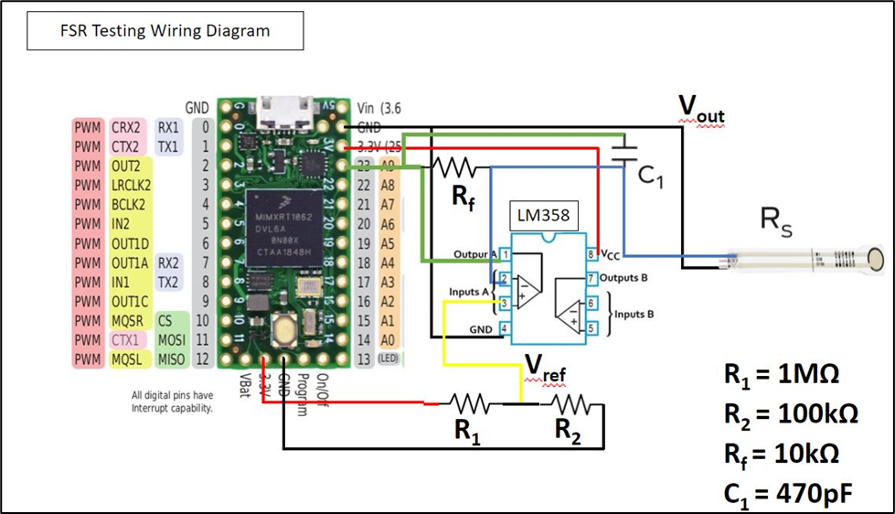

*Figure 5: General FSR Wiring Diagram*

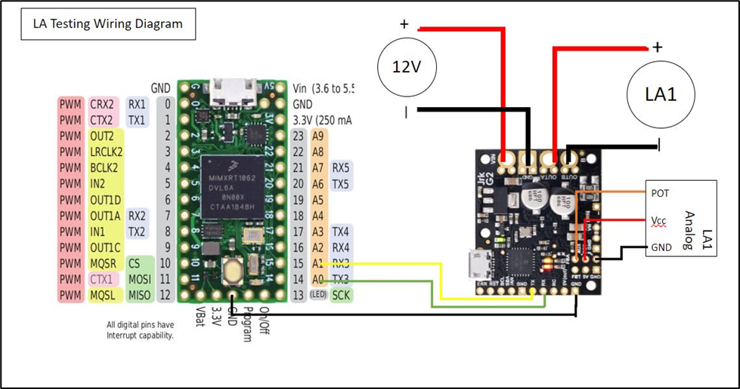

*Figure 6: General Linear Actuator Wiring Diagram*

# Appendix G: Engineering Drawings

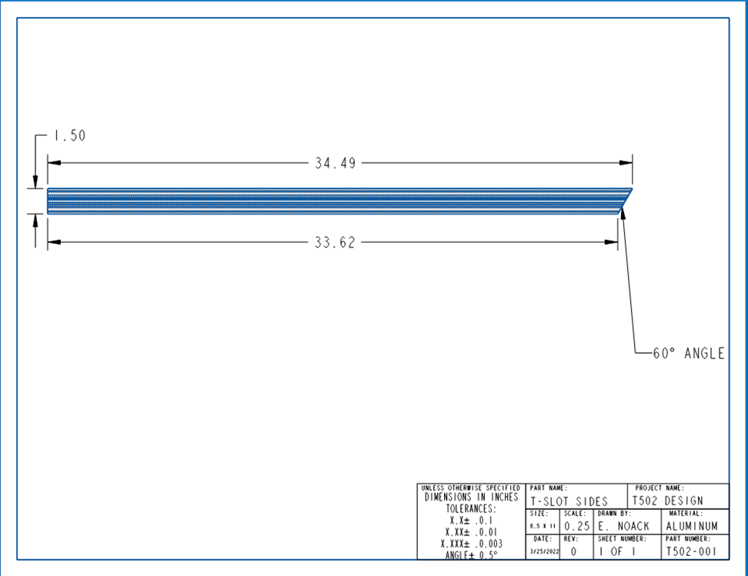

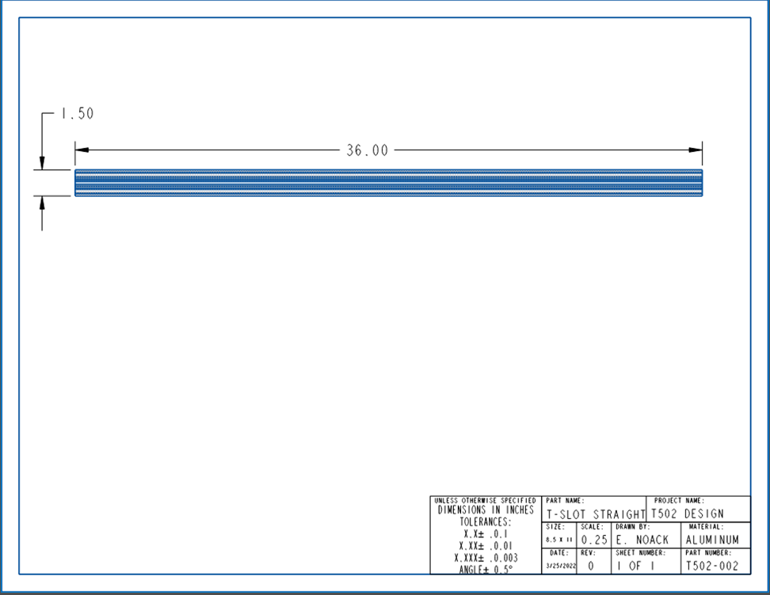

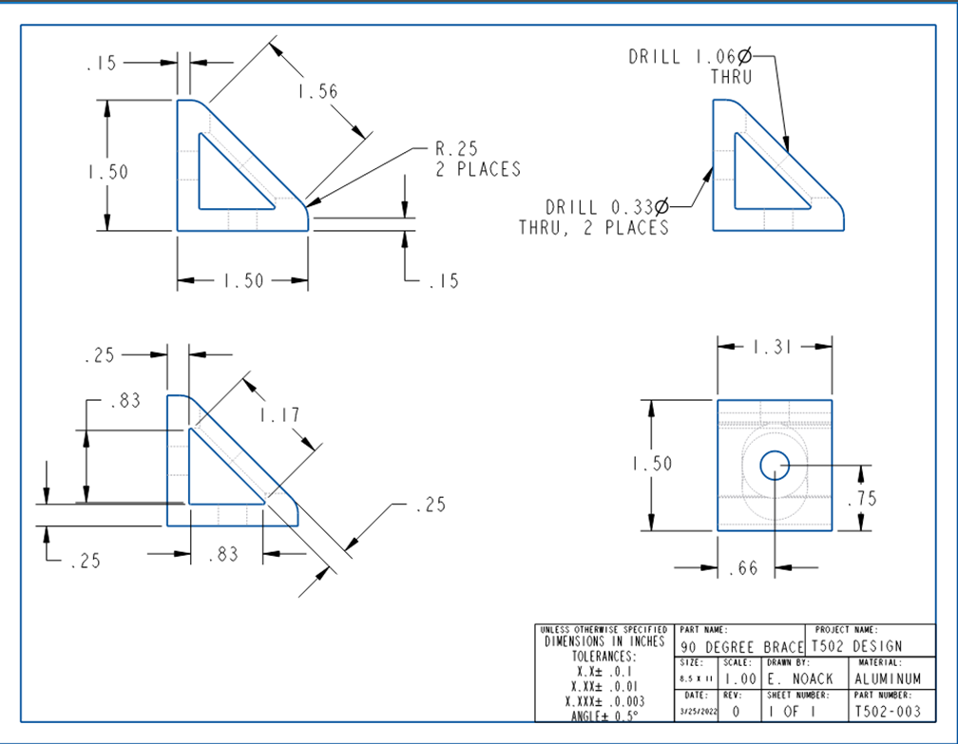

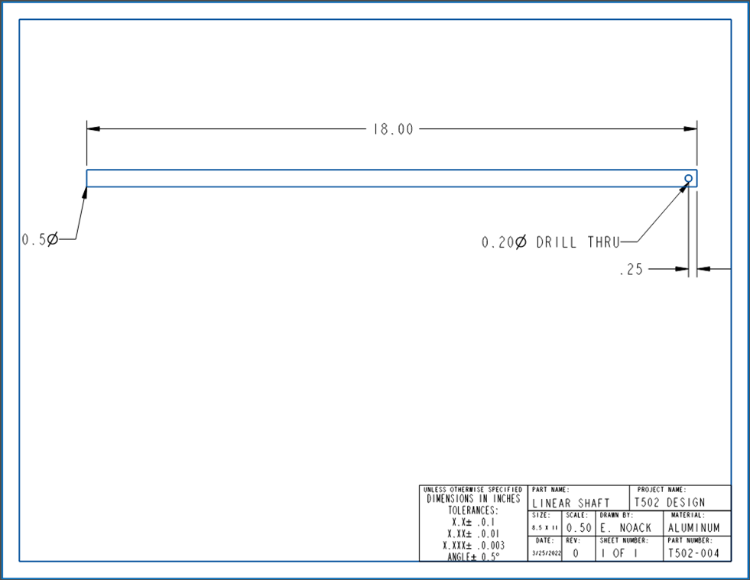

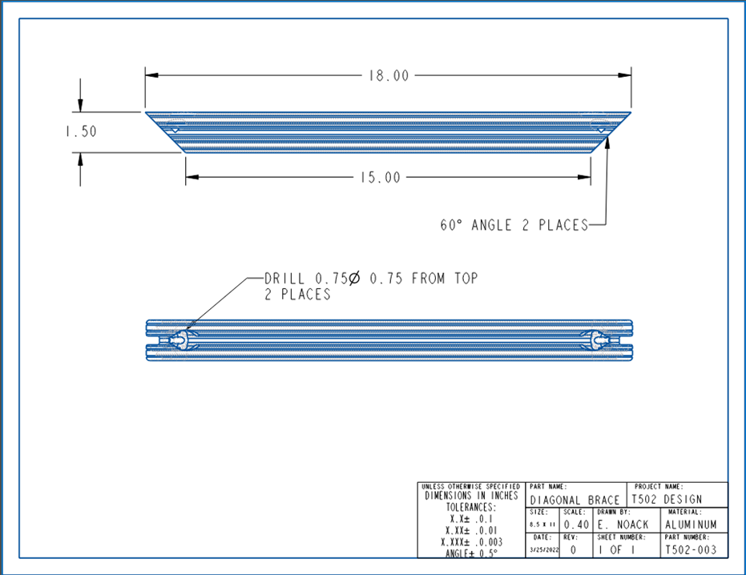

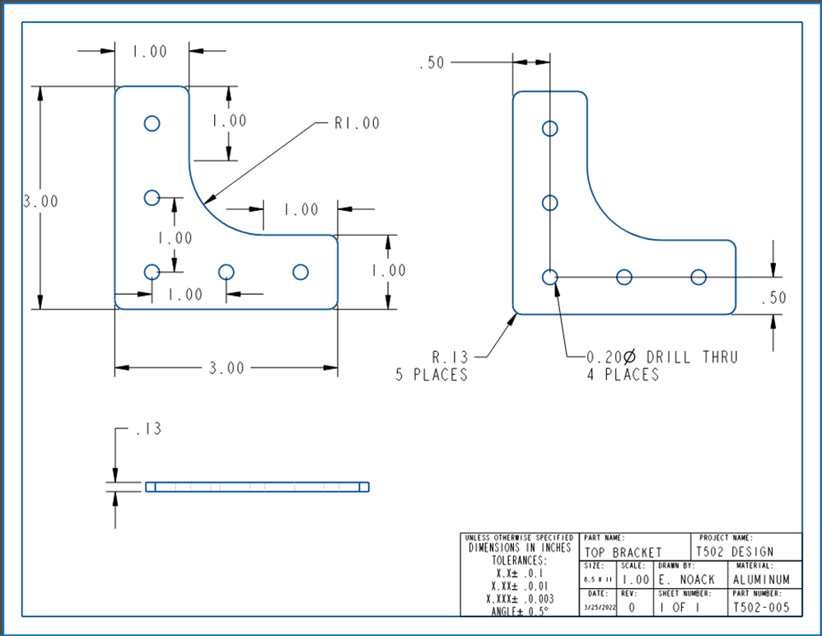

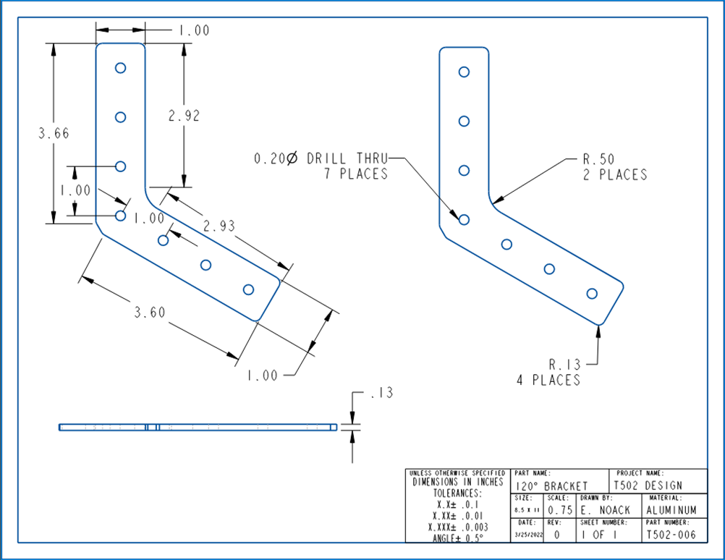

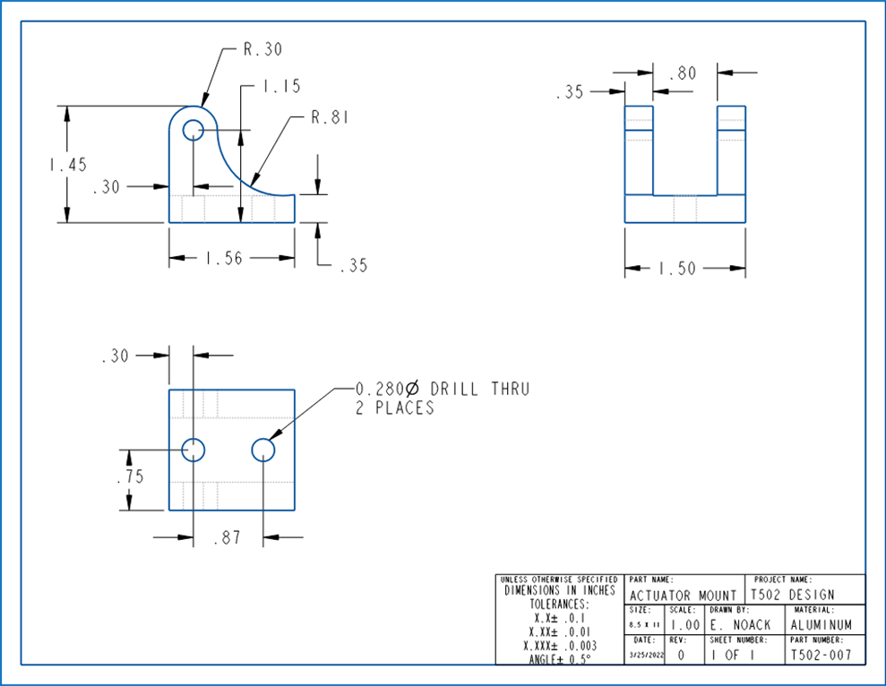

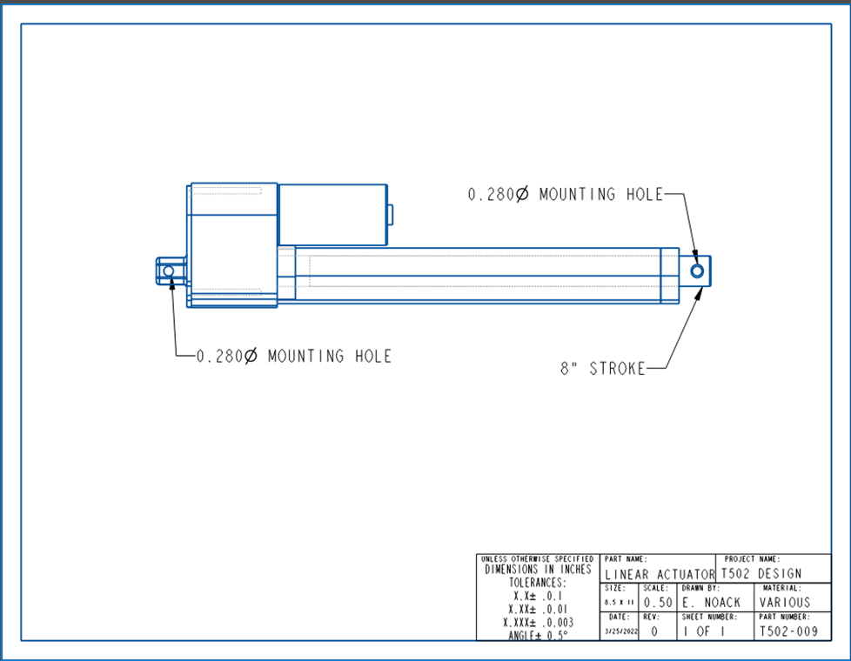

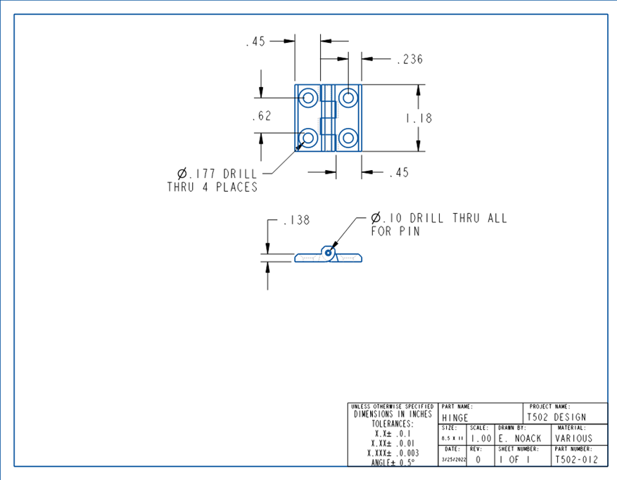

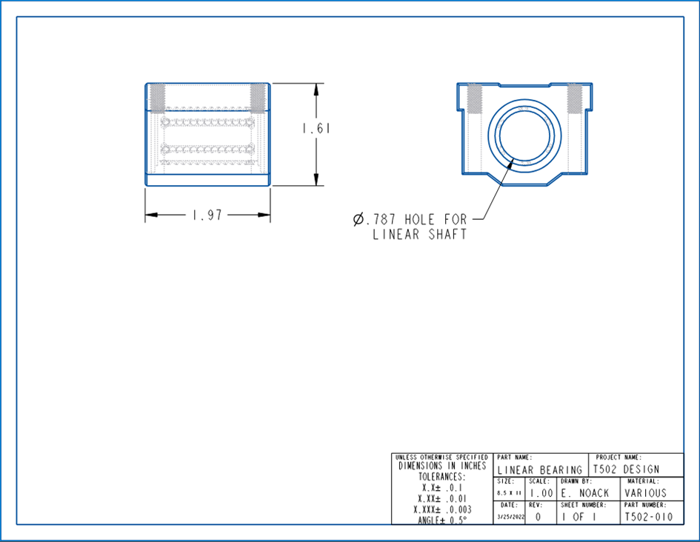

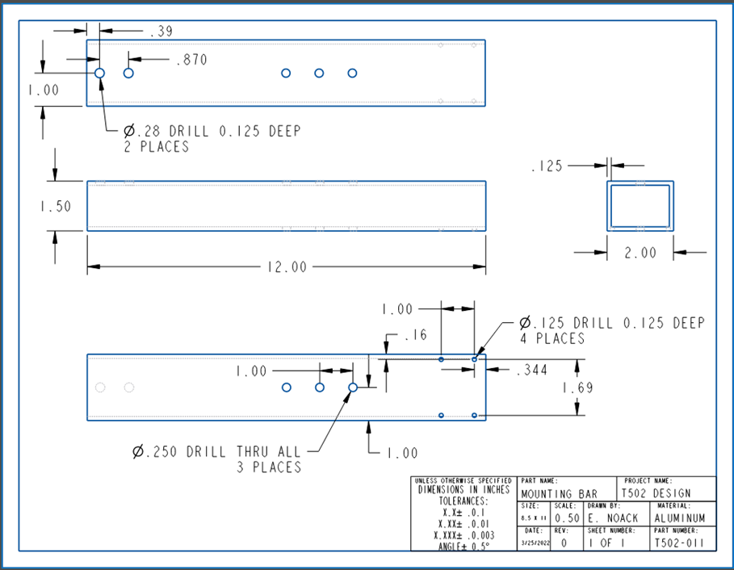

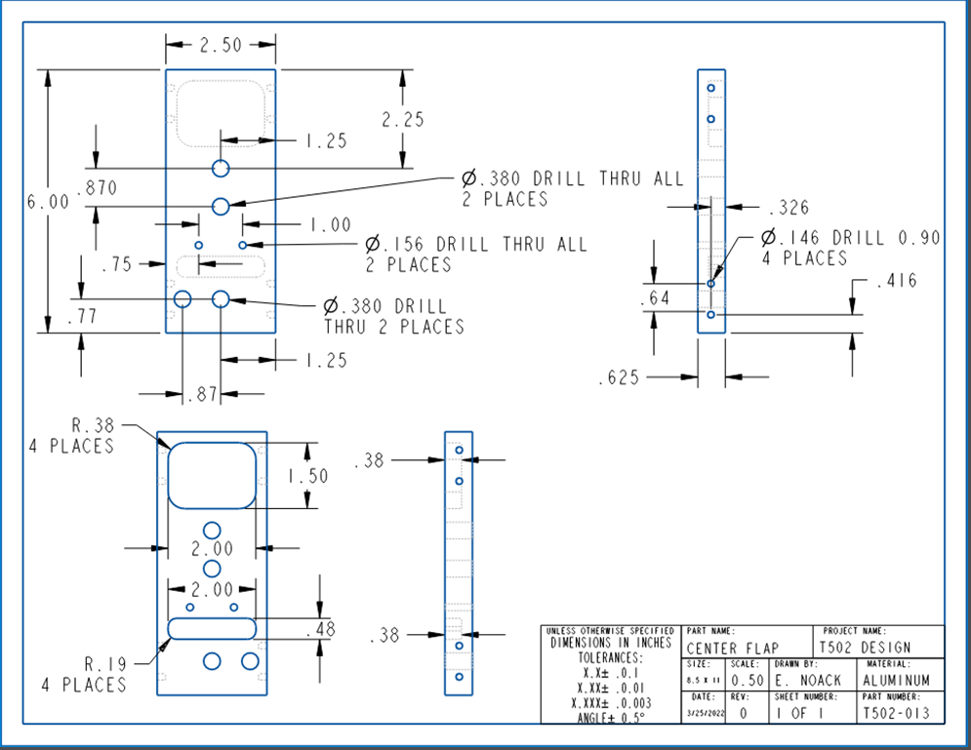

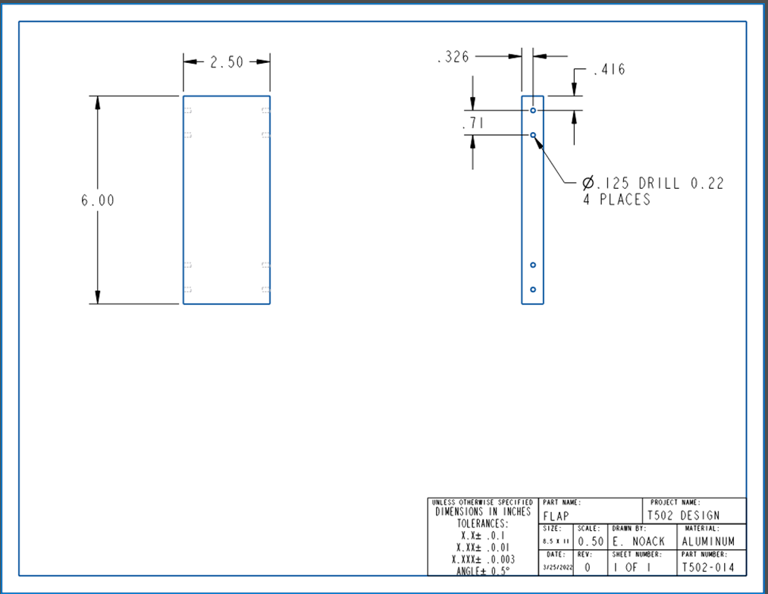

# Appendix H: Calculations

# Appendix I: Risk Assessment

**FAMU-FSU College of Engineering**

**Project Hazard Assessment Policy and Procedures**

**INTRODUCTION**

University laboratories are not without safety hazards. Those circumstances or conditions that might go wrong must be predicted and reasonable control methods must be determined to prevent incident and injury. The FAMU-FSU College of Engineering is committed to achieving and maintaining safety in all levels of work activities.

**PROJECT HAZARD ASSESSMENT POLICY**

Principal investigator (PI)/instructor are responsible and accountable for safety in the research and teaching laboratory. Prior to starting an experiment, laboratory workers must conduct a project hazard assessment (PHA) to identify health, environmental and property hazards and the proper control methods to eliminate, reduce or control those hazards. PI/instructor must review, approve, and sign the written PHA and provide the identified hazard control measures. PI/instructor continually monitor projects to ensure proper controls and safety measures are available, implemented, and followed. PI/instructor are required to reevaluate a project anytime there is a change in scope or scale of a project and at least annually after the initial review.

**PROJECT HAZARD ASSESSMENT PROCEDURES**

It is FAMU-FSU College of Engineering policy to implement followings:

1. Laboratory workers (i.e. graduate students, undergraduate students, postdoctoral, volunteers, etc.) performing a research in FAMU-FSU College of Engineering are required to conduct PHA prior to commencement of an experiment or any project change in order to identify existing or potential hazards and to determine proper measures to control those hazards.
2. PI/instructor must review, approve and sign the written PHA.
3. PI/instructor must ensure all the control methods identified in PHA are available and implemented in the laboratory.
4. In the event laboratory personnel are not following the safety precautions, PI/instructor must take firm actions (e.g. stop the work, set a meeting to discuss potential hazards and consequences, ask personnel to review the safety rules, etc.) to clarify the safety expectations.
5. PI/instructor must document all the incidents/accidents happened in the laboratory along with the PHA document to ensure that PHA is reviewed/modified to prevent reoccurrence. In the event of PHA modification a revision number should be given to the PHA, so project members know the latest PHA revision they should follow.
6. PI/instructor must ensure that those findings in PHA are communicated with other students working in the same laboratory (affected users).
7. PI/instructor must ensure that approved methods and precautions are being followed by:
   1. Performing periodic laboratory visits to prevent the development of unsafe practice.
   2. Quick reviewing of the safety rules and precautions in the laboratory members meetings.
   3. Assigning a safety representative to assist in implementing the expectations.
   4. Etc.
8. A copy of this PHA must be kept in a binder inside the laboratory or PI/instructor’s office (if experiment steps are confidential).

|  |  |  |  |  |
| --- | --- | --- | --- | --- |
| **Project Hazard Assessment Worksheet** | | | | |
| PI/instructor: Shayne McConomy | Phone #: 850-410-6624 | Dept.: Mechanical Engineering | Start Date: 11/19/2021 | Revision number: 1 |
| Project: Team 502 – Material Handling of Ceramics (Sponsored by Corning) | | | Location(s): FAMU FSU College of Engineering (COE) | |
| Team member(s): Makada Browne, Erich Noack, Charles Stubbs, Amelia Veith | | | Phone #: 850-653-5170 | Email: [ces17f@my.fsu.edu](mailto:ces17f@my.fsu.edu) |

|  |  |  |  |  |  |  |  |  |
| --- | --- | --- | --- | --- | --- | --- | --- | --- |
| **Experiment Steps** | **Location** | **Person assigned** | **Identify hazards or potential failure points** | **Control method** | **PPE** | **List proper method of hazardous waste disposal, if any.** | **Residual Risk** | **Specific rules based on the residual risk** |
| Assembly  Including: Fastening, Lifting, Assembling System and Test Fixture | ME Senior Design Lab | Erich Noack | Lifting heavy objects, pinching appendages | Design proper joints for connection, minimize pinch points, no team member lifts heavy objects alone. | Gloves, Safety Glasses, Closed Toed Shoes | N/A | HAZARD:3  CONSEQ:  Minor | Safety controls are planned by both the worker and supervisor. A  second worker must be in place before work can proceed (buddy system). Proceed with supervisor authorization. |
| Residual: Low-Med |
| Part Fabrication  Including: Machining, Touchups, 3d Printing, Drilling, Cutting | ME Senior Design Lab, COE Machine Shop | Makada Browne | Dust, sharp edges | The College of Engineering machine shop professionals will perform most of the wood working and metal working. | Safety Glasses, Closed Toed Shoes | N/A | HAZARD:2  CONSEQ:  Significant | After approval by the PI, a copy must be sent to the Safety Committee.  A written Project Hazard Control is required and must be approved by  the PI before proceeding. A copy must be sent to the Safety Committee.  A second worker must be in place before work can proceed  (buddy system). Limit the number of authorized workers in the hazard  area. |
| Residual:  Medium |
| Circuit Fabrication  Including: Soldering, Connecting, Crimping | ME Senior Design Lab | Amelia Veith | Electrocution, Burn from soldering, shock from wires, toxic fumes | Leadless solder, using a fan during soldering. Design circuit and print with PCB to avoid excessive soldering. | Safety Glasses, Shoes |  | HAZARD:  1  CONSEQ:  Minor | Safety controls are planned by both the worker and supervisor.  Proceed with supervisor authorization. |
| Residual:  Low |
| Detailed Software and CAD Design | Remote | Charles Stubbs | Radiation emission, exposure to Musculoskeletal Disorder risk factors | Using appropriate eyewear can minimize this radiation hazard. Comfortable seating. | Blue Light Glasses, Ergonomic Seating | N/A | HAZARD:  3  CONSEQ:  Negligible | Safety controls are planned by both the worker and supervisor.  Proceed with supervisor authorization. |
| Residual:  Low |
| Test Operation  Including: Startup, Each Test Condition and Shutdown | ME Senior Design Lab, COE Courtyard | Charles Stubbs | Electrocution, shock hazard, collision hazard | Using appropriate eyewear when running tests, not standing too close to the effector during operation. Operation protocol and test procedure must be followed. Test procedure will consider failure points. | Safety Glasses, Closed Toed Shoes | N/A | HAZARD:  3  CONSEQ:  Minor | Safety controls are planned by both the worker and supervisor. Proceed with supervisor authorization. |
| Residual:  Low |
| Teardown  Including: Disassembly, Inspection, Waste Disposal | ME Senior Design Lab | Erich Noack | Heavy lifting hazard, sharp edges | No heavy lifting alone, properly disposes of waste. | Safety Glasses, Closed Toed Shoes | Take to Marpan,  Give ceramic blanks to Dr. Hellstrom | HAZARD:  2  CONSEQ:  Minor | Safety controls are planned by both the worker and supervisor. Proceed with supervisor authorization. |
| Residual:  Low |

**Principal investigator(s)/ instructor PHA:** I have reviewed and approved the PHA worksheet.

|  |  |  |  |  |  |
| --- | --- | --- | --- | --- | --- |
| **Name** | **Signature** | **Date** | **Name** | **Signature** | **Date** |
| __________________________________ | ____________________ | ____________ | __________________________________ | ____________________ | ____________ |

**Team members:** I certify that I have reviewed the PHA worksheet, am aware of the hazards, and will ensure the control measures are followed.

|  |  |  |  |  |  |  |  |  |  |  |  |  |
| --- | --- | --- | --- | --- | --- | --- | --- | --- | --- | --- | --- | --- |
| **Name** | **Signature** | | | **Date** | **Name** | | | **Signature** | | | **Date** | |
|  |  | | |  |  | | |  | | |  | |
| Makada Browne | ____________________ | | | 03/08/2022 | Charles Stubbs | | | ____________________ | | | 03/08/2022 | |
| Erich Noack | ____________________ | | | 03/08/2022 | Amelia Veith | | | _____________________________ | | | 03/08/2022 | |
|  | |  |  | | |  |  | |  |
|  |  | | |  |  | | |  | | |  |

Copy this page if more space is needed.

**DEFINITIONS**:

**Hazard:** Any situation, object, or behavior that exists, or that can potentially cause ill health, injury, loss or property damage e.g. electricity, chemicals, biohazard materials, sharp objects, noise, wet floor, etc. OSHA defines hazards as “*any source of potential damage, harm or adverse health effects on something or someone".* A list of hazard types and examples are provided in appendix A.

**Hazard control:** Hazard control refers to workplace measures to eliminate/minimize adverse health effects, injury, loss, and property damage. Hazard control practices are often categorized into following three groups (priority as listed):

1. **Engineering control:** physical modifications to a process, equipment, or installation of a barrier into a system to minimize worker exposure to a hazard. Examples are ventilation (fume hood, biological safety cabinet), containment (glove box, sealed containers, barriers), substitution/elimination (consider less hazardous alternative materials), process controls (safety valves, gauges, temperature sensor, regulators, alarms, monitors, electrical grounding and bonding), etc.
2. **Administrative control:** changes in work procedures to reduce exposure and mitigate hazards. Examples are reducing scale of process (micro-scale experiments), reducing time of personal exposure to process, providing training on proper techniques, writing safety policies, supervision, requesting experts to perform the task, etc.
3. **Personal protective equipment (PPE):** equipment worn to minimize exposure to hazards. Examples are gloves, safety glasses, goggles, steel toe shoes, earplugs or muffs, hard hats, respirators, vests, full body suits, laboratory coats, etc.

**Team member(s):** Everyone who works on the project (i.e. grads, undergrads, postdocs, etc.). The primary contact must be listed first and provide phone number and email for contact.

**Safety representative:** Each laboratory is encouraged to have a safety representative, preferably a graduate student, in order to facilitate the implementation of the safety expectations in the laboratory. Duties include (but are not limited to):

* Act as a point of contact between the laboratory members and the college safety committee members.
* Ensure laboratory members are following the safety rules.
* Conduct periodic safety inspection of the laboratory.
* Schedule laboratory clean up dates with the laboratory members.
* Request for hazardous waste pick up.

**Residual risk:** Residual Risk Assessment Matrix are used to determine project’s risk level. The hazard assessment matrix (table 1) and the residual risk assessment matrix (table2) are used to identify the residual risk category.

The instructions to use hazard assessment matrix (table 1) are listed below:

1. Define the workers familiarity level to perform the task and the complexity of the task.
2. Find the value associated with familiarity/complexity (1 – 5) and enter value next to: HAZARD on the PHA worksheet.

**Table 1. Hazard assessment matrix.**

|  |  |  |  |  |
| --- | --- | --- | --- | --- |
|  | | **Complexity** | | |
| Simple | Moderate | Difficult |
| **Familiarity Level** | Very Familiar | 1 | 2 | 3 |
| Somewhat Familiar | 2 | 3 | 4 |
| Unfamiliar | 3 | 4 | 5 |

The instructions to use residual risk assessment matrix (table 2) are listed below:

1. Identify the row associated with the familiarity/complexity value (1 – 5).
2. Identify the consequences and enter value next to: CONSEQ on the PHA worksheet. Consequences are determined by defining what would happen in a worst case scenario if controls fail.
   1. Negligible: minor injury resulting in basic first aid treatment that can be provided on site.
   2. Minor: minor injury resulting in advanced first aid treatment administered by a physician.
   3. Moderate: injuries that require treatment above first aid but do not require hospitalization.
   4. Significant: severe injuries requiring hospitalization.
   5. Severe: death or permanent disability.
3. Find the residual risk value associated with assessed hazard/consequences: Low –Low Med – Med– Med High – High.
4. Enter value next to: RESIDUAL on the PHA worksheet.

**Table 2. Residual risk assessment matrix.**

|  |  |  |  |  |  |
| --- | --- | --- | --- | --- | --- |
| **Assessed Hazard Level** | **Consequences** | | | | |
| Negligible | Minor | Moderate | Significant | Severe |
| 5 | Low Med | Medium | Med High | High | High |
| 4 | Low | Low Med | Medium | Med High | High |
| 3 | Low | Low Med | Medium | Med High | Med High |
| 2 | Low | Low Med | Low Med | Medium | Medium |
| 1 | Low | Low | Low Med | Low Med | Medium |

**Specific rules for each category of the residual risk:**

Low:

* Safety controls are planned by both the worker and supervisor.
* Proceed with supervisor authorization.

Low Med:

* Safety controls are planned by both the worker and supervisor.
* A second worker must be in place before work can proceed (buddy system).
* Proceed with supervisor authorization.

Med:

* After approval by the PI, a copy must be sent to the Safety Committee.
* A written Project Hazard Control is required and must be approved by the PI before proceeding. A copy must be sent to the Safety Committee.
* A second worker must be in place before work can proceed (buddy system).
* Limit the number of authorized workers in the hazard area.

Med High:

* After approval by the PI, the Safety Committee and/or EHS must review and approve the completed PHA.
* A written Project Hazard Control is required and must be approved by the PI and the Safety Committee before proceeding.
* Two qualified workers must be in place before work can proceed.
* Limit the number of authorized workers in the hazard area.

High:

* The activity will not be performed. The activity must be redesigned to fall in a lower hazard category.

**Appendix A: Hazard types and examples**

|  |  |
| --- | --- |
| **Types of Hazard** | **Example** |
| Physical hazards | Wet floors, loose electrical cables objects protruding in walkways or doorways |
| Ergonomic hazards | Lifting heavy objects Stretching the body Twisting the body Poor desk seating |
| Psychological hazards | Heights, loud sounds, tunnels, bright lights |
| Environmental hazards | Room temperature, ventilation contaminated air, photocopiers, some office plants acids |
| Hazardous substances | Alkalis solvents |
| Biological hazards | Hepatitis B, new strain influenza |
| Radiation hazards | Electric welding flashes Sunburn |
| Chemical hazards | Effects on central nervous system, lungs, digestive system, circulatory system, skin, reproductive system. Short term (acute) effects such as burns, rashes, irritation, feeling unwell, coma and death.  Long term (chronic) effects such as mutagenic (affects cell structure), carcinogenic (cancer), teratogenic (reproductive effect), dermatitis of the skin, and occupational asthma and lung damage. |
| Noise | High levels of industrial noise will cause irritation in the short term, and industrial deafness in the long term. |
| Temperature | Personal comfort is best between temperatures of 16°C and 30°C, better between 21°C and 26°C.  Working outside these temperature ranges: may lead to becoming chilled, even hypothermia (deep body cooling) in the colder temperatures, and may lead to dehydration, cramps, heat exhaustion, and hyperthermia (heat stroke) in the warmer temperatures. |
| Being struck by | This hazard could be a projectile, moving object or material. The health effect could be lacerations, bruising, breaks, eye injuries, and possibly death. |
| Crushed by | A typical example of this hazard is tractor rollover. Death is usually the result |
| Entangled by | Becoming entangled in machinery. Effects could be crushing, lacerations, bruising, breaks amputation and death. |
| High energy sources | Explosions, high pressure gases, liquids and dusts, fires, electricity and sources such as lasers can all have serious effects on the body, even death. |
| Vibration | Vibration can affect the human body in the hand arm with `white-finger' or Raynaud's Syndrome, and the whole body with motion sickness, giddiness, damage to bones and audits, blood pressure and nervous system problems. |
| Slips, trips and falls | A very common workplace hazard from tripping on floors, falling off structures or down stairs, and slipping on spills. |
| Radiation | Radiation can have serious health effects. Skin cancer, other cancers, sterility, birth deformities, blood changes, skin burns and eye damage are examples. |
| Physical | Excessive effort, poor posture and repetition can all lead to muscular pain, tendon damage and deterioration to bones and related structures |
| Psychological | Stress, anxiety, tiredness, poor concentration, headaches, back pain and heart disease can be the health effects |
| Biological | More common in the health, food and agricultural industries. Effects such as infectious disease, rashes and allergic response. |

**Project Hazard Control- For Projects with Medium and Higher Risks**

|  |  |  |
| --- | --- | --- |
| **Name of Project: Material Handling of Ceramics** | | **Date of submission: 03/11/2022** |
| **Team member** | **Phone number** | **e-mail** |
| **Makada Browne** | **(786) 266 - 2428** | **msb16f@my.fsu.edu** |
| **Erich Noack** | **(813) 545 - 5771** | **ean18f@my.fsu.edu** |
| **Charles Stubbs** | **(850) 653 - 5170** | **ces17f@my.fsu.edu** |
| **Amelia Veith** | **(850) 206 -2282** | **afv17@my.fsu.edu** |
|  |  |  |
| **Faculty mentor** | **Phone number** | **e-mail** |
| **Shayne McConomy** | **(850) 410 - 6624** | **smcconomy@eng.famu.fsu.edu** |
|  |  |  |
| **Fabrication: The parts that compose the system and test fixture must be fabricated prior to assembly. The risks identified include potential electrical hazards, physical hazards, cutting hazards, chemical hazards and ergonomic hazards. The system will be designed to reduce the amount of soldering, cutting and time spent on a computer. There will be required PPE such as eyeglasses and closed toed shoes. Design considerations will be taken to primarily include parts that can be ordered off the shelf and can be produced by professionals.**  **Assembly: While assembling the project, the parts should be laid out and a plan must be followed. The risks identified include lifting heavy objects, pinching appendages, and using a knife to unbox parts. There will be required PPE such as gloves, safety glasses, and closed toed shoes. Multiple people must be involved in the assembly process to reduce risk of injury.**  **Operation: While the project is in operation, the system is designed to ensure everyone is safe. The risks identified include electrocution, shock, and collision. There will be required PPE such as safety glasses and closed toed shoes. All people involved must follow the provided operating procedure and test procedure.**  **Teardown: During teardown, the project must be completly without power. The risks identified include heavy lifting and handling sharp edges. There will be required PPE such as safety glasses and closed toed shoes.** | | |
| **Emergency Protocol:**  **Shut off equipment**  **Call for an ambulance**  **Call for a faculty member from the COE** | | |

|  |  |  |  |  |  |  |  |
| --- | --- | --- | --- | --- | --- | --- | --- |
| **List emergency response contact information:** | | | | | | | |
| * Call 911 for injuries, fires or other emergency situations * Call your department representative to report a facility concern | | | | | | | |
| Name | Phone number | | Team Member | | Faculty or other COE emergency contact | Phone number | |
| **Lyra Browne** | **(786)581-9230** | | **Makada Browne** | | 1. **Dr. Shayne McConomy** | **850-410-6624** | |
| **Demi Noack** | **(813)465-4950** | | **Erich Noack** | | 1. **Beth Gray** | **850-410-6625** | |
| **Chuck Stubbs** | **(850) 545-5975** | | **Charles Stubbs** | | 1. **Donald Hollett** | **850-410-6600** | |
| **Olivia Veith** | **(850) 207-2912** | | **Amelia Veith** | | 1. **Keith Larson** | **850-410-6108** | |
| **Safety review signatures** | | | | | | | |
| Team member | | Date | | Faculty mentor | | | Date |
| **Makada Browne** | | **03/11/2022** | |  | | |  |
| **Erich Noack** | | **03/11/2022** | |  | | |  |
| **Charles Stubbs** | | **03/11/2022** | |  | | |  |
| **Amelia Veith** | | **03/11/2022** | |  | | |  |

**Report all accidents and near misses to the faculty mentor.**