Clayton Cooley, Taylor Jacobs, Zachary Noay, Brenden Richman, Brian Thervil
FAMU-FSU College of Engineering 2525 Pottsdamer St. Tallahassee, FL. 32310

Team 518: Lightweight UAV
3/6/2020

Abstract
As drones become popular in government and civilian use, users want better abilities out of an equal scale aircraft. Government uses include surveillance, aerial defense, and moving goods. Civilian uses include surveying livestock, preserving crops, and hobbyist enjoyment. Because of increased demands, a need for advances of flying drones arose. Decreasing the weight of a drone while keeping the same performance allows companies to increase performance without scaling the craft. These airplanes can have increased flight time and payload size in the future. A lighter plane lessens the demands of individual parts. A lower weight needs smaller lift force to achieve flight and lower thrust to stay in flight. A decrease of lift and thrust allows businesses room to later increase performance or payload. For our project, we are decreasing the weight of the Believer 1960mm. This is a fixed wing drone that represents a scaled down modern plane, such as the Cirrus Vision Jet G2. Newer drones have their weight changed using standard techniques. A common standard technique is to switch to a lighter material. Because companies use these techniques we are using different methods, such as explorative design. To begin the weight decrease, we use Computer Aided Design programs, such as Fusion 360, to model the Believer and its parts. These can use explorative design to remove material from the body without changing strength. Then, we choose electric parts to match the new body of the aircraft. This entails choosing a lighter battery and motors with suitable performance needs. Body and electric items go through these steps again as changing the weight of a plane needs multiple runs for the best result. These methods allow us to decrease the weight of a commercially available drone.

Table of Contents
Abstract ii
List of Tables vi
List of Figures ix
Notation x
Chapter One: EML 4551C 11
1.1 Project Scope 11
1.2 Customer Needs 3
1.3 Functional Decomposition 5
Priorities Reasoning. 8
1.4 Target Summary 9
Mission Critical Targets and Metrics. 11
1.5 Concept Generation 13
Concept 1. 15
Concept 2. 16
Concept 3. 17
Concept 4. 18
Concept 5. 19
Concept 6. 20
Concept 7. 21
Concept 8. 22
1.6 Concept Selection 23
House of Quality. 23
Pugh Charts. 25
Analytical Hierarchy Process. 27
Selected Concept. 31
Appendices 33
Appendix A: Code of Conduct 34
Appendix B: Functional Decomposition 43
Appendix C: Targets and Metrics 44
Appendix D: Concept Generation 46
Morphological Charts 46
Crap Shoot 47
Forced Analogy 49
Appendix E: Concept Selection 51
Pairwise Comparison 51
House of Quality 52
Pugh Charts 53
Analytical Hierarchy Process 54
Empty Weight. 56
Endurance. 58
Wingspan. 60
Length. 61
Payload Weight. 63
Drag Coefficient. 64
Criteria Consistency Check. 66
Final Rating Matrix. 66
Alternative Weight. 67
References 68

List of Tables
Table 1 Customer Responses and Interpreted Needs from Asked Questions 3
Table 2 Major Functions Cross Reference Table 7
Table 3 Major Functions and Subfunctions Cross Reference Table 7
Table 4 Targets and Metrics for UAV Functions 9
Table 5 UAV Morphological Chart for Body Configuration 13
Table 6 UAV Morphological Chart for Hardware Configuration 14
Table 7 Pugh Chart Iteration One Against RQ-11B Raven 26
Table 8 Pugh Chart Iteration Two Against Concept 3 26
Table 9 [C] Matrix for All Selection Criteria 28
Table 10 Normalized [C] Matrix for All Selection Criteria 29
Table 11 Consistency Check for All Criteria 29
Table 12 Checking Consistency and Bias 30
Table 13 Final Rating Matrix 30
Table 14 Concepts Alterative Values 31
Table 15 Complete Targets and Metrics 44
Table 16 UAV Morphological Chart for Body Configuration 46
Table 17 UAV Morphological Chart for Hardware Configuration 46
Table 18 Pairwise Comparison for Customer Needs 51
Table 19 Pugh Chart Iteration One 53
Table 20 Pugh Chart Iteration Two 53
Table 21 [C] Matrix for All Criteria 54
Table 22 Normalized [C] Matrix 55
Table 23 All Criteria Consistency Check 55
Table 24 Consistency and Bias Check 56
Table 25 Empty Weight [C] Matrix 56
Table 26 Normalized Empty Weight [C] 57
Table 27 Consistency Check for Empty Weight 57
Table 28 Endurance [C] Matrix 58
Table 29 Normalized Endurance [C] Matrix 59
Table 30 Consistency Check for Endurance 59
Table 31 Wingspan [C] Matrix 60
Table 32 Normalized Wingspan [C]Matrix 60
Table 33 Wingspan Consistency Check 61
Table 34 Length [C] Matrix 61
Table 35 Normalized Length [C] Matrix 62
Table 36 Length Consistency Check 62
Table 37 Payload Weight [C] Matrix 63
Table 38 Normalized Payload Weight [C] Matrix 63
Table 39 Payload Weight Consistency Check 64
Table 40 Drag Coefficient [C] Matrix 64
Table 41 Normalized Drag Coefficient [C] Matrix 65
Table 42 Payload Weight Consistency Check 65
Table 43 Consistency and Bias Check for All Individual Criteria 66
Table 44 Final Rating Matrix 66
Table 45 Alternative Weights of Concepts 67

List of Figures
Figure 1. Functional decomposition of the drone systems. 6
Figure 2. Concept paths from body configuration morphological chart. 15
Figure 3. High wing, elongated fuselage, with inboard payload. 16
Figure 4. High wing, elongated fuselage, protruding payload. 17
Figure 5. High wing, elongated fuselage, protruding payload. 18
Figure 6. Mid wing, elongated fuselage, protruding camera. 19
Figure 7. Mid wing, underwing fuselage, inboard payload. 20
Figure 8. Mid wing, underwing fuselage, protruding payload. 21
Figure 9. High wing, underwing fuselage, inboard payload. 22
Figure 10. High wing, underwing fuselage, protruding payload. 22
Figure 11. House of quality with highlighted top engineering characteristics. 24
Figure 12. Functional decomposition of necessary drone actions. 43
Figure 13. House of Quality 52

Notation

UAV | Unmanned Aerial Vehicle
EO | Electro-Optical
IR | Infra-Red
M2-D | Micro gyro stabilized gimbal system
RQ-11B | Model of reference drone from AeroVironment
FLIR | Forward Looking Infrared Radar
UART | Universal Asynchronous Receiver-Transmitter
Empennage | Stability configuration of aircraft tail

Chapter One: EML 4551C

Project Scope
Project Description.

The objective of this project is to reduce the weight of a commercially available UAV through light weighting processes.
Key Goals.
The key goals are aspects of the project that we aim to accomplish with the end product. We have set the key goals to be:
- Maintain Performance characteristics of the UAV
- Decrease the weight of UAV
- Use more than one light-weighting techniques

Markets.
The markets for a project are the industries where the product is viable for use. There are generally two types of markets considered for projects, primary and secondary. The primary market is what the product is designed for, where the secondary market consists of other possible uses or interests for the product. For our project the primary market is identified as U.S. Government and military personnel. The secondary market is farmers, small companies, and enthusiasts.

Assumptions.
Our assumptions for this project are boundaries that must be set to complete this project by the set timeline of the school year. For our project we have the following assumptions:
- Used at Earth’s atmospheric pressure and air composition
- Used in open areas for flight

- Maximum flight time will be 1 hour or less
- UAV will comply to Category 1 specifications
- UAV will be user-controlled
A category 1 UAV is defined by the maximum take-off gross weight of 0-20 lbs, the normal operating altitude of less than 1200 ft above ground level, and the airspeed operation of less than 100 knots.
Stakeholders.
Stakeholders are parties considered to be invested, interested, or have control in the outcome of the project. For this project the stakeholders are:
- Northrop Grumman
- Dr. Shayne McConomy
- Dr. Rajan Kumar
- Dr. Jerris Hooker
- Dr. Camilo Ordonez
- Attendees of the Commercial UAV Expo

1.2 Customer Needs
The customer needs are interpreted statements that set product function, attributes, and requirements that the customer would like but have not necessarily been provided to the engineering team. The customer needs are obtained by asking the product sponsor questions relating to the general objective of the project. Table 1 below consists of the questions Team 518 asked the Northrop Grumman team during our initial meeting. The interpreted customer needs have been declared in the table beside the customer response.
Table 1
Customer Responses and Interpreted Needs from Asked Questions

Question Customer Response Interpreted Customer Need

Is the purpose of this lightweight drone to fly for longer periods, carry items for transport, have increased velocity, etc.? |  | The success will be judged by weight reduction to reference drone. |  | The drone’s gross weight is lighter than a specified reference drone
Is the team provided a drone to utilize for this project or should one be designed and constructed? |  | The senior design team has control over this, but they have access to construction resources. |  | The drone chassis/body is constructed and hardware components purchased.
Should the drone be able to withstand wet weather conditions, such as rain or mist from water? Is weatherproofing a vital aspect of this project? |  | The drone should be able to withstand weather conditions related to where the senior design team thinks it will be used. |  | The drone withstands standard/common flight weather conditions.
What is the desired flight time of the drone under its full capacity, e.g. full velocity, full load, etc. depending on purpose? |  | The design team has full control of flight time and payload. |  | Drone flight time is same or greater than reference drone.
What are the legal regulations for this project that we must abide by? FAA, U.S. DOT, other countries regulations, etc.? |  | The drone should follow any and all required government regulations. |  | The drone meets Federal Aviation Administration (FAA) and U.S. Department of Transportation (U.S. DOT) requirements.
Should the drone be constructed of 3D printed material or is that a secondary goal to being lightweight? |  | The team has access to the CAD software and 3D printing materials. |  | Drone chassis/parts are constructed of 3D printed materials.
What is the expected size of the drone in reference to current drones on the market? |  | The design team has full control over the reference and product specifications |  | The drone is smaller than double of the reference drone.
What are the desired flight climates for the lightweight UAV? |  | Drone should be comparable to current drones but will not be physically used by Northrop Grumman. |  | Drone operates in U.S. climate conditions.
What are the expected operation circumstances of this UAV, should it be autonomous or user controlled? |  | The team’s timeline does not account for autonomous control and user controlled is a better option. |  | The drone is user controlled.

From the gather customer needs the basis for our project was developed. Our project is aimed at constructing a lightweight drone out of 3D printed material, that can operate in local weather conditions, while abiding by all government regulations.

1.3 Functional Decomposition
A functional decomposition provides a simplified breakdown of a complex system into its action characteristics. In order to gain a better understanding, a functional decomposition was created for the Lightweight UAV. The customer requirements given by Northrop Grumman, were to identify ways of creating a lighter UAV and increase flight time. With this information the functional decomposition in Figure 1 was constructed.

Figure 1. Functional decomposition of the drone systems.

The fixed wing UAV can be broken down into 4 main subsystems (communication, flight, surveillance, and support). The communication system consists of all functions that are needed for the user to effectively control the UAV. The flight system incorporates functions that are needed for the UAV to takeoff and maintain course while in the air. The Surveillance system includes all functions needed for the drone to be able to properly record and take pictures while in the air. The support system encompasses any functions that are needed to provide stability and rigidity for the UAV while it’s in the air and allow proper mounting of hardware. The relationships between each main function is laid out in Table 2. These systems must be incorporated into the final design of the UAV so that it can fly and surveil properly. Once conceptual design has begun, the functions will be broken down into more specific actions.
Table 2
Major Functions Cross Reference Table

Function: Communication Flight Surveillance Support
Communication X X X
Flight X X X
Surveillance X X
Support X X X

The subfunctions of the main functions have an impact on other main functions of the system. To understand how these subfunctions can cross over to other areas the relationship between each subfunction and main function was identified in Table 3.
Table 3
Major Functions and Subfunctions Cross Reference Table
Subfunction: Communication Flight Surveillance Support

Send Commands X X X
Receive Data X X X
Accelerate X X
Decelerate X X
Adjust Roll, Pitch, Yaw X X
Power Payload X X
Record Data X
Orient Payload X X X
Generates Lift X X
Houses Hardware X
Couples payload X X

Priorities Reasoning.
Communication – Drone needs to able to communicate with user. This will allow for control of operations from user, while sending data to help user better under flight operations.
Flight – The reason it comes in second for priority is that the drone needs the first two priority in order to operate. The drone increased flight time is accomplished by reduction of weight and implementing components with lower power modes.
Surveillance – This comes in third, as this function was defined by Team 518. This function allows for a user to identify objects while the drone is in the air.
Support – This comes in fourth as this project mainly focuses on the design aspect of the drone. The drone needs to be able to fly and to navigate through the air. Allowing the user to adjust the speed and direction of the drone.
The priority ranking of the systems will impact how we delegate our time. Since communication is at the top of the priority list, we will be sure to focus on it and make sure the drone is able to communicate with the user properly. Since its functions are to send commands and receive data, one of our project objectives will be make sure we include a good transmitter and receiver in the design.

1.4 Target Summary
There are necessary goals to be set for a product’s functions in order to define how the functions will be evaluated. These necessary goals consist of the targets and metrics that are based upon the action items from the functional decomposition. The targets are the specific values that are used to design the product around. These would consist of exact measurements such as the length of a part, or the weight of the product. The metrics are how the function of the product is going to be achieved and determined a success. This would consist of an explanation of the function, an example being, for the Accelerate function to be achieved there would need to be an increase in thrust. The targets and metrics for our functions of the lightweight UAV are displayed in Table 4 with the critical targets and metrics shown with an asterisk.
Table 4
Targets and Metrics for UAV Functions
Function | Metric | Target
Send Commands | Range | 10 kilometers
Receive Data | Range | 10 kilometers
Accelerate | Thrust source increases | Thrust source > 50%
Decelerate | Thrust source decreases | Thrust source < 50%
Adjust Roll, Pitch, Yaw | Articulate ailerons, elevators, and rudders | -45°<=Ailerons <=45°  -45°<=Elevators<=45°  -45°<=Rudder <= 45°
Power Payload | Delivers power to payload and components | Voltage > 2.0 V
Record Data | Video Quality | Resolution >=480p
Orient Payload | Ruler | 360 degrees
Generate Lift | Airfoil produces greater lift force than gross weight | *Lift >=18.68 Newtons
House Hardware | Volume | <=0.30 m³
*Couple Payload | Payload attaches to drone | *>=160 g  *<=200 g
*Endure | Time while airborne | *>=60 minutes
Carry by Backpack | Stored Drone Dimensions | Stored Width <= 0.762 m  Stored Length <=0.508 m
 | Stored Drone Dimensions | >=30 km/hour
 | Cruising Speed of UAV | Hand Take off
 | Take off procedure | >=152.4 m
 | Cruising altitude | *<=1.905 kg

The targets are that we have used are based off the AeroVironment RQ-11B Raven. The RQ-11B Raven is a current military surveillance drone that is considered a group 1 UAV (U.S. Army Unmanned Aircraft Systems Roadmap 2010-2035). The Accelerate and Decelerate targets are based off the recommended thrust to weight ratio of 1.0 to generate vertical acceleration, however we aim to increase the ratio to at least 2.0 so that the aircraft can hover at half throttle for improved endurance (Hall, 2015). The drone will need to be transported via backpack, so the final stored transport dimensions of the drone are limited to the size of a standard doorway. The standard width of a doorway being 32 inches, this will allow for the end user to not be limited while carrying the UAV (Americans with Disabilities Act (ADA) Standards, 2010). The other targets are taken from the data sheet of the RQ-11B Raven directly from its manufacturer AeroVironment (UAS: RQ-11B Raven).
To be able to successfully validate the design of the UAV, various resources are needed. The biggest resource required to validate the design of the UAV is a wind tunnel or open airfield to allow extended flights.

Mission Critical Targets and Metrics.
Generating lift is a critical aspect of an aircraft, without lift an aircraft is just a ground vehicle. The target for lift was achieved by basing the aircraft mass of the RQ-11B and converting it to weight. The lift force generated then must be equal to the weight to hover, or greater than to increase altitude. To test this target, the weight of our drone, along with its airfoil profile, and estimated velocity will be used to calculate the lift force. Once initial testing is finished the UAV can be tested in a wind tunnel to confirm results.
The coupled payload function corresponds to the characteristics of the payload. The metric defined as the payload’s mass is the primary characteristic of the payload the team will be looking at. The target of greater than 160 grams was based on the M2-D Stabilized EO-IR FLIR UAV Drone unmanned thermal Camera Gimbal. This camera and gimbal fulfill the team’s expectations of camera imaging and stabilization. Its weight is 160 grams. The designed UAV should be able to take off with the camera attached. The camera will be represented using a 3-D printed shell of the same dimensions as the camera. The print will also be hollow. This will allow mass to be added to the print in order to replicate and test any payload mass the team desires. The mass of the payload will be tested using a scale in which the payload will be weighed. The target of less than 200 grams was determined by the team in order to keep the gross weight of the UAV down. This was to optimize flight time.
The target for this drone is to have increased endurance. This is done by increasing the flight time while airborne to be greater than or equal to 60 minutes. The team arrived at this target and metric by discussing some of the customer needs and our expectations of the UAV when compared to the RQ-11B Raven’s flight time. One of the customer needs that match this target is to have surveillance, allowing for 60 minutes or greater would allow the user to gather enough data of the surrounding environment. The way that this target will be met is by researching into different components and weight factors that will lead to power savings. This target will then be validated by performing time tests while the UAV and its components are operational. As the UAV flies, a stopwatch will be used to determine the flight time of the UAV. The stopwatch will be started when the UAV leaves the hand of the operator and will be stopped when the UAV ceases to fly. If the recorded time is greater than or equal to 60 minutes, the team’s target will be met. If this target is not met, adjustments to the drone will be made in order to increase this time.
The total weight of the UAV, including payload, is termed the gross weight. This target is critical to the success of this project as our objective is to develop a lightweight UAV. We must develop a UAV that has less mass than the RQ-11B for our project to be considered lightweight. We will test this target by weighing the drone with all components to get a final gross weight value and compare it to the mass of the RQ-11B.

1.5 Concept Generation
Concept generation allows for the team to produce as many possible designs that support the purpose of the project. The concept generation process that we used for this project consisted of morphological charts and a crap shoot. A morphological chart takes different aspects of a product and produces all possible combinations, resulting in many concepts. However, the concepts generally are quite similar and selecting the best ones can be time consuming. So, we broke the morphological process down into two separate parts, the physical design of the UAVs body and the combination of hardware. This reduced the number of concepts but increased the significance allowing for the best concepts to surface. The hardware configuration matrix was created, but not fully evaluated for concepts as there is lots of information, data, and risk factors that must be addressed. And for the sake of our project, determining a body configuration at this stage is paramount to the specific hardware methods. Our morphological charts are shown in tables 5 and 6 below.
Table 5
UAV Morphological Chart for Body Configuration
Wing Location | Empennage | Fuselage | Payload Location
Low Wing | T Tail | Elongated | Outboard of fuselage
Mid Wing | H Tail | Underwing | Inboard of fuselage
High Wing | V Tail |  | Protruding from fuselage
 | Fuselage Mount

Table 6
UAV Morphological Chart for Hardware Configuration
Thrust Motors | Battery Types | Transmitter | Software
Induction | Lithium | Radio Frequency | C++
Brushless | Aluminum-ion | Bluetooth | C
Combustion | Lead-acid | Wi-fi | Java
DC Shunt | Zinc Ion Battery | Satellite | Python
Series | Solar
Compound

The morphological process provided plenty of ideas for us to continue with the project, however limiting ourselves to such a structured method could limit our design. Thus, we also used the crap shoot to allow the teams creativity and knowledge to produce concepts that contain far-fetched and imaginative characteristics. The crap shoot consisted of team members producing thoughts and writing them in a list, which is in Appendix D. Another method used was forced analogy. This method consists of team members thinking of two different words. These words are then forced together and used to find a conceptual solution to the problem. This method generally leads to very creative yet unrealistic concepts that will likely not be used but hold some aspects of usefulness, like those created using the crap shoot method. The concepts from the forced analogy are in Appendix D. Figure # shows the combinations for the 8 selected concepts, where the solid lines follow combinations of high fidelity concepts and dotted lines follow medium fidelity concepts.

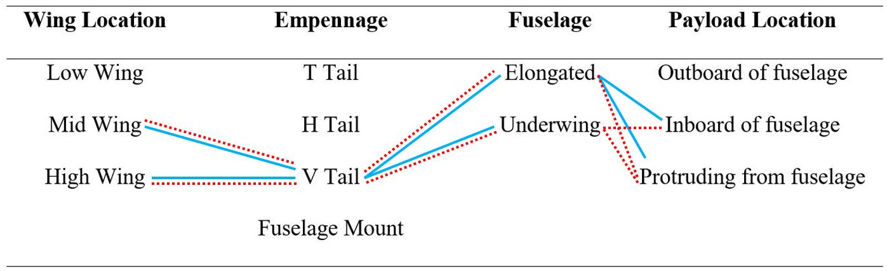
Figure 2. Concept paths from body configuration morphological chart.
The concepts listed below are the resulting high and medium fidelity concepts from the generation process, where concepts 1 through 3 are high fidelity and 4 through 8 are medium fidelity.

Concept 1.
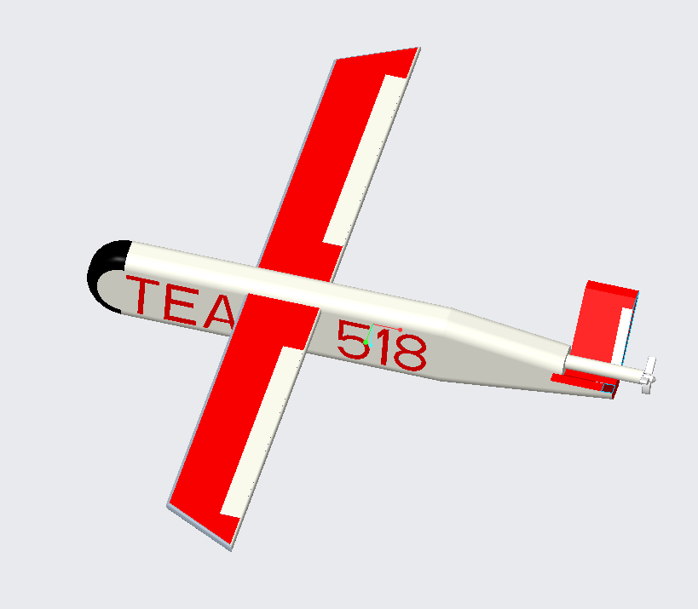
This concept consists of a high wing design centered over an elongated fuselage with the payload completely inside and a V configured empennage. The high wing design has the benefits of increased stability during flight. With the center of gravity of the UAV being below the wing a greater moment will result assisting in keeping the UAV upright during flight. The elongated fuselage will help to reduce the drag produced by the body. Making the design more streamline will allow air to smoothly flow around the body without any abrupt direction changes and reduce resulting force, especially at the front of the fuselage. Moving the payload to inside of the fuselage will keep it from influencing aerodynamics, however a clear portion of the body must be added to allow for visibility. Due to the application, the payload will only need to look below the horizontal plane, and pan about 135 degrees either direction from its heading. This viewing range makes the implementation of the clear body panel much easier to integrate. The V shaped empennage reduces a bit of weight on its own as its attached directly to the fuselage. Drag forces and radar recognition are also reduced due to the angle and shape of the tail fins, making it an ideal configuration for the surveillance application.
High wing
Elongated Fuselage
Inboard Payload
V Tail
Figure 3. High wing, elongated fuselage, with inboard payload.

Concept 2.
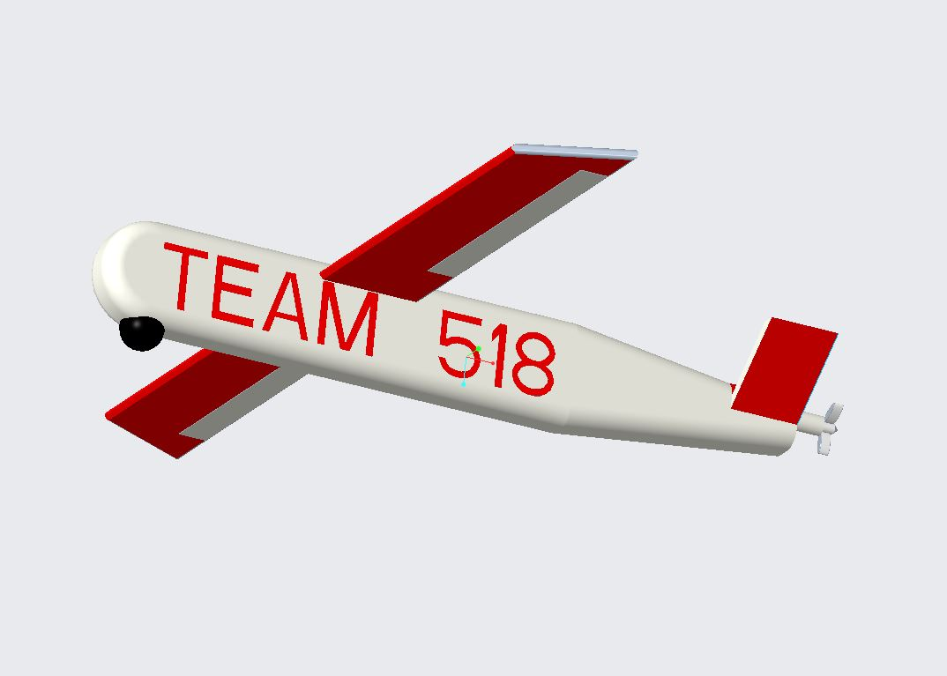
The configuration of this UAV concept is very similar to concept 1. above, but the payload is now located in a protruding position within the fuselage. The payload is placed about halfway inside the fuselage, with only the camera portion of the payload located outside. By placing the payload in such a location, the limitation of viewing can either be completely resolved or the need to develop an additional clear window is removed. By removing the clear window additional weight savings are gained, further reducing the required lift force for flight. The aerodynamic forces are influenced by the protruding camera, but this combination with the elongated fuselage will keep drag to a minimum and surveillance capabilities high.
High wing
Protruding Payload
Elongated Fuselage
V Tail
Figure 4. High wing, elongated fuselage, protruding payload.

Concept 3.
A mid wing configuration reduces the stability of the UAV slightly due to its location being closer to the center of gravity. However, attaching the wings to the fuselage allows for a section of wing that would be above the fuselage to be removed, reducing weight. Combining this weight reduction with the reduced drag from the elongated fuselage shape and V empennage configuration reduces the required lift force and velocity need for the UAV to maintain flight. This weight and force reduction allow for another cycle of the light-weighting process by reducing the motor until optimal parameters of lift are achieved.

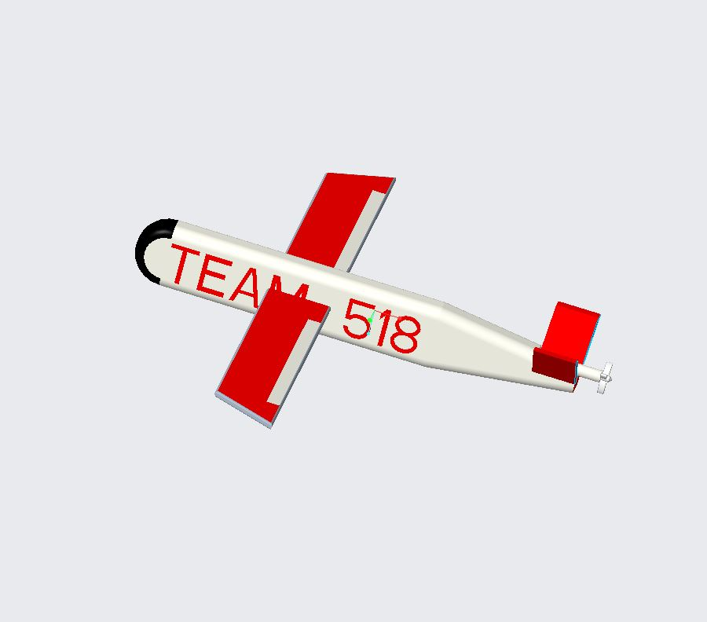
Mid Wing
Inboard Payload
Elongated
Fuselage
V Tail
Figure 5. High wing, elongated fuselage, protruding payload.

Concept 4.
Utilizing a mid-wing configuration with an elongated fuselage and V tail empennage results in weight and drag reduction. The protruding payload will add small amounts of drag force but reduce weight by not requiring a window to be developed. This allows for increased surveillance visibility as the camera is not obstructed or as limited in its viewing range.

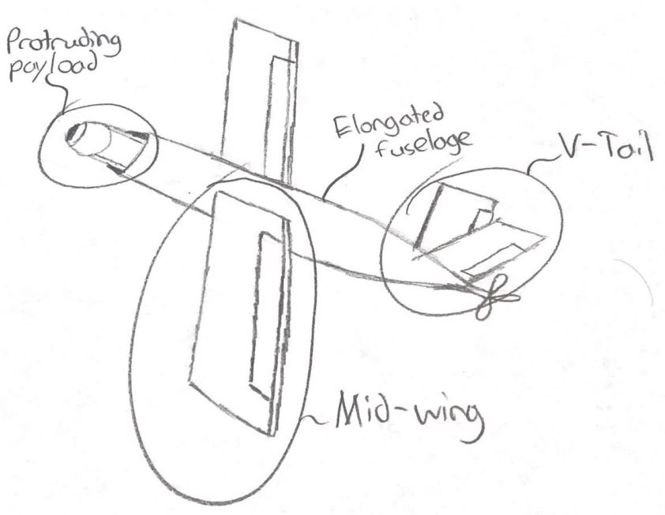
Figure 6. Mid wing, elongated fuselage, protruding camera.

Concept 5.
The underwing fuselage has increased drag properties as the components must be located within a tighter space. The center of gravity will be lower, increasing the stability of the UAV in flight however, the cross-sectional area of the fuselage will be larger to accompany the payload being located inside. This poses the problem of increased drag and decreased visibility, but improved stability and reduced weight from removing the middle wing section.

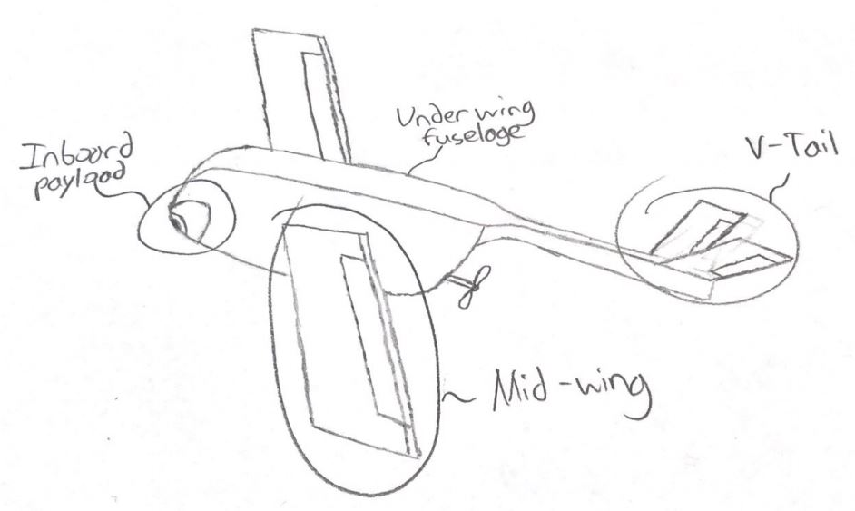
Figure 7. Mid wing, underwing fuselage, inboard payload.

Concept 6.
Having the payload of the UAV located in a protruding location so that only the camera is outside of the fuselage. This will increase the visibility of the payload while introducing small amounts of drag. The combination of the protruding payload and underwing fuselage makes the drone better for surveillance but reduces its possibilities for efficiency.

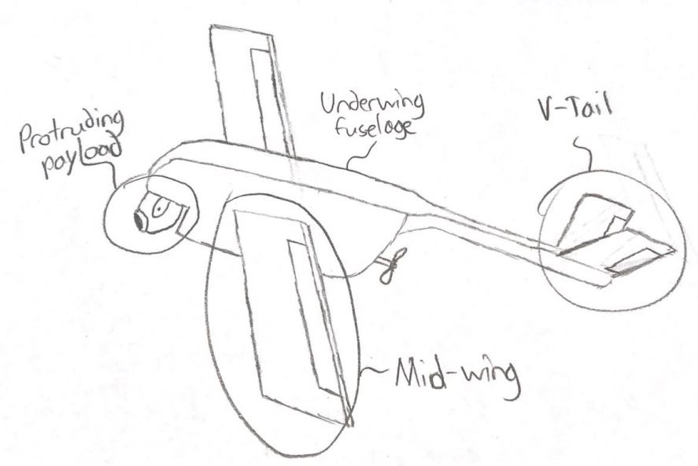
Figure 8. Mid wing, underwing fuselage, protruding payload.

Concept 7.
With the high wing design and underwing fuselage that has a lower center of gravity this design is very stable in flight. The inboard payload keeps drag to a minimum for the fuselage design but requires it to be larger to encompass the camera. There can also be the increased weight due to a window required to allow for payload visibility. Thus, drag is kept at a minimum but surveillance capabilities and efficiency are hindered.

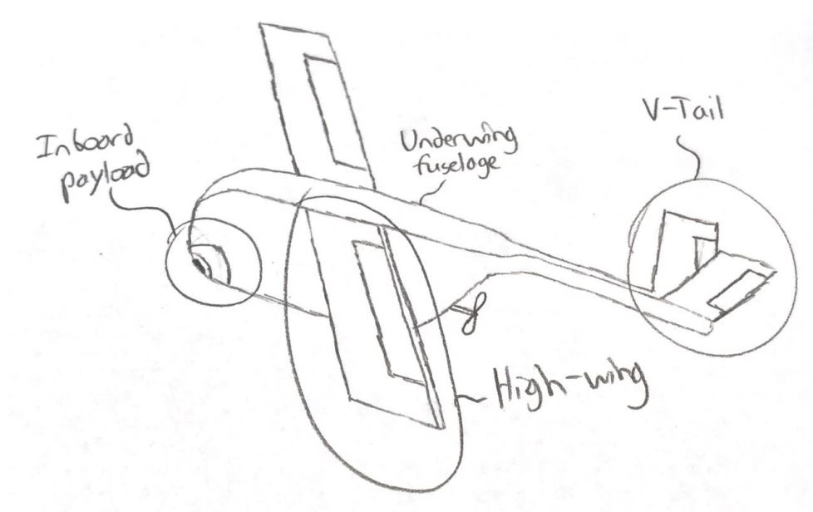
Figure 9. High wing, underwing fuselage, inboard payload.

Concept 8.
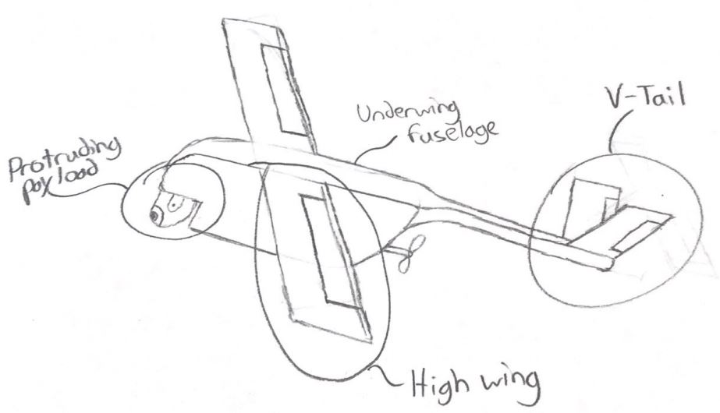
The combination of the underwing fuselage and a protruding payload combine to produce the highest drag force out of the fidelity concepts. Also, with the high wing design some weight can be added as another section of wing may be required. However, the design is extremely stable in flight with visibility for surveillance and only having the reduction in efficiency.
Figure 10. High wing, underwing fuselage, protruding payload.

1.6 Concept Selection
The concept selection process consists of the implementation of multiple concept selection methods to determine the best concept for the project. The major methods that were performed during our selection process were the house of quality, Pugh charts, and analytical hierarchy techniques. Each process takes in the top concepts and makes a comparison to determine how the concept achieves the goals of the project. These processes provide us with data about each concept, making the selection process much easier to comprehend and the differences between concepts easier to understand.

House of Quality.
The house of quality is a weighted matrix that utilizes the customer needs and correlates them to engineering characteristics that can be measured for each concept. The goal of the house of quality is to select the vital engineering characteristics that correlate to the projects purpose and compare the top concepts against them. This is a crucial step in the concept selection process as the selected characteristics are used for both the Pugh charts and the analytical hierarchy Process. Our house of quality for our concept selection is shown in Figure 11.

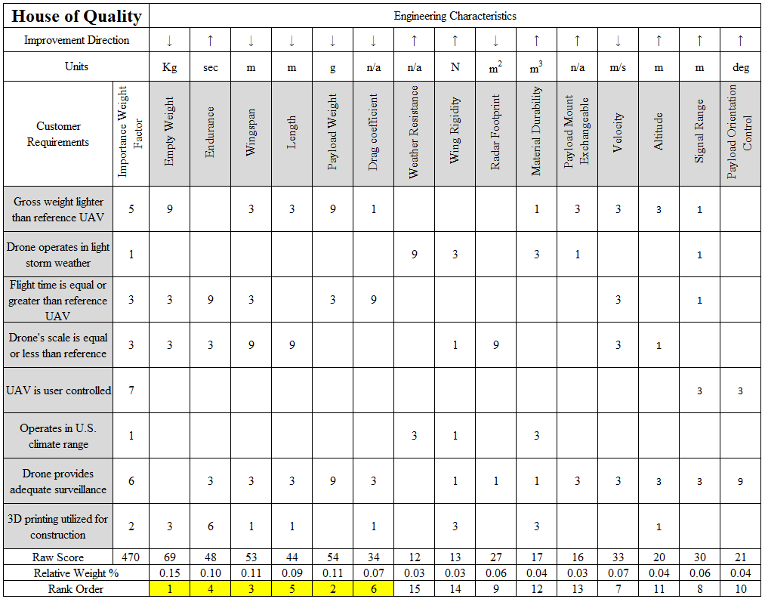
Figure 11. House of quality with highlighted top engineering characteristics.
Our house of quality consisted of 15 engineering characteristics in total and from the weighted comparison we chose the top 6 characteristics. These characteristics embody the main goals of our project, those being weight, size, and flight endurance. Specifically, the top engineering characteristics were empty weight, payload weight, wingspan, endurance, length, and drag coefficient.

Pugh Charts.
The Pugh chart is a comparison of the top concepts to the project datum by evaluating the 6 selected engineering characteristics from the house of quality. The initial datum is a current product that achieves a large part of project’s purpose. The concepts are compared to the datum individually, looking at each selection criteria as a characteristic of the design. The Pugh chart process is then repeated utilizing one of the well-rounded concepts as the new datum. This process helps to narrow down the top concepts, but more importantly it allows for the generated concepts to be weighed against a current market item to ensure the projects purpose will be fulfilled. The first iteration of the Pugh Chart, found in table 7, used the Raven RQ-11B as its Datum. The concepts in the table 7 were then compared to the Raven using the selection criteria. The second Pugh chart iteration using concept 3 as the datum is in table 8. For simplicity the concepts are described using abbreviations under their number, where HW refers to high wing, MW refers to mid wing, VT refers to v tail empennage, EF refers to elongated fuselage, UW refers to underwing fuselage, IP refers to inboard payload, and PP refers to protruding payload.

Table 7
Pugh Chart Iteration One Against RQ-11B Raven
Selection Criteria | Datum |  | Concepts
 | RQ-11B Raven |  | 1  HW-VT-EF-IP | 2  HW-VT-EF-PP | 3  MW-VT-EF-IP | 4  MW-VT-EF-PP | 5  MW-VT-UW-IP
Empty Weight | Datum |  | + | + | + | + | +
Endurance |  |  | S | S | - | - | -
Wingspan |  |  | + | + | S | S | -
Length |  |  | - | + | - | - | +
Payload Weight |  |  | + | S | + | + | +
Drag coefficient |  |  | - | - | + | S | S
# of pluses |  |  | 3 | 3 | 3 | 2 | 3
# of minuses |  |  | 2 | 1 | 2 | 2 | 2

Table 8
Pugh Chart Iteration Two Against Concept 3
Selection Criteria | Datum |  | Concepts
 | Concept 3  MW-VT-EF-IP |  | 1  HW-VT-EF-IP | 2  HW-VT-EF-PP | 4  MW-VT-EF-PP | 5  MW-VT-UW-IP
Empty Weight | Datum |  | S | S | S | +
Endurance |  |  | + | + | S | S
Wingspan |  |  | + | + | S | S
Length |  |  | S | + | + | +
Payload Weight |  |  | S | + | + | S
Drag coefficient |  |  | + | + | + | -
# of pluses |  |  | 3 | 5 | 3 | 2
# of minuses |  |  | 1 | 0 | 0 | 1

From the second iteration of the concepts shown in table 8, the winning concept is number 2. Concept number 2 is a UAV with high wing placement, an elongated fuselage with a protruding payload, and a V tail empennage. This concept came out better than the original datum of the RQ-11B Raven in the first iteration of the Pugh chart, having the most positive contributions and the fewest negatives compared to the other concepts. The second iteration compared the concepts against each other, with the datum being concept 3 as it was a balanced concept. After comparing the concepts against each other, the second concept came out with the most positive contribution to the purpose and having no negative effects. This supports the team’s thoughts on the concepts, as we expected a high wing design to be the best as the stability is important for quality surveillance.

Analytical Hierarchy Process.
The analytical hierarchy process compares the selection criteria, the top engineering characteristics from the house of quality, against themselves to determine their respective weight for the top concepts. This process begins with a matrix comparing the criteria on an exaggerated scale. This matrix is then normalized and the individual criteria weights are calculated. Utilizing the criteria weights the consistency of each criteria is checked and a final consistency is calculated to ensure the ratings in the matrix are not biased. The analytical hierarchy process is calculated for all the selection criteria, then this process is repeated for each individual criterion. During the individual criteria analytical hierarchies, the concepts are compared against one another for each criterion. Then a final rating matrix is created with the weights of the top concepts for all the criteria. Using this rating matrix and the concept weights an alternative weight value for each concept is created. This alternative value resembles the placing of the concept, where a higher alternative value means a better concept. Our analytical hierarchy process for the selection criteria is shown in tables 9 through 12. Again, for simplicity the concepts are described using abbreviations, where HW refers to high wing, MW refers to mid wing, VT refers to v tail empennage, EF refers to elongated fuselage, IP refers to inboard payload, and PP refers to protruding payload.
Table 9
[C] Matrix for All Selection Criteria
 | Empty Weight | Endurance | Wingspan | Length | Payload Weight | Drag coefficient
Empty Weight | 1.000 | 7.000 | 5.000 | 5.000 | 3.000 | 7.000
Endurance | 0.143 | 1.000 | 3.000 | 5.000 | 0.333 | 3.000
Wingspan | 0.200 | 0.333 | 1.000 | 3.000 | 0.333 | 3.000
Length | 0.200 | 0.200 | 0.333 | 1.000 | 0.111 | 0.333
Payload Weight | 0.333 | 3.000 | 3.000 | 9.000 | 1.000 | 5.000
Drag coefficient | 0.143 | 0.333 | 0.333 | 3.000 | 0.200 | 1.000
Sum | 2.019 | 11.867 | 12.667 | 26.000 | 4.978 | 19.333

Table 10
Normalized [C] Matrix for All Selection Criteria
 | Empty Weight | Endurance | Wingspan | Length | Payload Weight | Drag coefficient | Criteria Weights  {W}
Empty Weight | 0.495 | 0.590 | 0.395 | 0.192 | 0.603 | 0.362 | 0.439
Endurance | 0.071 | 0.084 | 0.237 | 0.192 | 0.067 | 0.155 | 0.134
Wingspan | 0.099 | 0.028 | 0.079 | 0.115 | 0.067 | 0.155 | 0.091
Length | 0.099 | 0.017 | 0.026 | 0.038 | 0.022 | 0.017 | 0.037
Payload Weight | 0.165 | 0.253 | 0.237 | 0.346 | 0.201 | 0.259 | 0.243
Drag coefficient | 0.071 | 0.028 | 0.026 | 0.115 | 0.040 | 0.052 | 0.055
Sum | 1 | 1 | 1 | 1 | 1 | 1 | 1

Table 11
Consistency Check for All Criteria
{Ws} = [C]{W}  Weighted Sum Vector | {W}  Criteria Weights | Cons = {Ws}./{W}  Consistency Vector
3.135 | 0.439 | 7.133
0.900 | 0.134 | 6.696
0.581 | 0.091 | 6.410
0.227 | 0.037 | 6.189
1.672 | 0.243 | 6.870
0.352 | 0.055 | 6.353

Table 12
Checking Consistency and Bias
Average Consistency | Consistency Index | Consistency Ratio | Is Comparison Consistent
6.609 | 0.122 | 0.097 | Yes

From this criteria comparison we can determine the criteria that have the most importance when evaluating the concepts. The three most important criteria being the empty weight, payload weight, and endurance. This analytical hierarchy process was then repeated for each of our selection criteria. The tables documenting this process for each individual criterion are in Appendix E. The final rating matrix and alternative weight values are shown in tables 13 and 14.
Table 13
Final Rating Matrix
 | HW-VT-EF-IP | HW-VT-EF-PP | MW-VT-EF-IP | MW-VT-EF-PP
 | Concept 1 | Concept 2 | Concept 3 | Concept 4
Empty Weight | 0.130 | 0.224 | 0.161 | 0.484
Endurance | 0.300 | 0.499 | 0.095 | 0.106
Wingspan | 0.395 | 0.395 | 0.092 | 0.118
Length | 0.129 | 0.388 | 0.179 | 0.304
Payload Weight | 0.159 | 0.501 | 0.077 | 0.263
Drag coefficient | 0.283 | 0.122 | 0.473 | 0.122

Table 14
Concepts Alterative Values
Concept | Alternative Value
HW-VT-EF-IP  Concept 1 | 0.233
HW-VT-EF-PP  Concept 2 | 0.355
MW-VT-EF-IP  Concept 3 | 0.180
MW-VT-EF-PP  Concept 4 | 0.233

The alternative values are calculated using the final rating matrix and the criteria weights from their individual analytical hierarchies. The alternative values show the ranking of the concepts compared to one another. The highest-ranking concept from the alternative values is concept 2 with a 0.355 ranking. This conclusion matches that from the Pugh charts, helping to conclude that concept 2 is the best for our project as it was the resulting concept out of two selection methods.

Selected Concept.
The concept that has been selected from the previous processes is the high wing placement, elongated fuselage with protruding payload, and a V tail empennage. This concept has been chosen because it will provide the best possible results for reducing the UAV’s weight while keeping or improving its flight endurance and providing great stability for surveillance. These aspects embody the entire objective of our project and being able to have multiple selection processes show that this concept is the best reassures that we have taken the correct approach in our research and ideas thus far.

Appendices

Appendix A: Code of Conduct
FAMU/FSU College of Engineering

Department of Electrical, Computer, and Mechanical Engineering

Code of Conduct

Team # 518 Northrop Grumman - Lightweight UAV

Names: Last First Major
Richman Brenden ME
Cooley Clayton ME
Jacobs Taylor ME
Thervil Brian ECE
Noay Zachary ECE

Date: January 10, 2020

Mission Statement
Team 518 is committed to ensuring a positive work environment that supports professionalism, integrity, respect, and trust. Every member of this team will contribute a full effort to the creation and maintenance of such an environment in order to bring out the best in all of us as well as this project.
Roles
Each team member is delegated a specific role based on their experience and skill sets and is responsible for all here-within:
Project Manager – Clayton Cooley
Manages the team as a whole; develops a plan and timeline for the project, delegates tasks among group members according to their skill sets; finalizes all documents and provides input on other positions where needed. The project manager is responsible for promoting synergy and increased teamwork. If a problem arises, the team leader will act in the best interest of the project.
He keeps the communication flowing, both between team members and Sponsor. The project manager takes the lead in organizing, planning, and setting up of meetings. In addition, he is responsible for keeping a record of all correspondence between the group and ‘minutes’ for the meetings. Finally he gives or facilitates presentations by individual team members and is responsible for overall project plans and progress

Team members:
Financial Advisor - Brenden Richman
Manages the budget and maintains a record of all credits and debits to project account. Any product or expenditure requests must be presented to the advisor, whom is then responsible for reviewing and the analysis of equivalent/alternate solutions. They then relay the information to the team and if the request is granted, order the selection. A record of these analyses and budget adjustments must be kept.
Flight Dynamics Engineer - Taylor Jacobs
Responsible for the dynamics behind the performance and control of the vehicle during flight. Determines the necessary forces to keep vehicle stable and in flight. Relays necessary information and equations to CAD and Software engineers.
CAD/Materials Engineer - Brenden Richman
Responsible for the optimization of material usage in the project and implementation of design specifications into CAD software.
Test Engineer - Clayton Cooley
Tasked with establishing a test environment and developing several test scenarios for collecting data and ensuring every aspect of the device is working correctly. Determines any errors and changes design test plans accordingly.
Software Engineer / Systems Integration Engineer - Brian Thervil
Responsible for designing, programming, and testing code that will be used for microcontroller. In addition, will be tasked with integrating mechanical and electrical systems together and ensuring that the electrical components are supplied with the required power according to system specifications.
Embedded Systems - Zachary Noay
Responsible for research, design, develop, test, and troubleshoot of embedded systems.
Subtasks
Tasks will continually be assigned as assignments/work accumulates in the project. Assignments for who is to carry out any other duties will be determined by the team based on the current workload of each member. At one time, three of the five group members will work on class required assignments while the other two members would be delegated to other duties.
All Team Members:
- Work on certain tasks of the project
- Buys into the project goals and success
- Delivers on commitments
- Adopt team spirit
- Listen and contribute constructively (feedback)
- Be effective in trying to get messages across
- Be open minded to others ideas
- Respect others roles and ideas
- Be ambassador to the outside world in own tasks

Communication
The main form of communication will be over the phone and text-messaging among the group, preferably phone as well as through regular meetings of the whole team. Members must respond to any sent messages within 24 hours of the message being sent. Email will be a secondary form of communication for issues not being time-sensitive. For the passing of information, i.e. files and presentations, email will be the main form of file transfer and proliferation.
Each group member must have a working email for the purposes of communication and file transference. Members must check their emails at least twice a day to check for important information and updates from the group. Although members will be initially informed via a phone call, meeting dates and pertinent information from the sponsor will additionally be sent over email so it is very important that each group member checks their email frequently.
If a meeting must be canceled, an email must be sent to the group at least 24 hours in advance.
Any team member that cannot attend a meeting must give advance notice of 24 hours informing the group of his absence. Reason for absence will be appreciated but not required if personal. Repeated absences without informant within 24 hours is in violation with this agreement and will not be tolerated.
Team Dynamics
The students will work as a team while allowing one another to feel free to make any suggestions or constructive criticisms without fear of being ridiculed and/or embarrassed. If any member on this team finds a task to be too difficult it is expected that the member should ask for help from the other teammates or colleagues. If any member of the team feels they are not being respected or taken seriously, that member must bring it to the attention of the team in order for the issue to be resolved. We shall NOT let emotions dictate our actions. Everything is done for the benefit of the project.
Attendance
Team members are expected to attend all team, advisor, and sponsor meetings. Emergencies regarding medical, transportation, or class would be excused. Possible absences will be communicated to the rest of the team as soon as they are realized. All team members are expected to arrive to meetings at least 5 minutes early. Possible tardiness will be communicated to the rest of the team as soon as they are realized. Three unexcused absences or failure to comply with the listed attendance policy will result in advisor notification.
Ethics
Team members are required to be familiar with the NSPE Engineering Code of ethics as they are responsible for their obligations to the public, the client, the employer, and the profession. There will be stringent following of the NSPE Engineering Code of Ethics.
Dress Code
Team meetings will be held in casual attire. Group presentations attire will include a black polo and khaki pants, unless discussed otherwise by the group per event. Sponsor/Professional interactions attire include a suit and a tie with black or grey pants, unless discussed otherwise by the group per event.
Weekly and biweekly Tasks
Team members will participate in meetings with the sponsor, adviser and instructor. During said times ideas, project progress, budget, conflicts, timelines and due dates will be discussed. In addition, tasks will be delegated to team members during these meetings. Repeat absences will not be tolerated.
Decision Making
It is conducted by consensus and majority of the team members. Should ethical/moral reasons be cited for dissenting reason, then the ethics/morals shall be evaluated as a group and the majority will decide on the plan of action. Individuals with conflicts of interest should not participate in decision-making processes but do not need to announce said conflict. It is up to each individual to act ethically and for the interests of the group and the goals of the project. Achieving the goal of the project will be a top priority for each group member. Below is an optional guideline of steps to be followed for each decision-making process:
- Problem Definition – Define the problem and understand it. Discuss among the
group.
- Tentative Solutions – Brainstorms possible solutions. Discuss among group most plausible.
- Data/History Gathering and Analyses – Gather necessary data required for implementing Tentative Solution. Re-evaluate Tentative Solution for plausibility and effectiveness.
- Design – Design the Tentative Solution product and construct it. Re-evaluate for plausibility and effectiveness.
- Test and Simulation/Observation – Test design for Tentative Solution and gather data. Re-evaluate for plausibility and effectiveness.
- Final Evaluation – Evaluate the testing phase and determine its level of success. Decide if design can be improved and if time/budget allows for it.
Conflict Resolution
In the event of discord amongst team members the following steps shall be respectfully employed:
- Communication of points of interest from both parties which may include demonstration of active listening by both parties through paraphrasing or other tool acknowledging clear understanding
- Administration of a vote, if needed, favoring majority rule
- Flip a Coin
- Team Leader intervention
- Instructor will facilitate the resolution of conflicts

Statement of Understanding
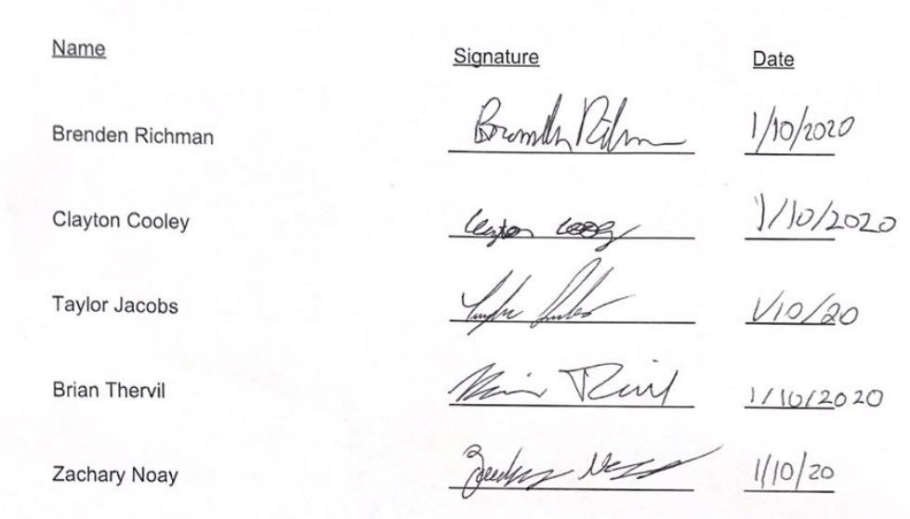
By signing this document the members of team 518 agree to all the above and will abide by the code of conduct set forth by the group

Appendix B: Functional Decomposition
Figure 12. Functional decomposition of necessary drone actions.

Appendix C: Targets and Metrics
Table 15
Complete Targets and Metrics
Function | Metric | Target
Send Commands | Range | 10 kilometers
Receive Data | Range | 10 kilometers
Accelerate | Thrust source increases | Thrust source > 50%
Decelerate | Thrust source decreases | Thrust source < 50%
Adjust Roll, Pitch, Yaw | Articulate ailerons, elevators, and rudders | -45°<=Ailerons <=45°  -45°<=Elevators<=45°  -45°<=Rudder <= 45°
Power Payload | Delivers power to payload and components | Voltage > 2.0 V
Record Data | Video Quality | Resolution >=480p
Orient Payload | Range of angle orientation | 360 degrees
*Generate Lift | *Airfoil produces greater lift force than gross weight | *Lift >=18.68 Newtons
House Hardware | Volume | <=0.30 m³
*Couple Payload | *Payload mass | *>=160 g  *<=200 g
*Endure | *Time while airborne | *>=60 minutes
Carry by Backpack | Stored Drone Dimensions | Stored Width <= 0.762 m  Stored Length <=0.508 m
 | Cruising Speed of UAV | >=30 km/hour
 | Take off procedure | Hand Take off
 | Cruising altitude | >=152.4 m
 | *Gross mass | *<=1.905 kg
 | Operation altitude | >= 100 ft  <= 500 ft
Speed | Speedometer | >31 km/h  <81 km/h
Communication (RF Chip) | Frequency band | 5GHz Band
Vibrational Sensor | Gyro for the drone | Digital Resolution: 10bit
Micro-USB adapter | Communication between programmer | UART Communication
Battery | Powers the drone | >= 850mA 4s 120c
Stores Data | Volume of Data | Stores 128kB data
Resistors | Size | Package Type <= 603
Capacitor | Size | Package Type <= 603
Control Motor | Variable Resistor | Slide Variable Resistor
Control Wings | Variable Resistor | Slide Variable Resistor

Appendix D: Concept Generation

Morphological Charts
Table 16
UAV Morphological Chart for Body Configuration
Wing Location | Empennage | Fuselage | Payload Location
Low Wing | T Tail | Elongated | Outboard of fuselage
Mid Wing | H Tail | Underwing | Inboard of fuselage
High Wing | V Tail |  | Protruding from fuselage
 | Fuselage Mount

Table 17
UAV Morphological Chart for Hardware Configuration
Thrust Motors | Battery Types | Transmitter | Software
Induction | Lithium | Radio Frequency | C++
Brushless | Aluminum-ion | Bluetooth | C
Combustion | Lead-acid | Wi-fi | Java
DC Shunt | Zinc Ion Battery | Satellite | Python
Series | Solar
Compound

Crap Shoot
1. Elevators removed, UAV will roll 180 degrees if the elevation must be changed at the same velocity, otherwise it will decrease velocity. This allows motors and components to be removed to save weight.
2. UAV is foldable and can be carried like a backpack and then deployed by using foldable wings.
3. The battery life and estimated remaining flight time of the UAV based on battery consumption is constantly visible to the user through use of an LED interface on the remote, assisting the user in efficient flight.
4. UAV adjusts its orientation during a flight without user input using a gyroscope to read angle rates allowing for maximum efficiency when flying.
5. The UAV can hot-swap payloads so different cameras can be quickly added and removed.
6. UAV senses barometric pressure along with other parameters to predict future weather conditions and reports back to the user for optimal flying trajectory.
7. When the UAV’s battery capacity is only capable of returning to its starting position, it will do so automatically to prevent damage and loss.
8. UAV wings are replaceable with surrounding objects, such as paper, plastic, and magazine clips.
9. UAV orients itself to utilize wind streams to increase lift force from its wings to keep power consumption to a minimum.
10. UAV can enter an autonomous mode to save power.
11. Drone is powered by wind generators
12. UAV has vents to cool down onboard electronics allowing for optimal battery efficiency.
13. Drone can track friendly vehicles and use their draft to reduce wind resistance.
14. Drone is powered by heat radiation from organisms.
15. Ability to harvest power from other drones.
16. Drone has different modules for wings so they can be carried in a separate bag and easily swapped for optimal flight condition.
17. Camera is turned off when not in use to save power.
18. Can be charged while flying through electromagnetic induction from a larger drone.
19. UAV can be charged through electromagnetic induction when landing on a friendly vehicle.
20. Drone uses the same aerodynamics of Santa reindeer.
21. Drone contains an onboard radar system for detecting power sources for mid-flight charging.
22. Drone body mimics that of a bat to allow for better flight.
23. Drone has solar panels on wings to greatly increase its battery life.
24. Drone can transform in midair from a fixed wing UAV to a quadcopter for increasing flight height for gliding rather than using power for motor.
25. UAV is a hybrid that can operate as a quadcopter or fixed wing UAV depending on what the application is to conserve power.
26. UAV is able to deploy a parachute for soft landing to save power normally diverted to motors for landing.
27. UAV thrust is generated by a wind-up motor
28. UAV is made from southeast Asian rainforest bamboo to save weight.
29. UAV can fly with no communication between the user and the drone.
30. UAV has a power saving mode that operates all components at their lowest possible power draw to increase flight time.
31. UAV can be powered by bullet shots.
32. UAV can be charged from lighting strikes.
33. Motor is separate from the embedded systems to save power.
34. Drone can be powered from trash, like in back to the future.
35. Drone uses the electric discharges in clouds.
36. Drones structure can be made from rods and sticks to reduce weight.
37. Drone uses a similar material to vibranium as a power source.
38. Drone motor uses hydrogen power to operate.
39. Wings of the UAV will be hollow to decrease weight.

Forced Analogy
1. Controls are drastically simplified to increase battery life.
2. Wingspan and fuselage are minimized in size and complexity using increased durability materials to save weight.
3. UAV body is made of paper to decrease weight.
4. UAV has decreased modularity of components and increased component life to save weight.
5. Wireless charging to the UAV during a flight via radioactive charging.
6. UAV has low density components to decrease overall weight.
7. UAV uses recycled materials for the body to save on overall cost allowing for more efficient system components to be used.
8. UAV is fully sealed to reduce drag and withstand high intensity weather conditions.
9. Wings of UAV are molded from candy and the fuselage is composed of candy wrappers to save weight.
10. Entire electrical system of UAV is comprised of a smart phone to save weight.
11. UAV is powered directly by solar panels to negate the need for a battery.

Appendix E: Concept Selection

Pairwise Comparison
Table 18
Pairwise Comparison for Customer Needs
 | Gross weight lighter  than reference UAV | Drone operates in light  storm weather | Flight time is equal or  greater than reference UAV | Drone's scale is equal or  less than reference | UAV is user controlled | Operates in U.S. climate  range | Drone provides  adequate surveillance | 3D printing utilized for  construction | Total
Gross weight lighter than reference UAV | - | 0 | 0 | 0 | 1 | 0 | 1 | 0 | 2
Drone operates in light storm weather | 1 | - | 1 | 1 | 1 | 0 | 1 | 1 | 6
Flight time is equal or  greater than reference UAV | 1 | 0 | - | 0 | 1 | 0 | 1 | 1 | 4
Drone's scale is equal or  less than reference | 1 | 0 | 1 | - | 1 | 0 | 1 | 0 | 4
UAV is user controlled | 0 | 0 | 0 | 0 | - | 0 | 0 | 0 | 0
Operates in U.S. climate  range | 1 | 1 | 1 | 1 | 1 | - | 1 | 0 | 6
Drone provides  adequate surveillance | 0 | 0 | 0 | 0 | 1 | 0 | - | 0 | 1
3D printing utilized for  construction | 1 | 0 | 0 | 1 | 1 | 1 | 1 | - | 5
Total | 5 | 1 | 3 | 3 | 7 | 1 | 6 | 2 | -

House of Quality
Figure 13. House of Quality

Pugh Charts
Table 19
Pugh Chart Iteration One
Selection Criteria | Datum |  | Concepts
 | RQ-11B Raven |  | 1  HW-VT-EF-IP | 2  HW-VT-EF-PP | 3  MW-VT-EF-IP | 4  MW-VT-EF-PP | 5  MW-VT-UW-IP
Empty Weight | Datum |  | + | + | + | + | +
Endurance |  |  | S | S | - | - | -
Wingspan |  |  | + | + | S | S | -
Length |  |  | - | + | - | - | +
Payload Weight |  |  | + | S | + | + | +
Drag coefficient |  |  | - | - | + | S | S
# of pluses |  |  | 3 | 3 | 3 | 2 | 3
# of minuses |  |  | 2 | 1 | 2 | 2 | 2

Table 20
Pugh Chart Iteration Two
Selection Criteria | Datum |  | Concepts
 | Concept 3  MW-VT-EF-IP |  | 1  HW-VT-EF-IP | 2  HW-VT-EF-PP | 4  MW-VT-EF-PP | 5  MW-VT-UW-IP
Empty Weight | Datum |  | S | S | S | +
Endurance |  |  | + | + | S | S
Wingspan |  |  | + | + | S | S
Length |  |  | S | + | + | +
Payload Weight |  |  | S | + | + | S
Drag coefficient |  |  | + | + | + | -
# of pluses |  |  | 3 | 5 | 3 | 2
# of minuses |  |  | 1 | 0 | 0 | 1

Analytical Hierarchy Process
Table 21
[C] Matrix for All Criteria
 | Empty Weight | Endurance | Wingspan | Length | Payload Weight | Drag coefficient
Empty Weight | 1.000 | 7.000 | 5.000 | 5.000 | 3.000 | 7.000
Endurance | 0.143 | 1.000 | 3.000 | 5.000 | 0.333 | 3.000
Wingspan | 0.200 | 0.333 | 1.000 | 3.000 | 0.333 | 3.000
Length | 0.200 | 0.200 | 0.333 | 1.000 | 0.111 | 0.333
Payload Weight | 0.333 | 3.000 | 3.000 | 9.000 | 1.000 | 5.000
Drag coefficient | 0.143 | 0.333 | 0.333 | 3.000 | 0.200 | 1.000
Sum | 2.019 | 11.867 | 12.667 | 26.000 | 4.978 | 19.333

Table 22
Normalized [C] Matrix
 | Empty Weight | Endurance | Wingspan | Length | Payload Weight | Drag coefficient | Criteria Weights  {W}
Empty Weight | 0.495 | 0.590 | 0.395 | 0.192 | 0.603 | 0.362 | 0.439
Endurance | 0.071 | 0.084 | 0.237 | 0.192 | 0.067 | 0.155 | 0.134
Wingspan | 0.099 | 0.028 | 0.079 | 0.115 | 0.067 | 0.155 | 0.091
Length | 0.099 | 0.017 | 0.026 | 0.038 | 0.022 | 0.017 | 0.037
Payload Weight | 0.165 | 0.253 | 0.237 | 0.346 | 0.201 | 0.259 | 0.243
Drag coefficient | 0.071 | 0.028 | 0.026 | 0.115 | 0.040 | 0.052 | 0.055
Sum | 1 | 1 | 1 | 1 | 1 | 1 | 1

Table 23
All Criteria Consistency Check
{Ws} = [C]{W}  Weighted Sum Vector | {W}  Criteria Weights | Cons = {Ws}./{W}  Consistency Vector
3.135 | 0.439 | 7.133
0.900 | 0.134 | 6.696
0.581 | 0.091 | 6.410
0.227 | 0.037 | 6.189
1.672 | 0.243 | 6.870
0.352 | 0.055 | 6.353
Table 24
Consistency and Bias Check
Average Consistency | Consistency Index | Consistency Ratio | Is Comparison Consistent
6.609 | 0.122 | 0.097 | Yes

Empty Weight.
Table 25
Empty Weight [C] Matrix
 | HW-VT-EF-IP | HW-VT-EF-PP | MW-VT-EF-IP | MW-VT-EF-PP
HW-VT-EF-IP | 1.000 | 0.333 | 1.000 | 0.333
HW-VT-EF-PP | 3.000 | 1.000 | 1.000 | 0.333
MW-VT-EF-IP | 1.000 | 1.000 | 1.000 | 0.333
MW-VT-EF-PP | 3.000 | 3.000 | 3.000 | 1.000
Sum | 8.000 | 5.333 | 6.000 | 2.000

Table 26
Normalized Empty Weight [C]
 | HW-VT-EF-IP | HW-VT-EF-PP | MW-VT-EF-IP | MW-VT-EF-PP | Criteria Weights  {W}
HW-VT-EF-IP | 0.125 | 0.063 | 0.167 | 0.167 | 0.130
HW-VT-EF-PP | 0.375 | 0.188 | 0.167 | 0.167 | 0.224
MW-VT-EF-IP | 0.125 | 0.188 | 0.167 | 0.167 | 0.161
MW-VT-EF-PP | 0.375 | 0.563 | 0.500 | 0.500 | 0.484
Sum | 1 | 1 | 1 | 1 | 1

Table 27
Consistency Check for Empty Weight
{Ws} = [C]{W}  Weighted Sum Vector | {W}  Criteria Weights | Cons = {Ws}./{W}  Consistency Vector
0.528 | 0.130 | 4.053
0.938 | 0.224 | 4.186
0.677 | 0.161 | 4.194
2.031 | 0.484 | 4.194

Endurance.
Table 28
Endurance [C] Matrix
 | HW-VT-EF-IP | HW-VT-EF-PP | MW-VT-EF-IP | MW-VT-EF-PP
HW-VT-EF-IP | 1.000 | 0.333 | 3.000 | 5.000
HW-VT-EF-PP | 3.000 | 1.000 | 5.000 | 3.000
MW-VT-EF-IP | 0.333 | 0.200 | 1.000 | 1.000
MW-VT-EF-PP | 0.200 | 0.333 | 1.000 | 1.000
Sum | 4.533 | 1.867 | 10.000 | 10.000

Table 29
Normalized Endurance [C] Matrix
 | HW-VT-EF-IP | HW-VT-EF-PP | MW-VT-EF-IP | MW-VT-EF-PP | Criteria Weights  {W}
HW-VT-EF-IP | 0.221 | 0.179 | 0.300 | 0.500 | 0.300
HW-VT-EF-PP | 0.662 | 0.536 | 0.500 | 0.300 | 0.499
MW-VT-EF-IP | 0.074 | 0.107 | 0.100 | 0.100 | 0.095
MW-VT-EF-PP | 0.044 | 0.179 | 0.100 | 0.100 | 0.106
Sum | 1 | 1 | 1 | 1 | 1

Table 30
Consistency Check for Endurance
{Ws} = [C]{W}  Weighted Sum Vector | {W}  Criteria Weights | Cons = {Ws}./{W}  Consistency Vector
1.280 | 0.300 | 4.270
2.192 | 0.499 | 4.389
0.401 | 0.095 | 4.210
0.427 | 0.106 | 4.043

Wingspan.
Table 31
Wingspan [C] Matrix
 | HW-VT-EF-IP | HW-VT-EF-PP | MW-VT-EF-IP | MW-VT-EF-PP
HW-VT-EF-IP | 1.000 | 1.000 | 5.000 | 3.000
HW-VT-EF-PP | 1.000 | 1.000 | 5.000 | 3.000
MW-VT-EF-IP | 0.200 | 0.200 | 1.000 | 1.000
MW-VT-EF-PP | 0.333 | 0.333 | 1.000 | 1.000
Sum | 2.533 | 2.533 | 12.000 | 8.000
Table 32
Normalized Wingspan [C]Matrix
 | HW-VT-EF-IP | HW-VT-EF-PP | MW-VT-EF-IP | MW-VT-EF-PP | Criteria Weights  {W}
HW-VT-EF-IP | 0.395 | 0.395 | 0.417 | 0.375 | 0.395
HW-VT-EF-PP | 0.395 | 0.395 | 0.417 | 0.375 | 0.395
MW-VT-EF-IP | 0.079 | 0.079 | 0.083 | 0.125 | 0.092
MW-VT-EF-PP | 0.132 | 0.132 | 0.083 | 0.125 | 0.118
Sum | 1 | 1 | 1 | 1 | 1
Table 33
Wingspan Consistency Check
{Ws} = [C]{W}  Weighted Sum Vector | {W}  Criteria Weights | Cons = {Ws}./{W}  Consistency Vector
1.602 | 0.395 | 4.053
1.602 | 0.395 | 4.053
0.368 | 0.092 | 4.014
0.473 | 0.118 | 4.012

Length.
Table 34
Length [C] Matrix
 | HW-VT-EF-IP | HW-VT-EF-PP | MW-VT-EF-IP | MW-VT-EF-PP
HW-VT-EF-IP | 1.000 | 0.333 | 1.000 | 0.333
HW-VT-EF-PP | 3.000 | 1.000 | 3.000 | 1.000
MW-VT-EF-IP | 1.000 | 0.333 | 1.000 | 1.000
MW-VT-EF-PP | 3.000 | 1.000 | 1.000 | 1.000
Sum | 8.000 | 2.667 | 6.000 | 3.333

Table 35
Normalized Length [C] Matrix
 | HW-VT-EF-IP | HW-VT-EF-PP | MW-VT-EF-IP | MW-VT-EF-PP | Criteria Weights  {W}
HW-VT-EF-IP | 0.125 | 0.125 | 0.167 | 0.100 | 0.129
HW-VT-EF-PP | 0.375 | 0.375 | 0.500 | 0.300 | 0.388
MW-VT-EF-IP | 0.125 | 0.125 | 0.167 | 0.300 | 0.179
MW-VT-EF-PP | 0.375 | 0.375 | 0.167 | 0.300 | 0.304
Sum | 1 | 1 | 1 | 1 | 1

Table 36
Length Consistency Check
{Ws} = [C]{W}  Weighted Sum Vector | {W}  Criteria Weights | Cons = {Ws}./{W}  Consistency Vector
0.539 | 0.129 | 4.172
1.617 | 0.388 | 4.172
0.742 | 0.179 | 4.140
1.258 | 0.304 | 4.137

Payload Weight.
Table 37
Payload Weight [C] Matrix
 | HW-VT-EF-IP | HW-VT-EF-PP | MW-VT-EF-IP | MW-VT-EF-PP
HW-VT-EF-IP | 1.000 | 0.333 | 3.000 | 0.333
HW-VT-EF-PP | 3.000 | 1.000 | 5.000 | 3.000
MW-VT-EF-IP | 0.333 | 0.200 | 1.000 | 0.333
MW-VT-EF-PP | 3.000 | 0.333 | 3.000 | 1.000
Sum | 7.333 | 1.867 | 12.000 | 4.667

Table 38
Normalized Payload Weight [C] Matrix
 | HW-VT-EF-IP | HW-VT-EF-PP | MW-VT-EF-IP | MW-VT-EF-PP | Criteria Weights  {W}
HW-VT-EF-IP | 0.136 | 0.179 | 0.250 | 0.071 | 0.159
HW-VT-EF-PP | 0.409 | 0.536 | 0.417 | 0.643 | 0.501
MW-VT-EF-IP | 0.045 | 0.107 | 0.083 | 0.071 | 0.077
MW-VT-EF-PP | 0.409 | 0.179 | 0.250 | 0.214 | 0.263
Sum | 1 | 1 | 1 | 1 | 1

Table 39
Payload Weight Consistency Check
{Ws} = [C]{W}  Weighted Sum Vector | {W}  Criteria Weights | Cons = {Ws}./{W}  Consistency Vector
0.644 | 0.159 | 4.050
2.152 | 0.501 | 4.294
0.318 | 0.077 | 4.135
1.138 | 0.263 | 4.326

Drag Coefficient.
Table 40
Drag Coefficient [C] Matrix
 | HW-VT-EF-IP | HW-VT-EF-PP | MW-VT-EF-IP | MW-VT-EF-PP
HW-VT-EF-IP | 1.000 | 3.000 | 0.333 | 3.000
HW-VT-EF-PP | 0.333 | 1.000 | 0.333 | 1.000
MW-VT-EF-IP | 3.000 | 3.000 | 1.000 | 3.000
MW-VT-EF-PP | 0.333 | 1.000 | 0.333 | 1.000
Sum | 4.667 | 8.000 | 2.000 | 8.000

Table 41
Normalized Drag Coefficient [C] Matrix
 | HW-VT-EF-IP | HW-VT-EF-PP | MW-VT-EF-IP | MW-VT-EF-PP | Criteria Weights  {W}
HW-VT-EF-IP | 0.214 | 0.375 | 0.167 | 0.375 | 0.283
HW-VT-EF-PP | 0.071 | 0.125 | 0.167 | 0.125 | 0.122
MW-VT-EF-IP | 0.643 | 0.375 | 0.500 | 0.375 | 0.473
MW-VT-EF-PP | 0.071 | 0.125 | 0.167 | 0.125 | 0.122
Sum | 1 | 1 | 1 | 1 | 1

Table 42
Payload Weight Consistency Check
{Ws} = [C]{W}  Weighted Sum Vector | {W}  Criteria Weights | Cons = {Ws}./{W}  Consistency Vector
1.173 | 0.283 | 4.147
0.496 | 0.122 | 4.065
2.054 | 0.473 | 4.340
0.496 | 0.122 | 4.065

Criteria Consistency Check.
Table 43
Consistency and Bias Check for All Individual Criteria
 |  | Average Consistency | Consistency Index | Consistency Ratio | Is Comparison Consistent
Empty Weight |  | 4.157 | 0.052 | 0.059 | Yes
Endurance |  | 4.228 | 0.076 | 0.085 | Yes
Wingspan |  | 4.033 | 0.011 | 0.012 | Yes
Length |  | 4.155 | 0.052 | 0.058 | Yes
Payload Weight |  | 4.201 | 0.067 | 0.075 | Yes
Drag Coefficient |  | 4.154 | 0.051 | 0.058 | Yes

Final Rating Matrix.
Table 44
Final Rating Matrix
 | HW-VT-EF-IP | HW-VT-EF-PP | MW-VT-EF-IP | MW-VT-EF-PP
 | Concept 1 | Concept 2 | Concept 3 | Concept 4
Empty Weight | 0.130 | 0.224 | 0.161 | 0.484
Endurance | 0.300 | 0.499 | 0.095 | 0.106
Wingspan | 0.395 | 0.395 | 0.092 | 0.118
Length | 0.129 | 0.388 | 0.179 | 0.304
Payload Weight | 0.159 | 0.501 | 0.077 | 0.263
Drag coefficient | 0.283 | 0.122 | 0.473 | 0.122

Alternative Weight.
Table 45
Alternative Weights of Concepts
Concept | Alternative Value
HW-VT-EF-IP  Concept 1 | 0.233
HW-VT-EF-PP  Concept 2 | 0.355
MW-VT-EF-IP  Concept 3 | 0.180
MW-VT-EF-PP  Concept 4 | 0.233

References
Americans with Disabilities Act (ADA) Standards. (2010). D.C., Washington, United States.
Hall, N. (Ed.). (2015, May 05). Thrust to Weight Ratio. Cleveland, Ohio, United States.
M2-D Stabilized EO-IR FLIR UAV Drone unmanned thermal Camera Gimbal. (n.d.). Retrieved from SPI Infrared: https://www.x20.org/m2-d-stabilized-eo-ir-flir-uav-flir-thermal-camera-gimbal/
Radio Spectrum Allocation. (2019, May 07). Retrieved from Federal Communications Commission: https://transition.fcc.gov/oet/spectrum/table/fcctable.pdf
U.S. Army Unmanned Aircraft Systems Roadmap 2010-2035. (n.d.). Fort Rucker, Alabama, United States.
UAS: RQ-11B Raven. (n.d.). Retrieved from AeroVironment: https://www.avinc.com/images/uploads/product_docs/Raven_Datasheet_2019_v1.pdf

