Author1: Fabrizio Alvarado;Author2: Paul M. Hromadka;Author3: Patrick H. Huffman;Author4: William Pineda
FAMU-FSU College of Engineering 2525 Pottsdamer St. Tallahassee, FL. 32310
Team 527: Completely Enclosed Mini-ITX Cooling Case
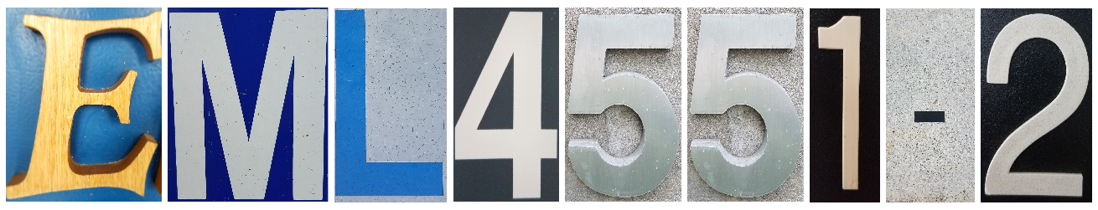
10/20/2018

Abstract
Our team is tasked with developing a Mini-ITX small form factor computer case. This computer case needs to provide a means of cooling for high end computer components. This means keeping the Computer Processing Unit (CPU) operating at 50℃ and Graphics Processing Units (GPU) at 70℃. Mini-ITX refers to the standardized geometry for the computer motherboard, created by Intel, which measures at an area of 17cm x 17cm. The goal is to keep the case below an overall volume of 7.5L, a number derived from competitor analysis. One of the primary assumptions for this product is that, barring the cooling system, consumers will be supplying their own computer components to use within the case. This product is being aimed primarily towards the PC Video Gaming community as well as institutions doing high powered data computation. Currently, a general design has been chosen through a concept selection crucible. This design relies on a parallel water cooling loop which relies on a single, large radiator to provide cooling. We have developed a bill of materials for the prototype and are in the process of requesting additional funding due to our very limited budget of $1000. Team 527 is also conducting market research and developing a strong business presentation in order to compete in the Florida State University Jim Moran School of Entrepreneurship InNOLEvation Challenge, as well as Engineering Shark Tank.

Keywords: Mini-ITX, Computer Case, Small Form Factor, Liquid Cooling

Disclaimer
Your sponsor may require a disclaimer on the report. Especially if it is a government sponsored project or confidential project. If a disclaimer is not required delete this section.

Acknowledgement
We would like to thank the Dean’s Officer of the FAMU-FSU College of Engineering for sponsoring and funding the Mini-ITX Computer Case Entrepreneurial Senior Design Project.
Thank you to Dr. Mike Devine for advising us on all matters related to the entrepreneurial aspect of our project. His help in formulating our Business Model Canvas, conducting market research, and participating in the Jim Moran School of Entrepreneurship InNOLEvation challenge as well as in Engineering Shark Tank was invaluable. We would also like to thank Dr. Juan Ordonez for his advising on the technical aspects of our project, specifically dealing with thermal fluids and fluid mechanics.

Table of Contents
Abstract 3
Disclaimer 4
Acknowledgement 5
List of Tables 10
List of Figures 11
Notation 12
Chapter One: EML 4551C 13
1.1 Project Scope 13
1.2 Customer Needs 13
1.3 Functional Decomposition 16
1.4 Target Summary 19
1.5 Concept Generation 19
Concept 1. 19
Concept 2. 21
Concept 3. 23
Concept 4. 24
Concept 5. 25
Concept 6. 27
Concept 7. 28
Concept 8. 28
Concept 9. 28
Concept 10. 29
1.6 Concept Selection 29
1.8 Spring Project Plan 34
Chapter Two: EML 4552C 35
2.1 Spring Plan 35
Project Plan. 35
Build Plan. 35
Appendix A: Code of Conduct 35
Appendix B: Functional Decomposition 42
Appendix C: Target Catalog 43
Appendix D 46
House of Quality 46
AHP Example 47
Comparing Design Ideas with respect to Universal Compatibility 47
Normalized Values from above 47
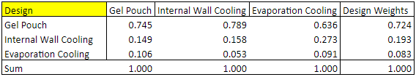 47
Consistency Check 47
Consistent Comparison 47
Heading 2 is Flush Left, Boldface, Uppercase and Lowercase Heading 48
Heading 3 is indented, boldface lowercase paragraph heading ending with a period. 48
Heading 4 is indented, boldface, italicized, lowercase paragraph heading ending with a period. 48
Heading 5 is indented, italicized, lowercase paragraph heading ending with a period. 48
Appendix B Figures and Tables (delete) 49
Flush Left, Boldface, Uppercase and Lowercase 50
Indented, boldface lowercase paragraph heading ending with a period 50
Indented, boldface, italicized, lowercase paragraph heading ending with a period. 50
Indented, italicized, lowercase paragraph heading ending with a period. 50
References 51

List of Tables
Table 1 Pugh Matrix 31
Table 2 Alternative Value and Concepts 33

List of Figures
Figure 1. Computer case with radiator inside the wall 20
Figure 2. What internal fluid channeling may look like 20
Figure 3. Illustration of GPU inside cooling sleeve 21
Figure 4. Illustration of motherboard in cooling sleeve 22
Figure 5. Basic layout of sleeve and its relation to GPU and CPU 22
Figure 6. Illustration of how cooling sleeve would work with heat exchanger 22
Figure 7. Vortex generating fin geometry sketch 24
Figure 8. Turbine cooling sketch 25
Figure 9. Central Cooling Block Sketch 26
Figure 10. Microfluidic channeling sketch 27
Figure 11. Counter flow cooling 28

Notation
CPU | Central Processing Unit
GPU | Graphics Processing Unit
PC | Personal Computer
PSU | Power Supply
RAM | Random Access Memory
SFX | Small Form Factor
SSD | Solid State Drive

Chapter One: EML 4551C

Project Scope
Project Description: The task is to create a Mini-ITX form factor computer case that is completely enclosed and capable of cooling high powered components.
Key Goals: To develop an enclosed, Mini-ITX computer case that uses thermal systems to keep high powered computer parts from overheating. The case must be feasible in terms of power usage, price, and scalability. Aside from the design, it is a key goal to place first in the InNOLEvation challenge.
Primary Markets: Computer Gaming, Bitcoin Mining, and Research Computation
Secondary Markets: Offices, Schools, Industrial Applications
Assumptions:
Stakeholders: Project Sponsor Dr. Mike Devine and Yourri Samuel Dessureault, who proposed the original idea to the FAMU-FSU College of Engineering.

1.2 Customer Needs
Questions Asked | Customer Response | Interpreted Need
Are there any specific heat dissipation rates? | Yes | The case must be able to dissipate heat from a Graphics Processing Unit (GPU) and Central Processing Unit (CPU) rated for 250W and 100W thermal design power, respectively.
Are there desired components? | Yes | Some important components that should be usable in the case would be a full-sized reference GPU, any socket motherboard of mini-ITX form factor, one 2.5in solid state drive, at least 8gb of DDR3-1600 ram, and internal power supply.
What is the market targeted? | 17-55 | The market for this product will be highly sought after a number of diverse consumers such as global gamers, bitcoin currency miners, companies and individuals that require machines capable of achieving a high-level computational factor, and more.
Are there any competitors for this product? | Yes | Currently, there are two potential challengers on the recent market, such as the DAN A4-SFX case and the Dr. Zaber computer case.
Are there any specific temperatures the system should try and achieve? | 65ºC | The CPU should be close to 50ºC and GPU around 70ºC. There must be no thermal-throttling and ideally the system should be under 65ºC.
What would be the desired size for the case? | >7.5 liters | The size desired for this case should be volumetrically approximated to 7.5 liters.

1.3 Functional Decomposition
MAJOR FUNCTIONS
- CPU Cooling
- GPU Cooling
- Structural Support for Components
- Provides Space for Full Sized GPU.
- Environmental Protection for Components
- Portability of Case
- Cooling System Monitoring and Manipulation*

Task 1.0: CPU Cooling
Sub Task 1.1: Absorb Heat From CPU With Medium
Aspect 1.1.1: Working Fluid/Medium
Aspect 1.1.2: Working Fluid/Medium Contact Area
Aspect 1.1.3: Possible Cold Temp Reservoir
Sub Task 1.2: Transfer Heat Through Medium
Sub Task 1.3: Dispel Heat From Medium
Task 2.0: GPU Cooling
Sub Task 2.1: Absorb Heat From GPU With Medium
Sub Task 2.2: Transfer Heat Through Medium
Sub Task 2.3: Dispel Heat From Medium
Task 3.0: Structural Support for Components
Sub Task 3.1: Case Remains Upright and Balanced
Aspect 3.1.1: Case Material
Aspect 3.1.2: Case Geometry
Sub Task 3.2: Case Has Holes For Supporting Screws
Aspect 3.2.1: Spacing for Mini-ITX Form Factor Motherboard
Aspect 3.2.2: Structural support for Solid State Drive
Sub Task 3.3: Case Provides Outlet for USB,HDMI, etc.
Task 4.0: Provides Space for Full Sized GPU
Sub Task 4.1: Case Has At Least 267mm x 11mm Allotted for GPU
Aspect 4.1.1: Case Geometry
Task 5.0: Environmental Protection for Components
Sub Task 5.1: Manage Dust Collection
Sub Task 5.2: Strong Supporting Structures for Components
Sub Task 5.3: Separation Of Any Working Fluids and Computer Components
Task 6.0: Easy to transport
Sub Task 6.1: Small Form Factor
Aspect 6.1.1: Case Geometry
Aspect 6.1.2: Case Material
Aspect 6.1.3: Case Weight
Sub Task 6.2: Lightweight
Aspect 6.2.1 Minimize material usage
Sub Task 6.3: Self contained system
Aspect 6.3.1 No additional power supply

CPU and GPU Cooling.
Rather than purchasing and installing a cooling system for the CPU, this case must have an integrated cooling system. A variety of different cooling options are being explored. The most common is water cooling, which involves passing cool water through a metal plate that is in contact with the CPU. The water absorbs heat from the CPU, and must transfer this heat out of the system. Other options include air cooling and the use of vapor chambers. The CPU and GPU cooling systems can be one combined system or two separate systems, but will operate under similar principles.

Structural Support for Components
The case must provide strong support for all computer components. It must have holes to allow a Mini-ITX form factor case to be mounted, as well as solid state drives, a full sized GPU, and power supply. There will also be a need to support any and all components of the integrated cooling system. This could mean supporting fans, piping for water cooling, vapor chambers, and more.

Provide Space for a Full Sized GPU
Full sized high end graphics cards are dimensioned at 267 mm x 11 mm with a dual slot width. Because this case is marketed towards high end computer gaming, it is a necessity that the internal volume of the case allows for the installation of a GPU of these dimensions.

Environmental Protection for Components
It is important not to overlook why a computer case is required at all. A case must provide protection from the elements for all components inside. Internal hardware should be able to withstand if the case is tipped over. There is also a need to minimize dust collection in and on the hardware. This may call for additional airflow, and thus the use of fans.

Portability of Case
It is a major goal of the project that the computer case be small enough and stable enough to be transported easily. The idea is that it can be unplugged from the wall and easily carried to and from different locations, preferably with a single hand. This will most likely call for the implementation of a handle.

1.4 Target Summary
The most important targets for the product involve the thermal regulation of the consumer’s CPU and GPU. The design goal is to maintain a temperature of 50C and 70C during steady state operations of the CPU and GPU, respectively. Remaining targets include keeping the size of the case competitive, around 7.5 L, maintaining environmental protection of internal components, and using no external components. See Appendix C for complete target tables.

1.5 Concept Generation

Concept 1.
Integrated Liquid Cooling and Radiator
Description: Design the case to contain channeling for liquid coolant and length-adjustable tubing inside the case walls. The radiator for the cooling loop would be built into the side panel of the case, acting both as a radiator and case wall. This would open up numerous options for the design of the radiator.
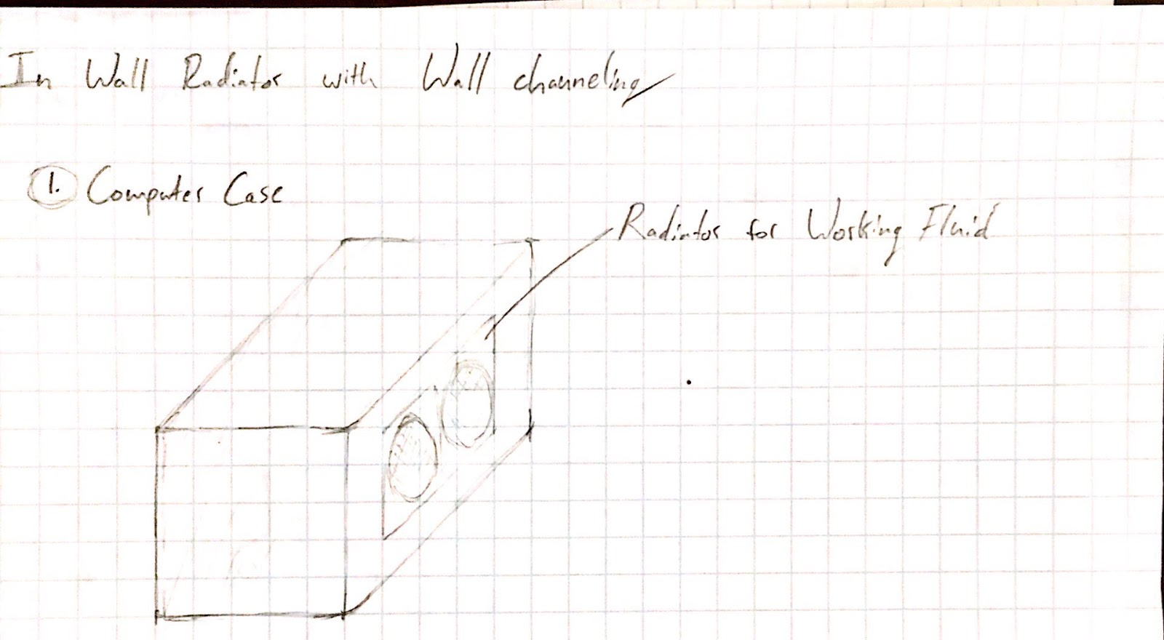
Figure 1. Computer case with radiator inside the wall.
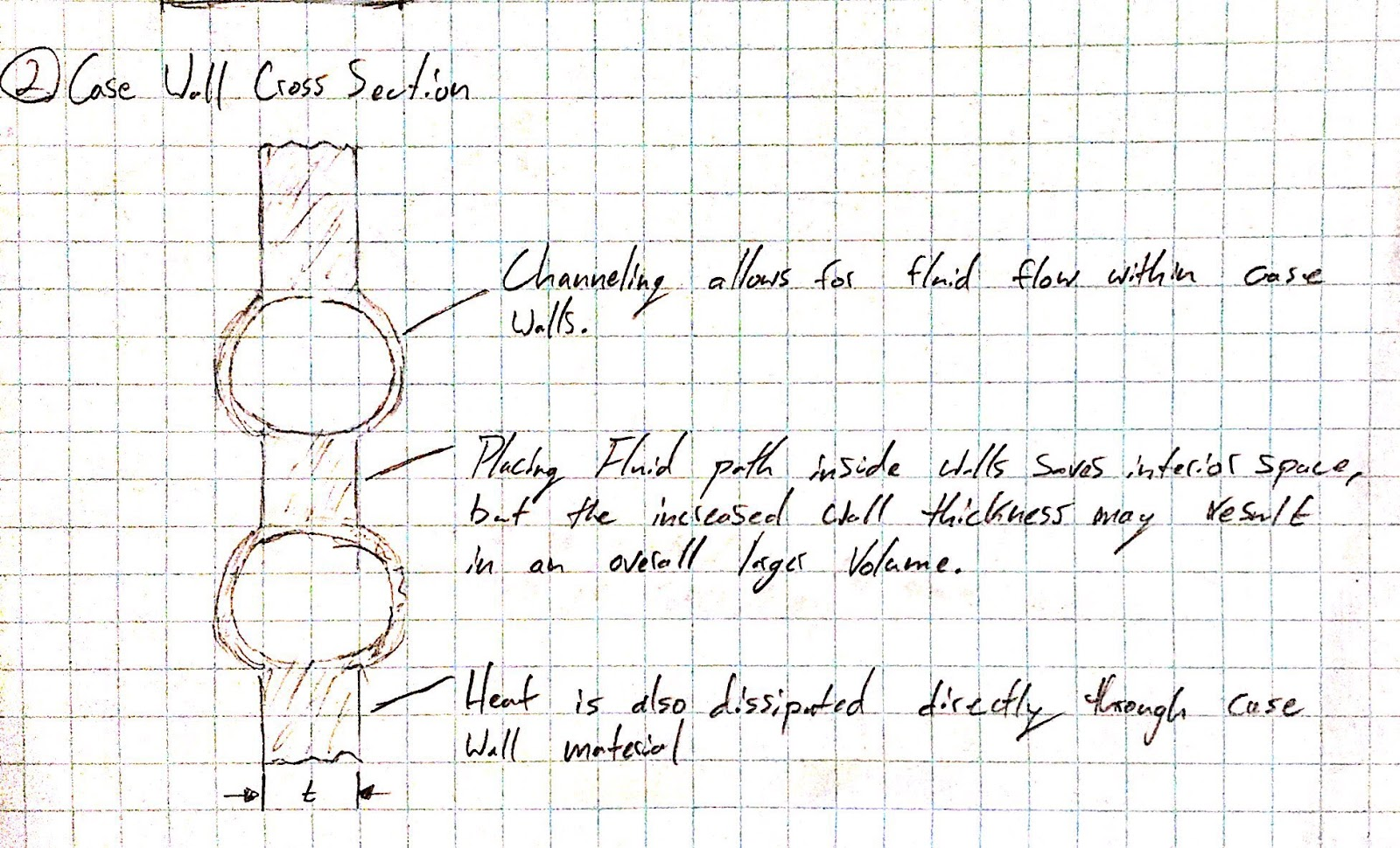
Figure 2. Example of what the interior fluid channeling may look like inside the case wall.
Pros: Ease of manufacturing, open ended radiator design, and the technology is not difficult.
Cons: Spatial constraints for liquid reservoir and pump. Customers would also need to purchase Computer Processor and Graphics Processor specific cooling blocks.

Concept 2.
Electronic Cooling Pad
Description: The purpose of the sleeve is to increase the amount of surface area contact between the CPU/GPU and a cool fluid. This is a unique way to approach to achieve that, while minimizing space. The concept is relatively difficult to show with an image, but the first two images below are an attempt at illustrating what the real product will look like.
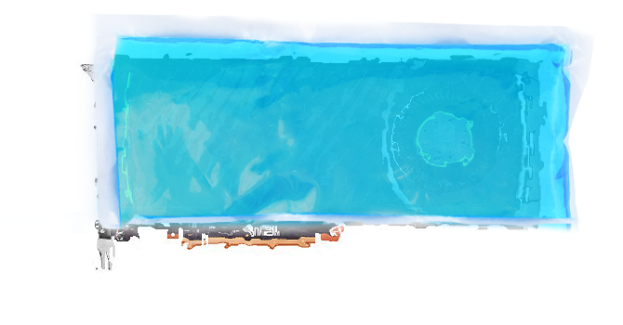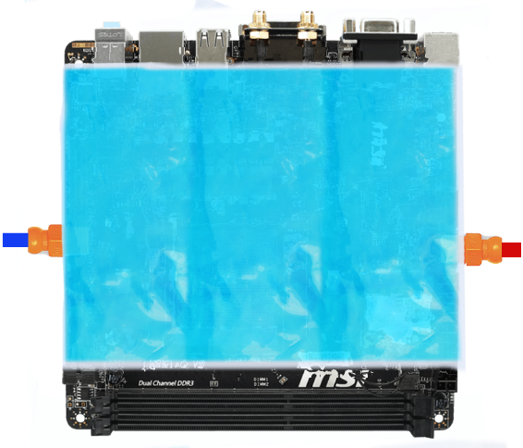
Figure 3: Illustration of GPU in cooling sleeve
Figure 4: Illustration of motherboard in cooling sleeve
Essentially, the sleeve will slip over the motherboard with the CPU and GPU already attached. The image can’t show the GPU sticking up through the image, therefore image 5 is used to show a different perspective of the motherboard and components.
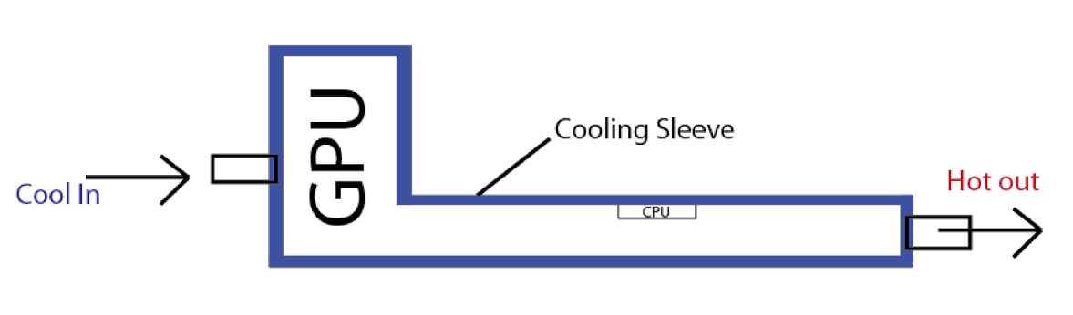
Figure 5. Basic layout of sleeve and its relation to CPU and GPU
The reason it needs to be a sleeve is to leave room for the ram sticks that will need to be mounted on the bottom part of the motherboard. The other side needs to remain open so that the components from the motherboard and GPU can stick out of the case. Those components are generally ports such as, USB, HDMI, ethernet, and so on. The direction of the cool fluid in and hot fluid out hasn’t be thermally analyzed, therefore the directions shown in the images are relatively arbitrary. The image below show how it will look in a computer case.
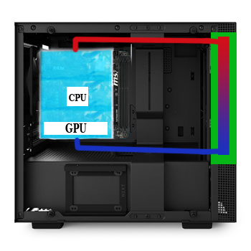
Figure 6. Illustration of how heat exchanger would work with the cooling sleeve

The green area shows, in a very simple way, how the fluid would be cooled in a heat exchanger, such as a radiator. The main material of the sleeve will need to be some form of plastic, so that it can hug the GPU and CPU surfaces for proper cooling. It will also have to be able to withstand significant direct heat.
Pros: Innovative, fits any GPU or CPU socket type, minimal size and weight impact
Cons: Difficult materials problem, still need to remove heat from cooling sleeve, risk of puncturing coolant sleeve

Concept 3.
Application of Vortex Generating Geometry for Increased Heat Transfer
Description: It is possible to interrupt airflow within the system such that it generates vortices within the flow. These vortices increase the heat transfer that occurs from the surface to the flow, more so than smooth, straight flow. This idea could stand alone, say to generate vortices directly onto the CPU and GPU, or it could be an application to additional designs. Meaning, apply the use vortex generators for a complex radiator design instead of direct contact to components.
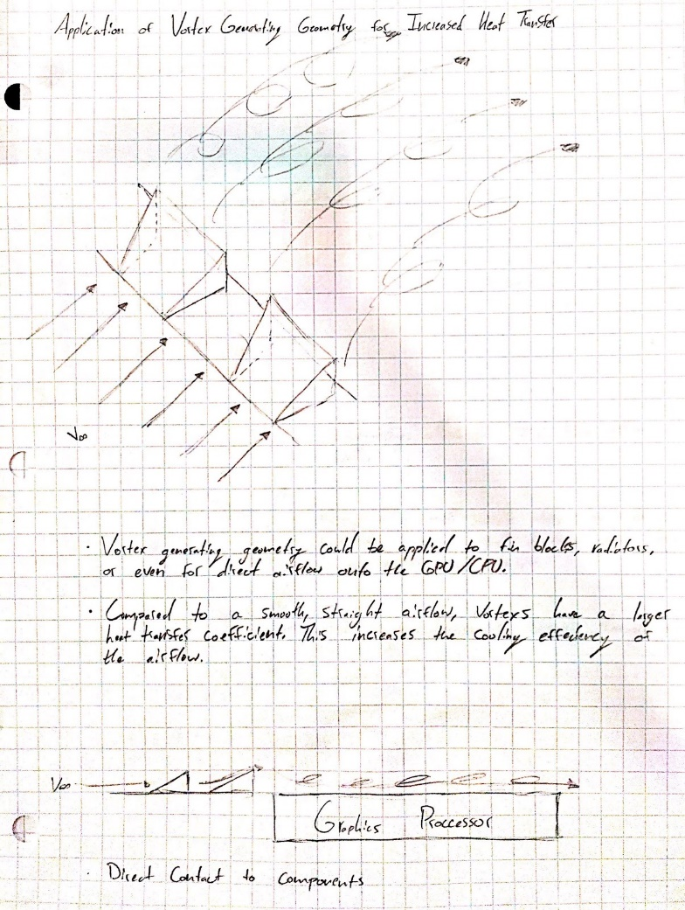
Figure 7. Vortex Generating Fin Geometry Sketch
Pros: Very innovative, much more efficient if done correctly. CFD data would get great reviews for presentations.
Cons: Complexity of design, complexity of manufacturing.

Concept 4.
Turbine Cooled
Description: Having 2 small high pressure turbines could drastically improve the cooling of the system. By having them correctly positioned we could have a pump that would blow hard air into the intake of the first turbine, spinning the fins and extracting heat, while the exhaust part of the turbine would be connected to the intake of the 2nd turbine, which would create more heat extraction in another location, therefore being able to control the temperature by modifying the pump values electrical
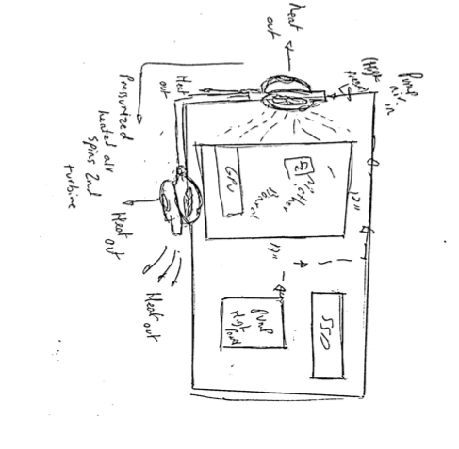
Figure 8. Turbine Cooling Sketch
Pros: Regulated cooling, very effective, non-corrosive
Cons: High complexity, power consuming

Concept 5.
Central Cooling Block Shared by CPU and GPU
Description: One central cooling block is fitted to both the CPU and GPU. The internal geometry of the block would be designed to sufficiently cool both components. Forced convection would aide in the heat transfer process. This would be provided through one channel that runs from one end of the case completely through the other end. An inlet and outlet fan (or possibly a turbine) would be placed at both ends. See the image below.
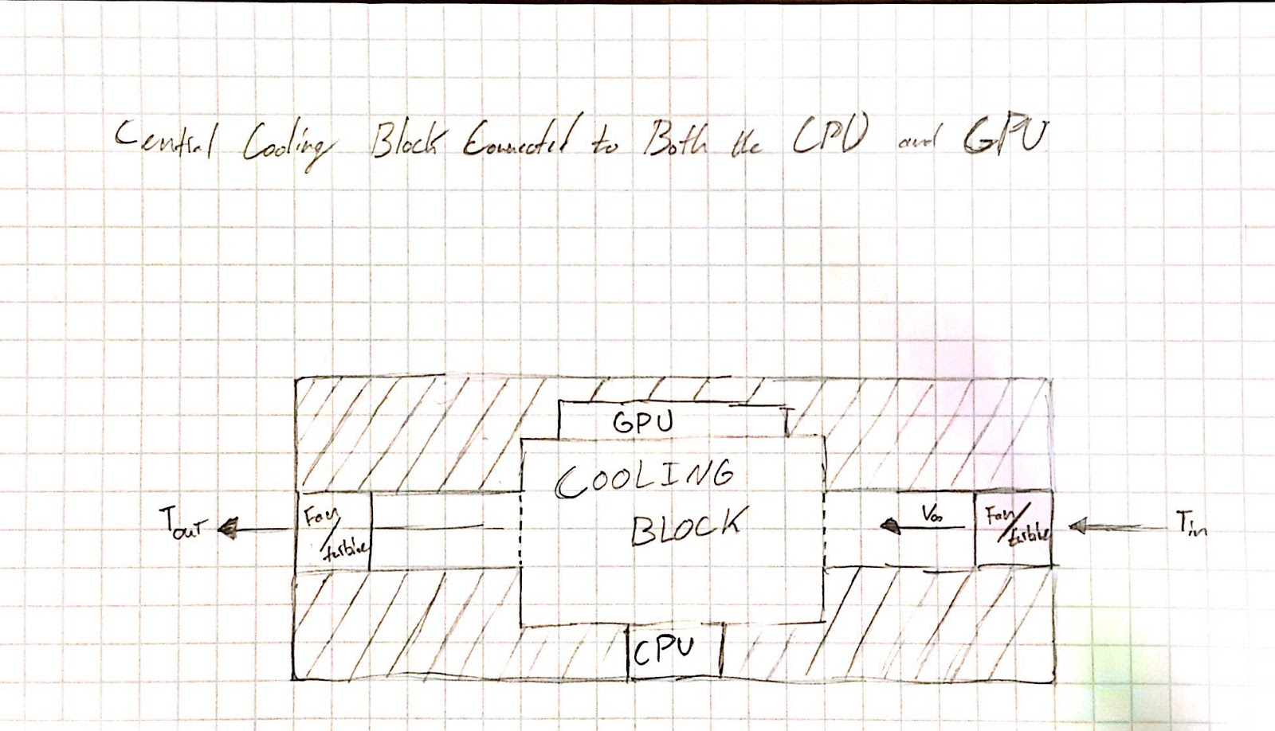
Figure 9. Central Cooling Block Sketch
Pros: Innovative design. Allows for very open ended design of the cooling block. Could use vapor chambers, heat pipes, and even vortex generating fin geometry.
Cons: Issues with providing direct contact between CPU and GPU. Central cooling block will likely push the product pass the intended volume target of 7.5L.

Concept 6.
Microfluidic Channels
Description: The case would use microfluidic channels in order to circulate a working fluid to transport the heat away from the CPU and GPU. This would involve some sort of CPU/GPU mount in order to maintain sufficient contact with the component. The channels would run throughout the case (in walls and interior components) in order to circulate the working fluid. Considering the size of the channels would need to be very small the system would ideally be closed to minimize user interaction with the system. Size, orientation of channels in mounts and in key exhaust locations would have to be optimized. The figure below shows how the flow of a working fluid would look in a CPU mount the case could include.
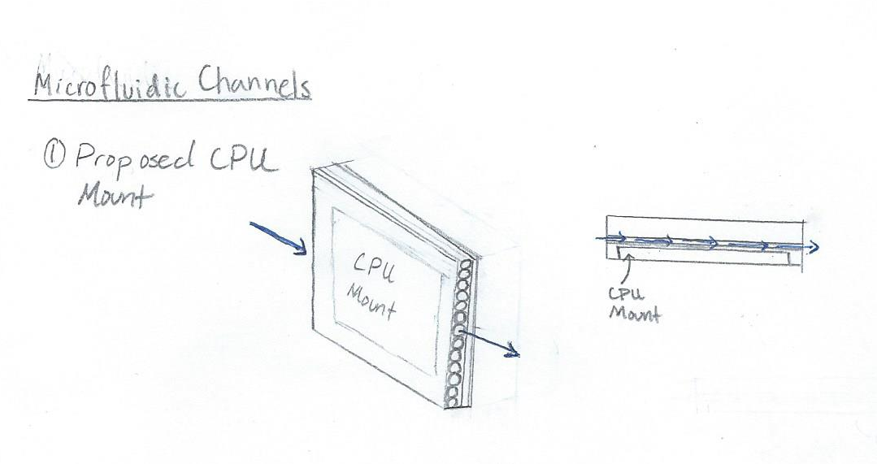
Figure 10. Turbine Cooling Sketch
Pros: High heat transfer coefficient, quiet, space saving
Cons: Difficult to machine, fairly specific working fluid

Concept 7.
Double tube cooler
Description: There would be two working fluids, one that transports the heat and another that flows above that cools the working fluid. The way the fluid gets cooled will be with a radiator.

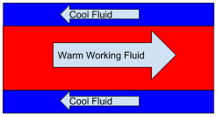
Figure 11. Counter Flow Cooler
Pros: Would be more simple than other designs
Cons: Networking many different flows may get complicated and take up a great deal of space

Concept 8.
Immersion Cooling
Description: Heat generated by the electronic components is directly and efficiently transferred to the fluid. The motherboard would be submerged on this liquid.
Pros: Reduces the need for active cooling components, such as interface materials, heat sinks and fans that are common in air cooling. Also inexpensive, reusable and energy efficient.
Cons: Prone to leakages

Concept 9.
Phase Change Cooling
Description: Would utilize a phase change in the working fluid to cool components. Similar to the refrigeration cycle but can be used with less equipment depending on the choice of working fluid. Would dissipate more than enough heat from both the CPU and GPU. Closed system eliminating the need for working fluid refills and condensation.
Pros: High heat transfer, space saving, closed system
Cons: system configuration is working fluid dependent

Concept 10.
Refrigerated rooms
Description: Have housing spots for motherboard and GPU to be place in which it is completely surrounded by plates that are refrigerated to keep the contents cool. May be very difficult to have a refrigerated system in such a small case. But wouldn’t need to keep a working fluid cold, but rather plates.
Pros: Possibility of minimizing noise, and depending on size of turbines maybe save plenty of space
Cons: High speed turbine may increase chance of component breakage

1.6 Concept Selection
Having several different designs with what we believe to all have some potential, we needed to narrow it down to one. Using several different methods, such as a House of Quality, Pugh matrix, and pairwise matrices narrowing it down to one design was possible. To limit the amount of biases, it was important to incorporate everyone in the group to determine the weights for characteristics and values throughout the process. The first method that we used was the House of Quality.
House of Quality
The House of Quality allows us to see how different engineering characteristics can help accomplish our customer’s requirements. We came up with 9 different engineering characteristics, against our 8 customer requirements. We had to first create weights for our customer requirements. This was done with a relation matrix that compares the customer requirements to each other. It effectively compares each requirement with one-another to see which are the most important in the end. The matrix concluded that the most important requirements are to keep the CPU and GPU at 50 and 70 degrees Celsius, respectfully. While on the lower spectrum of the requirements, we have the volume size of the case and the amount of SSD slots. These are important, but if they are not nearly as important as keeping the CPU and GPU at their respective temperatures. After evaluating each characteristic and requirement, we concluded that the most important characteristics were cooling efficiency, universal compatibility, power consumption, and total volume. These were the decided characteristics because the other engineering characteristics had significant lower scores. To see the House of Quality for our project, Appendix D will have the chart. Once the House of Quality was completed, the Pugh matrix could then be used to start narrowing down our designs.
Pugh Matrix
The first Pugh matrix was comparing 8 of our preliminary designs against a similar, competitor product, the Dan A4-SFX. Our project is essentially creating a whole new product, therefore the Dan A4 isn’t exactly the best comparison, but it is one of the best on the current market. When comparing that product against our designs, we further narrowed down our designs to 5, which were the “Gel Pouch”, “Liquid Cooling with Fluid in Walls”, “Evaporation Cooling” “Immersive Cooling”, and “Phase Change”. Evaluating four of those designs against the “Gel Pouch” idea as a datum resulted in 3 designs that we will further analyze to get down to one idea, table 1.
Table 1: Pugh Matrix
Selection Criteria | Gel Pouch | Liquid Cooling with Fluid in Walls | Evaporation Cooling | Immersive Cooling | Phase Change
Total Volume | DATUM | - | - | S | -
Power Consumption |  | S | S | + | -
Noise Level |  | - | - | + | -
Cooling Efficiency |  | + | S | S | S
Maintenance Req. |  | S | S | - | -
Env. Resistance |  | S | S | S | S
Compatibility |  | - | + | S | -
Accessibility |  | S | + | - | -
Material |  | + | + | - | S
 | # Pluses | 2 | 3 | 2 | 0
 | # Minuses | 3 | 2 | 3 | 6

Once we compared the different ideas in the Pugh chart, the outcome favored the design ideas of “Gel Pouch”, “Liquid Cooling with Fluid in Walls” and “Evaporation Cooling”. This chart had a tie between “Liquid Cooling within computer walls” and “Immersive Cooling”, therefore as a group we decided that the “Liquid Cooling” approach was more practical. These 3 designs and 5 characteristics (discussed earlier) were then analyzed using the Analytical Hierarchy Process (AHP).
Analytical Hierarch Process
There were several steps for the AHP, with the first step focusing on the four characteristics that were discussed earlier. Here, the characteristics are compared to each other to evaluate their importance, with respect to each other. The AHP process will later use the information that was gathered through this step to help in the final design selection.
The first step discussed above is done again, but rather than the engineering characteristics, the 3 design ideas will be analyzed. These designs will be evaluated against the four different characteristics, in four separate AHP tables. The idea is to evaluate each design to see which design will be most effective at satisfying the accompanying characteristic. Examples of the AHP process can be found in Appendix D.
Once that analysis is done and the values are normalized, there is an output of each design’s “weight”. These weights will then be multiplied by the weights of each of the engineering characteristic weights to determine which design idea is mathematically most appropriate to choose. These values can be found in table 2, below.

Table 2: Alternative Value and Concept
Concept | Alternative Value
Gel Pouch | 0.436
Internal Wall Cooling | 0.467
Evaporation Cooling | 0.098

Table 2 shows that the design that we will be working with in the Internal Wall Cooling idea. This design is ideal because it will have to be integrated into the walls of case, which will minimize the amount of space taken up, compared to aftermarket water coolers.
Our reasoning as to why we feel that the gel pouch may not be a more desired design would be the complication of the material and fluid to properly cool the system. Once we do find the appropriate materials, cooling the fluid could be a problem that may need a large system to cool it properly. This would take up a great amount of space, in a system that has very little available space. As far as power consumption and cooling efficiency, we had this idea pretty close to the internal wall cooling idea. We believed they would require similar methods of cooling (with the Gel Pouch potentially needing more), therefore having similar power consumption values. One big thing that the gel pouch had going for it, would be its diverse usability for several different components. The idea of the pouch was to create it large enough for any components, then adjusting and forming to any components that were attached to the motherboard.
The main problem with evaporation cooling is the amount of space it will take up. Not only will we need a place for the run off fluid to go, there will have to be a system to capture the vapors that evaporate from the part that it is cooling. There will need to be a large network of tubing and components to cycle this system. The cooling efficient of this system is also not very known since there isn’t anything on the market like it. The power needed to run the network of pumps, tubing, and sprayers would be much greater than the other ideas that we analyzed. One decent factor that it had was its potential to be universally compatible. But, even that may be a problem, simply because there may be a problem with the sprayer spraying the different areas that different components would need to be cooled.

1.8 Spring Project Plan

Chapter Two: EML 4552C

2.1 Spring Plan
1.0.0.0 Resolve thermal aspect of the design 14 days
1.1.0.0 Determine fluid flow rates 3 days Huffman
1.1.1.0 Ensure optimized cooling
1.1.1.0 Ensure optimized power consumption
1.2.0.0 Determine power needed to run pump 3 days Huffman
1.3.0.0 Specs of designed radiator 8 days Huffman and Pineda
1.1.1.0 Thickness of radiator
1.1.2.0 Number of fins on the radiator
1.1.3.0 Spacing between fins on the radiator

2.0.0.0 Create CAD model of prospected case 11 days
2.1.0.0 Design Internal Layout 7 days Pineda and Huffman
2.1.1.0 Optimize for Thermal Efficiency
2.2.0.0 Create a location for all components needed in the case 4 days Pineda
2.1.1.0 Measure known components to ensure it fits
2.1.2.0 Create holes for fasteners
2.1.3.0 Areas to run wires for clean wiring in case

3.0.0.0 Innolevation Challenge 30 days
3.1.0.0 Solidify Team Members by Jan 14 7 days All
3.1.1.0 Create LLC
3.2.0.0 Continually develop presentation without use of technical jargon 22 days Alvarado
3.2.1.0 “Develop a story” - Dr. Devine
3.2.2.0 Solidify Business Model Canvas
3.2.3.0 Market research and analysis
3.2.4.0 Analyze previous winners
3.2.5.0 Routinely practice business pitch
3.3.0.0 Attend all Jim Moran School of Entrepreneurship presentations All
3.4.0.0 Compete in Innolevation Challenge 1 day All

3.0.0.0 Order parts and material 30 days
3.1.0.0 Complete forms for purchasing through FAMU-FSU College of Engineering Hromadka
3.1.1.0 Purchase PC Parts
3.1.1.0 Purchase Raw material
3.1.1.0 Purchase Thermal parts
3.1.1.0 Purchase Fluid transportation components

4.0.0.0 Create final design for prototyping 11 days
4.1.0.0 Finalize Internal Layout 5 days Pineda and Huffman
4.1.0.0 Systems Engineering 5 days Hromadka
4.1.0.0 Ensure location for all components are sufficient 3 days Pineda
4.1.0.0 Create drawings for machining 3 days Pineda

5.0.0.0 Engineering Shark Tank 21 days
5.1.0.0 Prepare business pitch 2 days Hromadka
5.1.1.0 Attend business pitch workshop
5.2.0.0 Shark Tank Round 2 submission 12 days Alvarado and Hromadka
5.2.1.0 3 page business pitch summary
5.2.2.0 Business model canvas
5.2.3.0 Summary of customer interviewing summary
5.2.3.1 Conduct market surveys
5.3.0.0 Final Round Presentation [4/12/19] 7 days All
5.3.0.0 Create business presentation for Final Round
5.3.1.0 Finalist workshop

6.0.0.0 Build Prototype 4 days
6.1.0.0 Gather proper materials and components for building 3 days All
6.1.1.0 Ensure compatibility with components and parts
6.1.0.0 Ensure independent physical integrity 1 day All
6.1.2.0 Be sure the case can handle components and function as a case

7.0.0.0 Test Prototype 8 days
7.1.0.0 Ensure system transports fluid effectively 5 days Huffman, Pineda, Hromadka
7.1.1.0 Test thermal temperatures
7.1.1.1 Test with OpenGL
7.1.1.2 Verify Thermals with FEM - 5 days Hromadka
7.1.2.0 Test fluid transportation effectiveness 1 day All
7.1.1.1 Ensure 0 leaks
7.1.3.0 Ensure computer properly functions 1 day All
7.1.1.1 Proper computer boot up
7.1.1.2 Computer recognizes all components
7.1.4.0 Test ease of portability 1 day All
7.1.1.1 Overall weight
7.1.1.1 Method of holding

8.0.0.0 Redesign Prototype for Optimization 14 days
8.1.0.0 Correct any fluid transportation ineffectively 5 days Huffman
8.1.1.0 Check thermal calculations
8.1.2.0 Correct any fluid transportation problems 6 days Huffman, Hromdka
8.1.1.1 Review fluid medium choice
8.1.1.2 Ensure tubing and pumps are appropriate
8.1.3.0 Double check hardware and software compatibilities 1 day Pineda, Alvarado
8.1.4.0 Adjust for portability factor 2 days Pineda, Alvarado
8.1.1.1 Method of holding

9.0.0.0 Engineering Design Day 14 Days
9.1.0.0 Create Final Poster 6 days All
9.1.1.0 Assess Previous Team’s Posters
9.1.2.0 Assess our midtem poster’s shortcoming
9.1.2.1 Improve on midterm poster’s design and layout
9.1.4.0 Include all relevant new work from Spring 2019
9.1.5.0 Submit Poster
9.2.0.0 Create Final Technical Presentation 7 days All
9.2.1.0 Assess Previous Team’s Presentations
9.2.2.0 Assess our Fall 2018 and Spring 2019 presentation’s shortcomings
9.2.2.1 Improve on previous presentation’s designs
9.2.3.0 Include all relevant work and data from Fall 2018 and Spring 2019
9.2.4.0 Receive feedback from as many sources as possible
9.2.5.0 Revise Technical Presentation
9.2.6.0 Submit Final Technical Presentation
9.3.0.0 Day of Presentations 1 day All
9.3.1.0 Arrive to CoE early for technical presentation
9.3.2.0 Give technical presentation
9.3.3.0 Lunch and wait for poster presentations
9.3.4.0 Execute poster presentations in the afternoon

10.0.0.0 Finals 14 days
10.1.0.0 Prepare for Finals 14 days All
10.1.1.0 Outline Chapters
10.1.2.0 Review Notes
10.1.3.0 Practice Problems
10.1.4.0 Adequate sleep the night before each exam
10.2.0.0 Final Exams 1 day each All
10.2.1.0 Pass

11.0.0.0 Graduation Rolling Throughout Semester
11.1.0.0 Graduation Check
11.2.0.0 Declare Minor(s)
11.3.0.0 Apply for Graduation
11.4.0.0 Graduation Ceremony
11.4.1.0 Walk
11.4.2.0 Thank our families
11.5.0.0 Receive Diploma Hopefully All

Project Plan.

Build Plan.

Appendices

Appendix A: Code of Conduct
FAMU-FSU College of Engineering

Department of Mechanical Engineering

Code of Conduct

Team 527: Completely Enclosed Mini-ITX Form Factor Water Cooling Case

Advisor: Dr. Juan Ordonez
Sponsor: Dr. Mike Devine

Team Members:
Paul Hromadka pmh14@my.fsu.edu
Patrick Huffman phh14@my.fsu.edu
Fabrizio Alvarado fa13b@my.fsu.edu
William Pineda wgp14@my.fsu.edu
Submitted: 14 Sep 2018

Mission Statement Draft
Our team strives to facilitate an efficient and professional work environment through mutual respect, efficient time management, and quick and effective communication. Members of the team will be expected to consistently give full effort to all Senior Design tasks.

Dress Code
The dress code will remain casual for meetings between team members for discussion and work. During professional presentations, we will be all held to formal business attire. That includes a button down dress shirt, tie, slacks, belt and dress shoes. Formal meetings with sponsor and advisor will be held in business casual attire, however for informal meeting that are not scheduled a day in advance will remain in casual attire.

Team Roles
Paul Hromadka - Team Lead & Project Manager: The Team Lead will be expected to facilitate all communications between the team and any outside entities whether it be adviser, professor, sponsor, or anyone involved in the entrepreneurial side of the project. Responsibilities include group management, scheduling, taking attendance, recording meeting minutes, facilitation of open discussion, and consideration of all ideas. The roles that fall to the Project Manager include keeping the project on schedule, review of all final documents to be turned in, and completing paperwork required for participation in the entrepreneurial aspect of the project.

Patrick Huffman - Thermal Fluid Lead: The thermal fluid lead is to be the team expert on all thermal fluids issues that will be tackled during the project. Along with developing and documenting thermal fluid systems relevant to the project, the thermal fluids lead will listen to any design suggestions from team members and determine the feasibility of those designs. The thermal fluid lead will also be responsible for discussing all thermal fluids calculations with the academic advisor, Dr. Juan Ordonez.

Fabrizio Alvarado - Head of Business & Marketing: Head of business and marketing oversees selling the product. The objective will be to determine the audience of the product as well as making it appealing. Primarily, they are responsible for managing a team whose job it is to bring new customers and clients for the product.

William Pineda - Product Design Lead & Web Developer: As the design lead for the project the main goal will be to oversee the overall design of the components and outlook of the computer case and accompanying parts. This will include the CAD model, prototype, design drawings, and design discussions. Another focus will be to create a website that will display on-going work and development for the Mini-ITX case. This will allow anyone interested in the project, whether it’s our sponsor, advisor, or interested consumer, to see our active progress on the product.

 | Engineering Design | Head of Business | Marketing | Project Manager | Team Leader | Thermal Fluids Expert | Web Developer
Fabrizio Alvarado |  | ✓ | ✓
Paul Hromadka |  |  |  | ✓ | ✓
Patrick Huffman |  |  |  |  |  | ✓
William Pineda | ✓ |  |  |  |  |  | ✓

All Team Members
- Provide full effort to the team and project
- Provide respectful and constructive feedback
- Communicate quickly and effectively
- Deliver on all tasks pertinent to their role
- Be open minded to each individual's ideas regarding the project
- Adhere to the mission statement

Methods of Communication
For quick communications, a text message group chat will be used. This will mainly be for discussing minor design issues, decision making, and planning meetings. Email will be used for the sharing of files and to set up official meetings with our academic advisor and our sponsor. Emails should be replied to within 1 business day.
There will be weekly meeting that will primarily take place during the Senior Design class. In the event we need a longer meeting period, it will take place during Friday mornings or afternoons.

Attendance Policy
While 100% participation is preferred for all group, sponsor, and academic advisor meetings, it would be impossible for every member to attend every meeting that will be established due to a wide range of scheduling conflicts within the team. Everyone will be expected to be at all meetings and events unless prior acknowledgement be given to the team. Meeting minutes and attendance will be taken each time by the Team Lead as well as meeting minutes which will be sent to all team members post meeting in the event of absence. In the event of a team member 2 meetings or events the team will discuss and attempt to handle internally, if problem persists external support will be involved.

Conflict Resolution
In the event that there is a disagreement with a decision, a vote amongst those involved will be taken to settle the argument. If there is a tie, the leader of that ‘department’ that is up for discussion will make the final decision. For example, if there is a design disagreement, which result in a tied decision, William will make the final decision.

Ethics
Every member needs to adhere to the ethic code set forth by the National Society of Professional Engineers Code of Ethics for Engineers

Amendment
In the event anything in this code of conduct needs to be edited, all members will need to agree and sign the amendment.

Statement of Understanding
By signing this document, each member will have the same level of understanding as far ethics, expectations, communication, and other key aspects needed to work effectively to create a great product.

Name Signature Date

___________________ _____________________ _________________

___________________ _____________________ _________________

___________________ _____________________ _________________

___________________ _____________________ _________________

Appendix B: Functional Decomposition

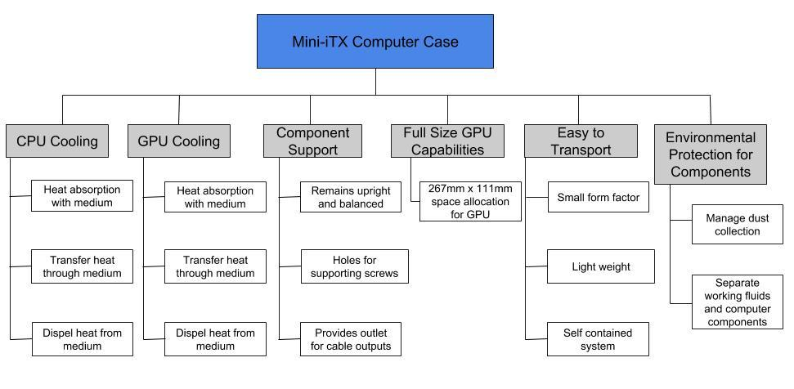

Appendix C: Target Catalog
 | CPU and GPU Cooling
Target |  | Value
CPU Max Temperature |  | 50C
GPU Max Temperature |  | 70C
Noise Level |  | 35 dBA
 | Reference GPU Capability
Target |  | Value
Adequate GPU Space |  | 267mm x 111mm
Adequate Clearance for Cooling |  | 287mm x 131mm

 | Environmental Protection
Target |  | Value
Cooling Leaks |  | 0
Dust Filters |  | 2-3
 | Component Support
Target |  | Value
Power Supply |  | 1
Motherboard |  | 1
GPU |  | 1
CPU |  | 1
Memory Slots |  | 2
SSD Slots |  | 2
 | Portability
Target |  | Value
Weight |  | 4.5 kg
Size |  | <7.5L

Appendix D: Figures and Tables
Case | Weight (kg) | Volume (L) | Price ($) | # 2.5" Slots | Power Source
Dr. Zaber Sentry | 2.90 | 6.9 | N/A | 2 | SFX
DAN A4-SFX v2 | 1.25 | 7.2 | 264.99 | 2 | SFX
Corsair Carbide Series 270R | 3.30 | 44.9 | 74.99 | 2 | ATX
NZXT H200i | 6.00 | 26.1 | 142.99 | 4 | ATX
Corsair Crystal 280X RGB | 7.10 | 38.5 | 109.99 | 4 | ATX
Thermaltake P1 Mini ITX | 2.72 | 54.4 | 109.99 | 2 | ATX
SilverStone (RVZ02B) | 4.37 | 12 | 89.99 | 3 | SFX
Average | 3.95 | 27.14
Cooling System | Weight (kg) | Size | Noise | Voltage Rating | Fan Airflow (per fan) | Fan Static Pressure
MasterLiquid Maker 92 | 0.875 | 99.9 x 81.6 x 167.5mm | <42 dBA | 12 VDC | 49.7 CFM | 6.4 mmH2O
MasterLiquid Pro 140 | 1.5 | 171 x 138 x 27 mm | <42 dBA | 12 VDC | 64.2 CFM | 3.15 mmH2O
Corsair Hydro Series H100i PRO | 0.75 | 276mm x 120mm x 27mm | <32 dBA | Not Given | 75 CFM | 4.2 mmH2O
EKWB Ek Fluid Gaming s240 | 2.94 | 370.8mm x 233.7mm x 124.5mm | <29.5 dBA | Not Given | 107 CFM | 2.24 mmH2O

House of Quality
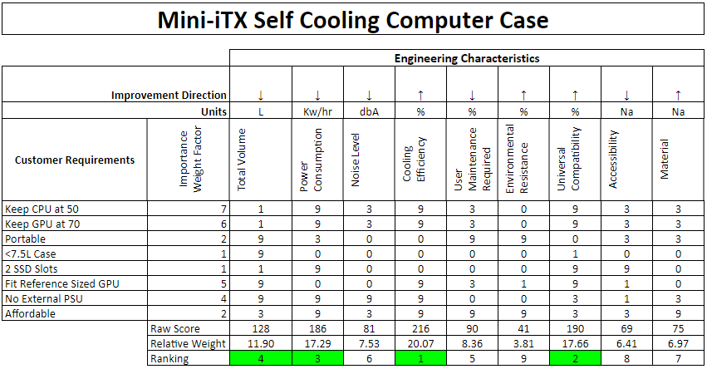

AHP Example

Comparing Design Ideas with respect to Universal Compatibility
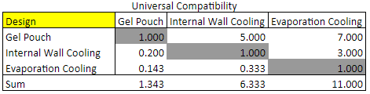

Normalized Values from above

Consistency Check
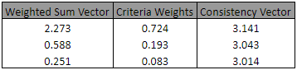

Consistent Comparison
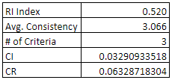

References
There are no sources in the current document.

