This section discusses the procedure completed by the team to come to a final design concept. Following concept generation, the team narrowed the options to eight possible which can be seen in table five. These eight concepts were then analyzed and compared through a process using a House of Quality, a Pugh chart, and an analytical hierarchy process.
Table 5 Final Eight Concepts for “The Detector Baby”

Concept | Passenger Detection/ Vital Reading | Interior Temperature Detection | Critical Temperature Cut Off | Secondary Response Device
1 | 1 | 2 | 1 | 3
2 | 5 | 2 | 1 | 1
3 | 6 | 1 | 1 | 3
4 | 2 | 3 | 2 | 1
5 | 3 | 4 | 2 | 2
6 | 5 | 1 | 1 | 4
7 | 1 | 1 | 1 | 1
8 | 4 | 2 | 1 | 1

House of Quality
The House of Quality was the first step we took in our concept selection process. A House of Quality is used for defining the relationship between customer desire and product capabilities. We took our customer requirements and compared them to the engineering characteristics that will essentially be factors within the design process and how the product is configured. The ranking system is on a scale from 1-9, 1 being least impactful in comparison and 9 being the most impactful when comparing the customer requirement to engineering characteristic. The engineering characteristics are as follows:

- Importance Weight Factor
- Defects Minimum Passenger Weight
- Initial Temperature Detection
- Critical Car Temperature
- Alert Tone to User
- Operate in Distance Range
- SOS Signal to Emergency Personnel
- Displays Temperature Ranges
- Power Source/Battery
- Detect - Alert Reaction Time
- Latency/Dormant Period
- Timer
- Displays Passenger Vitals
- Compatibility with Car Seat
- Key Fob Dimensions

The Customer Requirements are as follows:
- Effectively Alerts User
- Effectively Alerts Emergency Personnel
- Accurately Reads Interior Temperature
- Portable Secondary Device (Small)
- Compatibility with Car Seat
- Weighs Passenger
- Affordable
- Heat Resistance
- Snooze/ Void Feature
- Detects Baby Vitals

Once the House of Quality is properly filled out a “Raw Score” and “Relative Weight” is calculated a decision can be made about which concept will be best. From the relative weight the engineering characteristics are ranked in order of highest importance to lowest. This lets the team know which engineering requirements should be focused on to integrate the customer’s voice in the design.
Table 6 House of Quality for “The Detector Baby”
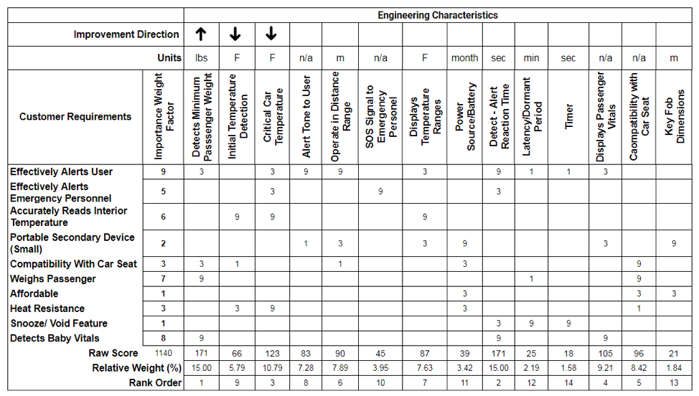
Pugh Matrixes
The next concept selection technique used was a Pugh Chart. Pugh’s method compares each concept to a specific datum concept, which in our case is the Elpho eClip. Each criterion determines whether the concept in question is better than (plus), worse than (minus), or about the same (same) as the datum concept. The design team first choose the criteria on which the concepts would be evaluated. This was done by choosing the ten highest ranked engineering characteristics produced from the house of quality. The criteria evaluated are as follows:
- Detects Minimum Passenger Weight
- Detect - Alert - Reaction Time
- Critical Car Temperature
- Displays Passenger Vitals
- Compatibility with Car Seat
- Operate in Distance Range
- Displays Temperature Ranges
- Alert Tone to User
- Initial Temperature Detection
- SOS Signal to Emergency Personnel

The design team then formulated three Pugh charts to narrow down the three final designs. The primary matrix included all eight designs being compared to a datum. The datum, a competitor, was chosen to be the Elpho eClip as the product has similar features that are desired in our final design. The Elpho eClip is a detection device that hooks to the seat buckle inside of a car and has a secondary key fob device that alarms when the two devices are more than 15 feet apart. It also has the ability to detect when temperatures become too cold or too hot inside the car,but does not display the temperature. The matrix was filled out by comparing the baby detector design concepts with the Elpho eClip, the number of pluses and minus were added up and then a new datum was chosen. The differential between the pluses and minuses was compared for each concept. Concept eight was chosen as the new datum because it had a high number of pulses, no minuses, and a differential of 5. It also had a plus in the number one concerned engineering characteristic. A new Pugh chart was then completed with concept eight as the new datum being compared to concepts one, two, three, five, and seven as they received the least differentials between the pluses and minuses. After completing the matrix, a new datum was chosen, which was concept three since it received the highest number of pluses. A third Pugh Chart was completed using concept three as the new datum compared to concept one, two, and seven as they had the lowest differentials of pluses and minuses. After completing the final matrix, the team chose to continue with concepts one, two, and seven because of their improvements over the datum in the top engineering characteristic categories.
Table 7 Primary Pugh Chart
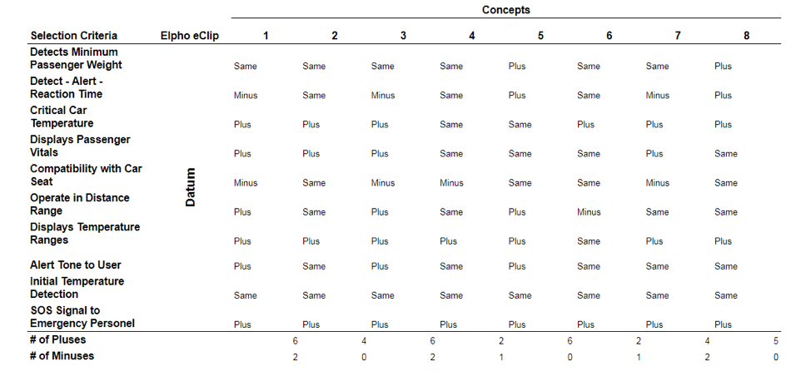

Table 8 Second Pugh Chart
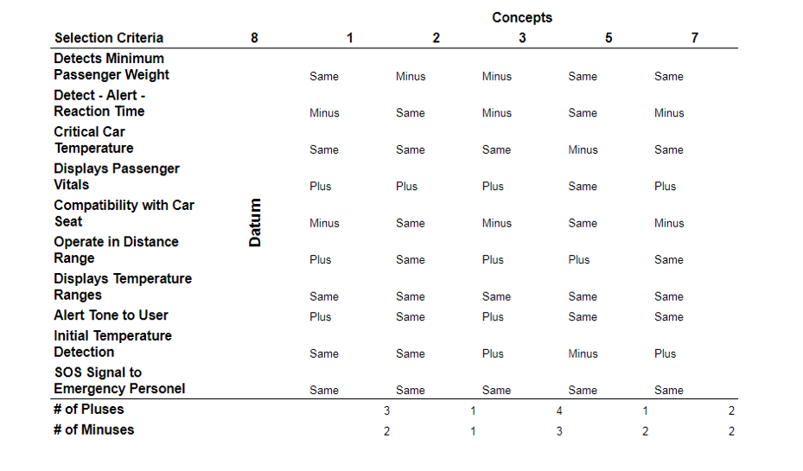
Table 9 Third Pugh Chart
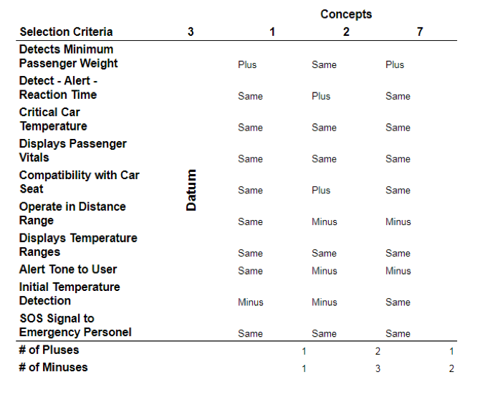
Analytical Hierarchy Process (AHP)
The iterations of the Pugh matrix helped narrow down the designs to concepts one, two, and seven, which were then evaluated in the analytical hierarchy process to establish numerical weights for each engineering characteristic and design concept. First, the top ten engineering characteristics were compared with themselves on a scale of one to nine in terms of how much more important one is compared to the other, nine being significantly more important. This matrix was then normalized and can be seen in table 10. Averaging each row in the matrix gave a criteria weight for each engineering concept. By multiplying the criteria weight matrix with the non-normalized matrix for the engineering concepts, a weighted sum vector was produced. The consistency vector was produced by dividing the weighted sum vector by their respective weights and then the average was taken. This average was used to determine the Consistency Index (CI) and Consistency Ratio (CR) values of the top ten engineering characteristics. A similar process was done for the final three concepts. A comparison chart was completed for each engineering characteristic to rank the importance between the concepts based on a certain engineering characteristic. Once this was completed for all ten engineering characteristics then a final rating matrix was formed including all the criteria weight values derived from the previous step. The alternative values were then calculated by multiplying the transpose of the final rating matrix and the criteria weight values found from the comparison of the engineering characteristic. The alternative values express which concept overall contributes to the success of the project based on the engineering concepts. The highest value would then be the concept to choose as a final design. Table 12 shows the final weights for each of the three final concepts. In our case this design is concept 7.

Table 10 Criteria Comparison Matrix
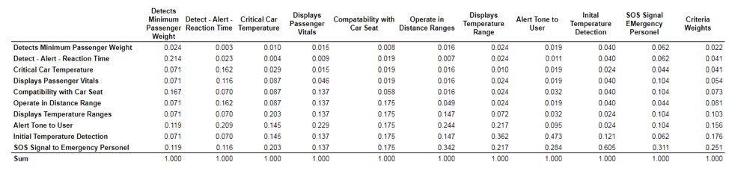
Table 11 Final Rating Matrix
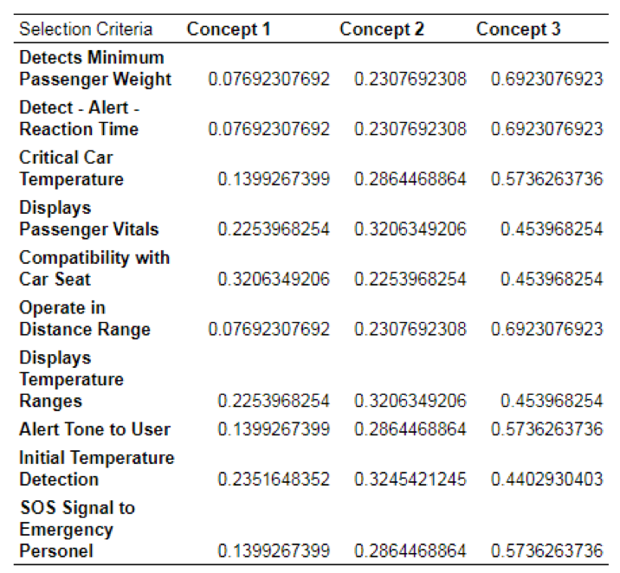

Table 12 Alternative Values for the Final Three Concepts
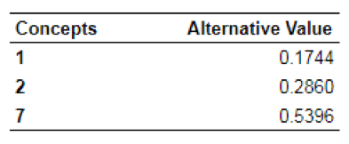

Final Design
The final chosen design for “The Detector Baby” was determined to be concept seven. Concept seven is a combination of the heart rate monitor bracelet that would be worn by the infant, a positive/negative temperature coefficient thermistor, a tracker of the rate of temperature increase, and a key fob that the user will carry with them to be alerted. This system will have both devices communicating over what the current situation in the vehicle is back and forth. This will let the user know if a passenger is still present in the vehicle, the current temperature in the car, and the rate at which temperature is increasing or decreasing. This concept was ultimately chosen due to its reliability to determine the baby’s vitals, accurately alter the user at the appropriate time, and would have fast reaction time system. The key fob is a practical choice given that the user will have their car keys when locking their vehicle. In order to keep designing cost down the thermistor was the appropriate selection. Overall this concept scored a good number of pulses in the Pugh charts and received the highest alternative value when completing the analytical hierarchy process.

