This section includes the concepts the team created. The system was broken down into four parts. These four parts, along with their different solutions, are included in the morphological chart below. Following the table is a description of each mechanism along with pictures or illustrations. From the created morphological chart there is a possible 6x4x2x4 = 192 concepts that can be created. Table 4 shows the top five concepts created with different combinations.

Table 3 Morphological Chart for “The Detector Baby”

Mechanism | Passenger Detection/ Vital Reading | Interior Temperature Detection | Critical Temperature Cut off | Secondary Response Device
1 | Heart Rate Monitor Bracelet | Positive/ Negative Temperature Coefficient Thermistor | Rate of Temperature Increase | Key Fob
2 | Smart Lock Mechanism | Resistance Temperature Detector (RTD) Sensor | Maximum/ Minimum Absolute Temperature | Phone App
3 | Airbag Technology Weight Detection | Thermocouple |  | Smart Watch
4 | Scale Mechanism Compatible with Car Seats | Semiconductor Based Sensors |  | Pager
5 | Baby Monitor Attached to Car Seat Buckles
6 | Smart Baby Onesie

Passenger Detection / Vital Reading
This component of the project is one of the main focuses of the overall device. The passenger detection component will not only read if there is an object left in the seat of the car, but will also monitor the vitals of the passenger if the elements of the surroundings begin to become unsafe or life threatening.

Mechanism 1. Heart Rate Monitor Bracelet
This concept is a bracelet that will have the characteristics of reading a heart rate similar to that of numerous exercise watches, fit bands etc. When detached from the passenger the heart rate will not be available for reading. When the bracelet is attached to a passenger it will continue to monitor heart rate and alert a receiving device when the passenger reaches an unsafe “at rest” heart rate of over 100 beats per minute.
Figure 2. Drawing of Heart Rate Monitor Baby Would Wear
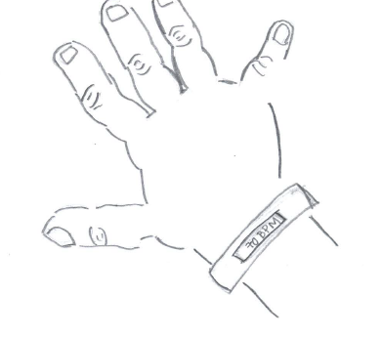

Mechanism 2. Smart Lock
This is a concept that would be connected to an alarm system that would go off if the car is parked and locked while a passenger is still left inside the car. The alarm will not turn off until the child is removed from the car.

Mechanism 3. Airbag Technology Weight Detection
This concept consists of components deriving from the functions of the front seat weight detector that is placed under the seat for airbags, which generally can be seen in most make and models indicated by an “airbag” light. Instead of notifying the driver that the airbag is operational when weight is sensed it will instead be a first step notification to the driver should a passenger, detected by weight, is left in the seat for too long after the engine is turned off.

Mechanism 4. Scale Mechanism Compatible with Car Seat
This concept will be similar to Mechanism 3, however with a more integrated system as part of the car seat. This concept will be solely made for the use of car seats and will have the passenger placed in seat with an unnoticed detector below the fabric of the car seat that can alert the driver if a child is left unattended while the car seat is still in use.
Figure 3. Drawing of Scale Mechanism Inserted in Baby Car Seat
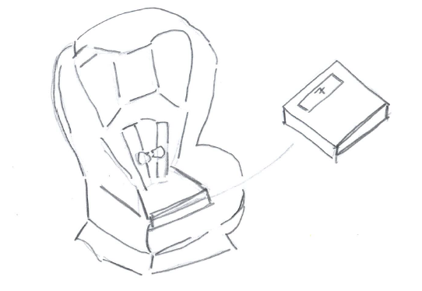

Mechanism 5. Baby Monitor Attached to Car Seat Buckles
This concept is geared to alert the driver of the conditions of their passenger when left in a car unattended. There will be a “baby monitor” that can alert the driver of any unusual movement or noise that is close to where the seat is buckled; this will eliminate the need to have to physically attach a monitor every time the car/car seat is occupied.
Figure 4. Drawing of Baby Monitor Attached to Car Seat Buckles
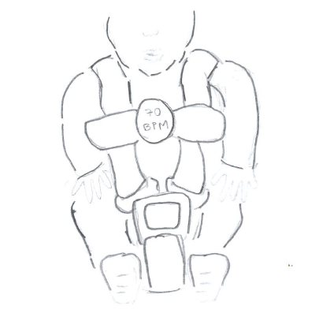

Mechanism 6. Smart Baby Onesie
This is a vital reading onesie that is cute and comfortable for the child to wear, and it will also monitor any abnormalities in vital life signs and alert the parent.
Figure 5. Drawing of Smart Baby Onesie
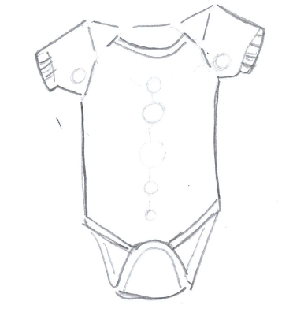
Interior Temperature Detection
This component of the project is separate from the main device located in the car and is mainly responsible for alerting and informing the user/parent when they have left their child behind in the car and if the environment is life threatening.

Mechanism 1. Positive or Negative Temperature Coefficient Thermistor
A temperature coefficient thermistor is a sensor that has an electrical resistance, which either raises or lowers with changing temperature. A positive temperature coefficient thermistor’s resistance increases with increasing temperature, while the negative temperature coefficient thermistor’s resistance decreases with increasing temperature. These can be made from metallic compounds or single crystal semiconductors, which can directly affect the resolution and temperature sensitivity of the thermistors. Generally, they are used in temperature ranges between -50 to 150 degrees Celsius with accuracy of 0.05 to 1.5 degrees Celsius (Ametherm Circuit Protection Thermistors).
Figure 6. Temperature Coefficient Thermistor
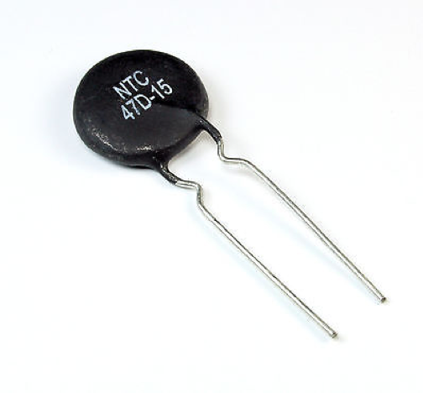

Mechanism 2. Resistance Temperature Detectors (RTD) Sensor
A resistance temperature detector also uses an electrical resistance that is sensitive to temperature changes. It is composed of a coil of wire wrapped around a glass or silicone core. The material of the wire affects the sensitivity of the RTD sensor, where the most accurate and expensive are made of platinum, and the inexpensive ones consist of nickel or copper. These have a larger temperature detection range compared to thermistors. The effective range for platinum RTD’s is between -200 and 850 degrees Celsius (Omega).
Figure 7. Resistance Temperature Detectors (RTD) Sensor
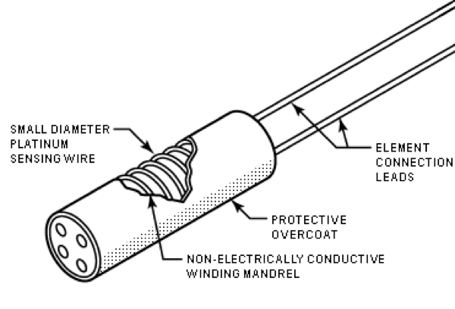

Mechanism 3. Thermocouples
According to the Seebeck effect, a temperature difference between two metals will create electricity. Thermocouples rely on this phenomenon by creating a loop with semiconducting metals when inserted between a temperature gradient. When the electricity is created, the voltage is measured and then translated to read the temperature difference between the materials. The type of thermocouple used is dependent on the material used. The most common and most inexpensive thermocouple is type K, which has a large range of temperature detection between -270 and 1260 degrees Celsius (Thermocouple Info).
Figure 8. Thermocouple
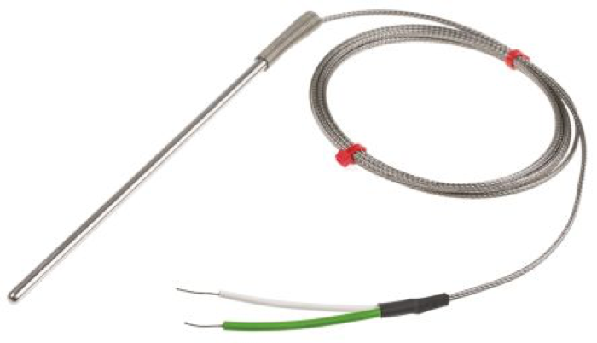

Mechanism 4. Semiconductor-Based Sensor
Semiconductor based sensors are electronic devices placed on an integrated circuit used to measure temperatures. Two diodes are placed between a temperature gradient to measure the voltage across which is proportional to the absolute temperature. These devices have an accurate but slow temperature detection system and are used over the range of -40 to 120 degrees Celsius (Capgo).
Figure 9. Semiconductor-Based Sensor
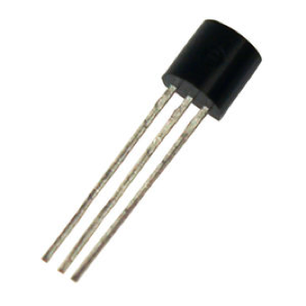

Critical Temperature Cut Off

Method 1. Rate of Temperature Increase
By constantly measuring the rate of change in temperature within the car the system will calibrate on a safe temperature and then register when temperatures within the car are rapidly increasing, or decreasing (in the cold), rapidly which can create life threatening conditions in the car in a very short time. Measuring the rate of increase/decrease in temperature over time will help the system determine whether the conditions are mostly normal, for example, when the air conditioner or heater is running, and the temperature is not changing significantly, or not normal, for example when the car is not running and the temperature within the car is rising or dropping at an alarming rate. If the amount of time between safe conditions and detrimental conditions is determined, the rate at which the baby’s health is impacted can be extrapolated. The system’s alarm will then be calibrated using this rating system.

Method 2. Maximum / Minimum Absolute Temperature
Choosing a specific temperature at which conditions are unstable is less challenging than determining a rate of temperature change but may not be as accurate of a method. In this case, the system is calibrated to respond when a specific temperature is reached inside the car. While this is simpler for the detection system, it may not allow the authorities enough time to respond because the rate of change is not considered, which could in turn cause them to be too late in responding to the situation. Alternately, if the temperature chosen is not critical, then the response may be premature.

Secondary Response Device
This component of the project is separate from the main device located in the car and is mainly responsible for alerting and informing the user/parent when they have left their child behind in the car and if the environment is life threatening.

Mechanism 1. Key Fob
This concept resembles a car key fob, it is small and can be carried on a key ring. This will allow the user to easily transport the device and insure they are in possession of it whenever they lock their car. It will consist of a small screen to display short messages and have buttons that allows the user to dismiss a message, or if there is an emergency send a signal to emergency personnel for a quick response.
Figure 10. Drawing of Key Fob
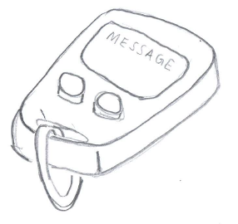

Mechanism 2. Phone App
A phone app would be a practical choice for the twenty first century parents who are always with their phones. The app will include many features including the ability to connect to the messaging system and send notifications to the user should they leave their child behind in the car. The app will also to be able to provide up-to-date readings of the inside temperature of the car along with the passenger’s vital life signs. With the addition of a camera inserted in the vehicle the user will also be able to receive a live video feed to monitor their child.

Mechanism 3. Smart Watch
This concept is a similar idea to that of an Apple watch or Fitbit. The parent user can wear this device and receive quick alerts. Having the product directly attached to the user will guarantee that they will acknowledge any messages received. For example, the user could place their phone or keys in their bag and may not hear the alert. If the user is unable to receive the messages, then that would be considered as an unsuccessful device as it could lead to an unwanted result up to and including possible death of the infant.
Figure 11. Drawing of Smart Watch
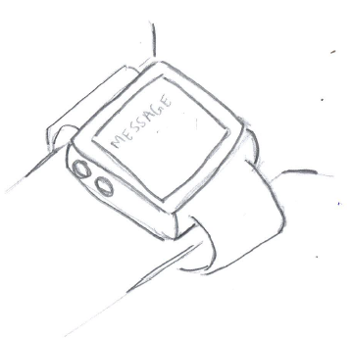

Mechanism 4. Pager
This is a simple solution that the user can carry or attached to their waist. The device will be able to send short messages to the user. This concept is the least practical since pagers are not really used today.
Figure 12. Drawing of Pager
Final Five Concepts
The following table shows five possible combinations from the morphological chart. These are our top five choices.
Table 4 Final Five Concepts Based on Morphological Chart for “The Detector Baby”

Concept | Passenger Detection/ Vital Reading | Interior Temperature Detection | Critical Temperature Cut Off | Secondary Response Device
1 | 1 | 1 | 1 | 3
2 | 5 | 2 | 1 | 1
3 | 6 | 1 | 1 | 3
4 | 2 | 3 | 2 | 1
5 | 3 | 4 | 2 | 2

Concept 1.
The first concept chosen is a combination of the heart rate monitor bracelet that would be worn by the infant, a positive/negative temperature coefficient thermistor, a tracker of the rate of temperature increase, and a smart watch-like device worn by the user. This system will have both wrist devices communicating back and forth the current situation in the vehicle. This will let the user know if a passenger is still present in the vehicle, the current temperature in the car, and the rate at which temperature is increasing or decreasing. This was one of five final concepts chosen people most often wear smart technology on their wrists. Both devices could be connected through an app designed specifically for this system, making it possible to use existing technology.

Concept 2.
The second concept chosen is a mixture of a baby monitor attached to the buckles of a car seat, an RTD sensor, a tracker of the rate of temperature increase, and a key fob. The key fob will display the infant’s vitals which are measured through the baby monitor along with the current temperature in the car. It will also show the rate at which temperature is increasing or decreasing. The reason for choosing this concept is because the monitor is attached to the seat belt buckle, meaning it doesn’t have to be removed. Also, using a key fob means this device will stay on a person’s key chain, which they will always have with their car keys when leaving the house.

Concept 3.
The third concept chosen incorporates a smart baby onesie, a positive/negative temperature coefficient thermistor, a tracker of the rate of temperature fluctuations, and a smartwatch- like device to be worn by the parent. This is a smarter take on the classic baby outfit that would be connected to a smartwatch device and would report the passenger’s vitals along with the current temperature situation in the vehicle. This timeless classic was chosen to keep parents from having to remember to put a device on or around the baby; it would already be incorporated into the clothing.

Concept 4.
The fourth concept chosen combines a smart lock mechanism found in cars with key fobs, a thermocouple, a maximum/minimum absolute temperature tracker, and a key fob. The idea behind this is to alert the parent of a passenger’s presence right after they close their door and try to lock the car. There would be an option to “snooze” the alarm if the parent needs to run an errand, in which case the key fob would report all temperature changes and passenger vitals. This concept made it to the final five because it is the best way to give an initial alert of an infant left behind in a vehicle. It is loud enough for anyone to notice as well as, allowing the parent the opportunity to quickly run an errand.

Concept 5.
The fifth concept chosen is a mashup of weight detection using airbag technology, semiconductor-based sensors, a maximum/minimum absolute temperature tracker, and a phone app. This concept uses the sensors that detect a passenger and trigger airbags in crashes by sensing the weight of an infant in a car seat and triggering and alarm. This would then alert the user through a phone app that is connected to the sensor and would keep track of temperature changes. Because of the availability of the technology within this system this was the final concept selected. Airbags are always on standby when it senses a passenger, and nearly every person has a smartphone with apps.

