Deliverable #2 – Project Plans and Product Specifications
EML 4551C
Dr. Amin

Team 4: Alternative material for compressor casing in turbocharger

Group Members
Oluwalowo Abiodun
Alexander Mankin- Team Webmaster
Harrison McLarty- Project Leader
Ralph Scott
Faculty Adviser
Dr. Peter Kalu
Sponsor
Cummins, Inc. – Roger England
Director, Advanced Manufacturing Technology and Materials Engineering
TABLE OF CONTENTS
1 Needs Assessment 1
2 Project Scope 1
2.1 Problem Statement: 1
2.2 Justification/Background: 1
2.3 Objectives: 1
2.4 Methodology: 2
2.5 Expected Results 2
2.6 Constraints 3
3. Deliverables 4
4 Assign Resources 5
5 Product Specifications 6
5.1 Design Specifications 6
5.2 Performance Specifications 7
6 References 7

1 Needs Assessment
Cummins has presented the team with the challenge of finding a cheaper and more cost effective material to replace the current aluminum casting solution, which is used to fabricate compressor casings in their B series turbochargers.

2 Project Scope

2.1 Problem Statement:
The project sponsor has conveyed the potential benefits for Cummins in selecting a cheaper and more cost effective material to use in fabricating their compressor casing. However, this alternate material must satisfy the current benchmarks and design parameters currently in place by Cummins in producing the compressor casings. Also, it must match or exceed the aluminum casing’s temperature and strength tolerances.

2.2 Justification/Background:
Turbochargers present many advantages in increasing the efficiency of internal combustion engines. The turbocharger essentially diverts heat from the exhaust side of the combustion chamber, which would otherwise be emitted to the atmosphere as waste heat. These hot gases then spin a turbine coupled on a shaft with a compressor. The compressor then is able to draw in atmospheric air which increases the air’s pressure while decreasing its velocity through a diffuser. After passing through the compressor the air’s temperature is considerably higher and is passed through an intercooler to increase its density before it is forced into the combustion chamber. With the increased amount of air there is a reduction in the amount of fuel required to power the vehicle, which increases its efficiency.¹ This particular project is concerned with the intake side of the turbocharger where the compressor is located. Our project sponsor has conveyed a desire to replace the aluminum alloy used to fabricate their compressor casings. Materials which are cheaper to manufacture and process, with the same properties and tolerances as those currently used in products, present huge advantages for companies such as Cummins. The revenue saved from using these more cost efficient materials can be used to increase the quantity of products manufactured and produced. This also allows the company an opportunity to expand its customer base while maintaining the same quality and reliability in its products. Cummins would like to use this approach in its B series turbochargers. The company wants to find a cheaper material capable of replacing the aluminum casting solution around the compressors in their turbochargers.

2.3 Objectives:
- Study the temperatures, pressures, and stresses a compressor experiences under extreme operating conditions
- Find materials, which can possibly withstand the variables and effects listed above , and are cheaper than the aluminum alloy material currently used
- Use cost analysis to discover how much revenue could approximately be gained by selecting some of the alternate materials under consideration
- Use simulations and CAD design to study these materials and their ability to withstand the stresses under operating conditions possibly aided by Finite Element Analysis.
- Use Failure Effect Mode Analysis during the design and simulation phase to narrow the selection process for the materials under consideration.
- Fabricate the compressor casing with the final selected material of choice which offers a fair balance between cost efficiency and emulating the material properties of the original aluminum alloy. Then commence testing with the prototype casing using a turbocharger provided by our sponsor.

2.4 Methodology:
Theoretical Analysis
- Research and study different materials and there properties to establish a data base of possible alternative materials for use in the turbo compressor casing.
- Study current turbo chargers and there compressor casings to analyses the different temperatures and stresses that they are expected to endure so we can model and test our new materials to the current standards.
- Use CAD models of the current turbocharger used on the Cummins 6.7 liters B-series motor to more accurately study the current compressor casing, and use the learned knowledge towards the development of a compressor casing made of a new material.
Experimental Analysis
- Work with the projects sponsor to try and develop prototypes of compressor casings made from different materials. These prototypes will then be used to test the durability and functionality of the new materials.
- Set up the proper testing rig with the appropriate instrumentation to accurately test and study each of the prototypes.
- Analyze the results gathered from testing the different prototypes and compare the data gathered to the specifications that the current aluminum compressor casing is held to.
- From the results gathered from the testing determine which of the new materials would provide the best alternative to the current aluminum compressor casing, or determine if aluminum still remains the best material to use.

2.5 Expected Results
The results that we feel should be expected and achieved are the following. First to be able to research new materials that could prove to be a practical alternative to the current aluminum for the use in the turbo charger compressor casing. Secondly test prototypes made of each of the alternative materials and compare the results to the aluminum compressor casings, to see if they meet the current standard. Finally see if the materials prove to not only be as strong and reliable as aluminum but more cost effective, and cheaper to manufacture.

2.6 Constraints
Cost:
Our main constraint for this project is the cost of the compressor itself. The sponsor made it clear that his concern was the overall cost of materials and manufacturing of this product while also keeping it as functional as the previously designed part.
Design:
The design of the compressor itself should be the same as the previous model; only slight changes can be made. It is already a proven design and there are many special constraints due to the small amount of open space in engine bays.
Weight:
Weight is not a main constraint in this project but if it is also possible to do so, a lighter weight material than the current one in use is desired.

Time and Budget:
Our total budget allotted for this project is $2000. The preliminary design and ordering of parts or materials should be completed by the end of fall of 2013.
Fig.1 Image of compressor casing taken from CAD assembly provided by project sponsor

3. Deliverables

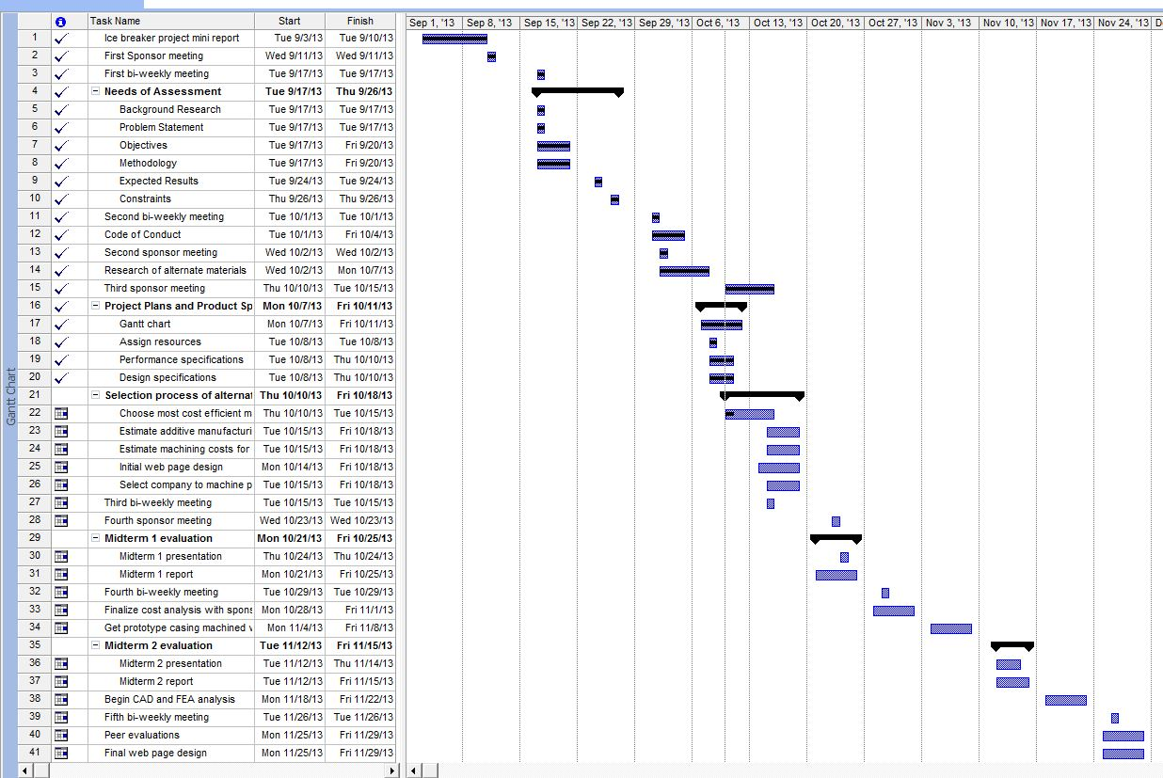
Fig. 2 Gantt chart summarizing list of deliverables and tasks to be completed for Fall 2013 semester
Fig. 3 Gantt chart continued for Fall 2013 semester

4 Assign Resources
Team Leader – Harrison McLarty
The team leader will be responsible for managing communication between team members and with the project sponsor. Responsibilities also include assigning tasks to team members equally and providing expectations for these objectives. Tasks will include completing deliverables, project presentations, bi-weekly reports, and assuring a satisfactory solution for the demands of the sponsor. In addition the team leader will assist in researching and prototyping materials selected to replace the aluminum alloy currently in use by Cummins. This will include researching companies who can machine the compressor casing based on the alternate material chosen. Machining and labor costs for the compressor casing will also be obtained from the company ultimately chosen. Finally, the team leader will assist in finalizing the completion of deliverables and presentations.
Team members:
Web Design Master: Alexander Mankin
The web design master will be assigned with keeping the group website up to date and current. All deliverables, reports, and presentations will be uploaded to the website. The team will assist the web design master in selecting a template and format for the website, and will provide assistance if needed. In addition the web design master will use Finite Element Analysis to obtain theoretical data on the alternate material ultimately chosen.
Financial Advisor: Ralph Scott
The financial advisor will be responsible for organizing supplies needed for the project and their estimated cost. The advisor will update on the team on estimated costs of supplies and the current balance. The main responsibility of the financial advisor is to ensure the team possesses responsible spending practices and ensure that with the supplied funds the project is completed efficiently. The financial advisor will also assist the team leader in calculating the machining and labor costs associated with the prototype compressor casing.

Materials and Metallurgical Advisor: Oluwalowo Abiodun
The materials and metallurgical advisor will provide input and suggestions for the most effective materials to be used in replacing the aluminum alloy currently used by Cummins. All team members will complete research for alternate materials and the materials advisor can provide suggestions and comments on the quality and effectiveness of the materials selected.
All team members:
The project sponsor has expressed a desire for the team to calculate the additive manufacturing costs for the material chosen, and an annual cost estimate to fabricate these casings based on the alternate material. This will provide the sponsor with a comparison between the current production costs and the proposed costs associated with the alternate material. It will be the group’s responsibility to estimate these costs collectively. Also, all group members will present their findings for an alternate material and the final material chosen will be the one which is most cost efficient based on an estimate of the material and its additives. However, the material must closely match the material properties of the original aluminum alloy, cast aluminum 356, and be able to withstand the operating conditions of the turbocharger. In addition, all group members will assist in completing deliverables, reports, and presentations associated with the project. Finally, there will be a collective effort in analyzing the test results completed on the prototype, which will be completed through resources provided by the project sponsor.

5 Product Specifications

5.1 Design Specifications
There are a few design specifications which the casing must adhere to. This consists of the turbocharger compressor’s geometry, its ability to withstand pressure and temperature, as well as weight. All of these specifications can be measured to ensure the specification is met.
The first main important aspect of the design is that it must feature the same geometry and tolerances (which have not been provided) as the previous cast aluminum model, this is to ensure that it is able to fit in the same constrained space in the engine bay.
The next critical specification is the heat it which it must be able to endure during operation. From testing done by Cummins the highest temperature in the worst and best case scenario were 191 °C and 172 °C respectively. To increase the safety of the compressor, it is recommended by Cummins to have a material which can withstand up to a temperature of 230°C for a long duration of time which can be expected as it is used in an automobile engine.
Pressure produced during the compression process is another issue which must be designed for. The maximum outlet pressure which was found during testing was 215 kpa and 188 kpa in the worst and best case scenarios. The compressor must be able to withstand that amount of pressure and most likely an even higher pressure to ensure no catastrophic failure during operation.
While weight was not a huge issue for the sponsor, the overall design could be improved if it was reduced as it would increase the overall efficiency of a vehicle. The previous model’s weight has not been provided to us but a polymer like material might lead to a large reduction in weight.

5.2 Performance Specifications
Because our project involves replacing an already proven material on an existing product. There are a lot of pre-existing performance specs that will need to be met with the new material we choose for the turbo charger compressor casing. One of the most important being that, it has to withstand the maximum allowable temperature for an extended period of time. Such as during long distance traveling or long hours of continuous use. Also users must not experience any issues with the new turbo charger compressor casing in below freezing conditions, such as cold weather starts and operations. The compressor casing should also be able to withstand and contain a catastrophic failure of the compressor blades caused by over boosting, without shattering. The new turbo compressor casing must be able to provide the same amount air flow rate as the existing material. This is so the new compressor casing is able to give the engine the same amount of power and torque that the current aluminum casing can provide. This new casing must also be able to hold up to the cyclic temperature changes that are experienced in the daily usage of the turbo. For example, having a cold start in below freezing temperatures, then bringing the turbo up to standard operating temperature during driving, then after turning off the engine, having the casing cool back down to below freezing temperatures. This casing needs to be able to do this reliably and consistently over the turbo long lifespan. This new material must also be able to withstand several corrosive materials that would be expected to come in contact with the casing in normal operating conditions. These corrosive materials could possible include, water, salt, oil, fuel, dirt and sand, engine coolant, and various other chemicals that would in and around an engine

6 References
- "How It Works: Two-In-One Turbocharger | Popular Science." Popular Science. N.p., n.d. Web. 26 Sept. 2013. <http://www.popsci.com/content/two-one-turbocharger>.

