Deliverable #1 – Needs Assessment
EML 4551C
Dr. Amin

Team 4: Alternative material for compressor casing in turbocharger

Group Members
Oluwalowo Abiodun
Alexander Mankin- Team Webmaster
Harrison McLarty- Project Leader
Ralph Scott
Faculty Adviser
Dr. Peter Kalu
Sponsor
Cummins, Inc. – Roger England
Director, Advanced Manufacturing Technology and Materials Engineering
TABLE OF CONTENTS
1 Needs Assessment 1
2 Project Scope 1
2.1 Problem Statement: 1
2.2 Justification/Background: 1
2.3 Objectives: 1
2.4 Methodology: 2
2.5 Expected Results 2
2.6 Constraints 3
3 References 4

1 Needs Assessment
Cummins has presented the team with the challenge of finding a cheaper and more cost effective material to replace the current aluminum casting solution, which is used to fabricate compressor casings in their B series turbochargers.

2 Project Scope

2.1 Problem Statement:
The project sponsor has conveyed the potential benefits for Cummins in selecting a cheaper and more cost effective material to use in fabricating their compressor casing. However, this alternate material must satisfy the current benchmarks and design parameters currently in place by Cummins in producing the compressor casings. Also, it must match or exceed the aluminum casing’s temperature and strength tolerances.

2.2 Justification/Background:
Turbochargers present many advantages in increasing the efficiency of internal combustion engines. The turbocharger essentially diverts heat from the exhaust side of the combustion chamber, which would otherwise be emitted to the atmosphere as waste heat. These hot gases then spin a turbine coupled on a shaft with a compressor. The compressor then is able to draw in atmospheric air which increases the air’s pressure while decreasing its velocity through a diffuser. After passing through the compressor the air’s temperature is considerably higher and is passed through an intercooler to increase its density before it is forced into the combustion chamber. With the increased amount of air there is a reduction in the amount of fuel required to power the vehicle, which increases its efficiency.¹ This particular project is concerned with the intake side of the turbocharger where the compressor is located. Our project sponsor has conveyed a desire to replace the aluminum alloy used to fabricate their compressor casings. Materials which are cheaper to manufacture and process, with the same properties and tolerances as those currently used in products, present huge advantages for companies such as Cummins. The revenue saved from using these more cost efficient materials can be used to increase the quantity of products manufactured and produced. This also allows the company an opportunity to expand its customer base while maintaining the same quality and reliability in its products. Cummins would like to use this approach in its B series turbochargers. The company wants to find a cheaper material capable of replacing the aluminum casting solution around the compressors in their turbochargers.

2.3 Objectives:
- Study the temperatures, pressures, and stresses a compressor experiences under extreme operating conditions
- Find materials, which can possibly withstand the variables and effects listed above , and are cheaper than the aluminum alloy material currently used
- Use cost analysis to discover how much revenue could approximately be gained by selecting some of the alternate materials under consideration
- Use simulations and CAD design to study these materials and their ability to withstand the stresses under operating conditions possibly aided by Finite Element Analysis.
- Use Failure Effect Mode Analysis during the design and simulation phase to narrow the selection process for the materials under consideration.
- Fabricate the compressor casing with the final selected material of choice which offers a fair balance between cost efficiency and emulating the material properties of the original aluminum alloy. Then commence testing with the prototype casing using a turbocharger provided by our sponsor.

2.4 Methodology:
Theoretical Analysis
- Research and study different materials and there properties to establish a data base of possible alternative materials for use in the turbo compressor casing.
- Study current turbo chargers and there compressor casings to analyses the different temperatures and stresses that they are expected to endure so we can model and test our new materials to the current standards.
- Use CAD models of the current turbocharger used on the Cummins 6.7 liters B-series motor to more accurately study the current compressor casing, and use the learned knowledge towards the development of a compressor casing made of a new material.
Experimental Analysis
- Work with the projects sponsor to try and develop prototypes of compressor casings made from different materials. These prototypes will then be used to test the durability and functionality of the new materials.
- Set up the proper testing rig with the appropriate instrumentation to accurately test and study each of the prototypes.
- Analyze the results gathered from testing the different prototypes and compare the data gathered to the specifications that the current aluminum compressor casing is held to.
- From the results gathered from the testing determine which of the new materials would provide the best alternative to the current aluminum compressor casing, or determine if aluminum still remains the best material to use.

2.5 Expected Results
The results that we feel should be expected and achieved are the following. First to be able to research new materials that could prove to be a practical alternative to the current aluminum for the use in the turbo charger compressor casing. Secondly test prototypes made of each of the alternative materials and compare the results to the aluminum compressor casings, to see if they meet the current standard. Finally see if the materials prove to not only be as strong and reliable as aluminum but more cost effective, and cheaper to manufacture.

2.6 Constraints
Cost:
Our main constraint for this project is the cost of the compressor itself. The sponsor made it clear that his concern was the overall cost of materials and manufacturing of this product while also keeping it as functional as the previously designed part.
Design:
The design of the compressor itself should be the same as the previous model; only slight changes can be made. It is already a proven design and there are many special constraints due to the small amount of open space in engine bays.
Weight:
Weight is not a main constraint in this project but if it is also possible to do so, a lighter weight material than the current one in use is desired.

Time and Budget:
Our total budget allotted for this project is $2000. The preliminary design and ordering of parts or materials should be completed by the end of fall of 2013.
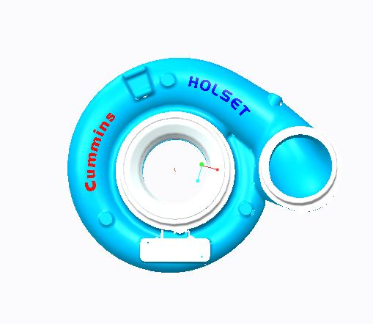
Fig.1 Image of compressor casing taken from CAD assembly provided by project sponsor

3 References
1. "How It Works: Two-In-One Turbocharger | Popular Science." Popular Science. N.p., n.d. Web. 26 Sept. 2013. <http://www.popsci.com/content/two-one-turbocharger>.

