Deliverable #4 – Midterm I – Concept Development
EML 4551C
Dr. Amin

Team 4: Alternative material for compressor casing in turbocharger

Group Members
Alexander Mankin- Team Webmaster
Harrison McLarty- Project Leader
Abiodun Oluwalowo
Ralph Scott
Faculty Adviser
Dr. Peter Kalu
Sponsor
Cummins, Inc. – Roger England
Director, Advanced Manufacturing Technology and Materials Engineering
TABLE OF CONTENTS
1. Abstract/ Executive Summary 1
2. Project Overview 1
2.1 Customer Requirement 1
2.2. Project Scope 1
2.2.1 Problem Statement: 1
2.2.2 Justification/Background: 1
2.3 Goals 2
2.4 Objectives: 2
2.4 Constraints 3
3. Design and Analysis 4
4. Risk and reliability Assessment & Environmental and safety 5
5. Detailed design and design for Manufacturing 6
6. Procurement 6
7. Conclusion 7
8. Future plans for prototype and others 7
9. Gantt chart, resources, and budget 9
9.1 Gantt Chart 9
9.2 Resources 10
9.3 Budget 11
10. References 11
11. Appendix 12

1. Abstract/ Executive Summary
The main goal of this project is to produce a cost efficient alternate material to be used on the compressor casing in Cummins B series turbocharger. Currently the company uses cast aluminum 356 to manufacture and produce their compressor casings. Research has commenced on materials, specifically polymers, which could offer long term cost reductions in manufacturing and production costs, but at the same time be reliable and safe to use under the operating conditions in a turbocharger. Operating temperatures and pressures were obtained from the sponsor as well some other stresses and load the compressor experiences under operation in order to find materials which could operate under these conditions. However, these materials must also possess adequate strength and fracture toughness to withstand an over boost event in which the compressor blades are thrown into the casing. Due to all of these considerations the search for adequate materials has been a challenge. Four candidates have been found which seem to satisfy the maximum operational conditions found within the compressor, and possess an adequate strength and fracture toughness. These materials are Extem UH, Fluorsint 500, PEEK, and Rulon 945. A final selection of the appropriate alternate material has not taken place because more information is required on the cost of these materials and their manufacturing methods. However, analysis and comparison of these materials to the required operational conditions have been included in this report.

2. Project Overview

2.1 Customer Requirement
Cummins has presented the team with the challenge of finding a cheaper and more cost effective material to replace the current aluminum casting solution, which is used to fabricate compressor casings in their B series turbochargers.

2.2. Project Scope

2.2.1 Problem Statement:
The project sponsor has conveyed the potential benefits for Cummins in selecting a cheaper and more cost effective material to use in fabricating their compressor casing. However, this alternate material must satisfy the current benchmarks and design parameters currently in place by Cummins in producing the compressor casings. Also, it must match or exceed the aluminum casing’s temperature and strength tolerances.

2.2.2 Justification/Background:
Turbochargers present many advantages in increasing the efficiency of internal combustion engines. The turbocharger essentially diverts heat from the exhaust side of the combustion chamber, which would otherwise be emitted to the atmosphere as waste heat. These hot gases then spin a turbine coupled on a shaft with a compressor. The compressor then is able to draw in atmospheric air which increases the air’s pressure while decreasing its velocity through a diffuser. After passing through the compressor the air’s temperature is considerably higher and is passed through an intercooler to increase its density before it is forced into the combustion chamber. With the increased amount of air there is a reduction in the amount of fuel required to power the vehicle, which increases its efficiency.¹ This particular project is concerned with the intake side of the turbocharger where the compressor is located. Our project sponsor has conveyed a desire to replace the aluminum alloy used to fabricate their compressor casings. Materials which are cheaper to manufacture and process, with the same properties and tolerances as those currently used in products, present huge advantages for companies such as Cummins. The revenue saved from using these more cost efficient materials can be used to increase the quantity of products manufactured and produced. This also allows the company an opportunity to expand its customer base while maintaining the same quality and reliability in its products. Cummins would like to use this approach in its B series turbochargers. The company wants to find a cheaper material capable of replacing the aluminum casting solution around the compressors in their turbochargers.

2.3 Goals
The goals that we feel should be achieved are the following. First to be able to research new materials that could prove to be a practical alternative to the current aluminum for the use in the turbo charger compressor casing. Secondly test prototypes made of each of the alternative materials and compare the results to the aluminum compressor casings, to see if they meet the current standard. Finally see if the materials prove to not only be as strong and reliable as aluminum but more cost effective, and cheaper to manufacture.

2.4 Objectives:
- Study the temperatures, pressures, and stresses a compressor experiences under extreme operating conditions
- Find materials, which can possibly withstand the variables and effects listed above , and are cheaper than the aluminum alloy material currently used
- Use cost analysis to discover how much revenue could approximately be gained by selecting some of the alternate materials under consideration
- Use simulations and CAD design to study these materials and their ability to withstand the stresses under operating conditions possibly aided by Finite Element Analysis.
- Use Failure Effect Mode Analysis during the design and simulation phase to narrow the selection process for the materials under consideration.
- Fabricate the compressor casing with the final selected material of choice which offers a fair balance between cost efficiency and emulating the material properties of the original aluminum alloy. Then commence testing with the prototype casing using a turbocharger provided by our sponsor.

2.4 Constraints
Cost:
Our main constraint for this project is the cost of the compressor itself. The sponsor made it clear that his concern was the overall cost of materials and manufacturing of this product while also keeping it as functional as the previously designed part.
Design:
The design of the compressor itself should be the same as the previous model; only slight changes can be made. It is already a proven design and there are many special constraints due to the small amount of open space in engine bays.
Weight:
Weight is not a main constraint in this project but if it is also possible to do so, a lighter weight material than the current one in use is desired.

Time and Budget:
Our total budget allotted for this project is $2000. The preliminary design and ordering of parts or materials should be completed by the end of fall of 2013.
Fig.1 Image of compressor casing taken from CAD assembly provided by project sponsor

3. Design and Analysis
Functional Analysis
Here is a Functional Analysis diagram of how a turbo charger works.
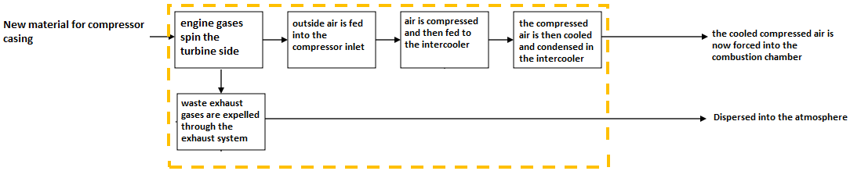
Design Concepts
Our design Concepts would be the multiple alternate materials that we have found through the research we have done up to this point. Through comparison of the current aluminum 356’s material characteristics, we have deemed these materials as possible candidates to replace the existing aluminum 356 as the material of choice in turbocharger compressor casings.
The first material we have selected is a polymer called Extem UH. Based on material properties alone this material seems capable of being a candidate to replace aluminum 356. The key properties that make this a viable material are the following. To begin, it has a tensile strength of 120 MPa, comparing that with aluminum 356, which has a tensile strength of 124 MPa, shows that these two materials have similar tensile strengths. One of the most important characteristics it displays is its ability to operate continuously at 230°C, which is right at our required 230°C mark. Also this material displays good ductile characteristics, with an elongation at break of 19-20%. This will help with the materials ability to withstand impacts without fragmenting. Some other advantages of this material are its ability to perform from temperatures below zero all the way up to 230°C, as well as good processability and chemical resistant’s. Some of the weaknesses would be that, at any temperature above 275°C the material will start to soften, and currently the cost of the material is unknown. Which if it his higher than aluminum 356, it becomes no longer viable.
The second material we selected was Fluorosint 500. Fluorosint has a continuous operating temperature of 260°C, which is above the limit set by our sponsor. It also is very ductile, with an elongation at break of 30%. Some additional advantages would be that it has machinability of 2 on a scale of 1-10 with one being the easiest to machine. This will prove helpful in the prototyping stage of our project. It also is nonabrasive to most mating materials which will be beneficial to any rubber hoses or fittings that will be attached to the compressor casing. It also displays good wear characteristics, which will help with the durability of the casing. Some of the weaknesses would be that it has a tensile strength of 7.58 MPa which is much lower than aluminum 356. Also the initial cost estimates seem high which could deter any further investigation into this material.
The third material is PEEK (polyetheretherketone) 30% carbon-filled. It has a continuous operating temperature of 260°C, which like Flourosint, is above our max temperature requirement. It also has a very high deflection temperature at 264 PSI of 316°C. this shows that not only can the material with stand the temperature generated in and around the compressor casing, but can also with stand well above the pressure requirements of 28 PSI. Its advantages include, excellent flexural, and impact characteristics, as well as exceptional chemical resistance and wear and abrasion resistance. The weaknesses of this material would be that it is the most brittle of the alternative materials, with an elongation at break of only 1.1%. But other than that it seems to not have any other major weaknesses.
The final material we have selected is Rulon 945. It has a continuous operating temperature of 288°C which is the highest of all the previous materials. But with an elongation at break of 20%, it is also ductile. Its advantages include low deformation under load, and high impact resistant. This high impact resistance is very important, because if the compressor shaft/blades have a catastrophic failure, the compressor casing needs to be able to contain it. It also has excellent abrasion resistance. The weaknesses of the material would be that, it has a low tensile strength of only 20.7 MPa. It also displays very little insulative properties, which may or may not be an issue with this compressor casing.
As far as manufacturing considerations, whereas the aluminum compressor casing was cast, compressor casings made from these polymer materials will most likely have to be injected molded. At this point in our research we have yet to conclude how much this will cost compared to that of casting aluminum. For prototypes however, a solid block of these materials would have to be ordered and then given to a machinist who would then machine a compressor casing from the block of material.
Evaluation of designs
The selected materials were evaluated based on their material properties. These properties were then compared to the properties of the current material, aluminum 356, as well as the design requirements given to us by our sponsor. With the main requirement being the 230°C max heat requirement. So after looking at these requirements we were able to weed out any materials that did not stand up to the requirements, and select ones that did.

4. Risk and reliability Assessment & Environmental and safety
There are several risks involved with selecting an alternate material for a device such as a compressor casing in a turbocharger. Due to the widespread use and importance of these devices it is crucial that any alternate material selected, even if cost efficient, be able to safely operate and withstand the physical conditions associated with a working turbocharger in an automobile. The catalyst of these potential risks can be attributed to the high operating temperatures associated with the compressor during operation and the relatively high pressures seen in its piping network.
The environments in which automobiles are used can also have a significant impact on the materials used to fabricate the compressor casing. Any alternate material considered must be able to operate under cyclic temperatures, for example from below zero freezing weather to normal operating conditions. Materials not suitable for these environments or operating conditions can fail catastrophically, leading to loss of property or life. Also, corrosive materials such as salt, dirt, engine coolant, oil, and other chemicals pose risks for the safe operation of a compressor casing. Therefore, the alternate material should be corrosion resistant to prevent failure and extend the lifetime of the product.
There is also the danger of an over boost event occurring where the compressor wheel within the housing becomes unbalanced and shatters within the compressor casing. Therefore, the fracture strength of the material must be high enough to contain and absorb the energy of such an impact. Again, materials with low fracture strength pose a serious threat to the operational status of the automobile and could endanger people within and around the vehicle. These liabilities are important issues for Cummins and must be taken into account when selecting an alternate material to replace the current cast aluminum solution. Although cost is an important factor for this project, the reliability and safe operation of this compressor casing is of utmost importance, which is directly dependent on the alternate material selected. Therefore these risks must be considered during the duration of the selection phase.

5. Detailed design and design for Manufacturing
Currently Cummins uses a casting solution to construct its compressor casing based on cast aluminum 356. For this project the team is considering more cost efficient materials and manufacturing processes. Based on these criteria the team will attempt to research and select a polymer material, which would cost less to manufacture and as a material. However, the design of the compressor casing must remain the same to ensure compatibility with their current turbochargers. Therefore no change in design will be considered for this project and all geometric tolerances will remain the same. One of the main issues for this project will be in researching, which manufacturing method would be most cost efficient for Cummins to employ in production of these compressor casings based on the selected alternate material. More research and information will be required in this area as this is a large portion of the project requirement. However, the team has begun preliminary insight into injection molding methods, 3-D printing, and perhaps an extrusion method.

6. Procurement
Currently the team has not completed any purchase orders and will not do so until an alternate material has been selected. However, there are potential vendors for some of the materials the team is considering, two of these being Professional Plastics and Ensinger. Both companies were seen to be promising in possessing polymers which could operate under the conditions found in the compressor in the turbocharger. The next step will to be contact companies such as these to receive quotes and question them about the best way to produce prototypes of the compressor casing based on one of their polymer materials.

7. Conclusion
From the research done at this time, the team has found that polymers most likely are the best candidates to replace the aluminum alloy. This material must be lower in cost than the current alloy and be able to withstand the operating conditions which the casing undergoes. These materials were researched based on the baseline properties of cast aluminum 356 as well as the data which Cummins found during performance testing. These polymers are Flurosint 500, Rulon 945, PEEK 30% Carbon filled, and Extem UH. These entire materials offer there advantages as well as limitations. The majority of them have similar characteristics to the cast aluminum in terms of tensile yield strength and they are able to operate at temperatures greater than the minimum temperature allowable. We are currently finalizing the choice of material and quotes are being obtained from the respective companies which sell these materials. Once the choice has been made we will construct a prototype and test to determine whether not our material choice will be a viable option. This will be done in conjunction with a cost analysis to prove further whether or not this would be beneficial to our sponsor.

8. Future plans for prototype and others

Our upcoming plans include final selection of material, finite element analysis of the casing, prototyping, and an overall cost analysis. The two most important things from the previously mentioned plans are the finite element analysis as well as the selection of material. Both prototyping and cost analyses are dependent upon those. This is because a prototype should not be made until we determine if our material can withstand the stresses and temperature which is found during the finite element analysis.
Once a material has been chosen, analyzed, and purchased, three prototypes need to be created. As per the sponsor’s orders, it is required that we have them machined from scratch rather than injection molding or other similar techniques. This means that we must find a machinist which is willing to do that much machining which is estimated to be very high due to the size of the casing along with the dimensional tolerances that we must come close to. Previously, the sponsor mentioned that they might be able to pay for the prototyping but that has not been discussed any further after the brief conversation. If the prototyping ends up being paid by our allotted money it is estimated that it will use up our whole $2000 budget.
In terms of finding the actual machinist or prototyping company, our first step is to look locally. This can reduce shipping cost and allow personal interactions with the machinist which can ensure the quality of the prototype. If we cannot find any machinist which is willing to work on this project locally, our next step is to look at prototyping companies which provide an adequate price. More than likely, if we do have to go this route, the cost will most likely rise above $2000 and will require financial help from Cummins in order to fulfill this part of the project.
Once we have found an adequate way to prototype the casing an overall cost analysis based on material cost as well as manufacturing cost can be done. This is important because this is how Cummins can gauge how much benefit this alternate material can provide. During this time we will have to recount manufacturing techniques found during the research and analyze each of the possible ways in order to see if it meets the sponsors standards

9. Gantt chart, resources, and budget

9.1 Gantt Chart

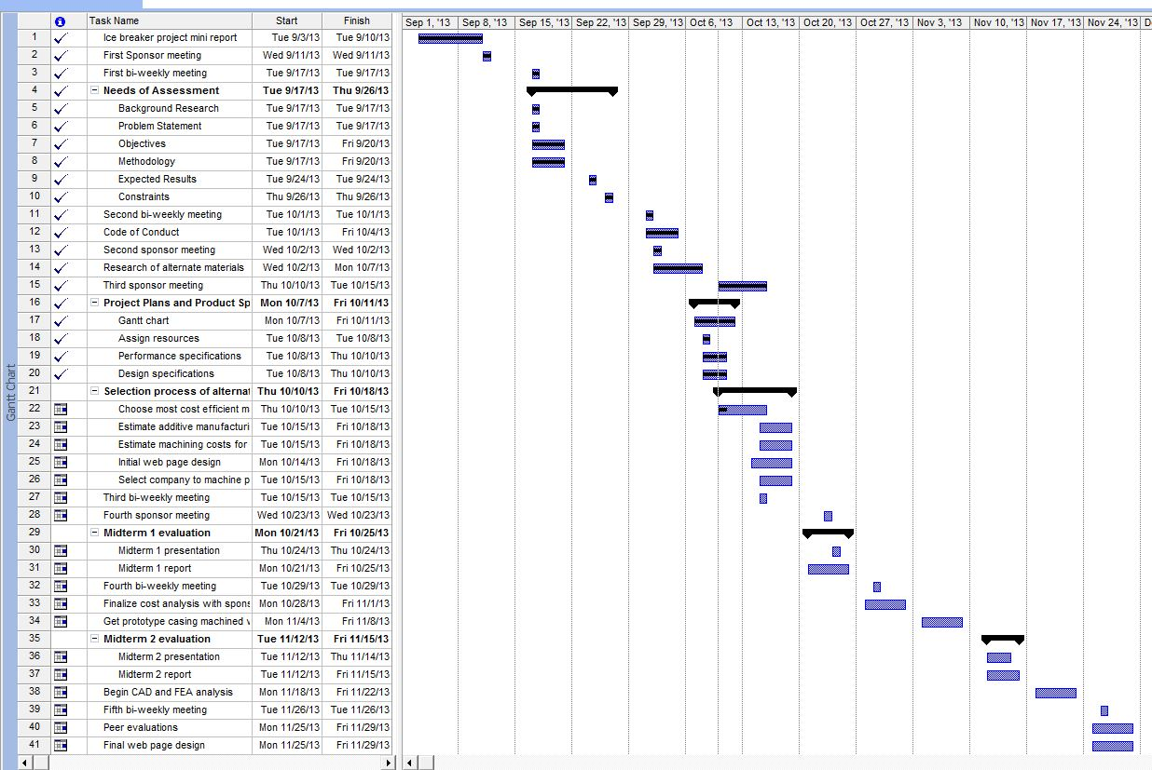
Fig. 2 Gantt chart summarizing list of deliverables and tasks to be completed for Fall 2013 semester
Fig. 3 Gantt chart continued for Fall 2013 semester

9.2 Resources
Team Leader – Harrison McLarty
The team leader will be responsible for managing communication between team members and with the project sponsor. Responsibilities also include assigning tasks to team members equally and providing expectations for these objectives. Tasks will include completing deliverables, project presentations, bi-weekly reports, and assuring a satisfactory solution for the demands of the sponsor. In addition the team leader will assist in researching and prototyping materials selected to replace the aluminum alloy currently in use by Cummins. This will include researching companies who can machine the compressor casing based on the alternate material chosen. Machining and labor costs for the compressor casing will also be obtained from the company ultimately chosen. Finally, the team leader will assist in finalizing the completion of deliverables and presentations.
Team members:
Web Design Master: Alexander Mankin
The web design master will be assigned with keeping the group website up to date and current. All deliverables, reports, and presentations will be uploaded to the website. The team will assist the web design master in selecting a template and format for the website, and will provide assistance if needed. In addition the web design master will use Finite Element Analysis to obtain theoretical data on the alternate material ultimately chosen.
Financial Advisor: Ralph Scott
The financial advisor will be responsible for organizing supplies needed for the project and their estimated cost. The advisor will update on the team on estimated costs of supplies and the current balance. The main responsibility of the financial advisor is to ensure the team possesses responsible spending practices and ensure that with the supplied funds the project is completed efficiently. The financial advisor will also assist the team leader in calculating the machining and labor costs associated with the prototype compressor casing.

Materials and Metallurgical Advisor: Abiodun Oluwalowo
The materials and metallurgical advisor will provide input and suggestions for the most effective materials to be used in replacing the aluminum alloy currently used by Cummins. All team members will complete research for alternate materials and the materials advisor can provide suggestions and comments on the quality and effectiveness of the materials selected.
All team members:
The project sponsor has expressed a desire for the team to calculate the additive manufacturing costs for the material chosen, and an annual cost estimate to fabricate these casings based on the alternate material. This will provide the sponsor with a comparison between the current production costs and the proposed costs associated with the alternate material. It will be the group’s responsibility to estimate these costs collectively. Also, all group members will present their findings for an alternate material and the final material chosen will be the one which is most cost efficient based on an estimate of the material and its additives. However, the material must closely match the material properties of the original aluminum alloy, cast aluminum 356, and be able to withstand the operating conditions of the turbocharger. In addition, all group members will assist in completing deliverables, reports, and presentations associated with the project. Finally, there will be a collective effort in analyzing the test results completed on the prototype, which will be completed through resources provided by the project sponsor.

9.3 Budget
The budget for the project is 2000 dollars

10. References
- "How It Works: Two-In-One Turbocharger | Popular Science." Popular Science. N.p., n.d. Web. 26 Sept. 2013. <http://www.popsci.com/content/two-one-turbocharger>.
- "Online Materials Information Resource - MatWeb." Online Materials Information Resource - MatWeb. N.p., n.d. Web. 21 Oct. 2013. <http://www.matweb.com/>.
- "Plastic Sheet, Plastic Rod, Plastic Tubing - Buy Online." Plastic Sheet, Plastic Rod, Plastic Tubing - Buy Online. N.p., n.d. Web. 21 Oct. 2013. <http://www.professionalplastics.com/>.

11. Appendix

A: Data Table Provided by Cummins
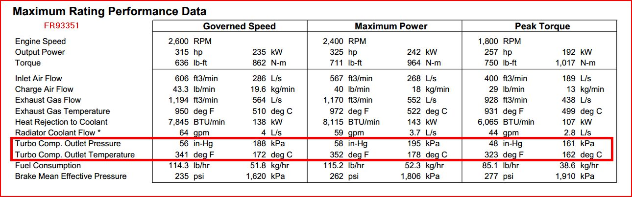

B: Material Properties of Aluminum 356
