SPRING 2014- FINAL REPORT
EML 4552C
Dr. Amin

Team 4: Alternative material for compressor casing in turbocharger

Group Members
Alexander Mankin- Team Webmaster
Harrison McLarty- Project Leader
Abiodun Oluwalowo
Ralph Scott
Faculty Adviser
Dr. Peter Kalu
Sponsor
Cummins, Inc. – Roger England
Director, Advanced Manufacturing Technology and Materials Engineering
TABLE OF CONTENTS
1. Abstract/ Executive Summary 1
2. Project Overview 1
2.1 Customer Requirement 1
2.2. Project Scope 2
2.2.1 Problem Statement: 2
2.2.2 Justification/Background: 2
2.3 Goals 2
2.4 Objectives: 2
2.5 Constraints 3
3. Design and Analysis 4
3.1 Functional Analysis 4
3.2 Design Concepts 4
3.3 Evaluation of Design 5
3.3.1 Finite Element Analysis 5
3.3.1 Finite Element Analysis: Results 6
5. Prototype Details 9
10
6. Design for manufacturing, reliability, and cost 10
6.1. Design for manufacturing 10
6.2. Design for reliability 11
6.3 Design for cost 12
7. Considerations for environment, safety, and ethics 13
8. Communications 13
9. Conclusions 13
10. Recommendations for future work 14
11. Gantt chart, resources, and budget 15
11.1 Gantt Chart 15
11.2 Resources 15
11.3 Budget 17
12. References 17
13. Appendix 18

1. Abstract/ Executive Summary
The main goal of this project was to provide a cost efficient alternate material to be used on the compressor casing in Cummins B series turbocharger. Currently the company uses cast aluminum 356 to manufacture and produce their compressor casings. Research was completed on materials, specifically polymers, which could offer long term reductions in manufacturing and production costs, but at the same time be reliable and safe to use under the operating conditions in a turbocharger. Operating temperatures and pressures were obtained from the sponsor, as well as other stresses and forces the compressor experiences under operation, in order to find materials which could operate under these conditions. In addition, the sponsor requested that this material be able to safely operate up to 230$℃$. These materials also had to possess adequate strength and ductility to withstand a burst event in which the impeller blades break off from the main shaft, due to high internal stresses, and impact into the casing. Due to all of these considerations the search for adequate materials was a challenge. The material PEEK, a polyether ether ketone polymer, was originally considered to be the best choice for an alternate material to be used to fabricate the compressor casings. However, theoretical results, obtained from finite element analysis simulating a burst event, showed that PEEK’s glass transition, 162$℃$, was too low for it to safely contain a burst event at 230$℃$. The mechanical properties of polymer materials, such as PEEK, begin to depreciate after reaching their glass transition temperature, which caused the casing during the analysis to deform significantly. However, another polymer material was researched and analyzed that had a glass transition temperature higher than 230$℃$, and possessed mechanical properties very similar to cast aluminum 356. This material was Torlon and the results obtained from the finite element analysis showed that it would contain a burst event without deforming significantly. A cost analysis was also performed on this material to estimate the manufacturing costs based on an injection molding production method. The cost analysis results showed that Torlon compressor casings would not be cheaper to manufacture than the cast aluminum 356 counterpart. Torlon was found to be a suitable material to replace the cast aluminum casing, but could not provide a financial advantage for Cummins. Future research in this subject should look at more effective near net shape forming processes, which could reduce manufacturing costs with cheaper metal alloys such as aluminum. Based on the senior design team’s research and analysis, polymers and thermoplastic materials, suitable to operate at the necessary conditions, do not offer a financial advantage over the current cast aluminum 356 material.

2. Project Overview

2.1 Customer Requirement
Cummins has presented the team with the challenge of finding a cheaper and more cost effective material to replace the current aluminum casting solution, which is used to fabricate compressor casings in their B series turbochargers.

2.2. Project Scope

2.2.1 Problem Statement:
The project sponsor has conveyed the potential benefits for Cummins in selecting a cheaper and cost effective material to use in fabricating their compressor casing. However, this alternate material must also satisfy the current benchmarks and design parameters currently in place by Cummins in producing the compressor casings. Also, it must match or exceed the aluminum casings’ temperature and strength tolerances.

2.2.2 Justification/Background:
Turbochargers present many advantages in increasing the efficiency of internal combustion engines. The turbocharger essentially diverts heat from the exhaust side of the combustion chamber, which would otherwise be emitted to the atmosphere as waste heat. These hot gases then spin a turbine coupled on a shaft with a compressor. The compressor then is able to draw in atmospheric air which increases the air’s pressure while decreasing its velocity through a diffuser. After passing through the compressor the air’s temperature is considerably higher and is passed through an intercooler to increase its density before it is forced into the combustion chamber. With the increased amount of air there is a reduction in the amount of fuel required to power the vehicle, which increases its efficiency.¹ This particular project is concerned with the intake side of the turbocharger where the compressor is located. Our project sponsor has conveyed a desire to replace the aluminum alloy used to fabricate their compressor casings. Materials which are cheaper to manufacture and process, with the same properties and tolerances as those currently used in products, present huge advantages for companies such as Cummins. The revenue saved from using these more cost efficient materials and manufacturing processes can be used to increase the quantity of products produced. This also allows the company an opportunity to expand its customer base while maintaining the same quality and reliability in its products. Cummins would like to use this approach in its B series turbochargers. The company wants to find a cheaper material and manufacturing process capable of replacing the aluminum casting solution around the compressors in their turbochargers.

2.3 Goals
The goals that we feel should be achieved are the following. First, research alternative materials that possess suitable mechanical properties to operate under the required service conditions. Also, ensure that this material is able to contain a burst event using finite element analysis. Next, perform a cost analysis and estimate the manufacturing costs associated with producing these alternate material based casings. Finally, procure a prototype of the casing for display purposes only.

2.4 Objectives:
- Analyze the temperatures, pressures, and stresses a compressor experiences under maximum operating conditions
- Research materials, which can possibly withstand the variables and effects listed above , and are cheaper than the aluminum alloy material currently used
- Estimate manufacturing costs associated with the alternate material based casings
- Utilize finite element analysis to ensure alternate material can contain a burst event
- Fabricate the compressor casing with the final selected material of choice which offers a fair balance between cost efficiency and emulating the material properties of the original material

2.5 Constraints
Cost:
Our main constraint for this project is the cost of the compressor casing itself. The sponsor made it clear that his concern was the overall cost of materials and manufacturing of this product while also keeping it as functional as the previously designed part.
Design:
The design of the compressor itself should be the same as the previous model; only slight changes can be made. It is already a proven design and there are many special constraints due to the small amount of open space in engine bays.
Weight:
Weight is not a main constraint in this project but if it is also possible to do so, a lighter weight material than the current one in use is desired.

Time and Budget:
Our total budget allotted for this project is $2000. The preliminary design and ordering of parts or materials should be completed by the end of fall of 2013.
Fig.1 Image of compressor casing taken from CAD assembly provided by project sponsor

3. Design and Analysis

3.1 Functional Analysis
Here is a Functional Analysis diagram of how a turbo charger works.
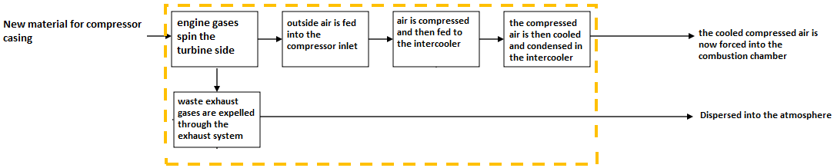

3.2 Design Concepts
Our design Concepts would be the multiple alternate materials that we have found that have proven to meet the demands of the turbo charger compressor casing environment given to us by Cummins. Through comparison of the current aluminum 356’s material characteristics, and with the help of Cummins, who helped verify our material choices, we have been able to successfully eliminate the materials deemed unsuitable for our application. With this knowledge we can now make a more informed and reliable material selection for the turbo charger compressor casing.
The original final material of choice the group selected was a polymer known as PEEK (polyetheretherketone) unfilled. Its advantages include excellent flexural and impact characteristics, as well as exceptional chemical resistance and wear and abrasion resistance. In addition, this material possesses excellent ductility with an elongation at break of approximately 20%. Cummins approved this material to be an acceptable possible replacement for aluminum 356. However, after further research and analysis the glass transition temperature of PEEK was found to be 162$℃$, which prevented it from successfully containing a burst event at the desired maximum operating temperature of 230$℃$. For polymer materials, the glass transition temperature marks a point at which the mechanical strength of the material and other properties begin to significantly change and decrease. Due to the inability of PEEK to successfully contain a burst event at the maximum operating conditions, another material was researched and selected to successfully complete the goal of the project.
This other material is Torlon which is manufactured by Solvay Advanced polymers. It is a polyamide-imide and possess many of the same characteristics and mechanical properties of the PEEK polymer. It also has the ability to be injection molded which is one important trait that it shared with PEEK. The largest and most important difference is its glass transition temperature. For Torlon it is above the maximum operating temperature of 230$℃$ that the casing will experience. This means there will be no degradation of the strength of the casing during operation. This is the main reason why Torlon was chosen as an alternative to PEEK.
As far as manufacturing considerations, whereas the aluminum compressor casing was cast, compressor casings made from these polymer materials will have to be injected molded. For prototypes however, a solid block of these materials would have to be ordered and then given to a machinist who would then machine a compressor casing from the block of material.

3.3 Evaluation of Design
The selected materials were evaluated based on their material properties. These properties were then compared to the properties of the current material, aluminum 356, as well as the design requirements given to us by our sponsor. With the main requirement being the 230°C maximum heat requirement. After looking at these requirements and with the help of our sponsor Cummins, we were able to eliminate any materials that did not stand up to the requirements, and select ones that did.

3.3.1 Finite Element Analysis
As previously discussed one of the main objectives of this project was to analyze different materials to replace the currently used cast aluminum alloy which Cummins uses for this turbocharger. The pressure and temperature reached during operation are crucial factors which must be accounted for when designing a turbocharger and most importantly choosing an adequate replacement material. Due to its operational conditions, it must be able to remain safe during a catastrophic failure of one of its components. For a turbocharger casing this type of failure is called a burst event due to the compressor wheel fracturing and impacting the casing. Therefore, being able to model a materials reaction to the operating conditions and a burst event is crucial when analyzing alternate materials. This analysis was performed using the different modules available in COMSOL Multiphysics.
At beginning of the analysis process, a simplified geometry of the casing was used to first validate the model. This was done by using boundary conditions based on the operational conditions provided by Cummins. The result from this analysis was then compared with the theoretical model of the same geometry. These equations along with the results from this validation can be found in section C in the appendix. The next step, once the model was verified, was to perform the analysis on a more complex three-dimensional model of the casing. The model that we used is an exact replica of the casing depicted in figure 2 below. Using this geometry allows for an accurate modeling of the real casing’s behavior. The analysis was done on three materials PEEK, Torlon, and the current cast aluminum A356 alloy.

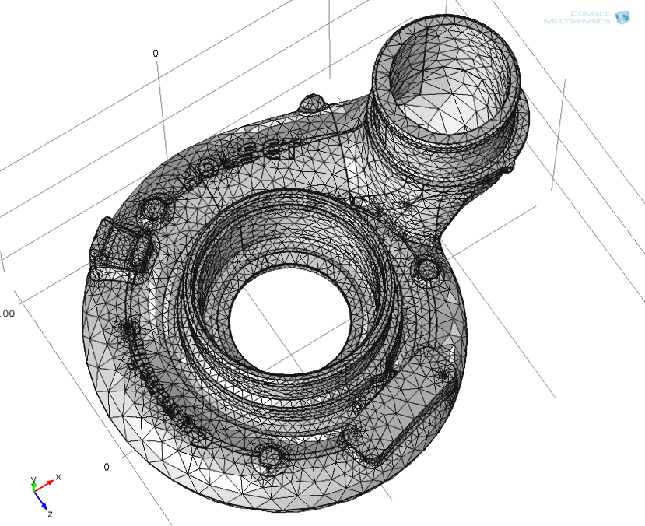
Fig. 2The three dimensional model imported into COMSOL

3.3.1 Finite Element Analysis: Results
The results of the analysis on the casing during maximum operating conditions for each of the three materials analyzed can be found in the table below. During the simulation of the operating conditions an inner pressure and temperature boundary condition of 195 kPa and 230 degrees Celsius were used along with an outer boundary condition of atmospheric pressure (101.321 kPa). It was also fixed in the same locations that it would be fixed when it is placed in a vehicle for normal operation.
The results show that, as expected, the cast aluminum responded with the least amount of strain and displacement when compared to the two polymers. This is due to its large Young’s Modulus and tensile strength. When comparing only the two polymers, it can be observed that the Torlon casing behaves similarly to the aluminum casing whereas the PEEK casing deforms a considerable amount. This is due to the maximum conditions being above PEEK’s glass transition temperature, which causes a large drop in the strength of the material. This was the first indication of the PEEK casing not being a viable option.

Aluminum A356 | Torlon | PEEK
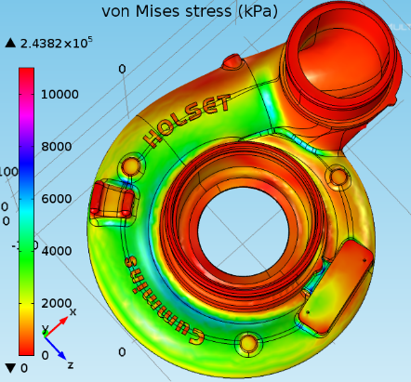 | 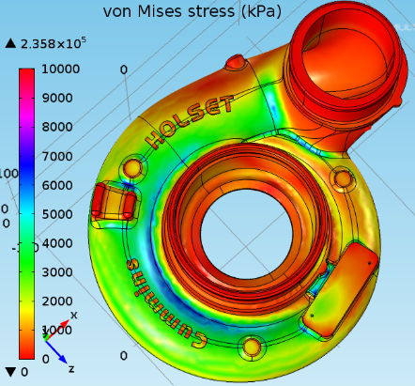 | 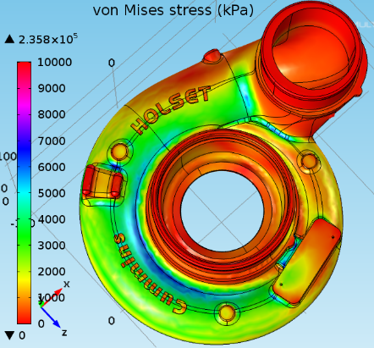
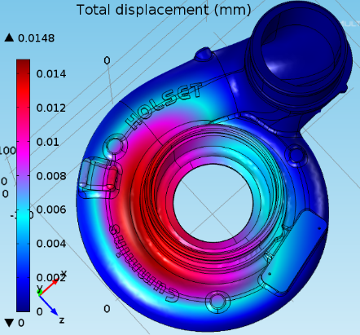 | 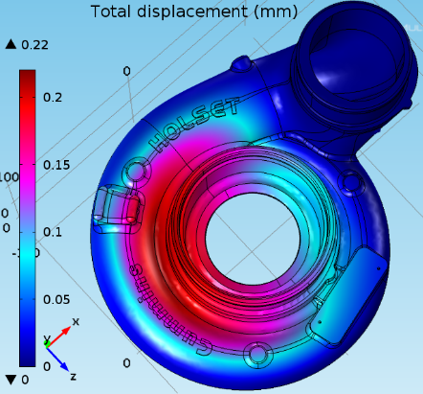 | 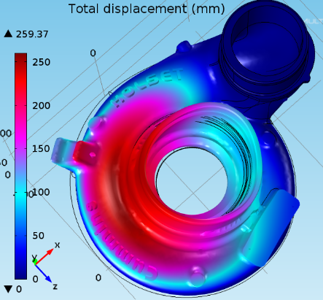
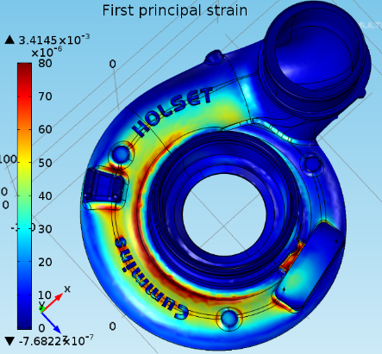 | 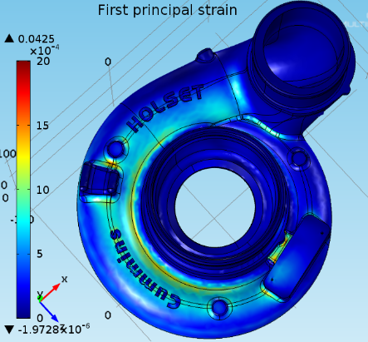 | 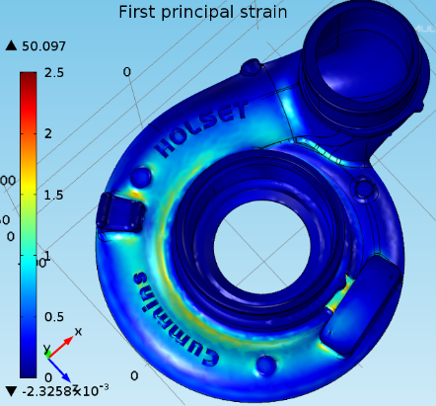
Table 1. Results from Maximum Operating Conditions Analysis
The burst event analysis was performed at two different compressor wheel speeds, 90,000 and 120,000 rpm. Using previous research it was also determined that the compressor wheel most commonly fractures into three separate pieces. Therefore in this analysis point loads were placed at three separate points to simulate this failure. The amount of force at which each piece impacted the casing was found first by finding the impact speed of the piece when hitting the casing. This was done by using the relationship between rotational kinetic energy and kinetic energy of a rigid body. The resulting force was then found. A sample of this derivation can be found in section C of the appendix.
The results from this analysis show large amounts of deformation for each of the casings. The smallest amount being the Aluminum casing and the largest being the casing made of PEEK which deformed a considerable amount more. Torlon, while still deforming a larger amount than Aluminum showed deformation which was fairly close in magnitude. This relative closeness means that the casing made of Torlon would be an adequate choice of a material based on its ability to contain the catastrophic failure of the compressor wheel. On the other hand the analysis shows that PEEK again fails to respond in a favorable manner and could present significant safety issues if used to fabricate the casings.
Table 2. Results from Burst Event Analysis
Aluminum A356 | Torlon | PEEK
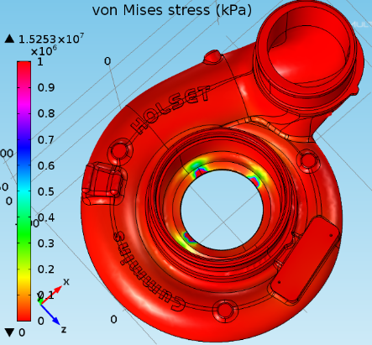 | 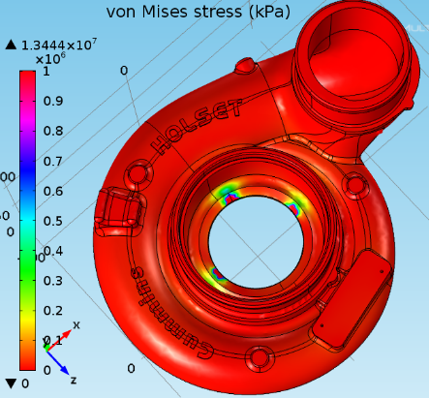 | 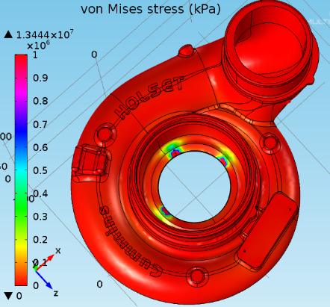
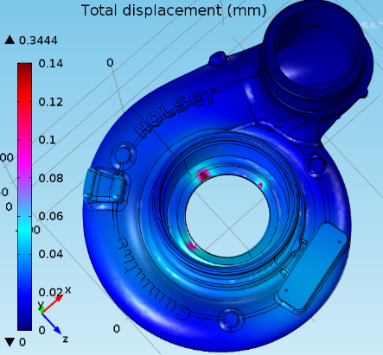 | 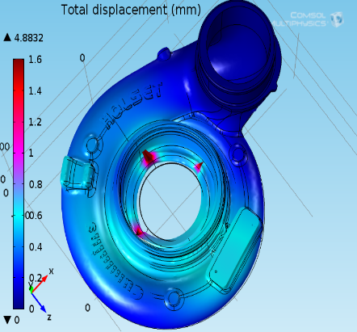 | 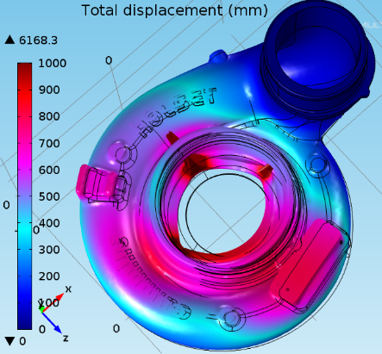
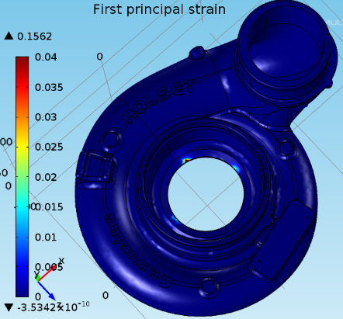 | 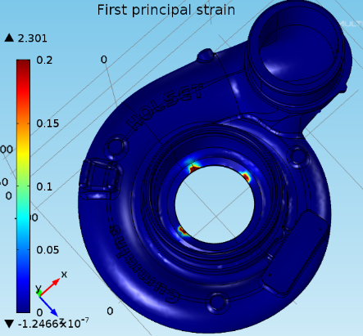 | 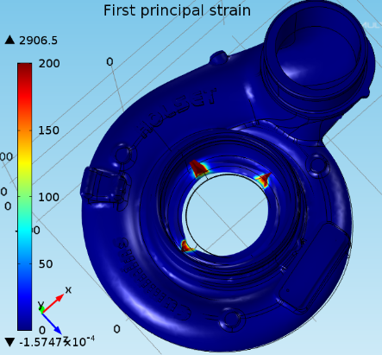

Based off both the maximum operating condition analysis and the burst event analysis it is clear that Torlon would be the most viable polymer material to replace the current aluminum alloy used. It possesses similar strength characteristics and behaves in a similar manner. Furthermore, it was determined PEEK would not be a suitable material choice due to its decreased strength at temperatures above its glass transition temperature.

5. Prototype Details
At first the plan for obtaining a prototype of the compressor casing was to obtain a solid block of the chosen material (Originally PEEK but now Torlon) and machine it down to the correct dimensions. These dimensions are roughly 12 x 4 x 6.5 inches. This would allow for an accurate burst event simulation to take place to determine if our analysis was valid or not. However, after researching and even consulting with a material specialist at Cummins we found that no companies offer a block of material large enough to suit the needs of team. In the end, with the help of the specialist, a 3D printing company was contacted in order to print our casing. The material used for this was a proprietary material called Z-Max.
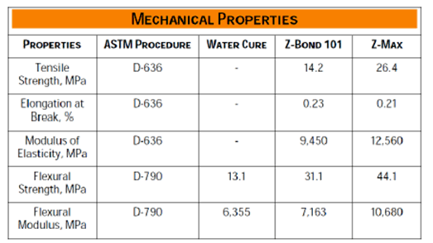
Fig 3. Mechanical Properties of Z-Max

Unfortunately, the properties for Z-max are much lower than the mechanical properties of the material which we chose to use for the actual casing. This meant we were not able to perform an actual operational condition and burst containment tests. A picture of the final product can be seen in Table 3. They provide an accurate representation of the casing, but due to the high price and reduction in mechanical strength of 3D printed products, compared to injection molding, it is not a viable option.
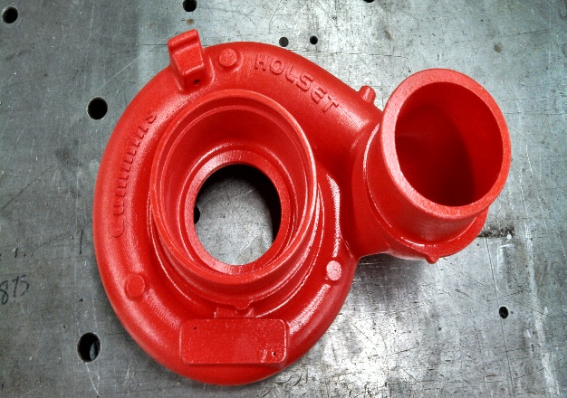  Fig 4. 3D Printed Z-Max Casing | 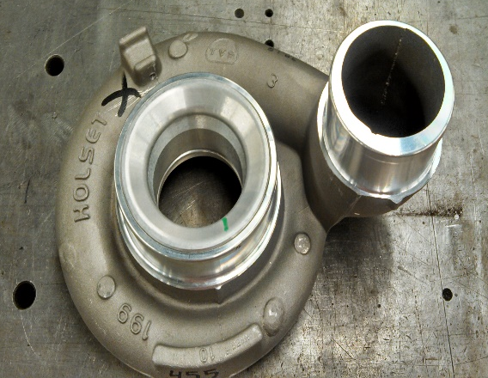  Fig 5. Cast Aluminum A356 Casing
Table 3. 3D Printed Prototype and Original Casing

6. Design for manufacturing, reliability, and cost

6.1. Design for manufacturing
For choosing an alternate material for the turbo charger compressor casing, we decided to select polymers, Polymers such as PEEK, and ultimately our chosen material, Torlon. Because of this, we could no longer use the cast method to make the compressor casings which is how the current aluminum 356 compressor casings are made. So we then decided to proceed with the concept of using injection molding to fabricate the turbo charger compressor casings out of our chosen material, Torlon.
Injection molding is a process in which a polymer, in our case Torlon, is heated and melted through the use of a screw, and is then forced under pressure into a mold of the desired part shape.
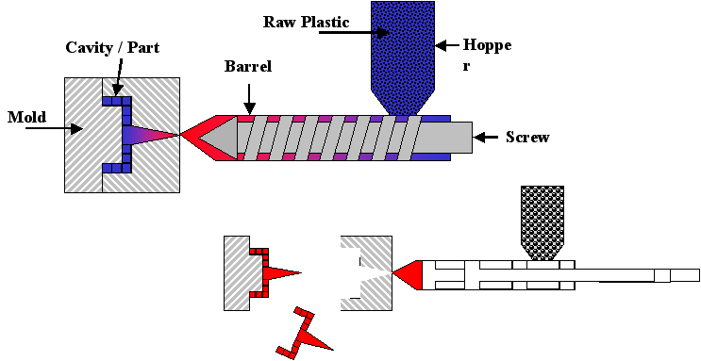
Fig. 6 The injection molding process
We chose injection molding as our design for manufacturing for several reasons. One of the main ones is that it is a common, effective, and efficient manufacturing process for polymers. Another, is that it is similar to the existing manufacturing process of casting compressor casings, in the fact that both processes require similar two piece molds. Finally, injection molding can produce a part with a fairly high amount of precision and quality, which in some cases is actually better than casting. The injection molded parts can also be machined in a similar way to the cast aluminum parts
As far as challenges encountered, there would be very few. The largest would be the extensive cost of the two piece molds required to make the compressor casing. These molds can range in upwards of $50,000.

6.2. Design for reliability
There are several risks involved with selecting an alternate material for a device such as a compressor casing in a turbocharger. Due to the widespread use and importance of these devices it is crucial that any alternate material selected, even if cost efficient, be able to safely operate and withstand the physical conditions associated with a working turbocharger in an automobile. The catalyst of these potential risks can be attributed to the high operating temperatures and stresses associated with the compressor during operation.
The environments in which automobiles are used can also have a significant impact on the materials used to fabricate the compressor casing. Any alternate material considered must be able to operate under cyclic temperatures, for example from below zero freezing weather to normal operating conditions. Materials not suitable for these environments or operating conditions can fail catastrophically, leading to loss of property or life. Also, corrosive materials such as salt, dirt, engine coolant, oil, and other chemicals pose risks for the safe operation of a compressor casing. Therefore, the alternate material should be corrosion resistant to prevent failure and extend the lifetime of the product.
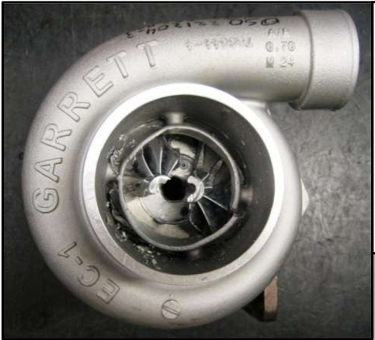
A major risk associated with selecting an alternate material for a compressor casing, in a turbocharger, is whether the material is able to successfully contain a burst event. A burst event occurs when the impeller blades, located in the compressor and turbine housing, experience failure due to the high centrifugal forces associated with the impeller wheel’s rotational velocity. These centrifugal forces can be high enough to eventually overcome the mechanical strength of the blades, which cause them to break off from the main shaft and impact into the casing. A view of such an event can be seen in Fig. 4. Burst events are caused by reduction of strength due to the high internal stresses associated with high temperatures and speeds, fatigue failure due to cyclic loading (stop and go motion of city bus), and foreign object damage (rock or piece of rubber impacting impeller blade). Burst events are rare occurrences, but there are serious safety concerns associated with them. For example, if either the compressor or turbine housing were unable to contain the debris associated with a burst event there is a possibility it could impact functioning equipment near the engine. One major concern would be if this debris were to strike a fuel line with the potential of a spark, flame, and explosion occurring endangering the lives of pedestrians within and near the automobile. A housing or casing must be able to contain any debris or shrapnel which could be produced from a burst event. A successful burst containment test for a certain material will not allow debris or broken material to pass through and exit the casing. It is for this reason that materials used to construct the casings around the compressor and turbine on the turbocharger must be strong, ductile, and be able to continuously operate at high temperatures.
Fig.7 An example of a burst event showing the impeller blades broken and separated from the main shaft.

6.3 Design for cost
Because we had decided to use injection molding to manufacture our turbo charger compressor casing, we then had to preform cost analysis on the injection molding process for making a casing out of Torlon and PEEK.
The first step was to identify the cost of the materials we were analyzing. Those prices are listed below in Fig. 8.
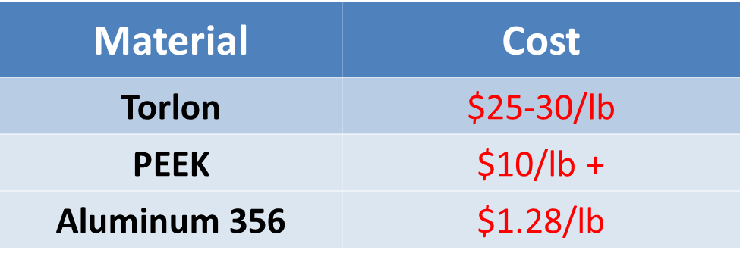
Fig. 8 the prices of the materials per pound
We then calculated the cost per part to produce by injection molding for both PEEK and Torlon. This was achieved with the use of the following equations that are used specifically for cost analysis of an injection molded part. These equations are listed below.
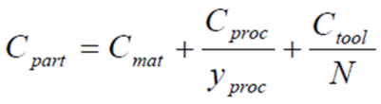
Eq. 1 Cost drivers of manufacturing injection molded parts
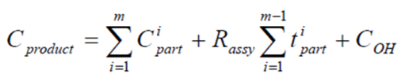
Eq. 2 Expression for the assembled product cost
With these equations all that was left to do was to locate all the variables and then plug them into the equations to determine both the cost of the part found in Eq. 1, and the total cost of the product found in Eq. 2. After doing so, we were left with the following results displayed on the next page.
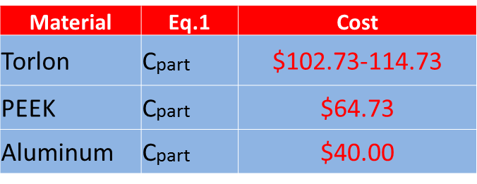
Fig. 9 The cost of the part
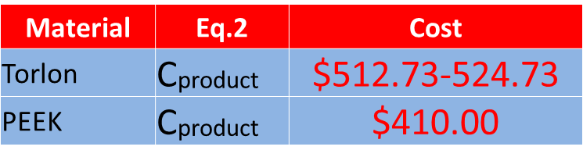
Fig. 10 Total cost of the product
Based on the cost analysis performed it is clear that to produce a compressor casing, out of either PEEK or Torlon through the use of injection molding, is significantly more expensive than that of the current aluminum 356. This is mainly due to the much higher cost per pound of Torlon and PEEK when compared to aluminum 356, and not necessarily to the process of injection molding itself.

7. Considerations for environment, safety, and ethics
There are no known environmental risks or concerns associated with the material Torlon, which would be used to fabricate the compressor casing. The main safety issue associated with the project was ensuring the compressor casing composed of Torlon was able to successfully contain a burst event.

8. Communications
Communication was carried out through cell phone, email, and personal interaction between all team members. The team leader was responsible for coordinating meetings between the group and project sponsor. Emails were primarily used by the team leader to forward all documents and attachments sent by the project sponsor to the team leader. This ensured that all team members were kept up to date with expectations and information provided by the sponsor. A folder, located through the web service drop box, was also shared by the group, which allowed team members to upload their work contribution in to one location and update and improve their work if need be. This also allowed team members to view each other’s work and make suggestions or corrections. The team leader also sent text messages and informed members in person of future meetings held by the group.

9. Conclusions
The idea of this project was to provide an alternate material that is cost efficient to be used to fabricate the compressor casing in Cummins B series turbocharger. Presently the company uses cast aluminum 356 to manufacture and produce their compressor casings. Research was carried out on several materials, specifically polymers, which could be cost efficient by providing long term cost reductions in manufacturing and production expenses. Also it must be reliable and safe to use under the operating conditions in a turbocharger. Several materials were researched and considered in our search for an alternate material to replace aluminum 356. The Operating criteria such as temperatures and pressures were obtained from the sponsor, as well as other stresses and forces the compressor experiences under operation, in order to find materials which could operate under these conditions. These materials also had to possess adequate strength and ductility to withstand a burst event in which the impeller blades break off from the main shaft, due to high internal stresses, and impact into the casing. After further preliminary research was completed, the most effective candidate was found to be PEEK. However, after the burst containment analysis was completed for the PEEK based compressor casing the results showed it would not be a suitable alternate material. This was due to PEEK possessing a glass transition temperature of 162$℃$, which was well below the maximum operating temperature of 230$℃$. The mechanical properties of polymer materials, such as PEEK, begin to decrease after reaching their glass transition temperature, which caused the casing during the analysis to deform significantly. Therefore, another polymer material was researched and analyzed that had a glass transition temperature higher than 230$℃$, and possessed mechanical properties very similar to cast aluminum 356. This material was Torlon, and the results obtained from the analysis showed that it would contain a burst event without deforming significantly. A cost analysis was also performed on this material to estimate the manufacturing costs based on an injection molding production method. Cost analysis results showed that Torlon compressor casings would not be cheaper to manufacture than the cast aluminum 356 counterpart. Torlon was found to be a suitable material to replace the cast aluminum casing, but could not provide a financial advantage for Cummins.

10. Recommendations for future work
Torlon was found to be a suitable material to replace the cast aluminum casing, but based on the team’s cost analysis could not provide a financial advantage for Cummins. Future research in this subject should look at more effective manufacturing methods while retaining the current cheap aluminum material used. A good example of a process that could be considered is near net shape forming. Instead of using the injection molding process for polymer based casings, a more efficient near net shape forming process could be explored which could reduce the manufacturing costs while retaining the current metal alloy used. The near net shape forming process has several advantages in that it can reduce manufacturing costs, and it can also be used to form complex shapes such as a compressor casing.

11. Gantt chart, resources, and budget

11.1 Gantt Chart

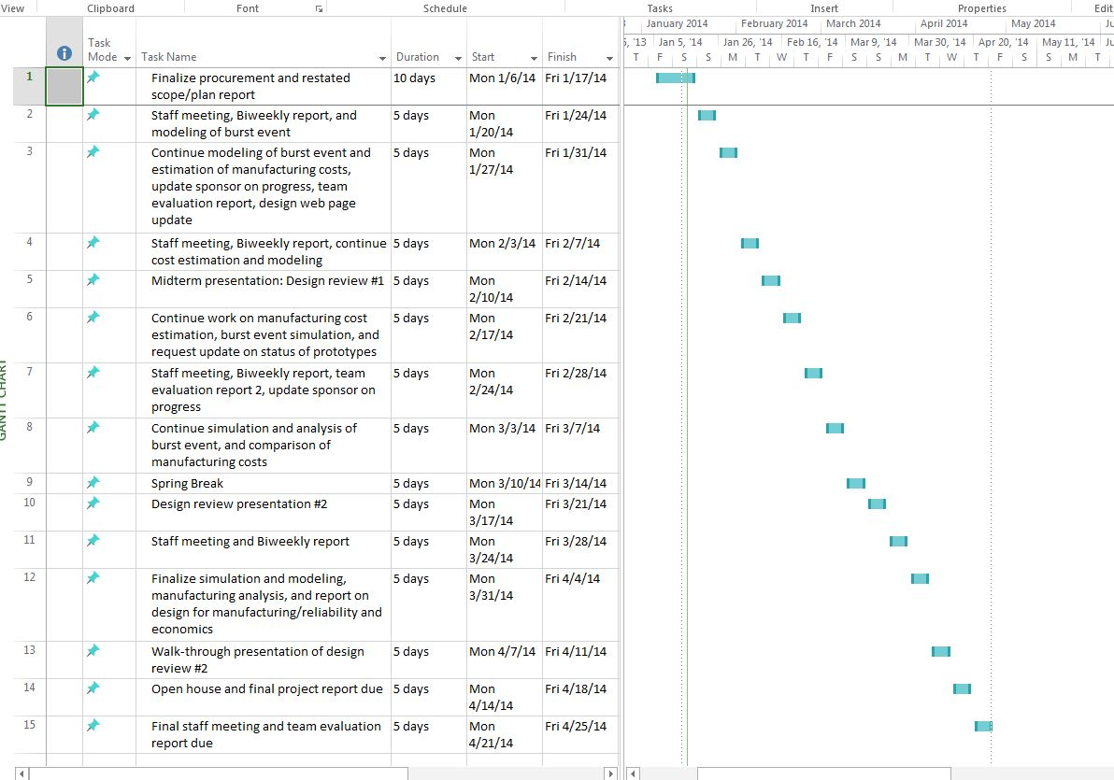
Fig.11 Gantt chart summarizing list of deliverables and tasks to be completed for Spring 2014 semester

11.2 Resources

Team Leader – Harrison McLarty
The team leader was responsible for managing communication between team members and with the project sponsor. Responsibilities also included assigning tasks to team members equally and providing expectations for these objectives. Tasks did include completing deliverables, project presentations, bi-weekly reports, and assuring a satisfactory solution for the demands of the sponsor. In addition the team leader did assist in researching and prototyping materials selected to replace the aluminum alloy currently in use by Cummins. This did include researching companies who can machine the compressor casing based on the alternate material chosen. Machining and labor costs for the compressor casing were also be obtained from the company ultimately chosen. Finally, the team leader assisted in finalizing the completion of deliverables and presentations.
Team members:
Web Master: Alexander Mankin
The web master was be assigned with keeping the group website up to date and current. All deliverables, reports, and presentations will be uploaded to the website. The team did assist the web design master in selecting a template and format for the website, and will provide assistance if needed. In addition the web design master did use Finite Element Analysis to obtain theoretical data on the alternate material ultimately chosen.
Financial Advisor: Ralph Scott
The financial advisor was responsible for organizing supplies needed for the project and their estimated cost. The advisor did update on the team on estimated costs of supplies and the current balance. The main responsibility of the financial advisor was to ensure the team possesses responsible spending practices and ensure that with the supplied funds the project is completed efficiently. The financial advisor did also assist the team leader in calculating the machining and labor costs associated with the prototype compressor casing.

Materials and Metallurgical Advisor: Abiodun Oluwalowo
The materials and metallurgical advisor did provide input and suggestions for the most effective materials to be used in replacing the aluminum alloy currently used by Cummins. All team members completed research for alternate materials and the materials advisor can provide suggestions and comments on the quality and effectiveness of the materials selected.
All team members:
The project sponsor has expressed a desire for the team to calculate the additive manufacturing costs for the material chosen, and an annual cost estimate to fabricate these casings based on the alternate material. This will provide the sponsor with a comparison between the current production costs and the proposed costs associated with the alternate material. It will be the group’s responsibility to estimate these costs collectively. Also, all group members will present their findings for an alternate material and the final material chosen will be the one which is most cost efficient based on an estimate of the material and its additives. However, the material must closely match the material properties of the original aluminum alloy, cast aluminum 356, and be able to withstand the operating conditions of the turbocharger. In addition, all group members will assist in completing deliverables, reports, and presentations associated with the project. Finally, there will be a collective effort in analyzing the test results completed on the prototype, which will be completed through resources provided by the project sponsor.

11.3 Budget
The budget allotted for the project was 2000 dollars. The majority of it ($1950.00) was spent on the prototype of the casing which we had 3D printed by a company which was contracted by Cummins.

12. References
- "How It Works: Two-In-One Turbocharger | Popular Science." Popular Science. N.p., n.d. Web. 26 Sept. 2013. <http://www.popsci.com/content/two-one-turbocharger>.
- "Online Materials Information Resource - MatWeb." Online Materials Information Resource - MatWeb. N.p., n.d. Web. 21 Oct. 2013. <http://www.matweb.com/>.
- "Plastic Sheet, Plastic Rod, Plastic Tubing - Buy Online." Plastic Sheet, Plastic Rod, Plastic Tubing - Buy Online. N.p., n.d. Web. 21 Oct. 2013. <http://www.professionalplastics.com/>.
- "VICTREX® PEEK Polymers." High Performance Polyaryletherketones, High Temperature Advanced PEEK Polymer, Thermoplastic. N.p., n.d. Web. 19 Nov. 2013. <http://www.victrex.com/en/products/victrex-peek-polymers/victrex-peek-polymers.php>.
- 5. "Burst and Containment: Ensuring Turbocharger Safety." Turbobygarrett.com. N.p., n.d. Web. 19 Nov. 2013. <http://www.turbobygarrett.com/turbobygarrett/sites/default/files/Garrett_White_Paper_02_Burst__Containment.pdf>.

13. Appendix

A: Data Table of operation conditions provided by Cummins
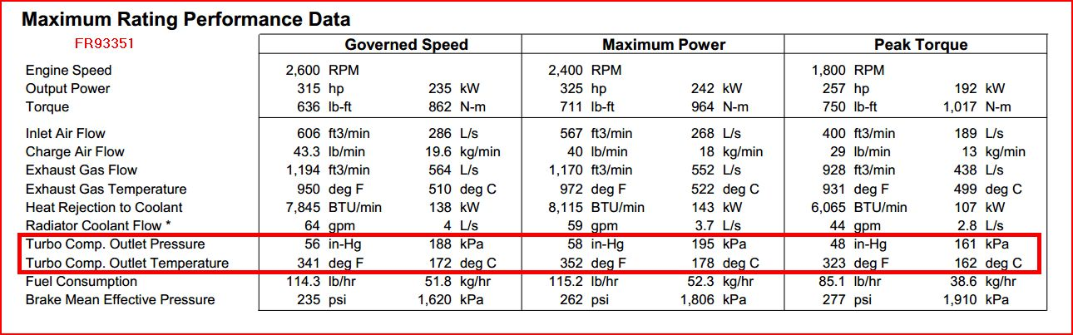

B: Material Properties
B-1: Aluminum 356
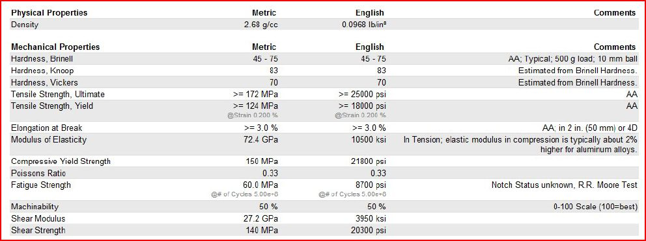

B-2 Torlon

B-3 PEEK
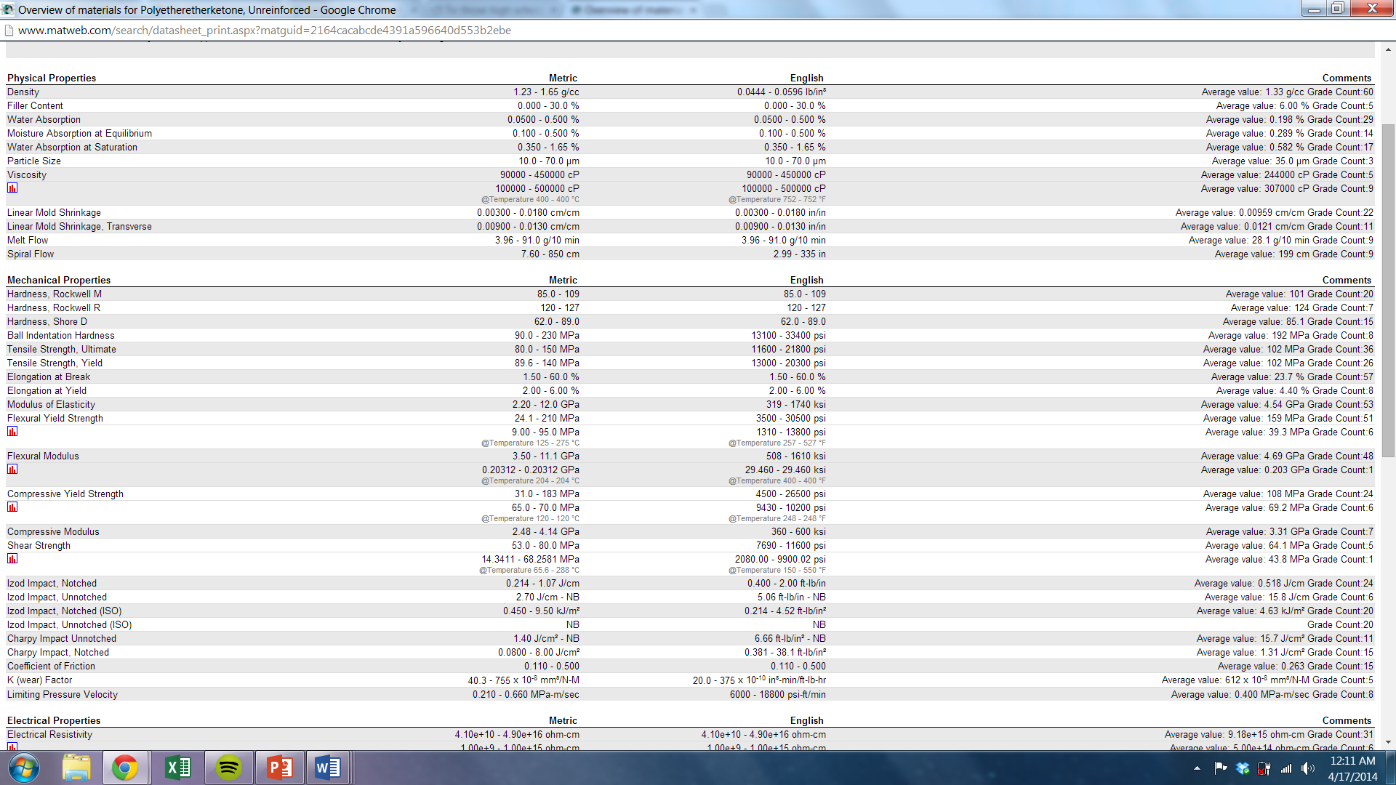

C: Finite Element Analysis Equations and Derivations
C-1 Theoretical model of a compressor casing
If the geometry of the casing were to be analyzed in small sections, the cross sectional object would be similar to that of a thick walled cylinder. Therefore the equations derived and used to validate the COMSOL analysis are based off the theory of stresses which occur in a thick walled cylinder.

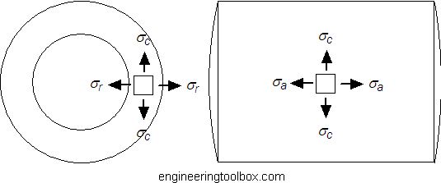
Figure 1. Stress Depiction of stresses in a thick walled cylinder
When splitting up the casing in to small sections, modeling this physical system can be considered done by solving a plane elasticity problem. In this case, since the amount of forces are known, it falls into the plane stress grouping. The material is assumed to be linear elastic or in basic terms obey Hooke’s law. This allows for it to be described by differential equations that describe displacement of a material. The only problem which arises from this is that an assumption is made which treats the axial stress as being 0. The governing equations for this problem will be discussed below. Also, the effect of assuming this stress is 0 as well as what occurs if this stress is accounted for will included.
In two dimensions with the assumption that stress in the z direction is 0, stress varies with radius, r ,in the normal direction for the inner radial stress to outer radial stress:
$σ_{rr}$ to $σ_{rr}+ \frac{dσ_{rr}}{dr}dr$ (1)
When a Force balance is done and is simplified version becomes:
$r\frac{dσ_{rr}}{dr}+\left( σ_{rr}- σ_{θθ}\right)=0$ (2)

Another assumption that must be made is that the geometry is axisymmetric, using this assumption allows for theory that the displacement varies along radius only because in the circumferential or hoop direction displacement, u, stays constant. This allows for the strain in the radial direction to describe the following equation:
$ε_{rr}=\frac{du}{dr}$ (3)
The strain in the hoop direction is equal to the elongation of the same area in respect to its corresponding radius.
$ε_{θθ}=\frac{u}{r}$ (4)
When Hooke’s law is applied to the situation, assuming no shearing is occurring, leads to the following strains in both the radial and hoop directions:
$ε_{rr}=\frac{1}{E}(σ_{rr}-vσ_{θθ})$, $ε_{θθ}=\frac{1}{E}(σ_{θθ}-σ_{rr}v)$ (5)
Where,
v is Poisson’s’ ratio
E is Young’s Modulus

Similarly, the stresses are:
$σ_{rr}=\frac{1}{E}(ε_{θθ}v+ε_{rr}){ σ}_{θθ}=\frac{E}{\left(1-v^{2}\right)}(ε_{rr}+vε_{θθ})$ (6)

If the previous equations are substituted into the force balance, equation, it forms an equation which can be integrated to find displacement.
If the object being analyzed is a circular cross section or has a cylindrical three dimensional shape and satisfies ( $\frac{r_{i}}{thickness}<10$) then it can be considered a thick walled pressure vessel. This means that the following boundary conditions can be applied in order to find the theoretical values.
$σ_{r}\left(a\right)=-p_{i}$ and $σ_{r}\left(b\right)=-p_{o}$ (7)
After a few substitutions the stress equations become:
$σ_{rr}= \frac{E}{1-v^{2}}\left[\left(1+v\right)C_{1}-(1-v)\frac{C_{2}}{r^{2}}\right]$ (8)

$σ_{θθ}= \frac{E}{1-v^{2}}\left[\left(1+v\right)C_{1}+(1-v)\frac{C_{2}}{r^{2}}\right]$ (9)
Where the constants are
$C_{1}= \frac{1-v}{E}\left[\frac{a^{2}p_{i}-b^{2}p_{o}}{b^{2}-a^{2}}\right]$ and $C_{2}=\frac{1+v}{E}(p_{i}-p_{o}) \frac{a^{2}b^{2}}{b^{2}-a^{2}}$ (10)
Where,
a is the inner radius $r_{i}$
b is the outer radius $r_{o}$
r is the radial distance from the center of the pipe
$p_{i}$ is the pressure on the inside of the pipe
$p_{o}$ is the pressure on the outside of the pipe

After a few more substitutions the equations become a well-known set of functions which are called Lame’s equations.
$σ_{rr}= \frac{a^{2}p_{i}-b^{2}p_{o}}{(b^{2}-a^{2})}-\frac{\left(p_{o}-p_{i}\right)a^{2}b^{2}}{\left(b^{2}-a^{2}\right)r^{2}}$ ,${ σ}_{θθ}=\frac{a^{2}p_{i}-b^{2}p_{o}}{(b^{2}-a^{2})}+\frac{\left(p_{o}-p_{i}\right)a^{2}b^{2}}{\left(b^{2}-a^{2}\right)r^{2}}$ (11)

The only issues with Lame’s equations are that it does not account for when the stress in the axial direction is above 0. If the ends of the cylinder are fixed, which it is in the case of a section of the turbocharger piping, stress and consequently strain will occur in the axial direction. To find its effect on the other stresses, Hooke’s law was applied in the z or axial direction:

$ε_{zz}=\frac{1}{E}(σ_{zz}-vσ_{rr}-vσ_{θθ})$ (12)

After some rearranging and substitution is done, the stress in axial direction becomes

$σ_{zz}= \frac{a^{2}p_{i}-b^{2}p_{o}}{(b^{2}-a^{2})}$ (13)
C-2 Burst Containment Calculations
Weight of the compressor wheel:
The dimensions and material properties of the compressor wheel were used to determine the weight
60x82mm comp wheel
Material: Aluminum C355
Density: 2.71 g/cm^3
Weight: 146.5g
D = 86 mm
R = 43 mm
R= .043 m

Speed of the compressor wheel:
The rotational speed in rpm was converted to rad/s
Increments of 30k
For rad/s
60 rpm = 6283 90k rpm = 9425 120k rpm = 12566
Rotational kinetic energy of the compressor wheel calculation:
The equation to find the rotational kinetic energy of a body is:
$I= \frac{1}{2}Iω^{2}$ (1)
Where,
I is the moment of inertia of a body
$ω$ is the rotational speed of the body

The equation to find the moment of inertia of a body is
$I= \frac{1}{2}mr^{2}$ (2)
Where,
m is the mass of a body
$r$ is the radius of the body

When combined it results in this equation.
$E= \frac{1}{4}mr^{2}ω^{2}$ (3)

Solving for the kinetic energy of the compressor wheel at 60,000 rpm gives:
$$E= \frac{1}{4}\left(.1465 kg\right){\left(0.043 m\right)}^{2}{\left(6283\frac{rad}{s}\right)}^{2}=2673 N*m$$

Kinetic energy of a rigid body:
The equation for kinetic energy of a rigid body is:

$E= \frac{1}{2}mv^{2}$ (4)
Where,
m is the mass of a body
$v$ is the velocity of the body
Since the mass and kinetic energy are known, the velocity can be solved for by doing some rearranging. The equation for velocity is
$v= \sqrt{\frac{2E}{m}}$ (5)
For 60,000 rpm this give a compressor wheel speed of
$$v= \sqrt{\frac{2*2673 n*m}{.1465 kg}}=191.03\frac{m}{s}$$

Using this velocity the impact force can be found. This is through the use of the simple force equation.
$F= m*\frac{∆v}{∆t}$ (6)

For 60k the force was found assuming a total change in time of .001 seconds.
$$F= .1465*\frac{191.03\frac{m}{s}}{.001 s}=28,000 N$$

Since it fractures into three separate pieces, the force can be divided by three to determine it separately for each part of the wheel.
$$F= \frac{28,000 N}{3}=9333.33$$

D: Cost Analysis Values

This is the equation for cost per part
$C_{part}=C_{mat}+\frac{C_{proc}}{y_{proc}}+\frac{C_{tool}}{N}$ (1)

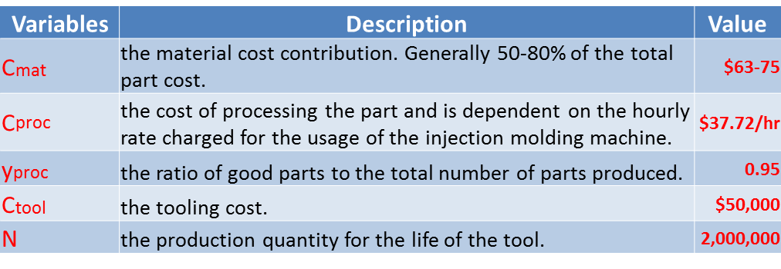

Here is a sample calculation using this equation.
$C_{part}=63+\left(\frac{37.72}{.95}\right)+\frac{50000}{2000000}=102.73$ (2)

This is the equation for cost of production.

$C_{product}=\sum_{i=1}^{m}{C_{part}^{i}+R_{assy}\sum_{i=1}^{m-1}{t_{part}^{i}+C_{OH }}}$ (3)

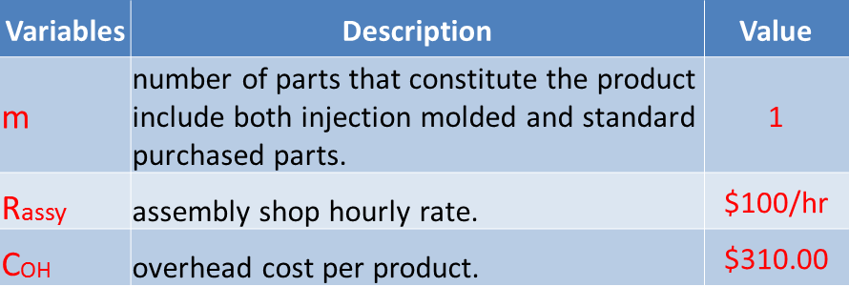
This is a sample calculation using the production equation.
$C_{product}=\sum_{i=1}^{1}{102.73+100{\sum_{i=1}^{1-1}{2}}^{1}+310}=512.73$ (4)

