The Florida State University – FAMU
College of Engineering

Department of Mechanical Engineering

EML4551 Senior Design Project II
Operation Manual

Group # 4

The CRUSHED Experiment
Sponsored by Eglin Air Force Base

Members:
- Phillip Munday
- Justin Roose
- Carlos Sanabria

The Requirements

The principal objective of the project is to design this system that applies a compressive pressure on the outer diameter of a pipe. The pressure must be able to be determined based on an applied force that can be regulated with a simple device, such as the hydraulic pump. For the final design, no sensors can be applied to the test cylinder; therefore a calibration of the system must be done. This system is segmental in nature (i.e. – several equal sized pieces) that can be combined to apply a continuous load over the entire circumference of the cylinder.

Safety
Safety should always be of the utmost importance. So a full system inspection should be completed before and after every use. The user must inspect the entire system and pay special attention to key areas, such as, the welded seams and look for cracks or signs of rust; this could lead to a catastrophic failure of the system when it is under pressure. The user must inspect all the hydraulic components and connections for ware and leaks, as well as the hoses themselves to ensure no cracking or dry rotted lines. If any component is determined unsafe, the system should not be used until the part is replaced.
The users’ safety was taken into consideration during the design of the system. The hydraulic hand pump is attached to the six foot hydraulic hose, which allows the user to be a safe distance away from the system if any failure, either hydraulic or mechanical failure, were to occur.

Operation
To operate this system the user must mount the grounding ring the ground platform the user will provide. Once is it mounted and the safety procedures meet, the system can now be used.
- Remove all pressure from the hydraulic system by turning the black knob on the hydraulic hand pump counter clockwise. Ensure that the hydraulic cylinders are completely retracted.
- Tighten the black knob on the hydraulic hand pump clockwise until it is fully turned.
- Insert the test pipe into the unit.
- Pump the hydraulic hand pump to the desired pressure. The gage attached to the hand pump reads the hydraulic pressure, this cannot exceed 10,000psi. The test pipe pressure (P_{pipe}) can be calculated from equation 1. P_{h} is the hydraulic pressure as read from the pressure gage on the system.

$${ P}_{pipe}\left(P_{h}\right)=\frac{P_{h}}{9.425} (1)$$

- Perform test
- Once test is complete remove pressure from the system by turning the black knob on the hydraulic hand pump counter clockwise.
- Remove pipe and store system in a non-corrosive environment to ensure hydraulic hose longevity.
The Physical System Assembly
The Crushed Experiment was designed around the criteria that there is no need to create a stationary platform and the final product should have the ability to be mounted to a stationary grounded location. The system that was designed and fabricated consists of a housing ring made out of steel I-beams for the purpose of being welded or bolted to the stationary platform that the user would provide. If the user wishes to weld to the steel I-beam, the user should remove all hydraulic components from the hexagonal ground ring before welding to it. The heat could ruin the seals in the hydraulic cylinders and render the system inoperable. The user should also take care to not warp the I-beams from excess heat do welding. If the ground ring warps, the system may not operate as intended.

This design consists of two subsystems, the hydraulic system and the stationary system. The hydraulic system is itemized in table 1; whereas the stationary system is itemized in table 2. The system is delivered as one unit; however, if the system is not assembled, there will be some assembly that will need to be performed. The ground ring assembly consists of six I-beams and three steel columns all welded together. For the mechanical drawings see the appendix of this operation manual.

Table 1: Hydraulic system
Part Number | Part | Qty.
1 | Hydraulic Pump | 1
2 | Hydraulic Cylinders | 3
3 | 1 foot hose | 3
4 | 6 foot hose | 1
5 | Hydraulic Manifold | 1
6 | Pressure Gauge | 1
7 | Pressure Adapter | 1
Total parts |  | 11
Table 2: Stationary system
Part number | Part | Qty.
8 | Ground Ring Assembly | 1
9 | Mounting fasteners | 6
10 | Aluminum Media | 6
 | Total parts | 13

To assemble the system:

1: Assembly starts with the Ground Ring. Have it situated such that the three welded columns are on the bottom unit, as shown below.

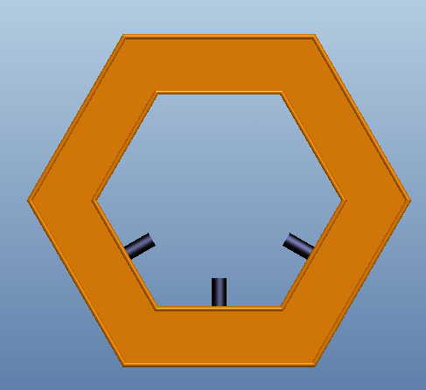

2: Find the six mounting fasteners and the three hydraulic cylinders. The hydraulic cylinders are mounted to the three remaining flat surfaces within the hexagon shaped ground ring such that the actuating piston is in the center of its mounting surface. These hydraulic cylinders are held into place via the mounting fasteners with two fasteners per hydraulic cylinder. Place the fasteners through the I-beam holes so that the head of the fastener is within the flanges of the I-beam and thread them into the hydraulic cylinders. REMEMBER to situate the hydraulic cylinders such that the actuating piston is in the center of the I-beam, see below.

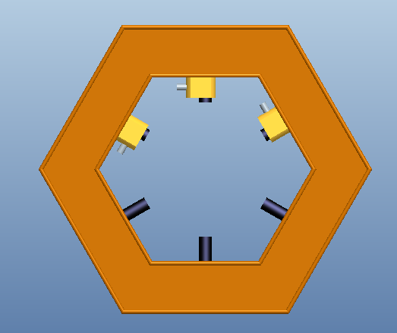

3: Assembly of the hydraulic system is needed to be completed next do to the fact that the hydraulic cylinders may need to be extended slightly to mount the aluminum incompressible media.
Start at the hand pump
3A) Attach the pressure adapter to the hydraulic hand pump.
3B) Attach the pressure gage to the top of pressure adapter.
3C) Attach the six foot hydraulic hose to the end of the pressure adapter.
Now move to the hexagonal ground ring
3D) Attach the each of the one foot hydraulic hoses to a hydraulic cylinder.
3E) Attach the now loose ends of these 3 hoses to the black hydraulic manifold.
3F) Attach the free end of the six foot hose to the black hydraulic manifold.
3D) Insert the remaining holes in the hydraulic manifold with the threaded plugs
Make sure to tighten all hoses securely before testing the system.

4: Locate the six aluminum incompressible media blocks. Separate the three aluminum blocks that has a 1/8in deep oval machined out of one side; these are the hydraulic cylinder blocks. The remaining aluminum blocks are the stationary blocks.
Place the stationary blocks on the columns that are welded to the ground ring such that the cut out radius will fit around and house the test pipe. The mounting holes on the aluminum blocks are machined to be a press fit. They will come to be fully seated when the system is placed under pressure.
Place the hydraulic cylinder blocks on the hydraulic cylinders that are bolted to the ground ring such that the cut out radius will fit around and house the test pipe. The hydraulic cylinders may need to have the actuating pistons extend, if so, pump the hydraulic hand pump until the pistons extend enough to mount the aluminum blocks. Again, the mounting holes on the aluminum blocks are machined to be a press fit. They will come to be fully seated when the system is placed under pressure.

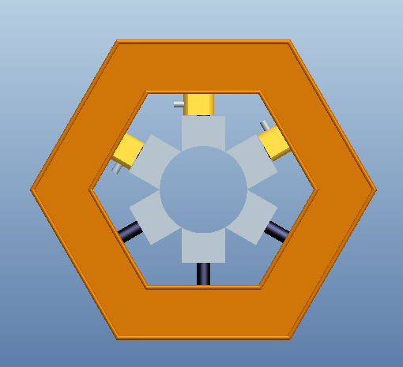

The Completed System and Testing
The entire system should look like the photo below when it is assembled correctly.

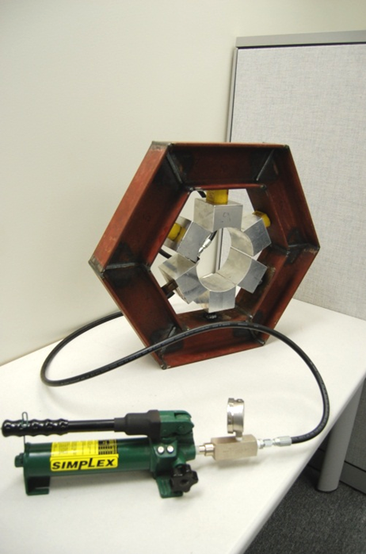

The main two requirements that will be tested is to see if the pressure is quasi-hydrostatic, and finding the pressure on the pipe. The test to see if the pressure is quasi-hydrostatic is to place a copper wire on top of the pipe and apply pressure. This test was performed at nine thousand five hundred psi, hydraulic pressure.
First a soft copper wire will be wrapped around the circumference of the pipe and the pressure applied on top of it to look at the deflection and the uniformity of the affected area. Figure 34 shows an image of the wire after testing. Throughout the length the affected area has a very uniform value except in between the sections were there is no pressure, see below.

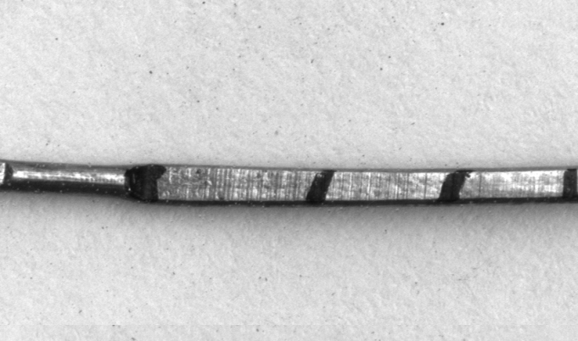

The second test will be to get a correlation between the pressure in the hydraulics and the pressure on the pipe. The correlation can be calculated mathematically but this test will be used to show accuracy of the equation. The way this experiment was carried out was with a strain gauge placed on the inside of the pipe, and data was taken at different increments of hydraulic pressure. Then the assumption was made that the pipe was a thin walled pressure vessel, which is how we correlated the strain to the pressure on the outside of the pipe; the equation can be seen below (eq. 2 and 3 ).
$${ σ}_{h}=ϵ*E eq.2$$
$$P_{p}=\frac{σ_{h}*t}{r} eq.3$$
Each of the variables correspond to; $σ_{h}$is the hoop stress in the pipe, $ϵ$ is the measured strain, E is the Young’s Modulus of the steel pipe (13.4*10^6 psi), t is the thickness of the wall (0.125 in.), and r is the radius of the pipe (3.125 in) The experiment was run three different times; rotating the pipe ten degrees each time to get an average reading. It can be seen in the data that the corners of the aluminum are large stress concentrators, because some of the data gives a much larger pressure than what was calculated mathematically. The variations can be seen more clearly in Chart 1 in the appendix. The pressure equation line is the equation used to calculate the pressure on the pipe. There are four other set of data points, the “pressure” sets are the exact pressure values calculated from the strain, and the “average” data set is an average of the first two pressure data sets. The average data set gives a very good indication that the formula above is a good estimate of the average pressure on the pipe given the pressure in the hydraulic fluid. Looking at the chart (in the appendix) it would appear that the pressure on the pipe is larger than the calculated pressure.
The data collected from the second experiment reinforced what was seen in the first experiment. The system is not a quasi-hydrostatic because of the gaps in the aluminum blocks, but this was an expected result. It will be talked about in upcoming sections how to decrease these stress concentrators to create more of a quasi-hydrostatic pressure.

Appendix

Calibration data
Experimental Values
Pressure (psi) | MicroStrain1 | Pressure1 (psi) | MicroStrain2 | Pressure2 (psi) | Avg MicroStrain | Pressureavg (psi)
1000 | -0.397 | 108.567 | -0.651 | 400.094 | -0.524 | 146.283
2000 | -1.200 | 328.163 | -1.500 | 921.875 | -1.350 | 376.875
3000 | -1.770 | 484.041 | -2.360 | 1450.417 | -2.065 | 576.479
4000 | -2.065 | 564.714 | -3.001 | 1844.365 | -2.533 | 707.129
5000 | -2.193 | 599.718 | -3.560 | 2187.917 | -2.877 | 803.023
6000 | -2.258 | 617.494 | -4.201 | 2581.865 | -3.230 | 901.569
7000 | -2.350 | 642.653 | -4.964 | 3050.792 | -3.657 | 1020.913
8000 | -2.500 | 683.673 | -5.850 | 3595.313 | -4.175 | 1165.521
9000 | -2.650 | 724.694 | -6.667 | 4097.427 | -4.659 | 1300.498
10000 | -2.810 | 768.449 | -7.500 | 4609.375 | -5.155 | 1439.104

Mechanical Drawings:

